*Rauwolfia serpentine*

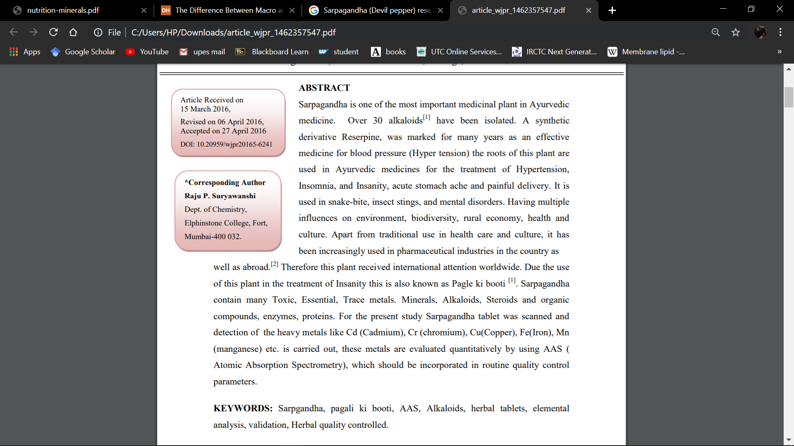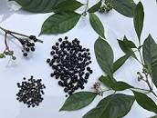**Common Name** – Snakeroot (Sarpagandha)

Ayurveda, Siddha, Unani and tribal medicines are the major ancient systems of medicines. Ayurveda is based on three essential elements called Tridosh like Vata, Pitta and Kapha. Theses includes seven basic entities (dhatu), which are plasma (rasa), blood (rakta), muscles (māmsa), fat (meda), bone (asthi), marrow (majja), and semen (shukra). [3,4] These are subject to wear and tear so that mala (excretory material) is formed from them. When tridosha, saptadhatu and mala are in balance with each other, it is called a healthy condition, while imbalance results in diseases. Plant-based treatments in Ayurveda derived from roots, leaves, flowers, fruits, bark, stems, and seeds. The origins of Ayurveda have been traced back to around 5,000 BC, found in Atharvaveda. Nature has provided a complete store house of remedies to cure all ailment of mankind. In the past almost all the medicines used were from the plants. Herbals are traditionally considered harmless and increasingly being consumed by people without prescription. Quality evaluation of herbal preparation is a fundamental requirement of industry and other organization dealing with Ayurvedic and herbal products, which is neglected till this date. The traditional approach towards standardization and validation is insufficient for current herbal products and hence there is need for more advanced techniques for standardization and validation, using sensitive instrumental analysis. The World Health Organization (WHO) in 1999 and 2011 has given a detail guideline for the standardization of herbal products (WHO 2011). [7] Ayurveda, an ancient science of life the well-known treatises in Ayurveda are Chakra Samhita and Sushrutha Samhita. Sarpagandhaa mitigates kapha and vaata. It induces sleep (niddrapradaa) slows heart (hardvasaadinee), suppresses libido (kaamaavasaadinee), is beneficial in colic pain (chaiv), fever (jvara) and parasitic infestation (krimi). Sushruta Uttara, 60:47. Sarpagandha is a species of flowering plant in the family Apocynaceae. It is nativeto the Indian subcontinent and East Asia. Root, bark is the richer in alkaloid.The alkaloids content varies depending on the local, season, and plant age at the time of harvesting of roots. Different names of Sarpagandha Common English names: Devil-pepper, Snake-root, Sanskrit: Sarpagandhaa (Ayurveda). Scientific Name: Rauvolfia serpentina (L.) Benth. Ex Kurz. Common Name: Serpentine, Serpentine root, Rauwolfia.