*Mentha arvensis.L.*

**Common Name** – Mint (Podina)

Abstract

*Mentha longifolia* (wild mint) is a popular folk remedy. Some parts of this plant have been used in traditional medicine of Iran and other countries. Many studies have shown various pharmacological and therapeutic effects of the plant. Our aim in preparing this study was to review the traditional uses of *M. longifolia* together with the pharmacological and therapeutic effects of its entire extract and major compounds. *Mentha longifolia* is an herb with a wide range of pharmacological properties such as antimicrobial, gastrointestinal, and nervous system effects. Pulegone is the main compound of the plant responsible for most of its pharmacological effects followed by menthone, isomenthone, menthol, 1, 8-cineole, borneol, and piperitenone. Moreover, the plant may dose-dependently exert toxic effects in different systems of the body. Based on the review of various studies, it can be concluded that *M. longifolia* is a potential natural source for the development of new drugs. However, further studies are required to determine the precise quality and safety of the plant to be used by clinicians.

**KEY WORDS:***Mentha longifolia*, menthol, pharmacological effects, traditional use

*Mentha longifolia* (wild mint) is a popular folk remedy. Some parts of this plant have been used in traditional medicine of Iran and other countries. Many studies have shown various pharmacological and therapeutic effects of the plant. Our aim in preparing this study was to review the traditional uses of *M. longifolia* together with the pharmacological and therapeutic effects of its entire extract and major compounds. *Mentha longifolia* is an herb with a wide range of pharmacological properties such as antimicrobial, gastrointestinal, and nervous system effects. Pulegone is the main compound of the plant responsible for most of its pharmacological effects followed by menthone, isomenthone, menthol, 1, 8-cineole, borneol, and piperitenone. Moreover, the plant may dose-dependently exert toxic effects in different systems of the body. Based on the review of various studies, it can be concluded that *M. longifolia* is a potential natural source for the development of new drugs. However, further studies are required to determine the precise quality and safety of the plant to be used by clinicians.

**KEY WORDS:***Mentha longifolia*, menthol, pharmacological effects, traditional use

INTRODUCTION

The wild mint (*Mentha longifolia* L. family *Lamiaceae*) grows extensively in Mediterranean regions, Europe, Australia, and North Africa. The plant is a variable perennial with a peppermint-scented aroma. It has a creeping rhizome with straight to creeping stems 40-120 cm in height. The leaves are oblong-elliptical to lanceolate, thinly to densely tomentose, green to greyish-green above and white below. The flowers are 3-5 mm long, lilac, purplish, or white, produced in dense clusters on tall, branched, and tapering spikes. *M. longifolia* is used in the pharmaceutical, tobacco and food industries and particularly in cosmetology. Different parts of the plant including its leaves, flower, stem, bark, and seeds have been also used widely in traditional folk medicine as antimicrobial, carminative, stimulant, antispasmodic and for the treatment of various diseases such as headaches and digestive disorders.] In pharmacological research, there is enough indication for different biological effects of *M. longifolia* and the chemical compounds present in the essential oil of the plant.

Table 1

Traditional uses of *M. longifolia*

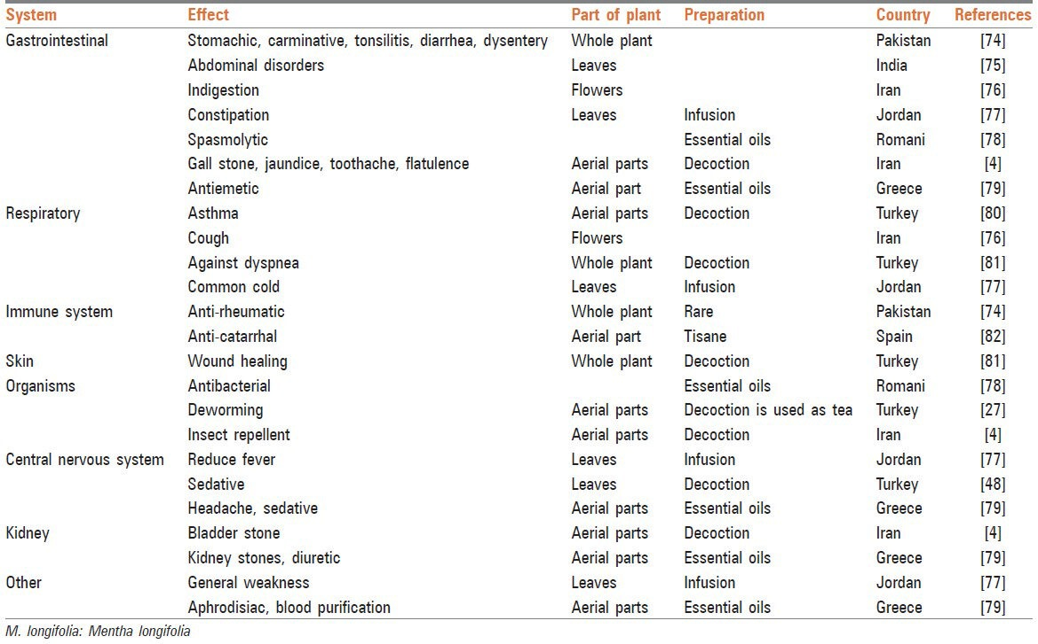

Table 2

The pharmacological effects of *M. longifolia* (L.)

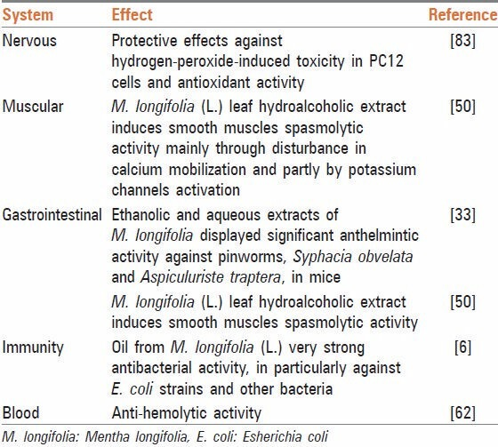

[Open in a separate window](https://www.ncbi.nlm.nih.gov/pmc/articles/PMC4171855/table/T2/?report=objectonly)

Studies carried out on the chemical composition of the plant have shown that the main chemical compounds present in *M. longifolia* essential oil are monoterpenes [[Figure 1](https://www.ncbi.nlm.nih.gov/pmc/articles/PMC4171855/figure/F1/)], particularly oxygenated ones such as pulegone, menthone, isomenthone, menthol, 1,8-cineole, borneol, and piperitenone oxide. Among them, menthol is the most important component responsible for most of the pharmacological effects of the plant. It is a waxy, crystalline substance, clear or white in color, which is solid at room temperature and melts at slightly high temperatures. *Mentha* is also found in the essential oils of other members of the mint family (*Mentha* spp.) such as peppermint and horse mint. Gas chromatography mass spectrometry analysis has shown that the main compounds within essential oil of *M. longifolia* are: Menthol (19.4-32.5%), menthone (20.7-28.8%), pulegone (7.8-17.8%), 1,8-cineole (5.6-10.8%), which have imperative roles in various effects of this plant. This article reviews the pharmacological effects of the total extract [[Table 2](https://www.ncbi.nlm.nih.gov/pmc/articles/PMC4171855/table/T2/)] and the most active ingredient [[Table 3](https://www.ncbi.nlm.nih.gov/pmc/articles/PMC4171855/table/T3/)] of *M. longifolia* (menthol) and its applications in traditional folk medicine [[Table 1](https://www.ncbi.nlm.nih.gov/pmc/articles/PMC4171855/table/T1/)].

[[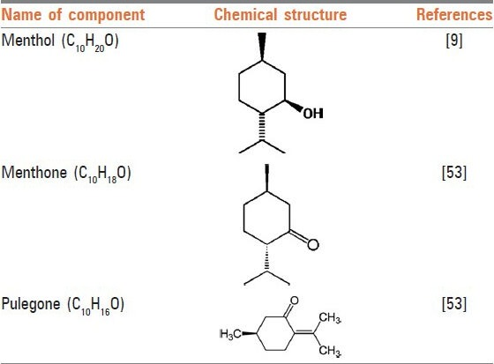](https://www.ncbi.nlm.nih.gov/pmc/articles/PMC4171855/figure/F1/)](https://www.ncbi.nlm.nih.gov/pmc/articles/PMC4171855/figure/F1/" \t "figure)

[Figure 1](https://www.ncbi.nlm.nih.gov/pmc/articles/PMC4171855/figure/F1/)

Structures of some active constituents of *Mentha longifolia*

Table 3

The pharmacological effects of menthol

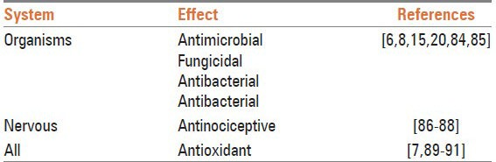

ANTIMICROBIAL ACTIVITY

Usage of *M. longifolia* in the treatment of throat irritation, mouth and sore throat is widespread. Studies have shown that plants of the genus *Mentha* possess significant antimicrobial activities, mainly due to the presence of oxygenated monoterpenes in their chemical composition. The essential oil of *M. longifolia* has shown interesting antimicrobial activity against *Escherichia coli, Salmonella typhimurium*, *Listeria monocytogenes, Aspergillus flavus, Botrytis cinerea, Fusarium oxysporum, Pseudomonas aeruginosa, Aspergillus niger*, *Trichophyton longifusus, Microsporm canis*, and *Mucor ramamnianus*. The most sensitive micromycetes against the extract of this plant were shown to be *Cladosporium fulvum*, *Penicillium ochrochloron*, and *Cladosporium cladosporioides* with a lethal dose of 2.5 μL/mL. A clinical study of methanolic extract and essential oil of *M. longifolia* showed that the essential oil has stronger and broader spectrum of antimicrobial activity compared with the methanolic extract. In another *in vitro* study, the anti-protozoal effect of ethanolic extract of *M. longifolia* against *Entamoeba histolytica* and *Giardia duodenalis* trophozoites was evaluated. The essential oil of the plant showed fungistatic and fungicidal activity that was significantly higher than that of the costlier fungicide bifonazole.Menthol has been shown to be an antimicrobial and antifungal agent against ringworm and other fungal infestations of different kinds. Anticandidial effect of menthol against *Candida albicans* (zone of inhibition range: 7.1-18.5 mm; minimal inhibitory concentration (MIC): 125.0 μg/mL) is comparable to amphotericin B (zone of inhibition: 10.2 mm; MIC: 7.8 μg/mL). Menthol is also effective against dental bacteria. It has commonly been reported that Gram-positive bacteria are more vulnerable to essential oils of the plant than Gram-negative bacteria. However, alkaloids isolated from *M. longifolia* have pronounced effects against growth of Gram-negative bacteria such as *E. coli.* One study on five flavonoids separated from *M. longifolia* extract showed that the quercetin-3-O-glucoside had the maximum antibacterial activity among the flavonoids tested. Apigenin is a common dietary flavonoid that is found in *Mentha* spp. and has many biological effects including antimicrobial activity. Other studies have shown the antimicrobial activity of *M. longifolia* against the two yeasts *C. albicans* and *Saccharomyces cerevisiae* (diameter of the inhibition zones in 25 and 28 mm respectively). *In vitro* anti-*Vibrio* effects of the essential oils obtained from *M. longifolia* have been also shown against *Vibrio* spp. This effect has been seen in administration of *M. longifolia* in cases of gastrointestinal and extra-intestinal troubles related to the consumption of insufficiently cooked seafood or contact with contaminated sea water with *Vibrio alginolyticus, Vibrio parahaemolyticus, Vibrio vulnificus* and *Vibrio fluvialis* strains. There is a report that piperitone from *M. longifolia* reduces the nitrofurantoin resistance of strains of *Enterobacteriaceae* and increases the value of the antimicrobial activity of nitrofurantoin, which is used for the treatment of urinary tract infections. Pulegone is considered as the main composition of *M. longifolia* against molds and against *Klebsiella pneumoniae*. Combination of nisin and the essential oil of *M. longifolia* showed significant inhibitory effect on the growth of the vegetative forms of *Bacillus subtilis* at 25°C. Nevertheless, the sole essential oil of the plant did not expressively inhibit bacterial growth at 25°C. Ethanolic and aqueous extracts from *M. longifolia* showed significant anthelmintic activity against pinworms, *Syphacia obvelata* and *Aspiculuris tetraptera*, in mice. In one study, *M. longifolia* was found highly effective (>88%) in spore germination tests against some fungi. Many studies have also reported the insecticidal activity of *M. Longifolia*. Feeding on this plant was found to cause death in *Chrysolina herbacea*. Piperitenoneoxide is the main integral that is attributed to the insecticidal activity of the plant (LC50, 9.95 mg/L). It is similarly shown that *M. longifolia* essential oil has 100% repellence against *Sitophilus zeamais* (10, 15, 20 days old), and *Tribolium castaneum* (25 days old). Two studies have reported the high efficacy of the ethanolic extract of *M. longifolia* against third- and fourth-instar larvae of house mosquito *Culex pipiens* (LC50-26.8 ppm), and against *Sitophilus oryzae* (24.2% repellency).