*Carica papaya*

**Common Name** – Papaya(papita)

**Abstract**

The health benefits of papaya include better digestion, relief from a toothache etc.It also helps to regulate menstruation,promote stronger immunity, healthy weight loss, skin care and the promotion of better heart health. Papaya is believed to prevent cancer.

**Papaya (Papita)**

Called the Fruit of the Angels by Christopher Columbus, papaya or papita is scientifically called as the Carica papaya. Papaya is a soft, fleshy cerise-orange colored juicy fruit.

**Nutritional Value of Papaya (Papita)**

Papayas are an excellent sources of [vitamin C](https://www.lybrate.com/topic/vitamin-c-benefits-sources-and-side-effects). It contains folate,vitamin A,magnesium,copper,pantothenic acid, dietary fiber etc. They also have B vitamins, alpha and beta-carotene, lutein and zeaxanthin, vitamin E, [calcium](https://www.lybrate.com/topic/calcium-benefits-sources-and-side-effects), [potassium](https://www.lybrate.com/topic/potassium-benefits-sources-and-side-effects), [vitamin K](https://www.lybrate.com/topic/vitamin-k-benefits-,-sources-and-side-effects), and [lycopene](https://www.lybrate.com/medicine/lycopene), a powerful antioxidant.

**Health Benefits of Papaya (Papit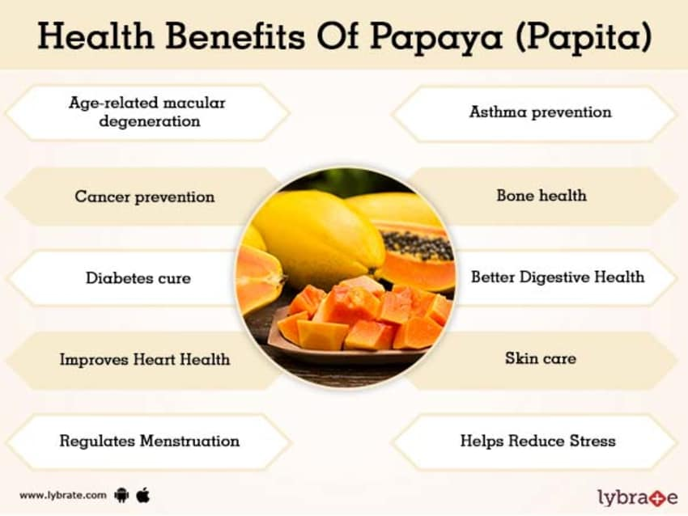a)**

Mentioned below are the best health benefits of Papaya (Papita)

**Age-related macular degeneration**

Macular degeneration is a disease of the eye. Zeaxanthin, an antioxidant found in papaya, helps to filter out harmful blue light rays. It is thought to play a protective role in eye health, and may ward off macular degeneration.A higher intake of papaya fruits has been shown to decrease the risk of [age-related macular degeneration](https://www.lybrate.com/treatment-for-age-related-macular-degeneration). It also hinders the progression of such associated diseases of the eyes.

**Asthma prevention**

[Vitamin A](https://www.lybrate.com/topic/vitamin-a-benefits-sources-and-side-effects), beta carotene help to prevent and reduce inflammation in the lungs. It is highly beneficial for smokers as a good intake of papaya or papaya juice can help in soothing the inflammation and reduce the chances of developing asthma.

**Cancer prevention**

Papaya is rich in anti-oxidants and phytonutrients that work against free radicals and make papayas effective against breast, pancreatic and other cancers. A leaf extract obtained from dried leaves of papaya plant produced anti-carcinogenic effects against tumor cells. Papaya seeds are rich in flavonoids that have chemotherapeutic effects which can reduce the risk of [cancer](https://www.lybrate.com/topic/cancer) by arresting the development of cancerous cells.

**Bone health**

Papayas, beneficial for bone health, have been known to be effective against [rheumatoid arthritis](https://www.lybrate.com/topic/rheumatoid-arthritis) and [osteoarthritis](https://www.lybrate.com/topic/osteoarthritis). One of the enzymes found in papayas, called chymopapain, has a significant effect on increasing the bone density and strength.Adequate vitamin K consumption is also important for good health, as it improves calcium absorption and may reduce urinary excretion of calcium. The higher proportion of calcium in the body, greater is the bone strength and rebuilding.Thus, consumption of papaya is highly recommended for bone health.

**Diabetes cure**

Low in [sugar](https://www.lybrate.com/topic/sugar), papaya can be an amazing option for those who have [diabetes](https://www.lybrate.com/topic/diabetes). Papaya helps maintain blood sugar level and cholesterol because of the high fiber content. Its extracts can actually decelerate the development of type-II diabetes, where the pancreas completely loses its ability to make and secrete insulin.

**Better Digestive Health**

Papaya is used to treat all kinds of stomach ailments, including [indigestion](https://www.lybrate.com/topic/indigestion), heartburn, [acid reflux](https://www.lybrate.com/topic/acid-reflux), and stomach ulcers.It is a rich source of dietary fiber, which is very good for our digestive system. Papaya also contains a [protein](https://www.lybrate.com/topic/protein-benefits-sources-and-side-effects)-dissolving, digestive super enzyme called papain, that eases many stomach ailments and aids digestion. It improves digestion by breaking down proteins,cleanses the digestive tract and also ensures a reduced conversion of protein into body fat.

**Improves Heart Health**

The seeds of papayas are beneficial for a healthy heart. Having three powerful antioxidant vitamins, namely vitamin A, vitamin C and vitamin E, papayas help to ward off heart diseases and in preventing problems such as atherosclerosis and diabetic heart disease. The presence of [pro](https://www.lybrate.com/medicine/pro-one-200-mg-capsule)- carotenoid phytonutrients in papaya helps prevent oxidization of the cholesterol in the body which otherwise can lead to heart attacks and strokes. Vitamin E and vitamin C obtained from papayas will help in preventing the cholesterol from sticking to the walls, thereby keeping the heart healthy. As a good source of fiber, papayas also help to reduce the cholesterol levels in the body.

**Skin care**

Papayas can be great revitalizing agents, which is why they are used for improving [skin health](https://www.lybrate.com/treatment-for-skin-health). Papain, enzyme present in papaya, kills dead cells and purifies the skin. The beneficial properties and the other healing enzymes present in papaya help treat [sunburn](https://www.lybrate.com/topic/sunburn) and irritated skin. It can also fight free radicals that age our skin and show premature aging signs. Papayas are also used to treat [skin disorders](https://www.lybrate.com/treatment-for-skin-disorders) like [eczema](https://www.lybrate.com/topic/eczema), [psoriasis](https://www.lybrate.com/topic/psoriasis), etc. The latex obtained from papayas is used to treat skin affected with acne. Topical application of papaya juice or atex helps in curing and provides relief. The fleshy side of the papaya skin can also be used as a mask to cure acne.Papayas are one of the most effective home remedies to cure [vitiligo](https://www.lybrate.com/topic/vitiligo), a condition where white patches appear on the skin.

**Regulates Menstruation**

Papaya juice can be of immense help for women with [irregular periods](https://www.lybrate.com/topic/irregular-periods). Consumption of green, unripe papayas helps to normalize the irregularity in the periodic cycle. The papain enzyme helps regulate and ease the flow of blood during menstruation, thus preventing cramps and not causing [pain](https://www.lybrate.com/topic/pain). Papaya also stimulates the production of [estrogen](https://www.lybrate.com/medicine/estrogen), thereby normalizing the period cycle

**Helps Reduce Stress**

This sweet juicy fruit contains active enzymes as well as vitamin C in large amount and thus, helps to [restore](https://www.lybrate.com/medicine/restore-25mg-tablet) our energy levels. Papaya also acts as a great [stress](https://www.lybrate.com/topic/stress-disorder) reducer.

**Activates Human Growth Hormones**

Dried papaya provides nourishment to the endocrine system and promotes the production of [arginine](https://www.lybrate.com/medicine/arginine) in the body. Arginine is a type of essential amino acid that is known to activate the human growth hormones (HGH). These hormones, present in papaya, play a key role in rebuilding bones, muscles, skin, and liver cells, and promote overall cell rejuvenation.

**Uses of Papaya (Papita)**

Papaya has immense benefits. It is one of the most popular fruit used to reduce inflammation in the lungs, heal wounds, treats gouts and other throat disorders like inflammation of tonsils – a symptom of [diphtheria](https://www.lybrate.com/medicine/diphtheria-toxoid/health-feed). It is also used to treat ringworm.Papaya [milk](https://www.lybrate.com/topic/milk-dudh-benefits-and-side-effects) contains carotene, and this compound can treat ringworm infection.It helps in muscle tissue renewal and aids weight loss. It is also effective in the treatment of neusea and [motion sickness](https://www.lybrate.com/topic/motion-sickness). For [pregnant](https://www.lybrate.com/treatment-for-pregnant) mothers and babies, papaya or papita is useful. Raw papaya, a galactagogue improves breast milk production and can be effective for lactating mothers.Besides the health benefits, papaya can also be used for the betterment of hair. It stimulates hair growth,controls [dandruff](https://www.lybrate.com/topic/dandruff) and also acts as a good hair conditioner.