Project Title: AI/ML Mood Tracker
Winter Semester 2025-26

Course Name: Fundamentals of AIML
Student Name: DIVYANKA BOHRA
Registration Number: 25BCE10142
Date: March 29, 2026

INTRODUCTION
This project, titled “AI/ML Mood Tracker”, is designed to analyse and track user emotions using natural language input. The system allows users to describe their feelings in text form, and it predicts the mood using a Machine Learning model.

The project uses Natural Language Processing (NLP) and a Naive Bayes classifier to understand text and classify it into categories such as Happy, Sad, Angry, Calm, Neutral, and Anxious. It also stores user mood data and provides basic analysis.

From an Artificial Intelligence perspective, this project demonstrates the use of supervised learning and text classification, which are important concepts in AI/ML systems.

PROBLEM STATEMENT
In today’s fast-paced life, people often ignore their mental health and emotional well-being. There is a lack of simple tools that allow users to track and understand their moods regularly.

Most existing solutions are either too complex or not easily accessible for beginners. Additionally, people may not always understand their emotional patterns or triggers.

Therefore, there is a need to develop a simple and intelligent system that can:
• Analyze user emotions from text
• Classify mood into meaningful categories
• Store mood history
• Provide basic insights

This project aims to solve these problems using Machine Learning and simple data analysis techniques.

FUNCTIONAL REQUIREMENTS
1. User Input Handling
The system should allow users to enter their feelings in text form.
2. Mood Prediction
The system should classify mood using a trained ML model.
3. Mood Categories
The system should categorize moods into:
• Happy
• Sad
• Angry
• Calm
• Neutral
• Anxious
4. Data Storage
The system should store mood entries in a CSV file.
5. View History
The system should allow users to view previous mood entries.
6. Mood Summary
The system should display mood statistics.
7. Menu-Based Navigation
Options include:
• Add Entry
• View History
• View Summary
• Exit

NON-FUNCTIONAL REQUIREMENTS
1. Usability
The system should be simple and easy to use.
2. Performance
The system should give quick predictions.
3. Reliability
The predictions should be consistent.
4. Scalability
The system should handle multiple entries.
5. Maintainability
The code should be modular and easy to update.
6. Portability
The program should run on any system with Python.
7. Data Integrity
Stored data should remain accurate.
8. Security
Basic input validation should be implemented

DESIGN DIAGRAM
SSTART
START

Input Mood Text (user feeling)

Text Processing

Predict Mood

Sad/Angry/Anxious
Show message
Happy/Calm/Neutral
Show message
Classify Mood

Save Record

View History/Statistics

EXIT

DESIGN DECISIONS & RATIONALE

1. Use of Machine Learning
Naive Bayes was chosen because it is simple and effective for text classification.
2. Use of NLP (Text Processing)
Text is converted into numerical form using vectorization.
3. Modular Design
Functions are used to improve readability and maintenance.
4. Menu-Based Interface
A simple loop-based system ensures easy interaction.
5. Data Storage
CSV file is used for storing mood logs.

IMPLEMENTATION DETAILS

1. Programming Language
The project is implemented using Python.
2. Libraries Used
• scikit-learn
• pandas
• datetime
3. Program Structure
• train_model() → trains ML model
• predict_mood() → predicts mood
• save_entry() → stores data
• show_summary() → displays analysis
4. Input Processing
User enters text describing their mood.
5. ML Model Logic
Naive Bayes classifier is trained on sample mood dataset.
6. Data Storage
Data is stored in a CSV file ("mood_log.csv").
7. Menu System
Loop-based system for continuous interaction.
8. Analysis
Counts frequency of moods and calculates trends.

CODE
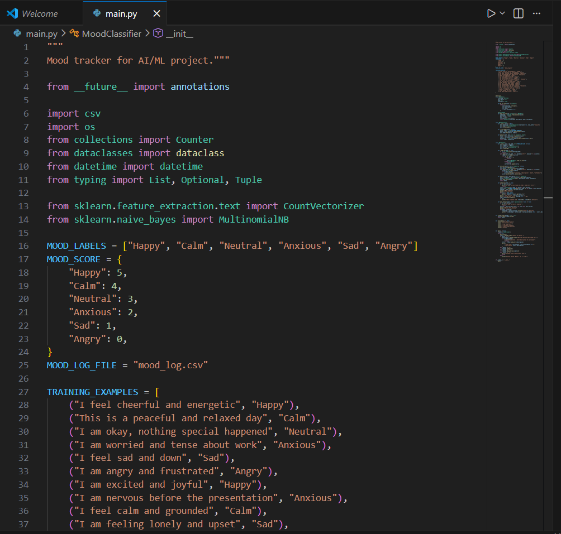
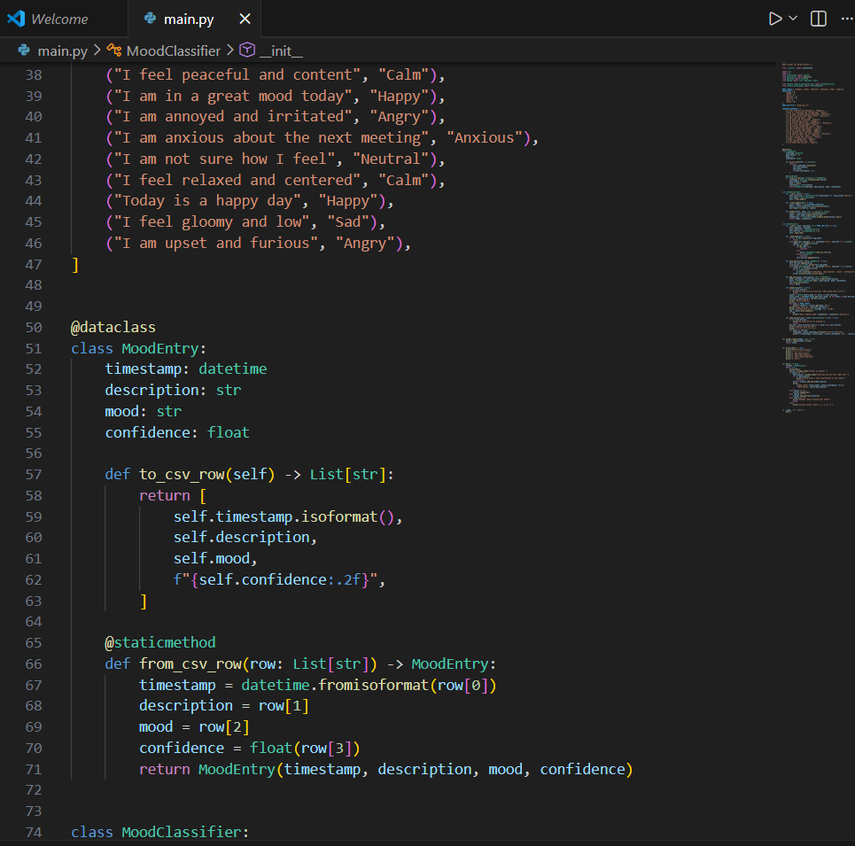
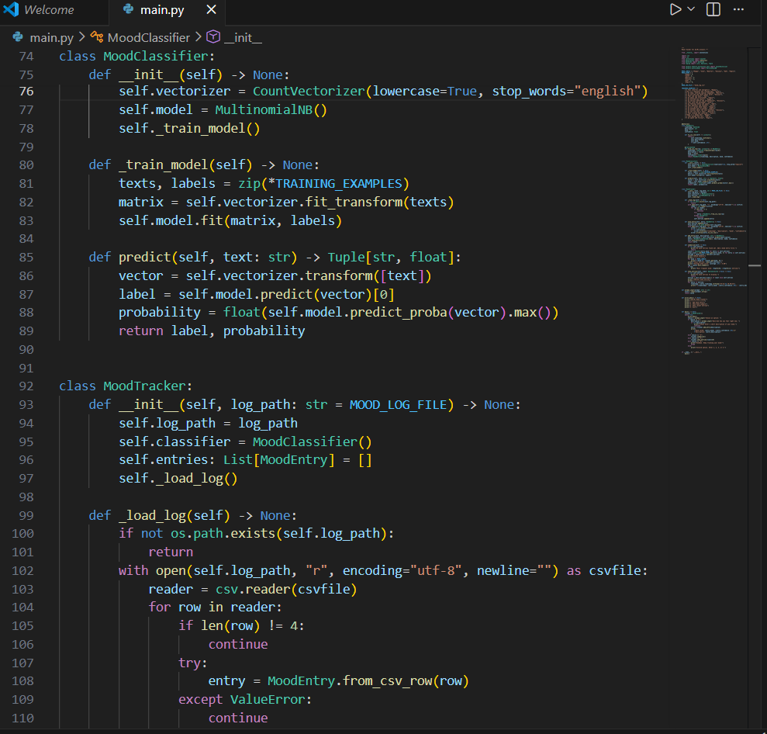
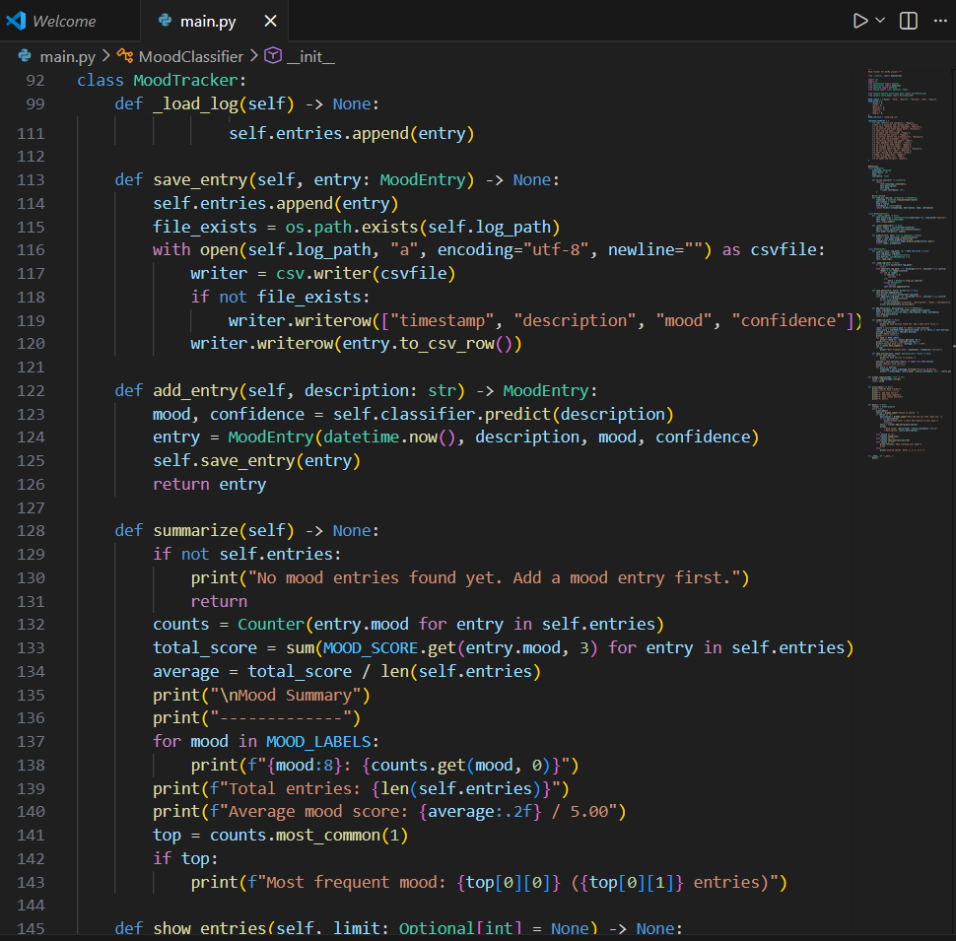
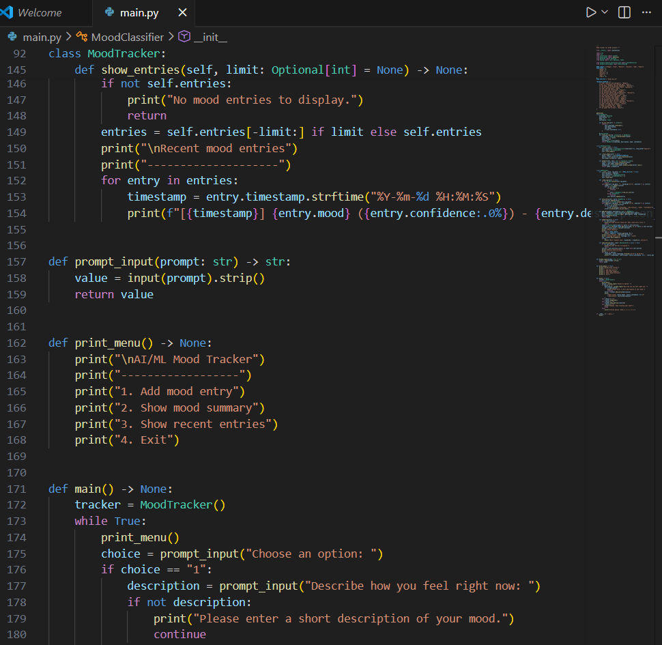
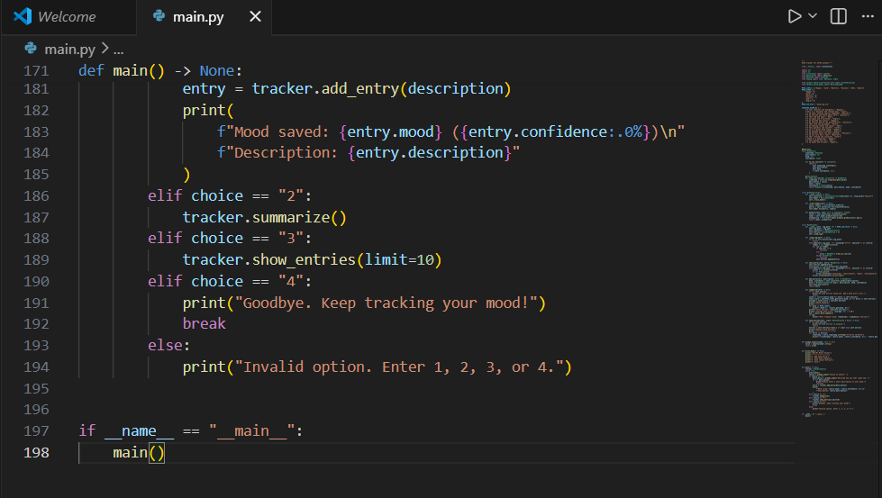

SCREENSHOTS/RESULTS
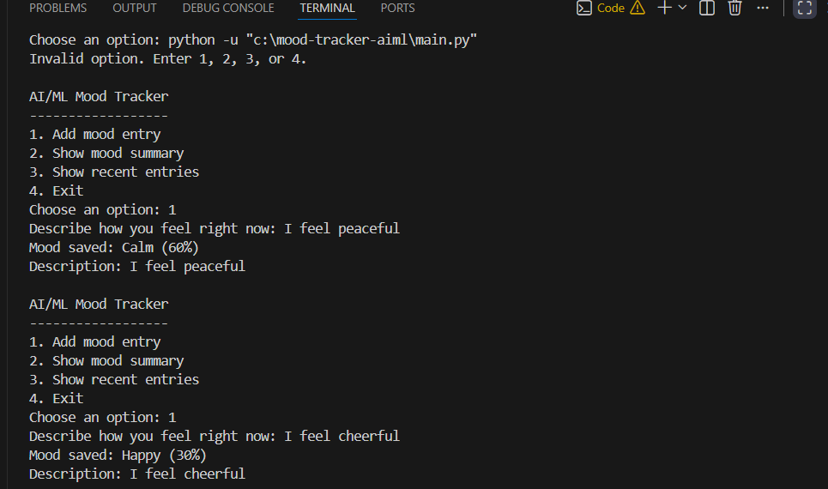
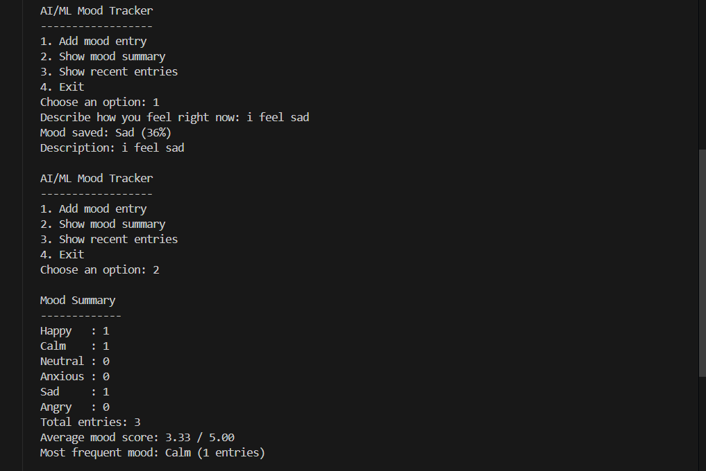
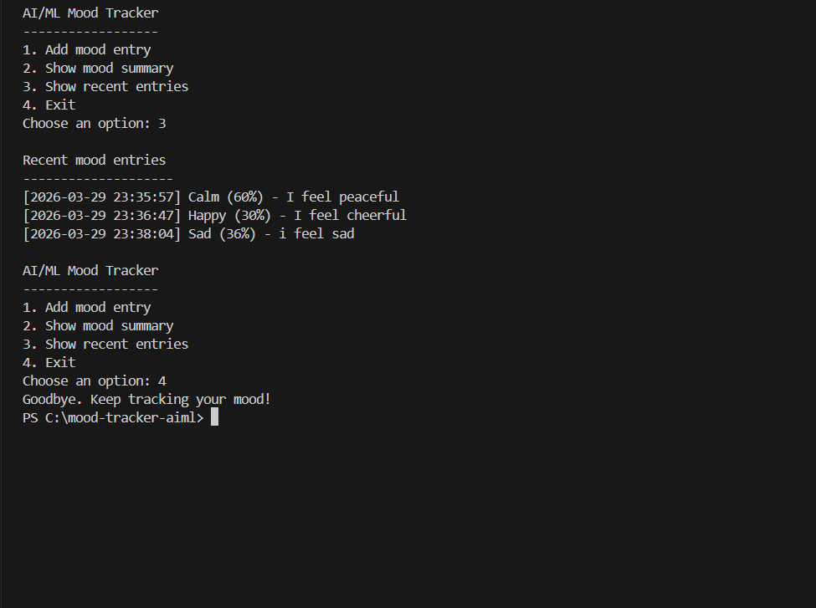

CHALLENGES FACED

1. Text Understanding
Handling different ways users express emotions was difficult.
2. Small Dataset
Limited training data can affect accuracy.
3. Input Variations
Users may enter unclear or mixed emotions.
4. Model Accuracy
Ensuring correct predictions required tuning.
5. File Handling
Managing CSV storage properly was challenging.

LEARNING & KEY TAKEAWAYS

1. Understanding Machine Learning
Learned how classification models work.
2. NLP Basics
Understood how text is processed for ML.
3. Python Skills
Improved coding with functions and libraries.
4. Data Handling
Learned to store and analyze data efficiently.
5. Problem Solving
Developed structured thinking for real-world problems.

FUTURE ENHANCEMENTS

1. Improve ML Model
Use larger dataset for better accuracy.

2. GUI Development
Build graphical interface using tkinter or web app.

3. Advanced Analysis
Add charts and mood trends visualization.

4. Personal Suggestions
Recommend activities based on mood.

5. Mobile App Integration
Convert into mobile-based application.

REFERENCES

1. Python Official Documentation
2. Scikit-learn Documentation
3. GeeksforGeeks

