PREDICTING SHORT TERM CUSTOMER SPEND (30 DAY CLV) IN RETAIL USING REGRESSION

Problem Statement:
Retail businesses serve many customers whose purchasing behaviors vary widely, making it important to identify those likely to continue spending. In this project, we build a machine learning system that predicts how much a customer will spend in the next 30 days using historical transaction data. By analyzing past purchases, we derive customer-level features that capture spending patterns and purchase frequency, and use these features to train a regression model that estimates future spending. This predictive approach helps retailers better understand customer value, anticipate demand, and support data-driven marketing and business decisions.
Objectives:
- Analyze customer purchasing behavior: Study historical retail transaction data to understand spending patterns, purchase frequency, and customer preferences.
- Define the prediction target: Formulate the problem as predicting the total amount a customer will spend in the next 30 days based on past activity.
- Create customer-level features: Transform raw transaction data into meaningful features that summarize customer behavior over time.
- Build and evaluate a regression model: Train a machine learning model to estimate future spending and assess its performance using metrics like MAE, RMSE, and R².
- Provide a usable prediction system: Integrate the trained model into a simple interface that allows users to input customer data and obtain predicted short-term spending insights.

Dataset Details

Dataset Size
- 286,392 transactions
- 36 columns

Important Fields
Column | Purpose
cust_id | Customer identifier
order_date | Transaction timestamp
total | Transaction value
category | Product category
payment_method | Payment type
age | Customer demographic
Region | Geographic data

Dataset- https://www.kaggle.com/datasets/miketaylor123/sales-data?resource=download

Design Justification :

- XGBoost is chosen because it is highly effective for tabular regression problems where customer spending depends on complex nonlinear relationships between multiple engineered features such as recent spend, transaction frequency, recency, average order value, and purchase behaviour. It handles feature interactions automatically, performs well even when customer histories vary in length, and is robust to missing or uneven patterns commonly found in retail transaction data. Its regularization mechanisms also help reduce overfitting, making it suitable for predicting short-term customer spend with better generalization than many traditional regression methods

A fixed cutoff date of 31 August 2021 is chosen so that all customer features are generated only from transactions up to that date, while the target variable is defined as the total amount spent during the last & next 30 days (1 September to 30 September 2021). This creates a consistent past-to-future training structure, prevents future data leakage, and allows customers with shorter purchase histories to remain in the dataset by representing limited history through features such as recency and history length.

High level Diagram:
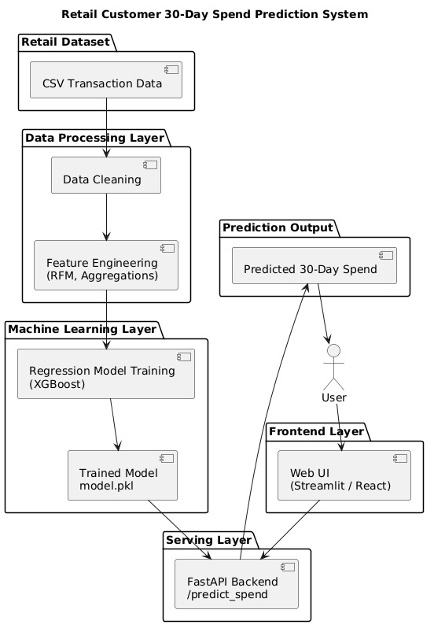
Fig1. System Architecture
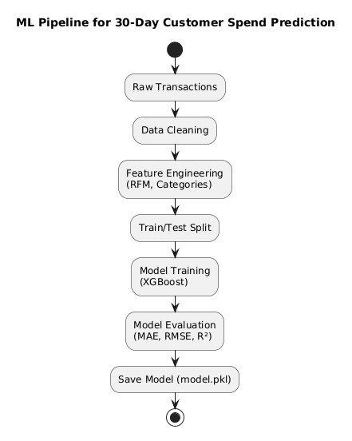
Fig 2. ML Pipeline

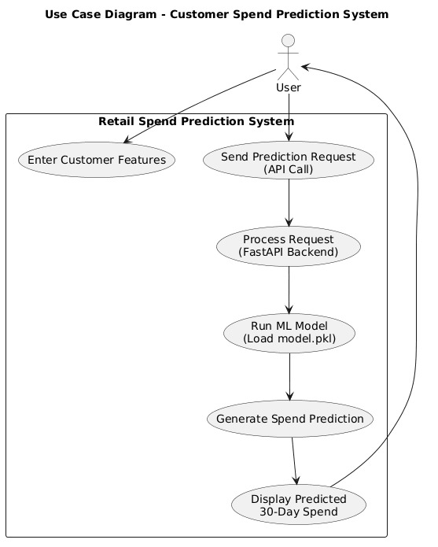
Fig 3. UI flow
TEAM MEMBERS
Abhijeet Kundu-22BDS0272
Divyansh Kumawat-22BCE2690
Shivani Pandey-22BEC0238
Tejeshwar D-22BEC0690

