OTC POC Installation Overview

The block diagram below represents the different entities involved in this POC. As you can see the browser initiates the request and the request flows thru the web server, OC4J, MTS and the request is serviced. Here the Tomcat web server represents the middle tier of the OD.

Browser
Web server (JSP, Servlet)
OC4J Instance (Session Bean)

Multi threaded Server (MTS)

DB

It can be understood that we need to install & configure

- Web application
- EJB application
- Multi Threaded Server (MTS)

The installation procedure for each of the above is described below

POC Web Application Web application is packed into a WAR file for easy deployment. From the OC4J admin console this deployment is just a few clicks away.

The broad level steps are illustrated below. First logon to OC4J admin console
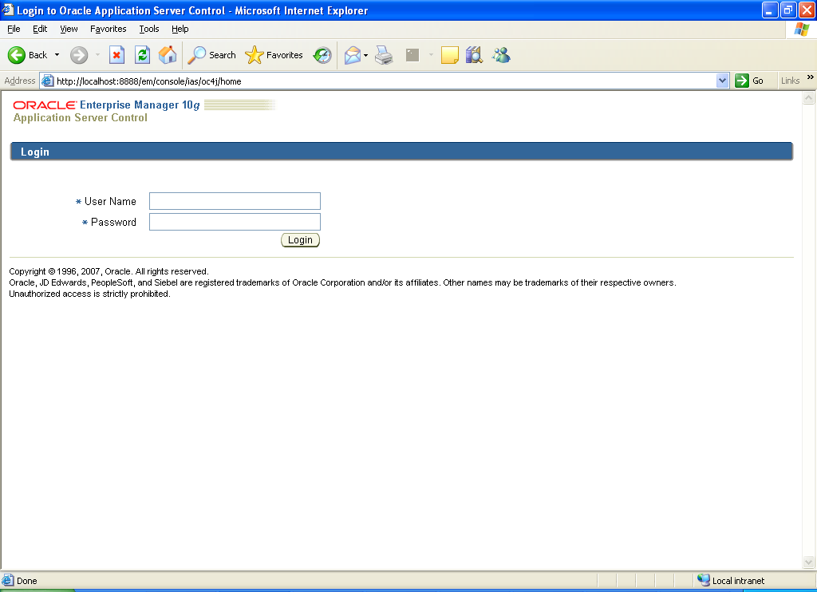

Step 1.2:
Click on Applications link and it should display the deployed J2EE applications as show in the next screen

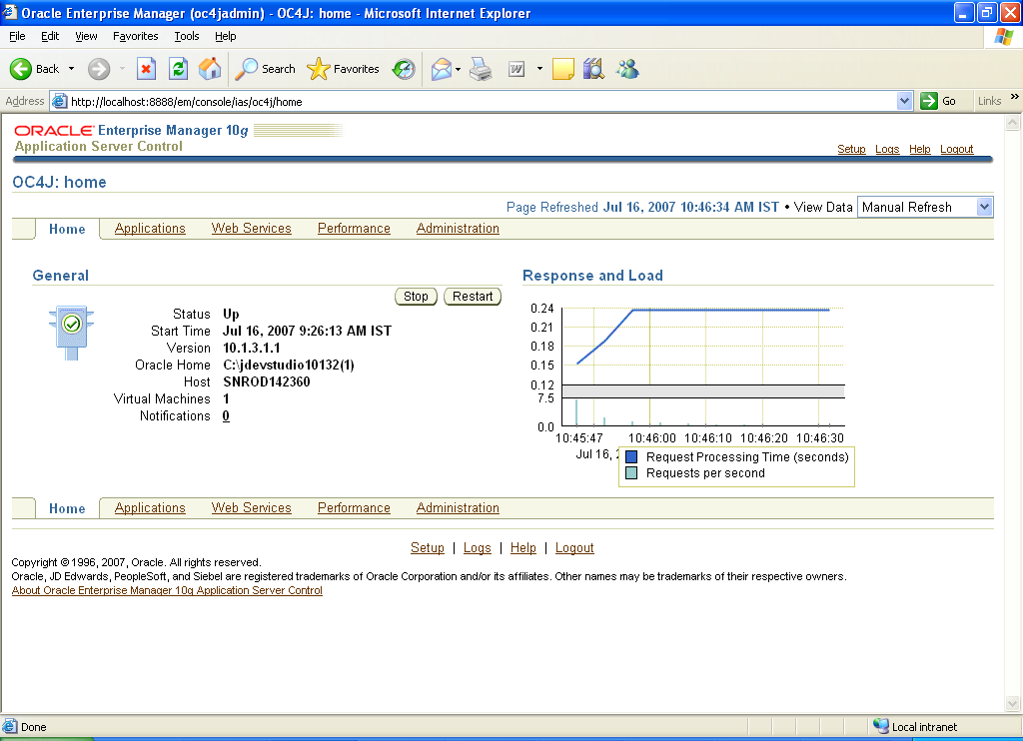

Step 1.3:

Click on the Deploy button to deploy our WAR file.

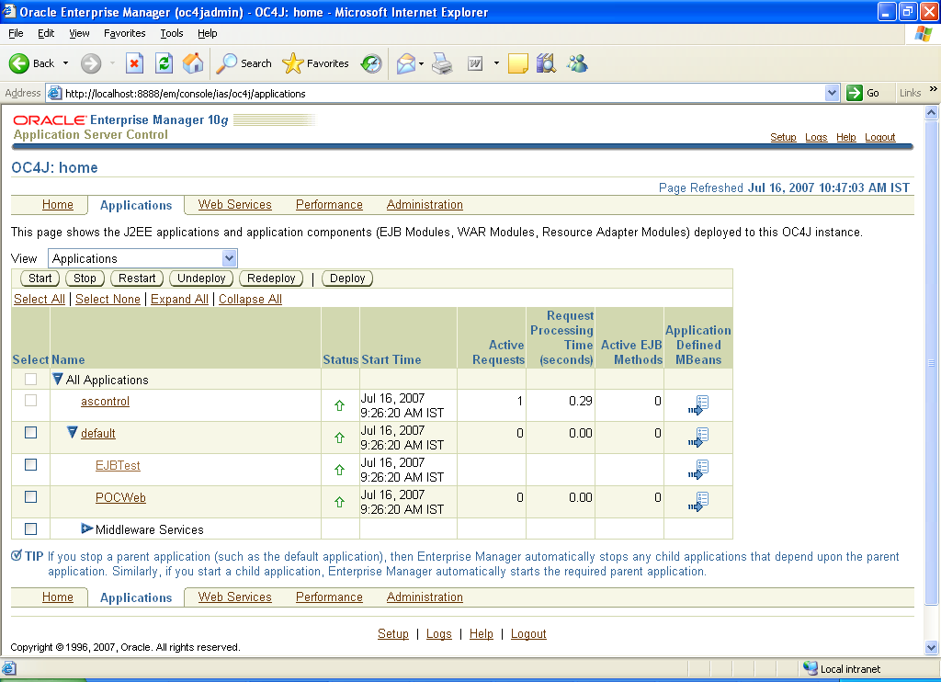

Step 1.4:

Click on the Browse button to choose the WAR archive file. Please note that the WAR file (otcpoc.war) should be available in a local driver of the server for it to be chosen here.

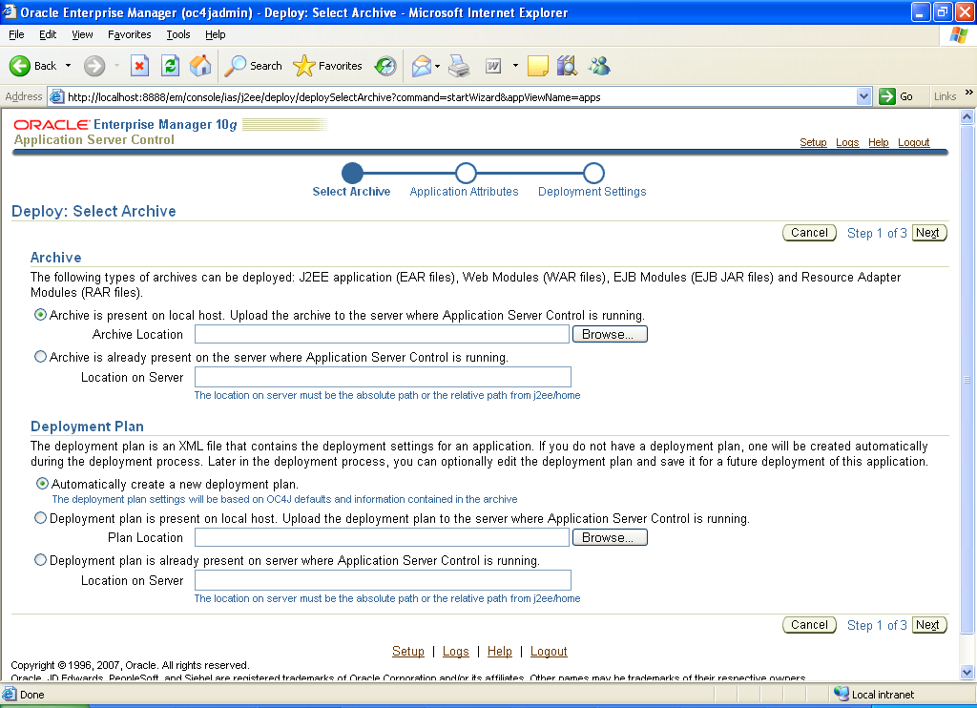

After choosing the WAR file click Next to proceed

Step 1.5:
Give the name as POC-WEB and leave the other inputs with the default values

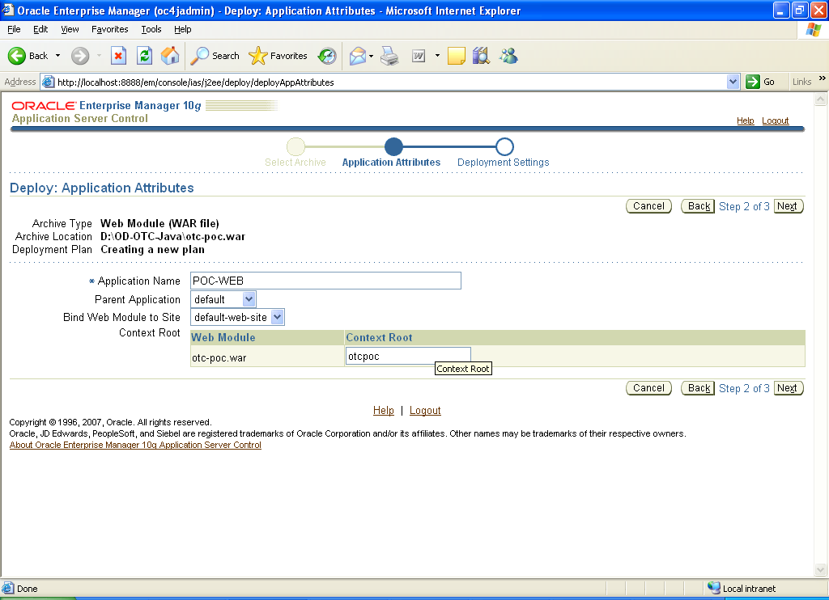

Give the Context-Root as otcpoc. This is very important & case sensitive.
Then click on Next to proceed

In the next page, accept the default and click on Deploy. This should display the message on the deployment status.

After successful deployment the Applications page (Step 1.3) should display the POC-WEB in the list, under the default.

Now accessing the url http://<servername>:<port>/otcpoc/poc.jsp should display the page for Item ID selection.
Data source setup for POC EJB Application

For the POC EJB application to interface with database a data source needs to be setup. Below are the steps for that

First we need to create a Connection Pool to the database
From the OC4J Admin Home page, choose the Administration link
Step 2.1

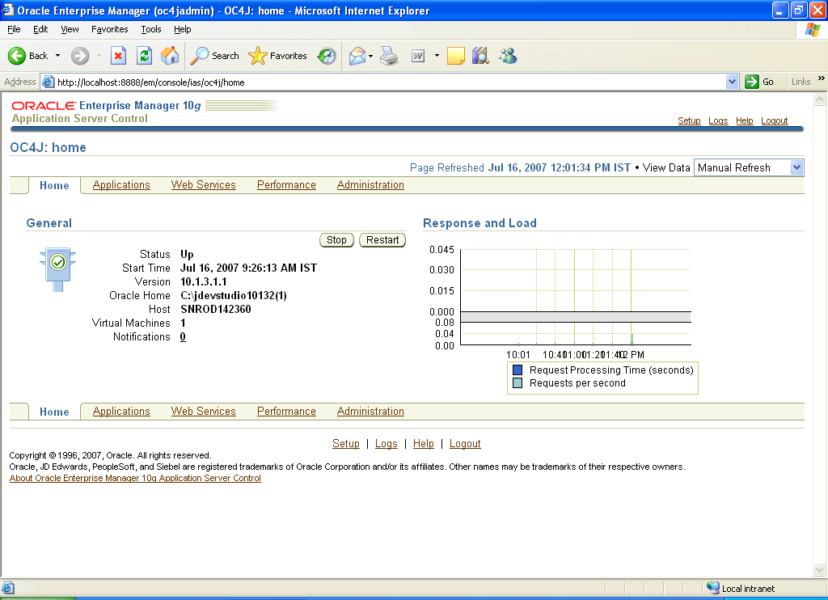

Step 2.2

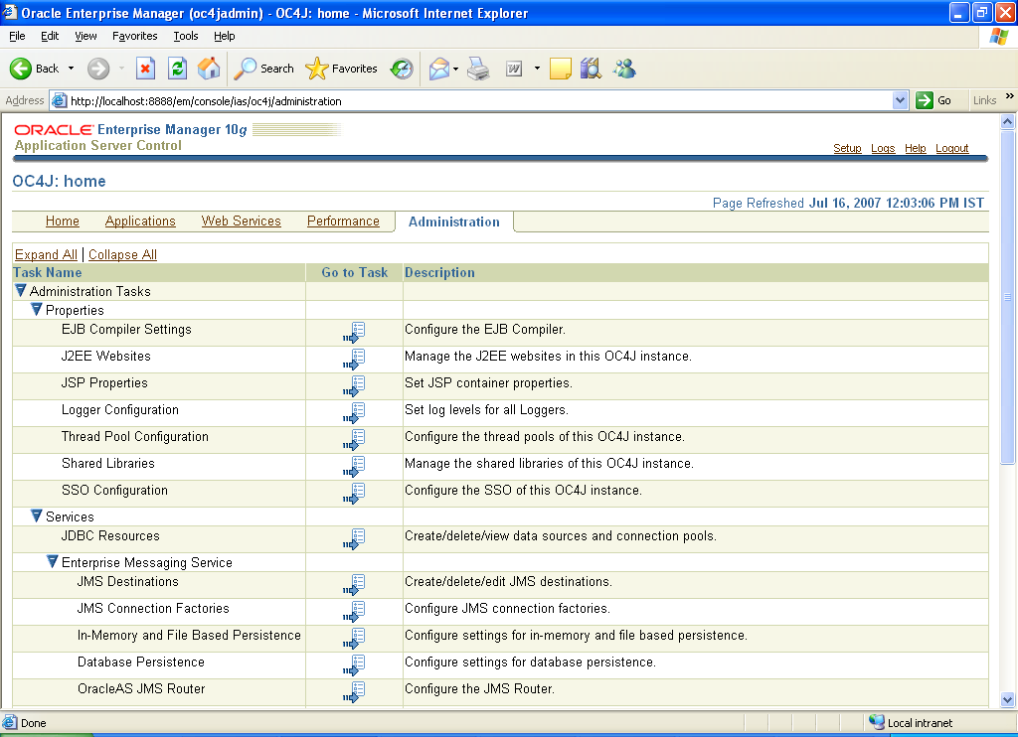
Choose the Task link against the JDBC Resource

Click on Create under Connection Pools

Step 2.3

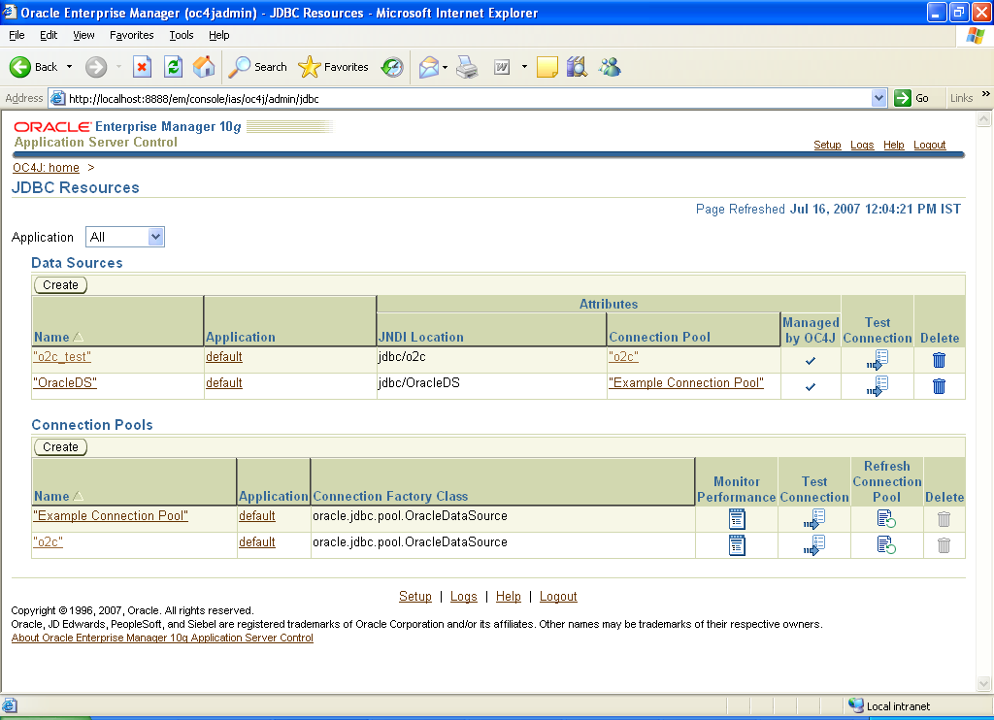

Leave the Application as default and choose the New Connection Pool and click Continue
Step 2.4

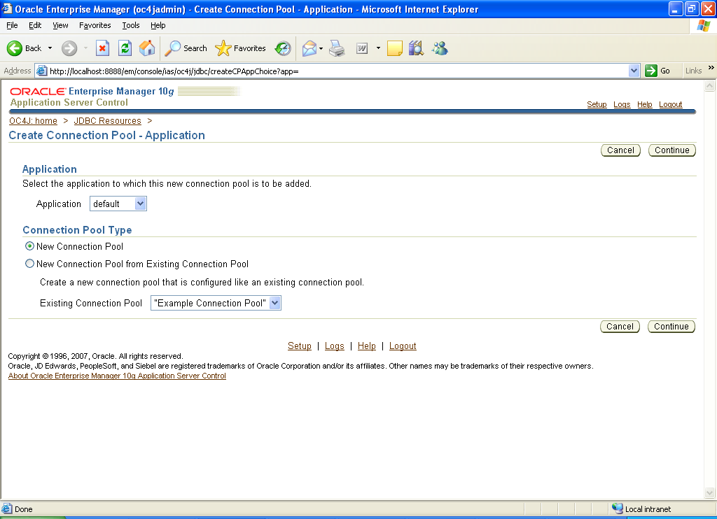

Step 2.5

Enter the name as OTCPOC-ConPool
Choose the Generate URL option give the DBDetails as here (The DB Host is choldbr18d.na.odcorp.net)

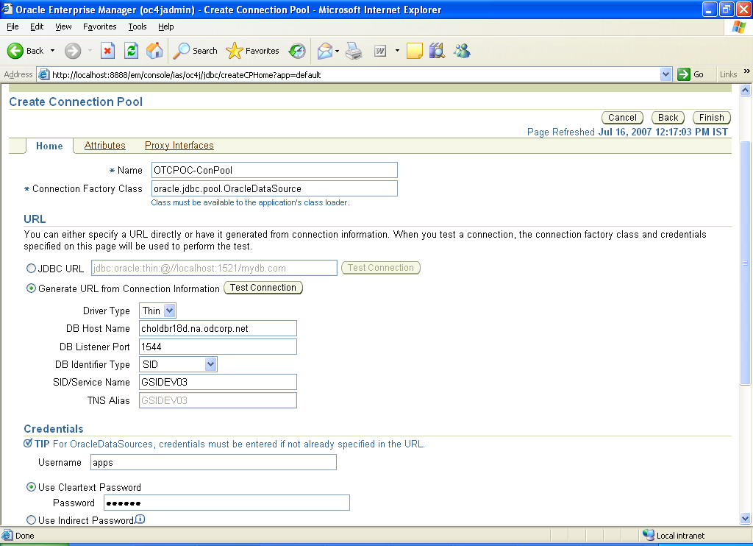
Give the DB Credential to GSIDEV03 for user apps
Then click on Test Connection button above
After successful test, click on Finish button

After successful creation of the database connection pool it should be listed in the screen in the Step 2.3

Now we need to create a Data Source for the just created connection pool. From the screen in the Step 2.3 choose the Create under Data Source, which should bring the below screen
Leave the application as Default

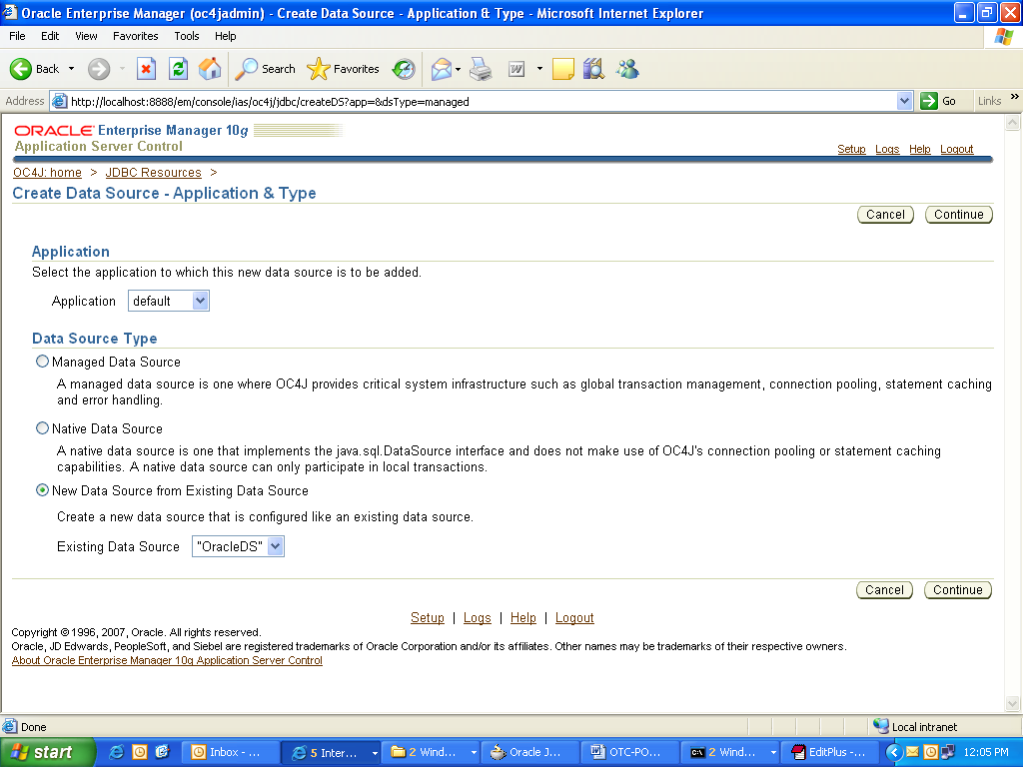
Choose the New data source option and click Continue

Give the name as OTCPOCDataSource
Give the JNDI Name as jdbc/o2c. This is important

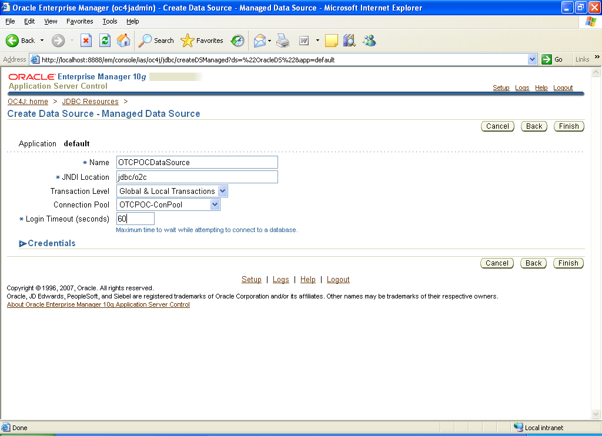
Choose the connection pool to the one we just created and give 60 as the value in Timeout.
Then click on Finish

After successful creation of the database source it should be listed in the screen in the Step 2.3

POC EJB Application

The POC’s EJB application is packed into EAR file for easy deployment. So the deployment of this EAR file is similar to WAR file (deployed in Steps 1.x above). The steps till Step 1.4 are the same as above. In the step 1.4, choose the EAR file, otcejb.ear from the local drive and choose next.

In the next screen (that is in Step 1.5) give the name as POC-EJB as below

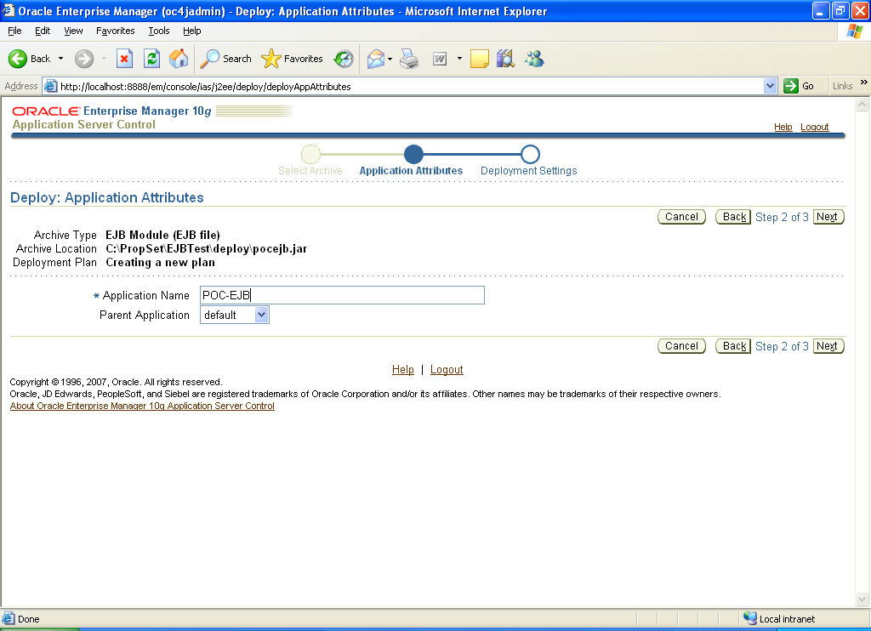

In the next page, accept the default and click on Deploy. This should display the message on the deployment status.

After successful deployment the Applications page (Step 1.3) should display the POC-EJB in the list, under the default.

Multi Threaded Server (MTS)

- Copy the zip file, otcmts.zip, to a directory (say /usr/local) in *nix server.
- Unzip the otcmts.zip file to a directory /usr/local/mtserver and it should produce a file structure like below

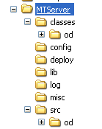

- The config file, MTServer.xml, needs to be edited now for any customization to the target environment
- The config file, log4j.properties needs to be edited for the log file’s path
- The shell script, startup.sh needs to be modified to reflect the current path in which MTServer is installed in the *nix server.

