Software Requirements Specification
Emotion and Sarcasm Detection from Text Project P098
Divyansh Yadav | Roll No 2400320100444
ABES Engineering College, Ghaziabad
Department of Computer Science and Engineering
B.Tech third year | Academic year 2026-2027
HCL Industrial Training | Project P_098
Revision 3.0 | November 2026

1 Introduction
This specification defines the implemented English emotion and sarcasm detector, its interfaces, model behavior and acceptance evidence. It is intended for the student developer and academic reviewers. The source baseline is commit 7f159b6.

1 1 Purpose and scope
The system accepts short English text, returns one of anger, disgust, fear, joy, neutral, sadness and surprise, and reports sarcasm/irony separately. The dashboard presents seven emotion scores, uncertainty, session history and a plain-text download.
The core requirement is classification through pretrained transformers: DistilRoBERTa for emotion and RoBERTa for irony as a sarcasm indicator. Translation, batch uploads, a custom REST API, persistent databases, authentication and clinical assessment are outside this implementation.

1 2 Terms and references
Term | Meaning
SRS | Software Requirements Specification
Pretrained transformer | A neural text encoder with previously trained classification weights
Irony score | RoBERTa output used as a proxy for possible sarcasm
Session | Temporary state for one Streamlit browser connection
Macro F1 | Mean class F1 score with equal class weighting

References: Hartmann's DistilRoBERTa model card; Barbieri et al. (2020), TweetEval; Streamlit, Transformers and PyTorch documentation; repository verification and regression results.

2 Overall description
Emotion and Sarcasm Detection from Text classifies English sentences with two pretrained transformers. A Streamlit dashboard presents seven emotion scores and a separate irony score used as an indicator of sarcasm. Both models run on the application server without an external inference API or API key.
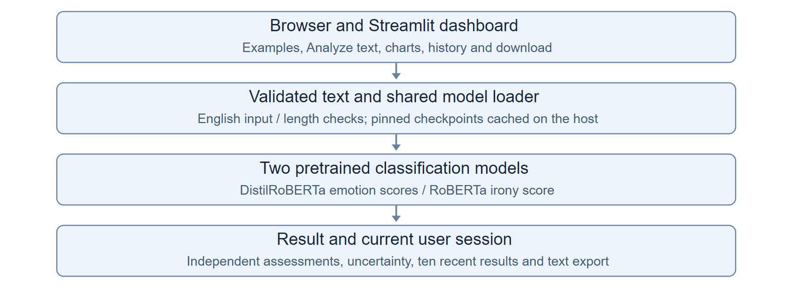
Figure 1 System context and implementation layers

2 1 Users and operating environment
Students and reviewers use the same dashboard. The developer maintains source code, pinned checkpoint revisions and deployment. There are no separate administrator or registered-user roles.
The target environment is Python 3.13 with Streamlit 1.66.1, Transformers 5.18.0 and PyTorch 2.14.0 CPU. Real-model tests also ran in the retained Python 3.11 environment. GitHub's Python 3.13 workflow succeeded. The developer reports the deployed Community Cloud app working.

2 2 Data and session state
Data | Lifecycle
Pretrained weights | Downloaded once per host cache; shared for inference
Input and current result | Current session only; cleared when edited or reset
Recent analyses | Ten successful results at most, newest first
Summary counters | All successful analyses since session reset
Downloaded report | Saved explicitly through Save result

Model weights are downloaded from pinned Hugging Face revisions and cached on the host. User text is sent to the app server for inference but is not written to an application database or log. There is no relational database schema.

3 Functional requirements
ID | Requirement | Verification
FR01 | Accept English words within 1,000 characters; reject blank, numeric-only, symbol-only and unsupported-script input. | Input checks
FR02 | Load both pinned pretrained models, cache them, and report failures without a fallback or partial result. | Real load and failure checks
FR03 | Return seven emotion scores and a separate irony score; reject inputs over either model's 512-token limit. | Real inference and token checks
FR04 | Show all seven emotion scores in a colored chart from 0 to 100 percent. | Interface check
FR05 | Flag emotion uncertainty below 45% or a lead under 10 points. Show Likely sarcasm at 80% or above, Sarcasm not detected at 20% or below, otherwise Uncertain. | Boundary checks
FR06 | Use pretrained RoBERTa irony classification for the sarcasm indicator; keep its output separate from the emotion label. | Independent model-output check
FR07 | Keep the ten latest successful analyses per session, newest first. | Bounded history check
FR08 | Show counts, average emotion score and uncertainty; failed analyses shall not change counters. | Session and failure checks
FR09 | Download text, both assessments, scores, interpretation and model revisions as plain text. | Download content check
FR10 | Input edits clear the result. Clear text retains history; Reset session clears history and counters. | Edit and reset checks
FR11 | Keep browser sessions separate; migrate old result state without rendering incompatible records. | Isolation and migration checks
FR12 | Provide emotion, sarcasm and sincere examples, model attribution and explicit limitations. | Source and interface review

Requirements are checked through automated tests, source review and the developer's deployment check. Model accuracy and browser compatibility are separate concerns; a passing interface test does not guarantee correct sarcasm classification.

4 External interface requirements
The Streamlit dashboard includes input/results panels, emotion and sarcasm summaries, an emotion chart, five session cards and recent history. Controls are Analyze text, Clear text, Reset session and Save result.
A modern browser and keyboard or touch input are required. Python libraries load two pretrained checkpoints through their tokenizers and model interfaces. The initial download needs internet access; later inference can use the cache.
Local access uses HTTP on port 8501; public access uses HTTPS on Streamlit Community Cloud. Hugging Face serves model files, not user-text inference. There is no custom REST API or paid inference service.

5 Non functional requirements
Attribute | Requirement or constraint | Evidence or status
Performance | Reuse models; retain the 150 ms mean warm-inference target. | 524.2 ms observed; target not met
Resources | Use CPU float16 weights and bounded simultaneous inference. | 394.4 MiB weights; 827 MB initial download
Reliability | Show validation/model errors without inventing results. | Failure and session checks passed
Privacy | Keep history within its session and allow explicit reset. | Isolation and reset checks passed
Maintainability | Separate UI, inference, result text and evaluation; pin model revisions. | Source structure and exact revisions
Portability | Support Python 3.13 and Community Cloud deployment. | GitHub workflow passed; owner tested cloud
Availability | Provide public access without an uptime/startup guarantee. | Free hosting may sleep

The performance target remains unmet in the recorded local run. Classification metrics are regression observations, not acceptance guarantees for arbitrary text. If either model fails, the app reports an error rather than substituting a different classifier.

6 System design and analysis models
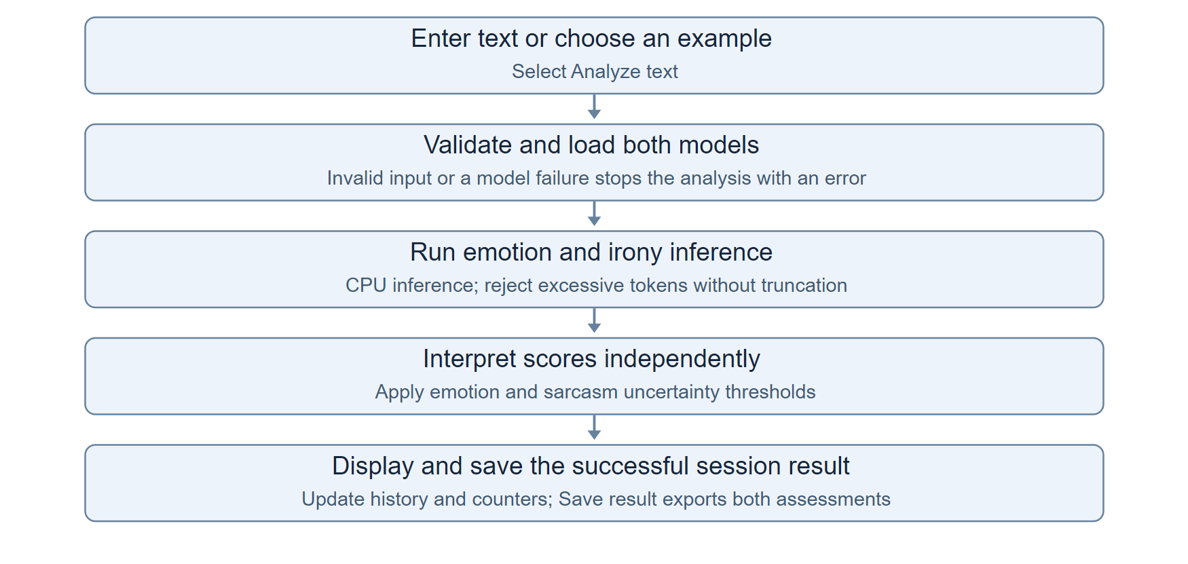
Figure 2 Analysis activity flow including validation exits
Use case | Precondition | Expected result
Analyze text | Page loaded, valid English input | Emotion and irony outputs; one new history entry
Review and download | Successful current result | Both assessments visible and downloadable
Recover from an error | Invalid input or model failure | Error; no new result or counter increment
Reset session | One or more results | Input/history emptied; counters zeroed

Sequence: a widget invokes the callback; input is validated; cached models run in sequence under an inference lock; both distributions are checked; session state is updated; the dashboard rerenders. Only model objects are shared between users.

7 Verification and acceptance
Eighteen contract/interface checks passed with controlled model outputs, and four real-transformer integration checks passed with cached weights. The GitHub Actions workflow for commit 7f159b6 completed successfully using Python 3.13.
On a previously reviewed set of 35 emotion and 35 sarcasm examples, emotion accuracy was 91.4% with macro F1 0.913; raw binary irony accuracy was 85.7% with macro F1 0.844. These are development regression results, not an independent benchmark. Known missed case: "I am busy right now, can I ignore you some other time?" received an irony score of 4.0% and was not detected as sarcasm.
Run python -m unittest discover -s tests -v. Set RUN_TRANSFORMER_TESTS=1 for the four real-model checks. evaluate_transformers.py records all 70 regression cases. Evidence is in docs/verification.json and docs/transformer-evaluation.json.

8 Deployment and public access
The app is deployed at the public URL below. Deployment acceptance is based on the developer's successful test of the uploaded transformer version on 1 November 2026. Free hosting can sleep after inactivity.
Deployment field | Value
Repository owner | Divyansh1-3
Repository | Emotion-Detection-from-Text-Project
Branch and entrypoint | main / app.py
Python version | 3.13
Secrets | None required
Public status | Developer confirmed working after transformer upload

Public app: https://emotion-detection-from-text-project-ncignaopdfgyjcymc264jq.streamlit.app/
For subsequent releases, check a sarcastic example, a sincere example, the chart, history, download and reset in a private browser session.

9 Academic review
This specification records the submitted implementation. Faculty review and approval must be completed by the actual reviewer.
Developer: Divyansh Yadav
Faculty reviewer: __________________________
Signature and date: ________________________
Repository https://github.com/Divyansh1-3/Emotion-Detection-from-Text-Project

