Software Requirements Specification
Emotion Detection from Text | Project P_098
ABES Engineering College, Ghaziabad
Department of Computer Science and Engineering
Divyansh Yadav | Roll No. 2400320100444
B.Tech, third year | Academic year 2026–2027
Revision 1.3 | November 2026

1 Introduction
Classify English text into anger, disgust, fear, joy, neutral, sadness or surprise. Return confidence, an uncertainty flag, an approximate sarcasm assessment and an explanation. This is linguistic analysis, not a psychological diagnosis. This specification describes the implemented academic prototype and identifies verification limits. Its organization follows the supplied academic SRS structure.
Flask is the chosen framework for this implementation. The supplied specification named FastAPI; this is an explicit implementation deviation. Flask provides the HTTP API and existing web interface. It does not implement FastAPI or automatic OpenAPI documentation.

2 Overall description
Flask serves Jinja templates, custom CSS and vanilla JavaScript. Chart.js is bundled locally with its license; textual score rendering remains available if the chart library fails. The audit view reads saved results and offers CSV export. Analysts submit messages, reviewers inspect records, and developers integrate through HTTP. All endpoints have the same local access; there is no implemented role-based authorization.
Environment: Python 3.11 or newer, Windows/Linux/macOS with compatible dependency wheels, and a JavaScript-capable browser. Model downloads require internet once. Subsequent model operation can use HF_HUB_OFFLINE=1. An 8 GB laptop is the design environment, not a measured memory guarantee.

3 Functional requirements
ID | Requirement | Verification
FR-01 | Accept 1 to 4,000 characters after sanitization. Reject empty/control-only input and invalid batch item types. Transformer tokenizers truncate at 512 tokens. CSV uploads are limited to 16 MB and 500 rows; oversized batches are rejected before processing. | Input and API regression tests
FR-02 | Seven emotion labels, confidence method and uncertainty flag. Fit temperature on development data; validate on separate data. Apply only to matching English full-model paths. | Fusion tests, calibration profile and benchmark
FR-03 | Context, model output and lexical cues determine the sarcasm flag. Detected irony may redistribute emotion scores toward anger or disgust. Common sincere phrases such as my favorite and cannot wait require adverse context before acting as sarcasm cues. False positives and false negatives remain possible. | Sarcasm fixtures and F1 report
FR-04 | Retrieve examples and expose actual embedding/TF-IDF/keyword backend. | Pipeline trace and health endpoint
FR-05 | The optional OpenAI-compatible client writes explanations only; it cannot change the final label. Malformed JSON gets one retry and then a template. API failures use the template. Default mock mode makes no API calls. Live provider access requires a valid independently configured key. | Mock client failure/retry tests
FR-06 | Preserve row positions and report each validation error explicitly. Return counts for attempted, successful and failed rows. Failed rows do not fabricate a neutral prediction. Valid rows use mode=batch and are persisted. Entirely malformed requests return HTTP 400 or 422. | CSV and batch regression tests
FR-07 | Save valid analyses and confidence method; expose history, stats, detail and CSV export using one stable database snapshot. | Persistence, migration and concurrent export tests
FR-08 | Display results, warnings and audit records with local charts. | Template/API checks and frontend smoke test
FR-09 | Normalize common Hindi/Hinglish phrases and negation; preserve original input and flag adapted/non-English predictions for review. | Language unit tests and 18-case demonstration

4 External interfaces
HTTP JSON is the API format. CSV uploads use multipart/form-data. Invalid input returns 400 or 422, missing records 404, oversized HTTP requests 413. Model fallback is reported in successful responses. Use a reverse proxy for external HTTPS deployment.
Method | Path | Purpose
POST | /api/v1/emotion/process | JSON object: input, optional session_id and options
POST | /api/v1/emotion/batch | JSON texts/inputs list or multipart CSV field file
GET | /api/v1/emotion/results | History with limit and offset; maximum page size 500
GET | /api/v1/emotion/results/<id> | One stored analysis; 404 for an unknown ID
GET | /api/v1/emotion/stats | Stored counts and emotion distribution
GET | /api/v1/emotion/export | Download stored results as CSV
GET | /health | Service status and actual loaded model/retrieval state
GET | / and /inspect | User dashboard and paginated audit history

5 Non functional requirements
The measured warm mean is 139.2 ms; the under-150 ms target is passed on this host. Startup, HTTP, database writes and concurrent traffic are excluded. Hosted performance needs separate measurement. Availability uses explicit fallbacks; it does not promise 100% uptime. Live API behavior, container execution and browser compatibility require environment-specific checks.
Metric | Target | Measured | Status
Emotion macro-F1 | >= 0.700 | 0.913 | Passed
Emotion accuracy | >= 70% | 91.4% | Passed
Sarcasm F1 | >= 0.650 | 0.842 | Passed
Warm pipeline mean | < 150 ms | 139.2 ms | Passed
Warm pipeline P95 | Reported separately | 154.8 ms | Measured
Model startup | Reported separately | 16.1 seconds | Measured
Evaluation: 2026-10-31T19:34:06.334481+00:00. Each task has 35 curated cases. Models used cached weights, embedding retrieval and template rationale. Timings exclude HTTP and persistence. Startup is separate. Results vary with hardware and load; memory was not measured.
Fallback benchmark: emotion accuracy 45.7%, emotion macro-F1 0.471, sarcasm F1 0.667. This mode preserves availability but is unsuitable for accuracy-sensitive use without review.
The 69-test automated suite passes with no failures. It covers unit behavior, API/storage integration, malformed batches, CSV BOM headers, row errors, sincere praise, invalid LLM output, concurrent export, retrieval traces, calibration safeguards and language normalization. Passing tests does not establish unrestricted real-world accuracy.

6 Design models
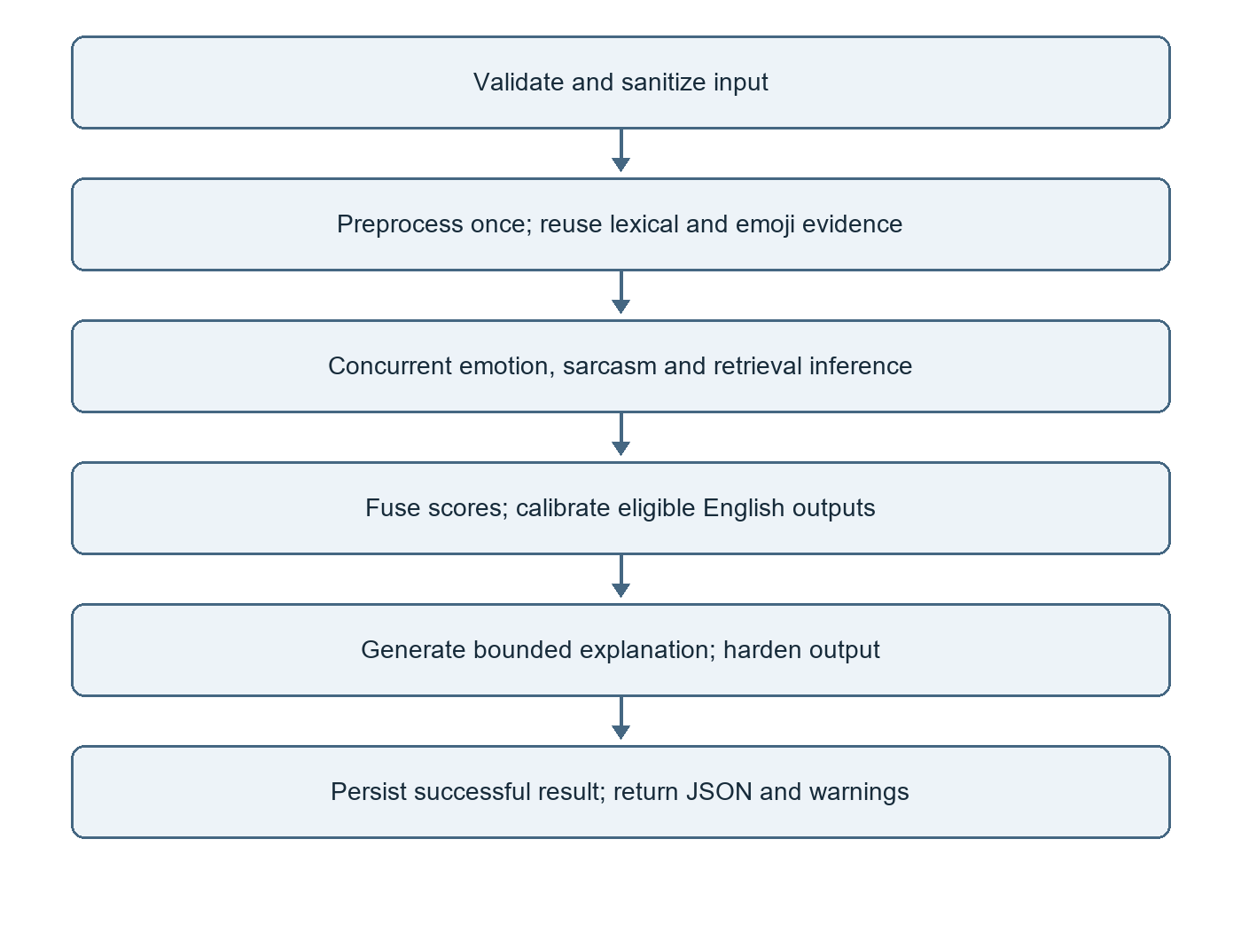
Use cases: user submits one message or a CSV; analyst views scores and exports results; reviewer inspects saved records. Each case uses the same Flask service and SQLite repository. Independent model stages execute concurrently before fusion.

6.1 Data model
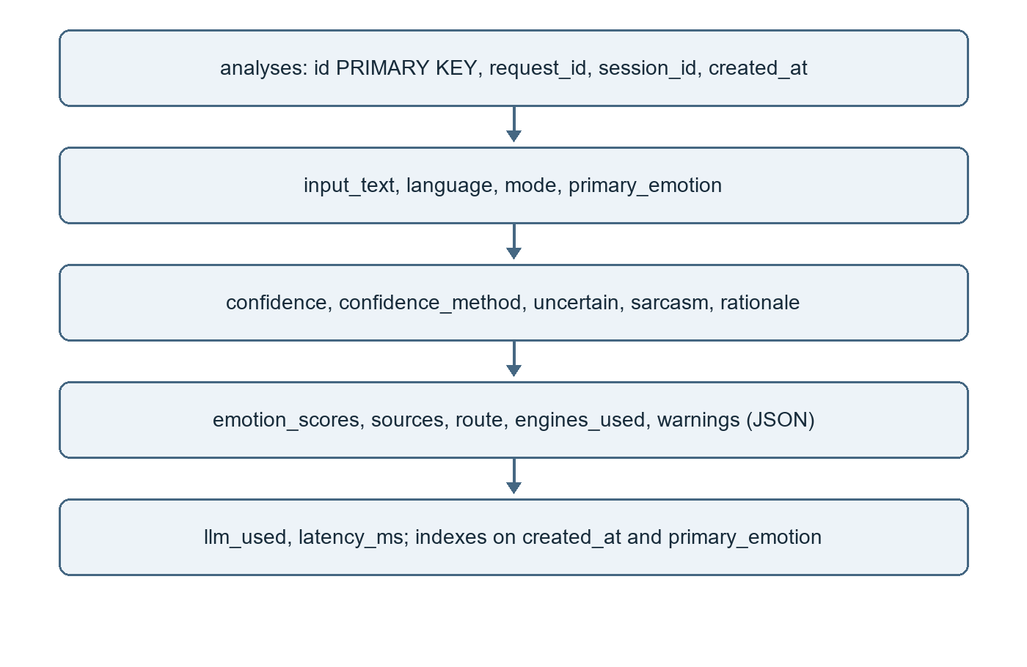

7 Confidence and language verification
Experimental temperature scaling uses 700 GoEmotions development examples and 350 disjoint test examples, with temperature 1.751. Validation calibration error fell from 17.4% to 4.2%; label accuracy remained 47.1%. The upstream model used GoEmotions, so training overlap is unknown. This is domain-specific calibration, not independent proof of general accuracy. Sarcasm and non-English scores remain uncalibrated. Common Hindi/Hinglish phrases are normalized for the English models. 17/18 curated demonstration inputs matched their expected emotion. These examples exercise supported phrases; they do not establish general multilingual accuracy. Adapted and other non-English outputs always require review. Hindi/Hinglish sarcasm was not benchmarked.

8 Academic review
The suite has 69 passing tests. Full model inference and the production Waitress entrypoint were exercised. Evaluation artifacts record actual paths and configuration. The public deployment, screenshots, Docker execution and live LLM provider remain unverified. Academic approval and signatures must come from the actual reviewers.
Repository: https://github.com/Divyansh1-3/Emotion-Detection-from-Text-Project
Developer: Divyansh Yadav
Faculty reviewer: ____________________
Signature and date: ____________________

