Emotion Detection from Text
Project Report | Streamlit Edition | November 2026
Divyansh Yadav | Roll No 2400320100444
ABES Engineering College, Ghaziabad
Department of Computer Science and Engineering
B.Tech third year | Academic year 2026-2027
HCL Industrial Training | Project P_098

Project synopsis
Emotion Detection from Text is a small academic web application that predicts the emotional tone of an English sentence. It presents a clear dashboard and uses a saved machine-learning model, so predictions do not require an external AI service or an API key.
Objective Classify sentences into anger, fear, joy, love, sadness and surprise; show the scores, indicate uncertain predictions, and make the result easy to review.
Implementation The implementation uses Python 3.13, Streamlit 1.66.1 and scikit-learn 1.9.1. TF-IDF represents single words and pairs of words using at most 12,000 features. A logistic-regression classifier with balanced class weights selects among six emotions. The fitted model is included with the project and loaded once per process.
Measured outcome The classifier trained on 16,000 English examples. It achieved 88.2% accuracy and 0.842 macro F1 on 1,989 test examples, after excluding 11 exact duplicates of training texts. All 14 automated model and interface checks passed. Dataset results do not guarantee the same accuracy for every new sentence.
User experience The dashboard includes input and output panels, session summaries, a colored chart, an explanation based on word weights, ten recent analyses and a text download.
Access The project is prepared for free deployment on Streamlit Community Cloud from its GitHub repository. A public deployment URL and remote browser verification remain pending. Free apps may sleep after inactivity, so the first visit can take longer. Local execution is available at http://localhost:8501 while the app is running.
Repository https://github.com/Divyansh1-3/Emotion-Detection-from-Text-Project

1 Problem and project scope
Written messages often express feelings without tone of voice or facial expressions. This project demonstrates how a simple text classifier can help a student explore those signals. The purpose is to build and explain an accessible machine-learning application with manageable installation and hosting requirements.
Students and academic reviewers are the main users. A user enters one sentence, reviews the suggested emotion, compares all scores, and decides whether the result is reasonable. No automated action is taken about a person.

2 Dataset and learning method
The DAIR-AI Emotion dataset, based on CARER, contains automatically labelled English messages. The included compressed CSV files retain the upstream labels and texts. The dataset is intended for educational and research use; its exact source revision and hashes are recorded in data/source.json.
Dataset portion | Examples | Use
Training | 16,000 | Fit the TF-IDF vocabulary and classifier
Original test split | 2,000 | Evaluation only; never used to fit the model
Evaluated test split | 1,989 | After excluding 11 exact training duplicates

TF-IDF gives a numeric weight to each recognised word or two-word phrase. Common terms receive less emphasis, and the feature vector is normalised. Logistic regression learns a weight for each feature and emotion. It converts the resulting scores into six values that sum to one.
Training uses a maximum of 12,000 features, word n-grams of length one and two, sublinear term frequency, balanced class weights, C = 3.0 and a maximum of 300 iterations. Training is performed by train_model.py; the web app only loads the resulting model.
Balanced class weights reduce the influence of the most frequent labels during fitting. They do not make all classes equally accurate, and the displayed score is not calibrated confidence.

3 System architecture
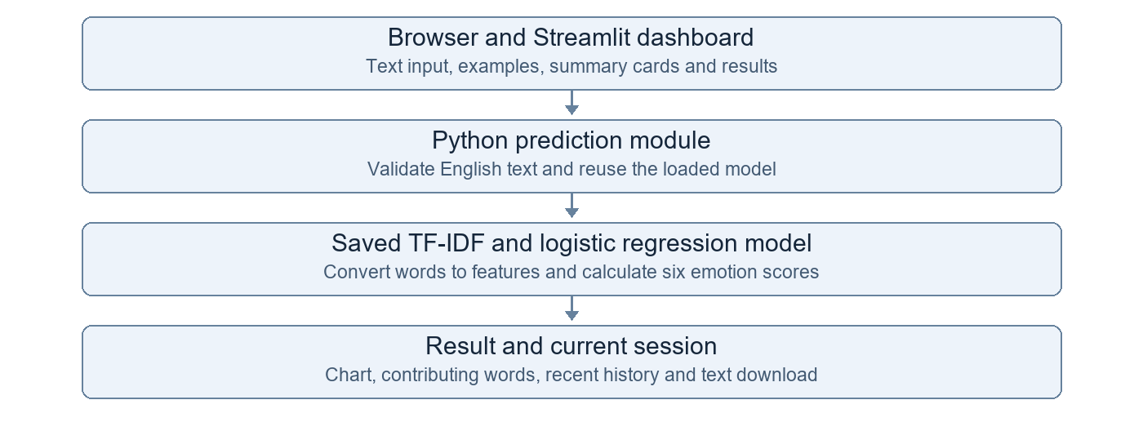
Figure 1 Implemented Streamlit architecture
Streamlit handles page rendering and user events in one Python application. The prediction module validates input, loads the local model, and returns scores and contributing words. The app then updates only that user's current session.
Component | Responsibility
app.py | Dashboard, callbacks, summaries, current-session history and result download
styles.css | Local colors, spacing and dashboard panels
emotion_model.py | Input validation, cached loading, prediction and contributing words
model/emotion_model.pkl.gz | Fitted TF-IDF vocabulary and logistic-regression weights
train_model.py | Optional reproducible training and held-out evaluation

The saved model is approximately 655 KiB. There are two direct application dependencies. No model training, model download, API-key setup or database migration runs when a user opens the app.

4 Dashboard and user workflow
The dashboard places the input panel beside the result panel. Four summary cards show successful analyses, average top model score, uncertain results and the six supported emotions. All summary values come from the current session.
User action | Application response
Choose a demo or enter text | Populate the text area; changing the text clears the previous displayed result
Analyze emotion | Validate the text and show the top emotion, percentage chart and explanation
Review recent analyses | Show up to ten results, newest first, without persistent storage
Save result | Download the current text, emotion, scores and explanation as a text file
Clear text | Clear the input and current result while retaining session history
Reset session | Clear input, current result, history and aggregate counters

4 1 Explanation and uncertainty
The explanation uses up to three input words or phrases with positive contributions to the selected emotion. Each contribution is the TF-IDF feature value multiplied by that emotion's learned coefficient. A local sentence template describes those words and the second-highest emotion. The model's label is not changed by the explanation.
A result is marked uncertain if its highest score is below 0.45 or the difference between the top two scores is below 0.10. These are practical thresholds, not a measured probability of correctness.

4 2 Example result
Input: what a bad day was today
Output: Sadness with model score 60.8%. Contributing words or phrases: bad, day, today.
This example is a demonstration, separate from the held-out dataset score. A plausible result for one sentence does not prove that all negative or ambiguous sentences will be handled correctly.

5 Testing and measured results
The classifier trained on 16,000 English examples. It achieved 88.2% accuracy and 0.842 macro F1 on 1,989 test examples, after excluding 11 exact duplicates of training texts. All 14 automated model and interface checks passed. Dataset results do not guarantee the same accuracy for every new sentence.
Measurement | Observed result
Held-out accuracy | 88.2%
Macro F1 | 0.842
Automated checks | 14 passed, 0 failed
Mean warm inference including word contributions | 9.94 ms over 60 local calls
Warm inference P95 | 11.82 ms
Model load and first prediction | 3.72 seconds in the local probe

Timings describe Python inference on the local Windows computer. They exclude the Streamlit page, network transfer and a full cold application launch. They are not measurements of free cloud hosting. Detailed evidence is stored in model/evaluation.json and docs/verification.json.
Emotion | Precision | Recall | F1 | Test count
Anger | 0.869 | 0.898 | 0.883 | 274
Fear | 0.893 | 0.817 | 0.853 | 224
Joy | 0.919 | 0.899 | 0.908 | 690
Love | 0.716 | 0.866 | 0.784 | 157
Sadness | 0.933 | 0.895 | 0.914 | 579
Surprise | 0.642 | 0.800 | 0.712 | 65

Automated coverage includes the six clear emotions, the bad-day example, invalid/empty input, unsupported scripts, unknown words, input length, model reuse, charts and download presence, stale-result clearing, history limits, reset behavior and separate user sessions. The local server page and its health route also returned HTTP 200.

6 Installation and free deployment
Install Python 3.13, open a terminal in the project directory, and run the following one-time setup:
py -3.13 -m venv .venv
.\.venv\Scripts\python.exe -m pip install -r requirements.txt
Start the app by double-clicking start_app.bat or running:
.\.venv\Scripts\python.exe -m streamlit run app.py
Open http://localhost:8501 and keep the terminal running. The local app can work without internet after installation. To rerun verification, use python -m unittest discover -s tests -v in the project environment.
For free hosting, sign in to Streamlit Community Cloud, create an app from the GitHub repository, choose branch main and entrypoint app.py, and select Python 3.13 under Advanced settings. No secrets are needed. After deployment, check a fresh prediction and Save result from the public link before sharing it.
The project is prepared for free deployment on Streamlit Community Cloud from its GitHub repository. A public deployment URL and remote browser verification remain pending. Free apps may sleep after inactivity, so the first visit can take longer. Local execution is available at http://localhost:8501 while the app is running.

7 Limitations and conclusion
The model supports English text and six emotion labels. Neutral and disgust are not labels in this dataset. Sarcasm, negation, mixed feelings and unfamiliar vocabulary may produce incorrect predictions. Other scripts are rejected, but the app does not reliably identify every language written with English letters. It describes text tone and does not diagnose a person's mental state.
The project demonstrates the full path from labelled text to a usable prediction dashboard with a small classical model. Future improvements can focus on more varied English training data, a neutral label, and better evaluation of negation and ambiguous sentences. These improvements are outside the current implementation.

8 References
Saravia et al. 2018. CARER: Contextualized Affect Representations for Emotion Recognition. EMNLP, pages 3687-3697. https://aclanthology.org/D18-1404/
Dataset and educational-use terms: https://huggingface.co/datasets/dair-ai/emotion
Streamlit documentation: https://docs.streamlit.io/
scikit-learn text feature extraction and logistic regression: https://scikit-learn.org/stable/
Project source: https://github.com/Divyansh1-3/Emotion-Detection-from-Text-Project

