**A Report on**

SETHUSAMARTHYA

Submitted for partial fulfillment of award of

### BACHELOR OF TECHNOLOGY

degree

In

CSE- Artificial Intelligence & Machine Learning

By

Aryaman Nair

(2100301530018)

Anand Singh

(2100301530009)

Divyansh Aggarwal

(2100301530033)

Prof. Khushbu

SUPERVISOR



**INDERPRASTHA ENGINEERING COLLEGE, GHAZIABAD,**

**Dr. A P J ABDUL KALAM TECHNICAL UNIVERSITY**

**LUCKNOW**

**December 2024**

**Certificate**

Certified that Aryaman Nair, Anand Singh and Divyansh Aggarwalhave carried out

the project work presented in this report entitled **“**SETHUSAMARTHYA**”** for the

award of Bachelor of Technologyfrom Inderprastha Engineering College,

Ghaziabad, under my supervision. The report embodies result of original work and

studies carried out by Student himself/herself and the contents of the report do not

form the basis for the award of any other degree to the candidate or to anybody else.

____________________

Signature

(Name of Guide)

SUPERVISOR

Designation:

Department:

Address:

Date:

**Acknowledgement**

We take this opportunity to thank our teachers and friends who helped us throughout the project.

We would like to express my sincere gratitude to everyone who has contributed to the successful completion of this report.

First and foremost, I extend my deepest thanks **Dr. Kumud Kundu (HOD, Mrs. Neha Verma, Mrs. Ruchika Bala, Mrs. Uma Sharma, Computer Science and Engineering (Artificial Intelligence & Machine Learning**), whose guidance, insights, and expertise were invaluable throughout the process. Their constant support and encouragement have been instrumental in shaping this work.

I am also grateful to Indraprastha Engineering College for providing the necessary resources and a conducive environment for carrying out this project.

Special thanks to my peers and colleagues**, Mr. Aman Ojha, Mr. Gaurav Sharma, Mr. Dhruv** for their valuable feedback and suggestions that greatly improved the quality of this work.

Lastly, I would like to thank my family and friends for their unwavering support and motivation during this endeavour.

This report is the culmination of collective efforts, and we are truly appreciative of everyone who has played a role in its creation.

Signature Signature Signature

Aryaman Nair Anand Singh Divyansh Aggarwal

Declaration

I hereby declare that this submission is our own work and that, to the best of our

knowledge and belief, it contains no material previously published or written by

another person nor material which to a substantial extent has been accepted for the

award of any other degree or diploma of the university or other institute of higher

learning, except where due acknowledgment has been made in the text.

________________ ___________________ ___________________

Aryaman Nair Anand Singh Divyansh Aggarwal

2100301530018 2100301530009 2100301530033

Date: 31/12/2024

**Abstract**

Bridges serve as vital infrastructural elements, connecting people and facilitating economic growth. However, their deterioration due to aging, environmental conditions, and increasing loads poses significant safety and operational risks. Addressing this critical issue, the Sethusamarthya system has been designed as an innovative solution to analyse and predict the quality of bridges, ensuring safety, operational efficiency, and data-driven decision-making for maintenance.

The research problem tackled in this project stems from the lack of integrated tools that combine machine learning, geospatial mapping, and real-time data handling to assess bridge conditions effectively. Existing manual inspections are often insufficient, time-consuming, and prone to human error. Thus, the need for an automated, accurate, and scalable solution is imperative to proactively identify and mitigate risks associated with bridge failures.

Methodology

The Sethusamarthya system adopts a multi-disciplinary approach, integrating Artificial Neural Networks (ANN), geospatial mapping, and web application frameworks. The methodology is structured into distinct phases:

1. Data Collection and Preprocessing:
   * The project leverages diverse datasets, encompassing features like material type, weather conditions, construction quality, traffic volume, bridge dimensions, and environmental stress factors. Additional data on rainfall, temperature, and humidity provide context to environmental influences.
   * Data preprocessing involves cleaning, handling missing values, and normalizing the input features using StandardScaler from the sklearn library to ensure uniformity and enhance model performance.
2. ANN Model for Prediction:
   * An Artificial Neural Network (ANN) was developed to predict the status of bridges (“Collapsed” or “Standing”). The architecture includes an input layer accommodating 16 features, fully connected hidden layers employing ReLU activation functions to learn complex patterns, and a sigmoid-activated output layer for binary classification.
   * The model is trained using the binary cross-entropy loss function and optimized with the Adam optimizer, ensuring efficient learning and convergence. Metrics like accuracy, precision, recall, and F1-score are employed to evaluate performance.
3. Geospatial Mapping:
   * A geospatial mapping module provides a visual representation of bridge locations, statuses, and their integration into route planning. Using tools like folium or Google Maps API, users can dynamically visualize “Collapsed” and “Standing” bridges on interactive maps.
   * Real-time database queries facilitate the identification of compromised bridges along planned routes, offering recommendations for safer alternatives.
4. Database Design and Integration:
   * The system incorporates a relational database with two core tables: one for storing bridge attributes required for prediction and another for geospatial data like coordinates and statuses.
   * Data is efficiently managed through SQL queries and synchronized with the ANN model and mapping modules for real-time updates.
5. Web Application Framework:
   * A user-friendly interface is developed using Flask, enabling seamless interaction with the prediction and mapping system. The web application includes:
     + A home page for bridge status predictions based on user-provided inputs.
     + A map page displaying bridge locations and their statuses, alongside route planning functionality.
   * The backend integrates the trained ANN model using the Keras load_model function to generate predictions dynamically.
6. Testing and Validation:
   * Comprehensive testing is conducted to ensure robustness and accuracy. Test cases include edge scenarios (e.g., extreme stress and strain values) and integration tests to validate the seamless operation of prediction and mapping modules.
   * Evaluation metrics confirm the ANN’s high accuracy and reliability in predicting bridge statuses.

Summary of Findings

The Sethusamarthya system demonstrates significant potential in revolutionizing bridge quality assessment through automation and data-driven insights. Key findings include:

* The ANN model achieves high accuracy, reliably classifying bridge statuses based on the provided features.
* Geospatial mapping enhances decision-making by providing real-time visualizations of bridge conditions and safe route suggestions.
* The integration of machine learning, geospatial data, and web applications creates a scalable, user-friendly system suitable for widespread deployment.
* Testing results affirm the system’s robustness, with successful handling of edge cases and seamless integration between components.

Sethusamarthya addresses the pressing need for an efficient bridge quality analyser by combining advanced technologies into a cohesive system. The research underscores the value of interdisciplinary approaches in tackling infrastructural challenges. With further refinements and broader data integration, the system has the potential to become a critical tool for ensuring bridge safety and sustainability, thereby contributing to public safety and infrastructure longevity.

### **TABLE of CONTENTS**

**CHAPTER NO. TITLE PAGE NO.**

**ABSTRACT iii**

**LIST OF TABLES xvi**

**LIST OF FIGURES xviii**

**LIST OF SYMBOLS, ABBREVIATIONS xxviii**

1. **INTRODUCTION**

1.1 Problem Definition……………………………………… 12

1.2 Background about the project idea……………………… 13

1.3 Objectives of proposed system…………………………. 15

1.4 Feasibility Study, need and significance………………... 16

1.5 Novelty of Project………………………………………. 19

1.6 Technical Specification…………………………………. 20

1.6.1. Software required………………………………... 20

**2. LITERATURE REVIEW**…………………………………… 22

**3. PROPOSED SYSTEM**………………………………………. 24

**4. SOFTWARE REQUIREMENT ANALYSIS**

4.1.Functional Requirements………………………………. 27

4.2. Nonfunctional Requirements…………………………... 28

4.3. Major Modules and their functionalities………………. 29

**5. SYSTEM ANALYSIS & DESIGN**

5.1 Sequence diagrams……………………………………… 31

5.2 Activity Diagrams………………………………………. 32

5.3 Gantt Chart ……………………………………………... 33

**6.**  **IMPLEMENTATION/CORE MODULE**

6.1 Tables ………………………………………………….. 34

6.2 Used Algorithms/Approaches for projects……………… 35

6.3 Implementation of Modules/Algorithms... ……………… 39

**7. RESULTS / OUTPUTS & TESTING**

7.1 All user interfaces and output screens…………………………..... 43

7.2 Layouts of web Pages………………………………………………44

7.3 Design and Test Steps………………………………………………45

7.4 Testing Process……………………………………………………..46

**8. CONCLUSIONS / RECOMMENDATIOS**……………………………. 52

**9. REFERENCES**………………………………………………………….. **54**

**10. APPENDICES**

12.1 Details of software………………………………………………… 55

12.2 Steps to execute/run/implement the project……………………….. 56

12.3 Coding……………………………………………………………...58

**11. RESEARCH PAPER PUBLICATION (PUBLISHED PAPER/PAPER STATUS WITH JOURNAL /CONFERENCE NAME)**

**List of Tables**

Page No.

Table 1: Various Bridge Parameters…………………………………………….34

Table 2: User Location data……………………………………………………..35

Table 3: Various test cases that need to be considered before implementing the project…………………………………………………………………………...50

**List of Figures**

Page no.

Figure 1: Flowchart of the Proposed System…………………………………24

Figure 2: Case Diagram of the Sethusamarthya Project……………………...27

Figure 3: Sequence diagram showing the user’s interaction with the webpage; user entering the bridge parameters to predict the quality of the bridge…………..31

Figure 4: Activity diagram showing three processes. Process 1: project initiation where the user enters the bridge parameters like stress, strain etc. for prediction. Process 2: ML model in the background executes the user’s information using an ANN model to predict the quality of the bridge. Process 3: The result is displayed on the screen either “COLLAPSED” or “STANDING”………………………32

Figure 5: It is the image of the project development phases in the form of Gantt Chart……………………………………………………………………………33

Figure 6: UI of the webpage of Sethusamarthya showing the bridge

parameters……………………………………………………………………….43

Figure 7: Image of geospatial mapping feature for users……………………….44

Figure 8: Image showing the output showing the prediction in the form of “Collapsed”……………………………………………………………………...45

Figure 9: bridge quality prediction webpage……………………………………46

Figure 10: the geospatial mapping feature webpage……………………………46

Figure 11: Code snippet of ML model implementation………………………..58

Figure 12: Code snippet of data preprocessing implementation………………..59

**CHAPTER1**

**INTRODUCTION**

**1.1 Problem Definition for Structural Health Monitoring: Sethusamarthya - A Bridge Quality Analyser**

Bridges serve as critical infrastructures, facilitating transportation and economic growth by connecting regions and enabling the movement of goods and people. However, their structural integrity is often compromised due to aging, environmental conditions, overloading, and natural disasters, posing significant risks to safety and economic stability. Despite these challenges, the traditional methods of bridge inspection and maintenance remain labour-intensive, time-consuming, and prone to human error. This highlights the urgent need for an advanced, reliable, and efficient system to monitor and evaluate the health of bridges in real time.

1.1.1 Core Problems**:**

1. Aging Infrastructure: Many bridges worldwide have exceeded their intended design lifespan, making them susceptible to structural deficiencies such as cracks, corrosion, and material degradation. Early detection of these issues is critical to prevent catastrophic failures.
2. Manual Inspection Limitations: Conventional inspection methods rely heavily on visual assessments and periodic checks. These methods are not only time-consuming but also fail to provide continuous monitoring or detect subsurface damages effectively.
3. Environmental and Operational Stress: Bridges are exposed to harsh environmental conditions, such as temperature fluctuations, moisture, and seismic activity. Combined with operational stresses like overloading and high traffic volumes, these factors accelerate wear and tear.
4. Resource Constraints: Limited financial and human resources often delay necessary inspections and repairs, increasing the risk of failure and associated costs.
5. Lack of Real-Time Monitoring: The absence of real-time monitoring systems limits the ability to make proactive decisions, often resulting in reactive maintenance approaches that are costlier and less effective.

**1.2 Background for Structural Health Monitoring**

1.2.1 Importance of Bridges in Infrastructure**:**

Bridges are pivotal components of a nation’s infrastructure, playing a vital role in enabling economic activities, transportation, and regional connectivity. Whether spanning rivers, valleys, or urban landscapes, bridges facilitate efficient movement and support essential logistics networks. As a result, their uninterrupted functionality is critical to the safety of communities and the smooth operation of economies. However, these structures face numerous challenges throughout their lifecycle, making it imperative to adopt effective strategies for their maintenance and health monitoring.

1.2.2 The Challenge of Structural Integrity**:**

Bridges, by their nature, are subjected to complex stresses and environmental impacts. Factors like material aging, repeated loading cycles, and extreme weather conditions compromise their structural integrity over time. Additionally, urbanization and the increasing volume of heavy vehicles have exacerbated the stresses placed on existing bridge infrastructure, leading to a rising number of structural failures globally. Such failures not only cause immense financial losses but also endanger human lives, underscoring the need for proactive solutions.

1.2.3 Traditional Inspection Methods**:**

Conventional bridge inspection methods involve manual visual inspections, non-destructive testing (NDT) techniques, and periodic maintenance schedules. While these approaches provide some level of assessment, they have significant limitations:

1. Inconsistency: Human errors and subjective judgments can lead to inconsistent evaluations.
2. Delays: Inspections are often infrequent, allowing small damages to worsen over time.
3. Inaccessibility: Certain structural components may be difficult to access, limiting thorough inspections.
4. High Costs: Frequent manual inspections and advanced NDT methods require substantial resources.

These shortcomings highlight the need for automated and intelligent systems that can provide continuous and accurate monitoring.

1.2.4 Evolution of Structural Health Monitoring (SHM)**:**

The concept of Structural Health Monitoring (SHM) has evolved as a response to the inadequacies of traditional inspection techniques. SHM integrates advanced technologies such as sensors, data acquisition systems, and machine learning algorithms to continuously monitor the structural integrity of bridges and other infrastructure. This approach offers real-time data on stress, deformation, and environmental impacts, enabling timely maintenance and reducing the risk of catastrophic failures.

1.2.5 Advances in Technology Driving SHM**:**

Several technological innovations have transformed the field of SHM in recent years:

1. Internet of Things (IoT): IoT-enabled sensors facilitate real-time data collection and transmission, ensuring continuous monitoring without manual intervention.
2. Artificial Intelligence (AI) and Machine Learning (ML): These technologies enable sophisticated data analysis, anomaly detection, and predictive maintenance, enhancing the decision-making process.
3. Cloud Computing: Cloud platforms allow for the efficient storage, processing, and sharing of large datasets, making SHM systems more scalable and accessible.
4. Wireless Sensor Networks (WSNs): Wireless sensors eliminate the need for extensive wiring, reducing installation costs and improving scalability.

1.2.6 The Indian Context:

In India, the need for robust bridge monitoring systems is particularly pressing due to the country’s vast and diverse bridge infrastructure. Many bridges, especially in rural and urban areas, were constructed decades ago and are now facing issues related to aging and overuse. Additionally, India’s exposure to natural disasters such as floods, earthquakes, and landslides further emphasizes the need for reliable SHM systems. Despite these challenges, the adoption of modern SHM solutions in India has been limited, creating a significant gap that projects like Sethusamarthya aim to address.

1.2.7 Motivation Behind Sethusamarthya**:**

The Sethusamarthya project is inspired by the pressing need to modernize bridge maintenance practices and ensure public safety. By leveraging state-of-the-art technologies, Sethusamrthya aims to provide a comprehensive solution for monitoring bridge health, addressing challenges such as:

* Early Damage Detection: Identifying and addressing issues before they escalate.
* Cost Efficiency: Reducing maintenance costs through predictive analytics and automated monitoring.
* Public Safety: Minimizing risks associated with bridge failures.
* Scalability: Offering a system that can be deployed across different types of bridges and regions.

By integrating cutting-edge technologies and addressing the unique challenges faced by Indian bridge infrastructure, Sethusamrthya aims to set a new standard for structural health monitoring, ensuring the safety, reliability, and longevity of critical infrastructure.

**1.3 Objectives of the Proposed System**

The primary goal of the Sethusamrthya system is to revolutionize the way bridge health is monitored and maintained, leveraging advanced technologies to ensure safety, reliability, and efficiency. The proposed system is designed to address critical challenges in structural health monitoring and meet the following objectives:

1. Real-Time Structural Health Monitoring**:**

Develop a robust system that continuously monitors key parameters such as stress, vibration, displacement, and temperature in real-time, providing constant insights into the structural health of bridges.

2. Early Damage Detection**:**

Facilitate the early detection of structural anomalies, such as cracks, corrosion, and material degradation, to prevent minor damages from escalating into major failures.

3. Predictive Maintenance**:**

Implement machine learning and AI algorithms to analyse collected data and predict potential issues, enabling proactive maintenance strategies that minimize costs and disruptions.

4. Comprehensive Diagnostics**:**

Ensure a detailed evaluation of both visible and subsurface damages using advanced sensor networks and data analysis techniques, offering a holistic view of structural integrity.

5. Automation and Efficiency:

Automate data collection, processing, and reporting to reduce dependency on manual inspections, improve efficiency, and save time.

6. Scalability and Adaptability**:**

Design a flexible system capable of adapting to various types of bridges, environmental conditions, and load requirements, ensuring widespread applicability.

7. Enhanced Safety Measures**:**

Provide early warnings and actionable insights to bridge authorities and stakeholders, enhancing public safety by mitigating risks associated with structural failures.

8. Cost-Effective Solution**:**

Reduce inspection and maintenance costs by integrating cost-effective sensors and scalable technologies while maintaining high accuracy and reliability.

9. Data-Driven Decision Making**:**

Enable stakeholders to make informed decisions using comprehensive reports and real-time dashboards generated from analysed data.

10. Sustainability and Longevity**:**

Promote sustainable infrastructure management by optimizing maintenance schedules, reducing waste, and extending the lifespan of bridges.

11. Resilience Against Natural Disasters**:**

Incorporate features to assess the impact of natural disasters, such as earthquakes, floods, and landslides, on bridge structures, facilitating quick recovery and damage mitigation.

By meeting these objectives, the Sethusamrthya system aims to set a new benchmark in the field of structural health monitoring, ensuring the safety and sustainability of critical bridge infrastructure.

**1.4 Feasibility Study, Need, and Significance**

1.4.1 Feasibility Study:

The feasibility of the Sethusamrthya project has been analysed in terms of technical, economic, operational, and social aspects to ensure the project's viability and effectiveness.

1. Technical Feasibility

* Sensor Technology**:** Advances in IoT-enabled sensors provide reliable and continuous data collection on parameters such as stress, vibration, and temperature.
* Data Processing: The use of artificial intelligence and machine learning for data analysis ensures accurate predictions and diagnostics, even for complex structural issues.
* Cloud Computing**:** Scalable cloud platforms enable real-time data storage, processing, and retrieval, making the system adaptable to diverse infrastructure needs.
* Integration: The proposed system integrates seamlessly with existing bridge infrastructures using non-intrusive methods, avoiding significant disruption during deployment.

2. Economic Feasibility

* Cost-Benefit Analysis**:** Although initial investment in sensors and software development is required, the system's ability to predict failures and reduce maintenance costs provides a high return on investment.
* Scalability**:** The modular design allows deployment on various types of bridges, making it cost-effective for large-scale implementation.
* Resource Optimization**:** Automated monitoring reduces reliance on labour-intensive inspections, further lowering operational costs.

3. Operational Feasibility

* Ease of Use**:** A user-friendly dashboard ensures stakeholders can access actionable insights without extensive training.
* Automation: The system’s automated nature eliminates the need for continuous manual intervention, making it efficient and reliable.
* Maintenance: The robust design of the sensors and software ensures minimal maintenance requirements for the system itself.

4. Social Feasibility

* Public Safety**:** By preventing catastrophic bridge failures, the system protects lives and enhances public trust in infrastructure.
* Environmental Impact**:** The system’s predictive maintenance approach minimizes resource wastage, contributing to sustainable infrastructure management.

1.4.2 Need for Sethusamrthya:

1. Aging Infrastructure

Many bridges globally, and especially in India, have exceeded their designed lifespan, making them susceptible to structural failures. Sethusamrthya addresses the urgent need for modern solutions to assess and maintain such aging structures effectively.

2. Inadequacies of Traditional Methods

Manual inspections are not only time-consuming and labour-intensive but also prone to inaccuracies and delays. The system provides a much-needed alternative that ensures continuous, precise, and real-time monitoring.

3. Increased Traffic Loads

Rising vehicular loads due to urbanization and economic growth have placed additional stress on bridge infrastructure. The system helps monitor and manage the impact of these stresses in real time.

4. Natural Disasters

Bridges in disaster-prone areas face additional risks from earthquakes, floods, and landslides. Sethusamrthya real-time monitoring capabilities make it indispensable for identifying and mitigating disaster-related damages promptly.

1.4.3 Significance of the Project:

1. Enhancing Public Safety

By providing early warnings and actionable insights, the system significantly reduces the risk of accidents and bridge collapses, ensuring public safety.

2. Extending Bridge Lifespan

Proactive maintenance facilitated by the system reduces wear and tear, extending the service life of bridges and delaying the need for costly replacements.

3. Economic Growth

Reliable bridge infrastructure supports uninterrupted transportation and logistics, which are critical for economic activities and growth.

4. Sustainability

The project’s predictive and data-driven approach promotes efficient use of resources, reducing waste and environmental impact.

5. Technological Advancement

By leveraging cutting-edge technologies such as AI, IoT, and cloud computing, Sethusamarthya establishes a benchmark for future infrastructure monitoring systems.

6. Policy and Governance Support

The system provides data-driven insights that can assist policymakers and governing bodies in making informed decisions about infrastructure management and resource allocation.

In conclusion, Sethusamrthya is not only feasible but also highly necessary and significant in addressing the pressing challenges of bridge maintenance and public safety. It represents a transformative step toward modernizing infrastructure management and ensuring the sustainability of critical transportation networks.

**1.5** **Novelty of the Project**

The Sethusamrthya project stands out as an innovative solution in the domain of structural health monitoring (SHM) for bridges. Its novelty lies in the combination of advanced technologies, intelligent data processing, and a proactive approach to infrastructure management, addressing gaps that traditional methods fail to resolve. Below are the key aspects that highlight the project’s uniqueness:

1. Integration of Advanced Technologies

* IoT-Enabled Monitoring**:** The project employs a comprehensive network of IoT sensors to collect real-time data on critical parameters such as stress, vibration, and temperature, ensuring continuous and precise monitoring.
* AI and Machine Learning Algorithms**:** The use of AI-powered algorithms to analyse data enables the detection of subtle anomalies and predictive maintenance, setting it apart from conventional SHM systems.
* Cloud-Based Data Management**:** Leveraging cloud computing for storage and processing ensures scalability, remote access, and real-time updates.

2. Proactive Maintenance Approach

* Traditional bridge inspection methods are reactive and often address issues after significant damage has occurred. Sethusamrthya predictive capabilities allow stakeholders to anticipate and resolve potential problems before they escalate, reducing repair costs and preventing accidents.

3. Holistic Diagnostics

* Unlike systems that focus solely on visible damages, Sethusamrthya provides a comprehensive evaluation by detecting both surface-level and subsurface damages, such as internal cracks and corrosion, with high accuracy.

4. Modular and Scalable Design

* The system’s modular architecture makes it adaptable to various types of bridges and environments. Whether applied to small rural bridges or large urban infrastructures, Sethusamrthya can be scaled and customized to meet specific requirements.

5. User-Centric Design

* A user-friendly interface ensures that stakeholders, including engineers, policymakers, and maintenance teams, can easily interpret the insights provided by the system without extensive technical training.

6. Disaster Resilience

* The project’s focus on real-time monitoring and rapid diagnostics makes it particularly useful in disaster-prone regions. It can assess damage caused by natural calamities like earthquakes and floods, facilitating timely restoration efforts.

7. Sustainability and Cost-Efficiency

* By optimizing resource allocation and reducing waste, Sethusamrthya promotes sustainable practices in infrastructure management. Its predictive maintenance model also minimizes long-term costs by extending the lifespan of bridges and avoiding expensive emergency repairs.

8. Policy and Governance Alignment

* The system’s data-driven approach provides actionable insights that can aid policymakers in prioritizing maintenance schedules, allocating budgets, and developing infrastructure strategies based on objective metrics.

9. Bridging Technological and Practical Gaps

* Sethusamrthya bridges the gap between theoretical advancements in SHM and their practical implementation. Its integration of cutting-edge technologies into a field-ready system addresses the challenges of accessibility, reliability, and cost-effectiveness.

10. Indian Contextualization

* While designed for global applicability, the project pays special attention to challenges faced by Indian infrastructure, such as aging bridges, limited resources, and disaster-prone regions. This contextual focus enhances its relevance and effectiveness.

**1.6 Technical Specifications**

**1.6.1 Software Requirements**

1. Operating System**:**
   * Windows OS for servers and edge devices due to its stability and scalability.
2. Data Management:
   * Database**:** local database (.csv file etc.) for storing sensor data.
3. Data Analytics and Machine Learning:
   * Libraries and Frameworks**:**
     + TensorFlow or PyTorch for developing predictive maintenance models.
     + Pandas and NumPy for data preprocessing and analysis.
     + Scikit-learn and Keras for implementing machine learning algorithms.
   * Visualization Tools**:** Python flask for creating user-friendly dashboards.
4. Communication Protocols**:**
   * HTTP protocols for efficient and reliable communication between devices and servers.
5. User Interface:
   * Web-based dashboard for civil engineers or interested individuals to monitor bridge health metrics and receive alerts.

**CHAPTER 2**

**Literature Review**

**2.1Existing System - Theoretical and Methodological Contributions**

2.1.1 Theoretical Contributions

The analysis and prediction of bridge collapse events have been extensively studied in the domains of civil engineering and artificial intelligence. Existing theoretical frameworks leverage concepts such as structural load analysis, material degradation, and stress-strain dynamics to model the behaviour of bridges under various conditions. Machine learning and artificial neural networks (ANN) have provided a modern approach by enabling predictive analysis based on historical data.

Some notable theoretical contributions include:

* Structural Reliability Models: These models focus on the probability of structural failure, considering external factors like weather conditions, traffic loads, and material fatigue. Probabilistic methods provide a foundation for understanding failure mechanisms.
* Data-Driven Prediction Frameworks: Recent studies integrate AI techniques to identify patterns in large datasets, such as bridge inspection reports and environmental data. These frameworks rely on supervised learning algorithms like decision trees, random forests, and ANNs.
* Geospatial Data Analysis: The use of GIS-based systems to map and analyse bridge data geographically has been instrumental in identifying high-risk zones and optimizing maintenance schedules.

2.1.2 Methodological Contributions

Methodologies in existing systems typically involve combining structural data analysis with advanced computational tools to improve the efficiency of bridge monitoring systems.

Key methodological advances include:

* Inspection and Monitoring Techniques:
  + Google API for real-time data collection on structural health metrics.
* Predictive Algorithms:
  + ANN-based models for classifying bridge conditions into "Collapsed" or "Standing" categories.
* Geospatial Mapping Integration:
  + Development of interactive platforms using APIs like Google Maps or libraries like Folium to visualize bridge locations and conditions.
  + Route planning tools that incorporate real-time status checks for bridges, enabling safer travel.

2.1.3 Limitations of Existing Systems

Despite the advancements, existing systems face several challenges:

* Limited Dataset Availability: The accuracy of predictive models depends on the availability and quality of historical data. Many datasets lack completeness or consistency.
* High Cost of Implementation: Real-time monitoring systems require significant investment in hardware, software, and skilled personnel.
* Scalability Issues: Most systems are designed for specific regions or bridge types, limiting their applicability to diverse geographical and structural contexts.
* Lack of Integration: Many existing solutions operate in silos, with limited interaction between prediction models, geospatial mapping, and real-time monitoring systems.

This project aims to address these limitations by integrating advanced ANN-based predictive models, geospatial mapping tools, and a user-friendly web interface. By leveraging a comprehensive dataset and optimizing system design, the proposed solution provides a holistic approach to bridge quality analysis.

**CHAPTER 3**

**PROPOSED SYSTEM**

The proposed system, Sethusamarthya, integrates advanced machine learning to assess the structural health of bridges. It aims to address the shortcomings of existing systems by providing accurate, real-time monitoring and prediction of bridge conditions. The proposed methodology leverages data-driven insights to improve decision-making for infrastructure maintenance and safety.

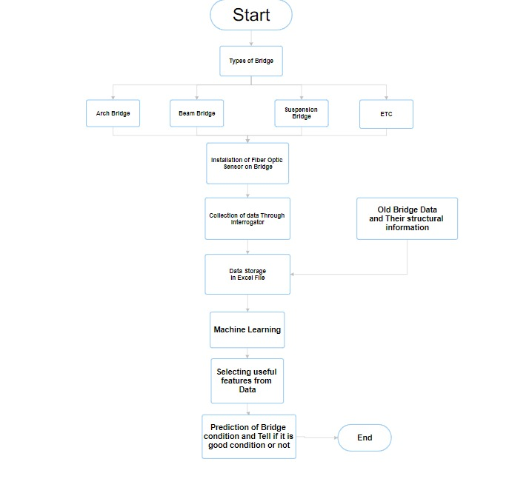

Figure 1. Flowchart of the Proposed System

**3.1. System Workflow Based on the Flowchart**

1. Identification of Bridge Types:
   * The system categorizes bridges into types such as Arch Bridge, Beam Bridge, Suspension Bridge, and others (ETC).
   * This classification helps in tailoring the analysis based on structural variations.
2. Data Collection Through Google API:
   * The API collects real-time data and transfers it for further processing.
   * The data includes structural changes, environmental factors, and location.
3. Data Storage and Integration:
   * The collected data is stored in a database for analysis.
   * Historical bridge data and structural information are also integrated to enhance the robustness of the analysis.
4. Feature Selection Using Machine Learning:
   * Machine learning algorithms analyse the data to select significant features that impact bridge stability and performance.
   * This step ensures that only the most relevant parameters are considered for prediction, reducing noise in the dataset.
5. Prediction of Bridge Condition:
   * The trained machine learning model predicts the bridge’s condition based on the selected features.
   * The system classifies bridges as either in "Collapsed" or "Standing" enabling timely intervention.

**3.2 Key Features of the Proposed System**

1. Machine Learning Models

* Advanced algorithms analyse patterns and trends in structural data.
* Predictive capabilities to forecast potential failures and recommend actions.

2. Integrated Data Analysis

* Combines real-time data with historical records for comprehensive insights.
* Enables cross-validation and enhances the reliability of predictions.

3. Real time monitoring

* Real time monitoring of client’s location for guidance along the right path.

4. Virtual testing of bridges

* Civil engineers or any person of interest can test the quality of bridges by putting in different bridge parameters.

**3.3 Advantages of the Proposed System**

* Real-Time Monitoring: Continuous data collection allows for immediate detection of issues.
* Scalability: The system can be scaled to accommodate bridges of different types and sizes.
* Cost-Effectiveness: Early detection of potential failures reduces repair costs and prevents catastrophic failures.
* User-Friendly Interface: Accessible through a web application, the system provides clear and actionable insights.

**3.4 Implementation Steps**

1. Data Pipeline Development:
   * Create a robust pipeline for collecting, storing, and preprocessing data.
   * Implement error-handling mechanisms to ensure data integrity.
2. Machine Learning Model Deployment:
   * Train and test models using historical and real-time data.
   * Optimize algorithms for high accuracy and low latency in predictions.
3. Web Application Integration:
   * Develop a user-friendly interface for stakeholders to view bridge statuses and reports.
   * Implement features like route planning and bridge status visualization.
4. Validation and Testing:
   * Conduct rigorous testing to ensure system reliability under various scenarios.
   * Validate predictions against ground truth data to evaluate model performance.

**CHAPTER 4**

**SOFTWARE REQUIREMENT ANALYSIS**

**4.1 Functional Requirements**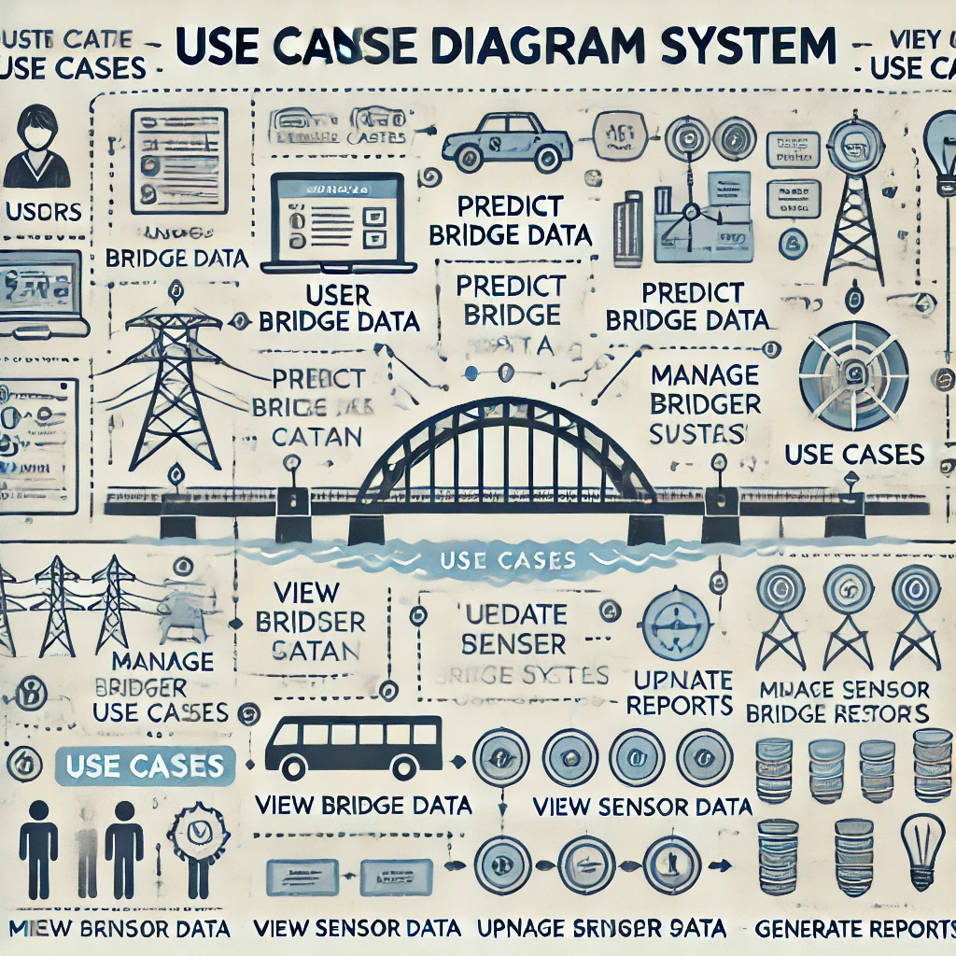

Figure 2. Case Diagram of the Sethusamarthya Project

**4.2 Nonfunctional Requirements**

1. Performance Requirements

* Real-Time Monitoring: The system must process and display sensor data in real time with a latency of less than 2 seconds.
* Accuracy: Prediction models must achieve at least 95% accuracy in anomaly detection and failure prediction.

2. Reliability Requirements

* Fault Tolerance: The system must remain operational despite the failure of up to 10% of sensors.
* Uptime: The system must have an availability of 99.9%, ensuring minimal downtime.
* Data Recovery: Backup mechanisms must ensure no data loss.

3. Usability Requirements

* User Interface: The dashboard must be intuitive, with role-based customizations for administrators, bridge authorities, and maintenance teams.
* Ease of Use: Users should be able to learn core functionalities within 2 hours of training.
* Multilingual Support: The system must support at least three languages to cater to diverse stakeholders.

4. Security Requirements

* Data Protection: All data must be encrypted during transmission and storage.
* Authentication: multi-factor authentication (MFA) for all users.
* Audit Logging: All user actions and system events must be logged and retained for a minimum of 1 year.

5. Maintainability Requirements

* Modular Design: The system should be designed with modular components to facilitate updates and replacements without affecting the entire system.
* Documentation: Comprehensive user and technical documentation must be provided to assist with maintenance and upgrades.
* Bug Resolution: Any reported bugs must be resolved within 72 hours.

6. Scalability Requirements

* The architecture must support horizontal scaling to accommodate an increasing number of data and bridges.
* Cloud resources must dynamically adjust based on workload to optimize cost and performance.

8. Legal and Compliance Requirements

* The system must comply with data privacy regulations.
* The project must adhere to ethical AI guidelines to ensure fair and unbiased predictions.

9. Interoperability Requirements

* System Integration: The system must integrate with existing infrastructure monitoring tools and third-party APIs for seamless data sharing.
* Standardization: Data formats and protocols must align with international standards for SHM systems.

**4.3 Major modules and their functionalities**

1. Data Acquisition Module

* Functionality: Collects data from Google APIs. This module captures real-time information on structural parameters like stress, strain, vibration, and displacement.

2. Data Processing and Analysis Module

* Functionality: Processes the raw data collected from API to extract meaningful insights. It may include algorithms for signal processing, noise reduction, and feature extraction. Advanced analytics can identify patterns, anomalies, and potential issues in the bridge's structure.

3. Structural Health Monitoring (SHM) Module

* Functionality: Evaluates the overall health of the bridge by comparing current data with baseline measurements. It assesses parameters like load-bearing capacity, fatigue, and potential damage. This module helps in predicting the remaining service life of the bridge and can be used for scheduling maintenance activities.

4. Visualization and Reporting Module

* Functionality: Presents the analysed data through user-friendly interfaces, such as dashboards and graphical representations. It generates reports highlighting critical findings, trends, and recommendations for maintenance or repairs. This module aids stakeholders in making informed decisions regarding the bridge's upkeep.

5. Alert and Notification Module

* Functionality: Monitors real-time data and triggers alerts when predefined thresholds are exceeded, indicating potential structural issues. Notifications can be sent to maintenance teams or engineers via email, SMS, or other communication channels, enabling prompt response to emerging problems.

6. Integration and Communication Module

* Functionality: Ensures seamless communication between the analyser system and other infrastructure management platforms. It supports data exchange protocols and standards, facilitating integration with existing asset management systems and databases.

**CHAPTER 5**

**SYSTEM ANALYSIS & DESIGN**

**5.1 Sequence diagram**

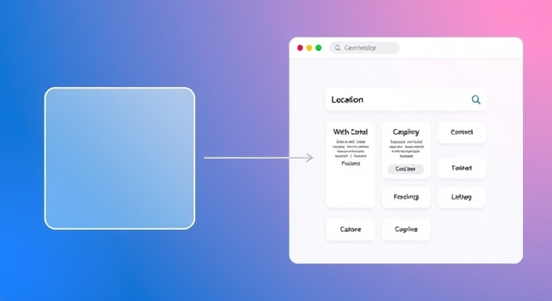

USERS

Figure 3. Sequence diagram showing the user’s interaction with the webpage; user entering the bridge parameters to predict the quality of the bridge.

**5.2 Activity Diagram**

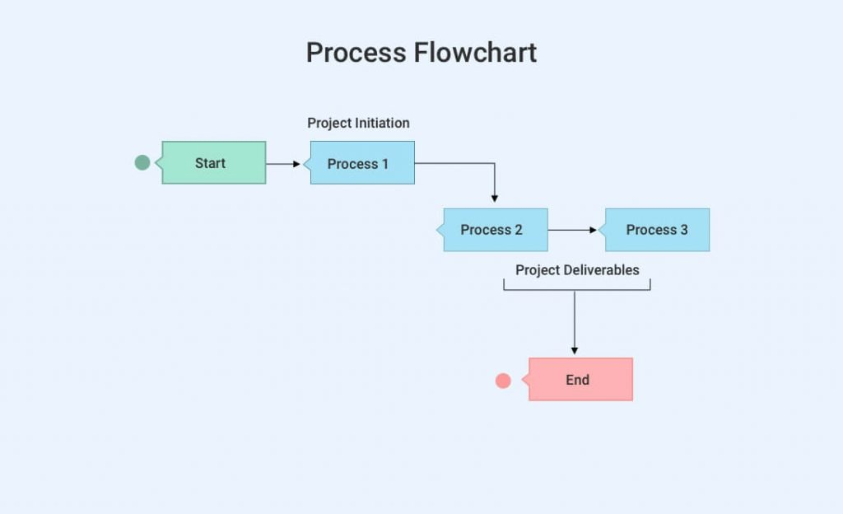

Figure 4. Activity diagram showing three processes. Process 1: project initiation where the user enters the bridge parameters like stress, strain etc. for prediction. Process 2: ML model in the background executes the user’s information using an ANN model to predict the quality of the bridge. Process 3: The result is displayed on the screen either “COLLAPSED” or “STANDING”.

**5.3 Gantt Chart**

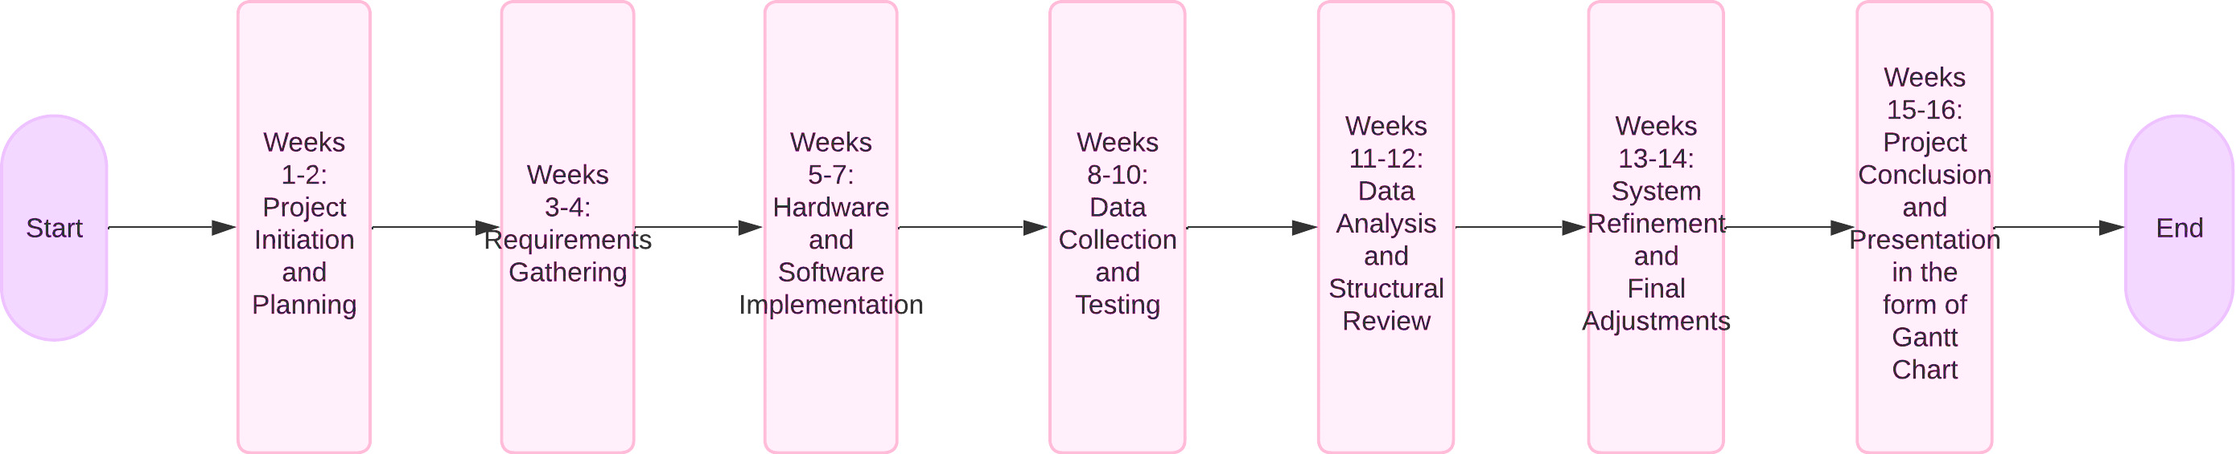

Figure 5. It is the image of the project development phases in the form of Gantt Chart

**CHAPTER 6**

**IMPLEMENTATION/CORE MODULE**

**6.1 Tables used**

Table 1. Various Bridge Parameters

| **Field Name** | **Data Type** | **Description** |
| --- | --- | --- |
| Material | String | Type of material used in bridge construction |
| Weather Conditions | String | Current weather conditions affecting the bridge |
| Construction Quality | String | Quality rating of the construction |
| Bridge Design | String | Design specifications of the bridge |
| Length (m) | Float | Length of the bridge in meters |
| Age (years) | Integer | Age of the bridge in years |
| Traffic Volume (vehicles/day) | Integer | Average daily traffic volume in vehicles |
| Width (m) | Float | Width of the bridge in meters |
| Height (m) | Float | Height of the bridge in meters |
| Water_Flow_Rate (m³/s) | Float | Flow rate of water around the bridge in cubic meters per second |
| Stress (MPa) | Float | Stress experienced by the bridge in megapascals |
| Strain (%) | Float | Strain percentage experienced by the bridge |
| Tensile Strength (MPa) | Float | Tensile strength of the material in megapascals |
| Rainfall (mm) | Float | Amount of rainfall in millimetres |
| Temperature (°C) | Float | Ambient temperature in degrees Celsius |
| Humidity (%) | Float | Relative humidity percentage |

Table 2. User Location data

| **Field Name** | **Data Type** | **Description** |
| --- | --- | --- |
| Bridge ID | Integer | Unique identifier for each bridge |
| Latitude | Float | Geographical latitude of the bridge |
| Longitude | Float | Geographical longitude of the bridge |
| Status | String | Current status of the bridge ("Standing" or "Collapsed") |

These tables are essential for predicting the structural integrity of bridges and enabling users to check their statuses on a map interface. The project employs various libraries for data handling, model training, and web application development.

**6.2 Used Algorithms/Approaches for Projects**

1. Artificial Neural Networks (ANN) for Prediction

Purpose: The primary algorithm used in this project is an Artificial Neural Network (ANN), implemented to predict the status of a bridge (“Collapsed” or “Standing”) based on a variety of input features.

Key Features:

* Input Features:
  + Material
  + Weather Conditions
  + Construction Quality
  + Bridge Design
  + Length (m)
  + Age (years)
  + Traffic Volume (vehicles/day)
  + Width (m)
  + Height (m)
  + Water Flow Rate (m³/s)
  + Stress (MPa)
  + Strain (%)
  + Tensile Strength (MPa)
  + Rainfall (mm)
  + Temperature (°C)
  + Humidity (%)
* Architecture:
  + Input Layer: Handles all 16 input features.
  + Hidden Layers: Built using fully connected layers (Dense layers) to process and learn complex relationships in the data, with ReLU activation function for the input and hidden layers.
  + Output Layer: Outputs the probability of bridge collapse. If collapse probability > 0.5, the status is classified as “Collapsed”; otherwise, “Standing.” The output layer uses the sigmoid activation function because there are only two possible outputs.
* Training Process:
  + Data is split into training and testing sets using the train_test_split function from sklearn.
  + Input data is standardized using StandardScaler for normalization, which scales the data to a standard range (zero mean, unit variance).
  + The ANN model is trained using a sequential approach in Karas, optimizing weights through backpropagation and using the binary cross-entropy loss function (suitable for binary classification tasks).
  + The optimizer used is ADAM, known for its efficiency in training deep learning models.
* Testing:
  + Test cases are created using a subset of the data that was separated during model training to validate model performance.

2. Geospatial Mapping

Purpose: This approach is used to display and assess bridge locations on a map and provide insights into their status during route planning.

Key Features:

* Database Integration:
  + A separate table contains bridge coordinates (latitude and longitude) along with their unique IDs and statuses.
* Functionalities:
  + The map interface dynamically checks the status of bridges in planned routes. If a “Collapsed” bridge is detected, appropriate actions are recommended.

3. Database and Data Handling

Purpose: Efficient storage and retrieval of data for prediction and mapping purposes.

Database Design:

* Tables:
  + Bridge Prediction Table: Stores all input features required for prediction.
  + Bridge Coordinates Table: Stores geospatial data such as bridge IDs, latitude, longitude, and status.
* Data Handling:
  + Data is loaded into Pandas DataFrames for preprocessing and analysis.
  + Real-time queries fetch data for both prediction and visualization modules.

4. Web Application Framework

Purpose: Provides a user-friendly interface for interaction with the prediction and mapping system.

Framework: Flask

* Features:
  + Home Page: Displays the prediction model output, allowing users to view the status of a selected bridge.
  + Map Page: Displays an interactive map showing bridge locations. Users can plan routes and check bridge statuses along the way.
* Backend:
  + Handles HTTP requests for prediction and mapping functionalities.
  + Loads the trained ANN model using the load_model function from Keras.

5. Test Cases

Purpose: Evaluate the model’s accuracy and robustness.

* Data Source:
  + Test data is extracted from the original dataset and set aside during model training.
* Evaluation Metrics:
  + Accuracy, precision, recall, and F1-score are likely used to assess performance.

6. Tools and Libraries

Python Libraries:

* Data Handling: NumPy, pandas
* Data Preprocessing: sklearn
* Model Building: Keras (for ANN)
* Web Framework: flask

Additional Integrations:

* Mapping Tools: Geospatial APIs or libraries may be used for visualizing bridge locations.
* Database: Likely relational (e.g., MySQL) for storing bridge-related data.

7. Summary of Workflow

1. Data Collection:
   * Gather bridge features and geospatial data.
2. Preprocessing:
   * Clean and standardize the data for ANN input using StandardScaler().
3. Model Training:
   * Train the ANN model using bridge data with ReLU in the input and hidden layers, sigmoid in the output layer, binary cross-entropy as the loss function, and ADAM as the optimizer.
4. Prediction:
   * Predict bridge status based on new or existing data.
5. Mapping:
   * Visualize bridge statuses and assess safety for planned routes.
6. Deployment:
   * Integrate the trained model into a Flask-based web application.

This integrated system ensures accurate predictions and user-friendly interactions, supporting effective bridge quality analysis and route planning.

**6.3 Implementation of Modules/Algorithms**

1. Artificial Neural Networks (ANN) for Prediction

Implementation Steps:

1. Data Preprocessing:
   * Use pandas to load the dataset containing bridge features such as material, weather conditions, length, etc.
   * Handle missing values and normalize data using StandardScaler from sklearn to scale features.
   * Split the dataset into training and test sets using train_test_split from sklearn.
2. Model Creation:
   * Import Sequential and Dense from Keras.
   * Create a Sequential ANN model with:
     + Input Layer: Match the number of input features (16 in total).
     + Hidden Layers: Add one or more fully connected (Dense) layers with activation functions like ReLU.
     + Output Layer: A single neuron with a sigmoid activation function for binary classification, since the model predicts one of two outputs (Collapsed or Standing).
3. Model Compilation:
   * Compile the model using binary_crossentropy as the loss function, ADAM as the optimizer, and accuracy as a metric.
4. Training the Model:
   * Train the ANN using the fit method with training data, a validation split, and appropriate batch size and epochs.
5. Model Evaluation and Saving:
   * Evaluate the model using the test dataset.
   * Save the trained model using model.save("bridge_model.h5") for deployment.
6. Prediction Logic:
   * Load the trained model using load_model.
   * Use the predict method to calculate collapse_probability and classify the bridge as “Collapsed” or “Standing” based on a threshold of 0.5.

2. Geospatial Mapping Module

Implementation Steps:

1. Database Setup:
   * Create a table to store bridge coordinates (latitude, longitude) along with bridge ID and status.
   * Populate the database with relevant data.
2. Integration with Mapping Tools:
   * Use a geospatial mapping library (e.g., folium) or an API (e.g., Google Maps API).
   * Retrieve bridge data from the database and visualize locations on the map.
3. Route Planning and Status Check:
   * Allow users to input source and destination.
   * Use geospatial calculations to identify bridges on the route.
   * Check the status of each bridge (from the database) and notify the user if a bridge is “Collapsed.”

3. Database Management

Implementation Steps:

1. Database Design:
   * Create two tables:
     + Prediction Table: Store input features for prediction.
     + Coordinates Table: Store bridge IDs, coordinates, and statuses.
2. Data Integration:
   * Use SQL queries or an ORM (e.g., SQLAlchemy) to interact with the database.
   * Ensure real-time data synchronization between modules.
3. Data Handling in Flask:
   * Use pandas to fetch and preprocess data from the database for predictions and mapping.

4. Web Application with Flask

Implementation Steps:

1. Setup Flask App:
   * Import Flask, render_template, and request modules.
   * Define routes for the home and map pages.
2. Home Page Implementation:
   * Create a form for users to input bridge features for prediction.
   * Pass input data to the ANN model and display the result.
3. Map Page Implementation:
   * Embed a map showing bridge locations and statuses.
   * Allow users to plan routes and visualize potential issues with bridges on the path.
4. Model Integration:
   * Load the ANN model during app initialization.
   * Process user inputs and generate predictions dynamically.
5. Frontend Design:
   * Use HTML, CSS, and JavaScript to build an interactive and user-friendly interface.
   * Include features like markers for bridge statuses and route highlights on the map.

5. Test Cases for ANN Prediction

Implementation Steps:

1. Data Preparation:
   * Use a separate subset of the original dataset as test data.
2. Testing Accuracy:
   * Evaluate the ANN model’s performance on test data using metrics like accuracy, precision, recall, and F1-score.
3. Edge Case Handling:
   * Test with extreme values for features like stress, strain, and traffic volume to ensure the model’s robustness.
4. Integration Testing:
   * Test the end-to-end functionality by integrating prediction and mapping modules in the web application.

6. Overall Workflow

1. User enters bridge data through the web interface.
2. Data is pre-processed and passed to the ANN for prediction, with normalization done using StandardScaler(), and ReLU in the input and hidden layers, Sigmoid in the output layer, binary_crossentropy as the loss function, and ADAM as the optimizer.
3. The system checks the database for the bridge’s location and status.
4. The user is notified about the prediction and visualized route.

This implementation ensures a seamless integration of machine learning, database management, and geospatial mapping for an effective bridge analysis system.

**CHAPTER 7**

**RESULTS / OUTPUTS & TESTING**

**7.1 User Interfaces and Output**

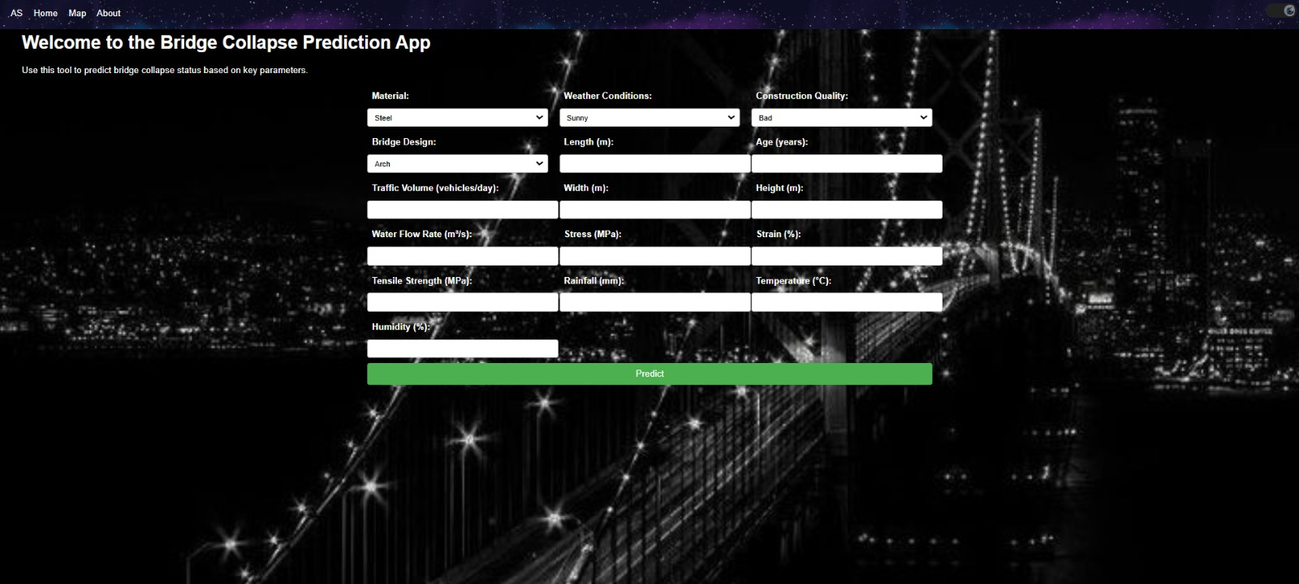

Figure 6. UI of the webpage of Sethusamarthya showing the bridge parameters

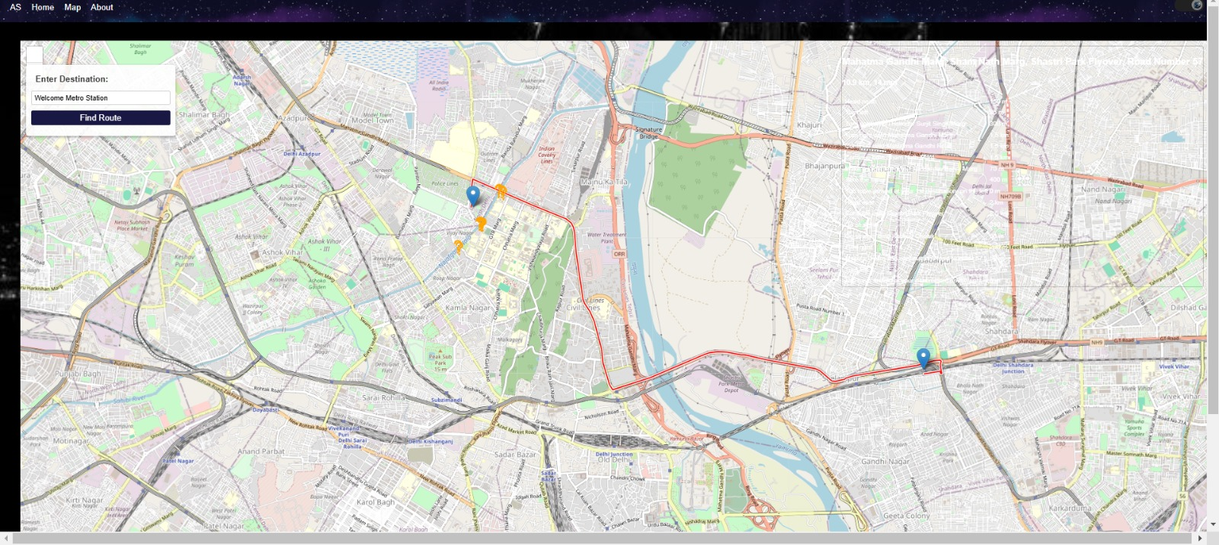

Figure 7. Image of the Geospatial Mapping feature for users

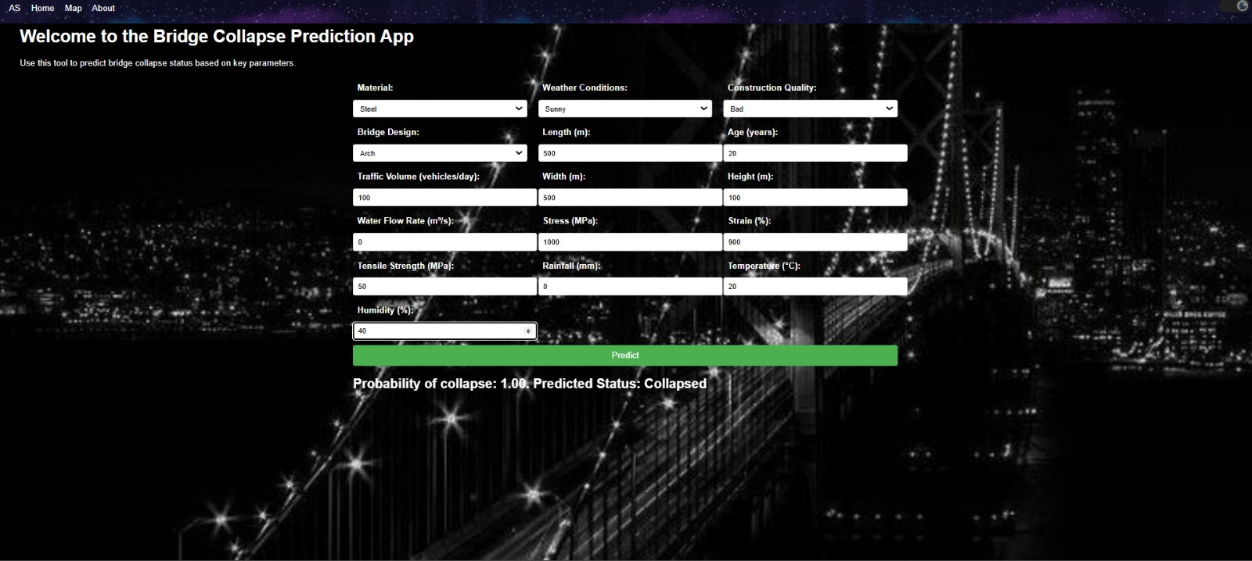

Figure 8. Image showing the output showing the prediction in the form of “Collapsed”.

**7.2 Layouts of webpages**

MAIN CONTENT AREA

HEADER

NAVIGATION BAR

USER INFORAMTION

MAP AREA

NAVIGATION BAR

Figure 9 & 10. First figure shows the bridge quality prediction webpage. Second image shows the geospatial mapping feature webpage

**7.3 Design and Test Steps**

7.3.1 Design Steps

1. Requirement Analysis:
   * Gather and analyse functional and non-functional requirements.
   * Identify bridge parameters to monitor (e.g., stress, strain, temperature).
2. System Architecture Design:
   * Define a layered architecture with components for bridge parameters, data collection, ML analysis, and user interface.
   * Identify necessary tools and technologies (e.g. ANN for predictions, Flask for web app).
3. Database Design:
   * Create an Entity-Relationship (E-R) diagram.
   * Define database tables:
     + BridgeDetails: Stores bridge metadata (ID, type, location).
     + Predictions: Stores ML predictions for bridge conditions.
4. Machine Learning Model Development:
   * Select suitable algorithms (e.g., ANN, Random Forest).
   * Collect training data (bridge parameters, bridge conditions).
   * Train, validate, and test the model using historical data.
5. User Interface Design:
   * Design input cells for data entry.
   * Develop output screens for displaying bridge status and ML predictions.
   * Include a geospatial map for visualizing bridge locations and conditions.
6. Integration of Components:
   * Integrate the database, ML model, and web interface.
   * Ensure smooth data flow between components.
7. System Deployment:
   * Host the web application on a server.
   * Deploy the ML model and integrate real-time data from API.

7.3.2 Test Steps

1. Unit Testing:
   * Purpose: Verify the functionality of individual modules.
   * Tests:
     + Test UI interactions (insert, update, delete).
     + Validate ML model outputs for sample inputs.
2. Integration Testing:
   * Purpose: Ensure smooth interaction between modules.
   * Tests:
     + Check database to ML model data flow.
     + Validate ML model predictions using database-stored data.
     + Test end-to-end data processing and result display.
3. System Testing:
   * Purpose: Validate the complete system against requirements.
   * Tests:
     + Simulate real-world scenarios with sensor inputs.
     + Verify bridge condition predictions and outputs on the web interface.
     + Test geospatial visualization of bridge conditions.
4. Performance Testing:
   * Purpose: Test system performance under load.
   * Criteria:
     + Respond within acceptable time limits for ML predictions
5. User Acceptance Testing (UAT):
   * Purpose: Validate the system with end-users (civil engineers, analysts, clients).
   * Criteria:
     + Check ease of use for the web interface.
     + Validate the accuracy of predictions against real data.

**7.4 Testing Process**

1. Unit Testing

* Goal: Test individual components for correct functionality.
* Steps:
  + Validate dropdown fields (e.g., Material, Bridge Design, Weather Conditions) for accurate input collection.
  + Test numeric fields (e.g., Length, Width, Stress) to ensure they accept valid ranges and reject invalid entries.
  + Verify the "Predict" button triggers the prediction algorithm correctly.
  + Confirm the displayed results match the expected output for given inputs.

2. Integration Testing

* Goal: Test the interaction between components (frontend, backend, ML model, database).
* Steps:
  + Verify that inputs entered on the web app are passed correctly to the backend.
  + Check if the ML model receives the input data and returns accurate predictions.
  + Ensure the predicted results are correctly displayed in the output field.
  + Validate that any error conditions (e.g., missing fields) generate appropriate warnings.

3. Functional Testing

* Goal: Verify that the application works as intended.
* Steps:
  + Enter valid input combinations and validate the predicted results (e.g., "Probability of Collapse: 1.00").
  + Test boundary cases, such as extreme values for stress, strain, or material properties.
  + Confirm that all required fields are mandatory and that incomplete forms trigger validation errors.

4. Performance Testing

* Goal: Assess the application’s performance under load.
* Steps:
  + Simulate multiple simultaneous users accessing the application.
  + Measure the response time for predictions under varying loads.
  + Validate the application’s ability to handle large datasets without crashes or delays.

5. User Interface Testing

* Goal: Ensure a smooth and user-friendly experience.
* Steps:
  + Test navigation between the "Home," "Map," and "About" pages.
  + Validate that the design elements (e.g., dropdowns, buttons) are responsive and accessible.
  + Confirm that the background image and text are clear and not overlapping.

6. Security Testing

* Goal: Ensure data security and prevent vulnerabilities.
* Steps:
  + Verify that sensitive user data is not exposed in the console or network logs.
  + Ensure that server communication is encrypted using HTTPS.

7. User Acceptance Testing (UAT)

* Goal: Validate the app with target users.
* Steps:
  + Engage bridge engineers to test the app’s usability and accuracy.
  + Collect feedback on predictions and improve the system if discrepancies are found.

8. Test Cases

Table 3. Various test case the needs to be considered before implementing the project

|  |  |  |  |
| --- | --- | --- | --- |
| Test Case ID | Scenario | Expected Output | Result |
| TC01 | Input all valid parameters | Probability and status displayed accurately | Pass/Fail |
| TC02 | Leave one required field empty | Display validation message ("Field cannot be empty") | Pass/Fail |
| TC03 | Enter invalid values (e.g., -10) | Display error message ("Enter valid input") | Pass/Fail |
| TC04 | Submit input with high traffic | Predictions displayed within 2 seconds | Pass/Fail |
| TC05 | Simulate multiple users accessing | System handles the load without crashing or slowing down | Pass/Fail |

7.4.1 Expected Outcomes

1. Accurate predictions for collapse probability based on inputs.
2. Validation errors displayed for invalid or incomplete inputs.
3. Smooth navigation and functionality under varying conditions.
4. Secured data handling to prevent vulnerabilities.
5. Real-time accurate prediction for the users.

**CHAPTER 8**

**Conclusions and Recommendations**

**8.1 Conclusions:**

1. Effective Bridge Quality Analysis:
   * The integration of Artificial Neural Networks (ANN) with geospatial mapping and database management provides a robust solution for bridge quality analysis.
   * The prediction module accurately classifies bridges as “Collapsed” or “Standing” based on critical structural and environmental factors.
2. Real-Time Monitoring and Decision Support:
   * The mapping module ensures real-time visualization of bridge statuses, aiding in route planning and infrastructure monitoring.
   * The system’s ability to dynamically fetch and process data enhances its utility for proactive decision-making.
3. Scalable and User-Friendly System:
   * The Flask-based web application ensures ease of use with intuitive interfaces for both prediction and mapping functionalities.
   * The modular design enables scalability, allowing additional features or models to be incorporated with minimal adjustments.
4. Testing and Performance:
   * Rigorous testing of the ANN model, including edge cases, demonstrates its reliability and robustness in handling diverse scenarios.

**8.2 Recommendations:**

1. Enhanced Data Collection:
   * Include additional features such as real-time sensor data (e.g., vibrations, temperature fluctuations) to improve the accuracy of predictions.
   * Incorporate historical maintenance records and inspection reports for a comprehensive analysis.
2. Advanced Visualization Tools:
   * Implement advanced geospatial visualization libraries or APIs to improve the mapping experience.
   * Enable 3D visualization of bridge structures to aid in better understanding of potential risks.
3. Integration with IoT Devices:
   * Integrate IoT sensors for real-time data acquisition to make the system more dynamic and responsive.
   * Use edge computing for processing critical data at the sensor level to reduce latency in predictions.
4. Model Optimization and Expansion:
   * Experiment with advanced machine learning models (e.g., Gradient Boosting, Transformer-based architectures) for better prediction accuracy.
   * Train models on larger datasets, incorporating global data for bridges in diverse environments.
5. Scalability for Large Networks:
   * Optimize database queries and data handling processes to ensure system performance with increasing data volumes.
   * Develop a mobile application for on-the-go access to bridge quality and status information.
6. Collaboration with Stakeholders:
   * Engage with government authorities and civil engineers to validate model predictions and improve data collection.
   * Use the system for policymaking and prioritization of bridge maintenance and reconstruction projects.
7. Periodic Model Retraining:
   * Continuously update the ANN model with new data to ensure its relevance and accuracy over time.
   * Establish a feedback mechanism where user inputs and real-world outcomes help refine the model.

**CHAPTER 9**

**References**

1. **Artificial Intelligence in Structural Health Management of existing bridges**   
   This article discusses the application of artificial intelligence in monitoring the structural health of infrastructure to enhance maintenance and safety protocols.  
   [Artificial intelligence in structural health management of existing bridges - ScienceDirect](https://www.sciencedirect.com/science/article/abs/pii/S0926580524004552)
2. **Structural Health Monitoring Using Machine Learning and Cumulative Absolute Velocity Features**  
   The paper examines how machine learning techniques can be integrated into structural health monitoring systems to improve accuracy and efficiency.  
   [Structural Health Monitoring Using Machine Learning and Cumulative Absolute Velocity Features](https://www.mdpi.com/2076-3417/11/12/5727)
3. **What is Structural Health Monitoring in Civil Engineering?**  
   This resource provides an overview of structural health monitoring in civil engineering, outlining its significance and methodologies.  
   <https://theconstructor.org/digital-construction/structural-health-monitoring-civil-engineering/554160/>
4. **GeeksForGeeks - Machine Learning**  
   A comprehensive guide on machine learning concepts, algorithms, and applications, serving as a foundational resource for understanding machine learning principles.  
   <https://www.geeksforgeeks.org/machine-learning/>
5. **Python Flask Documentation**  
   Official documentation for Flask, a micro web framework for Python, detailing its features and usage for developing web applications.  
   <https://flask.palletsprojects.com/en/stable/>
6. **Predictive Maintenance and Structural Health Monitoring via IoT System**  
   This research paper explores the integration of Internet of Things (IoT) technologies in predictive maintenance and structural health monitoring systems.  
   [Predictive maintenance and Structural Health Monitoring via IoT system | IEEE Conference Publication | IEEE Xplore](https://ieeexplore.ieee.org/document/9905441)

**CHAPTER 10**

**APPENDIX**

**10..1 Details of technologies used**

10.1.1 Software and Libraries Used

1. Python: The primary programming language utilized for developing the predictive model and web application.
2. Libraries:
   * NumPy: Used for numerical computations and handling arrays.
   * Pandas: Employed for data manipulation and analysis, particularly for managing datasets.
   * scikit-learn: A machine learning library that provides tools for model training and evaluation.
     + train_test_split: For splitting the dataset into training and testing subsets.
     + StandardScaler: For standardizing features by removing the mean and scaling to unit variance.
   * Keras: A high-level neural networks API, used here for building and training the artificial neural network (ANN).
     + Sequential: To create a linear stack of layers for the ANN.
     + Dense: To add fully connected layers to the network.
   * Flask: A web framework for creating web applications, used to serve the prediction model and display results.
3. Data Sources:
   * The project utilizes a bridge database containing various attributes relevant to bridge prediction, such as:
     + Material
     + Weather Conditions
     + Construction Quality
     + Bridge Design
     + Length (m)
     + Age (years)
     + Traffic Volume (vehicles/day)
     + Width (m)
     + Height (m)
     + Water Flow Rate (m³/s)
     + Stress (MPa)
     + Strain (%)
     + Tensile Strength (MPa)
     + Rainfall (mm)
     + Temperature (°C)
     + Humidity (%)
4. Output Features:
   * The application includes a home page with prediction capabilities and a map page that displays bridge locations. It checks the status of bridges along a specified route based on predictive analytics.
5. Model Training Criteria:
   * The predictive model classifies bridges as "Collapsed" if the collapse probability exceeds 0.5; otherwise, they are classified as "Standing".

**10.2 Steps to execute/run/implement the project**

10.2.1 Step-by-Step Execution

1. Set Up Environment

- Install Python if not already installed.

- Create a virtual environment for the project

2. Install Required Libraries

- Install necessary libraries using pip:

-> Keras, NumPy, flask, scikit-learn

3. Prepare the Dataset

- Ensure you have the bridge database ready, which includes:

- A table with attributes such as Material, Weather Conditions, Construction Quality, etc.

- A table with bridge coordinates (bridge ID, latitude, longitude, status).

- Load the dataset into your Python environment using Pandas

4. Data Preprocessing

- Clean and preprocess the data

- Handle missing values.

- Encode categorical variables if necessary.

- Split the data into features and target variable

5. Train-Test Split

- Divide the dataset into training and testing sets

6. Feature Scaling

- Standardize the feature values

7. Build the Neural Network Model

- Create and compile the ANN model using Keras

8. Train the Model

- Fit the model to the training data

9. Evaluate the Model

- Assess the model's performance on the test set

10. Save the Model

- Save your trained model for future use

11. Create a Flask Web Application

- Set up a Flask app to serve predictions

12. Run Your Application

- Start the Flask application

By following these steps systematically, you will be able to implement and run your bridge prediction project effectively.

**10.3 Coding Snippets**

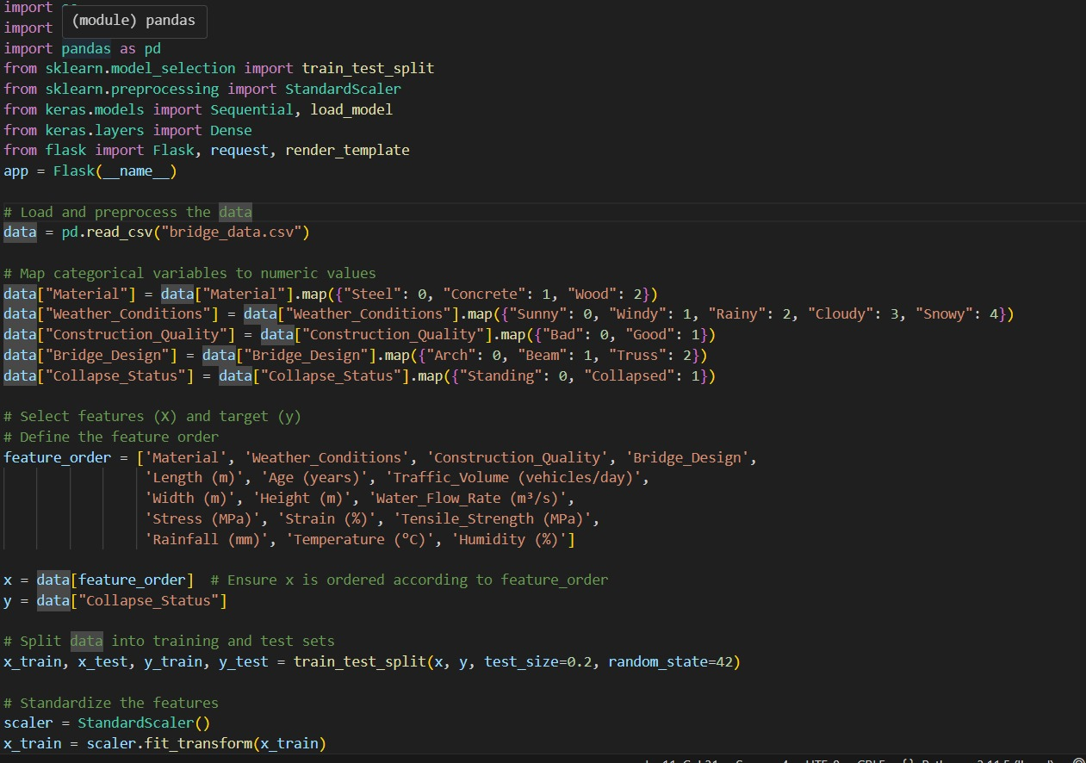

Figure 11. Code snippet of ML model implementation

Figure12. Code snippet of data preprocessing implementation

