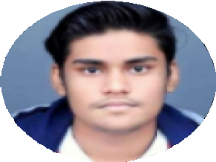

# GET IN TOUCH!

Mobile:

+91-9140945385

Email:

[18BCS2265@cuchd.in](mailto:18BCS2265@cuchd.in)

# SKILLS

* **Python**
* **HTML**
* **CSS**
* **Android**
* **XML**
* **Java**

- C++

# CERTIFICATIONS

* **C Programming**
* **Python Programming**
* **Android Development**
* **Data Structures**
* **Java Programming**

# LANGUAGES KNOWN

English and Hindi

INTERPERSONAL SKILLS

-Teamwork

-Active Listening

Divyansh Sachan

# EDUCATION

## Graduation

Course BE / B.Tech ( Computer Science )

College Chandigarh University, Mohali Year of Passing Graduating In Jul 2022

Score 7.91/10

## Schooling Class XII ClassX

Board Name CBSE CBSE

Medium English English

Year of Passing 2017 2015

Score 89.2% 95%

# PROJECTS

## Python based virtual assistant | 8 Week(s)

* **The Project is a python based virtual voice assistant that uses vast libraries to assist the user in day-to- day tasks such as web search, sending an email, etc.**

## Shopping Website | 4 Week(s)

* **Shopping Cart System is a simple shopping solution. It is a full featured website and shopping cart system that gives you the flexibility you need to run your online store.**

# PERSONAL DETAILS

Current Location Lucknow HomeTown Lucknow

Date of birth November 19, 1999

Gender Male

Looking for a Full Time Job Can start working Immediately

Preferred location Hyderabad / Secunderabad, Ahmedabad, Bengaluru / Bangalore, Anywhere in India, Chandigarh