**Objective Questions**

**What is the total no. of tables present in the data?**

Ans. 28028

**What is the total no. of attributes present in the data?**

Ans. 35

**What is the change in daily call volume day by day and also find the average daily call volume.**

Ans.

|  |  |  |  |
| --- | --- | --- | --- |
| consultationType | Call |  |  |
|  |  |  |  |
| **Row Labels** | **Count of CallSid** |  | **Change in calls volume** |
| 01-Jan | 115 | 115 | 81 |
| 02-Jan | 196 | 196 | -89 |
| 03-Jan | 107 | 107 | 265 |
| 01-Dec | 372 | 372 | -39 |
| 02-Dec | 333 | 333 | 50 |
| 03-Dec | 383 | 383 | -19 |
| 04-Dec | 364 | 364 | -111 |
| 05-Dec | 253 | 253 | 1 |
| 06-Dec | 254 | 254 | 0 |
| 07-Dec | 254 | 254 | -116 |
| 08-Dec | 138 | 138 | 150 |
| 09-Dec | 288 | 288 | 142 |
| 10-Dec | 430 | 430 | -6 |
| 11-Dec | 424 | 424 | -66 |
| 12-Dec | 358 | 358 | -10 |
| 13-Dec | 348 | 348 | -122 |
| 14-Dec | 226 | 226 | 50 |
| 15-Dec | 276 | 276 | -18 |
| 16-Dec | 258 | 258 | -73 |
| 17-Dec | 185 | 185 | 48 |
| 18-Dec | 233 | 233 | -24 |
| 19-Dec | 209 | 209 | -31 |
| 20-Dec | 178 | 178 | -19 |
| 21-Dec | 159 | 159 | 4 |
| 22-Dec | 163 | 163 | 78 |
| 23-Dec | 241 | 241 | -9 |
| 24-Dec | 232 | 232 | 26 |
| 25-Dec | 258 | 258 | -3 |
| 26-Dec | 255 | 255 | -13 |
| 27-Dec | 242 | 242 | -61 |
| 28-Dec | 181 | 181 | 77 |
| 29-Dec | 258 | 258 | -79 |
| 30-Dec | 179 | 179 | -21 |
| 31-Dec | 158 | 158 | -158 |
| **Grand Total** | **8508** |  |  |

|  |
| --- |
| **Average** |
| **250.2353** |

**Which months experienced the highest and lowest call volumes?**

Ans. Highest – December

Lowest – January

**What is total operational cost for that month?**

Ans.

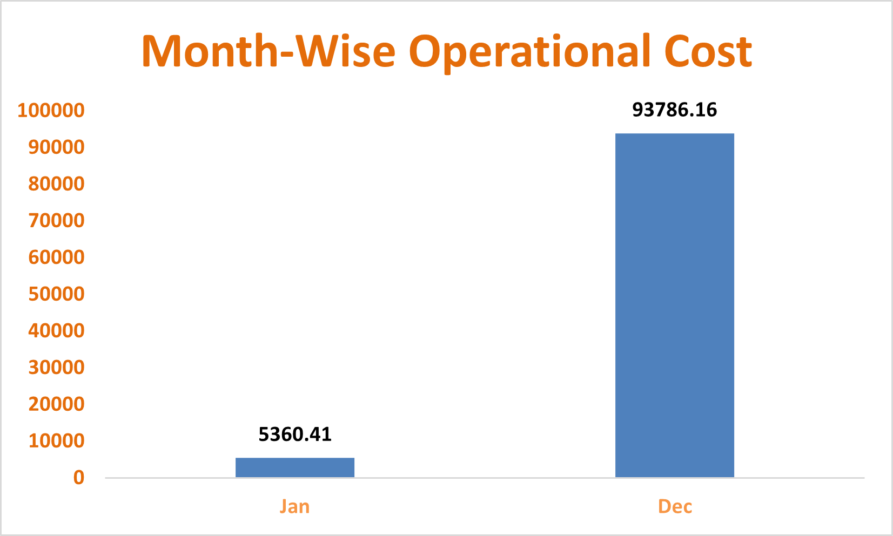

**What is the average number of calls handled per agent per day?**

Ans. 2 (Rounding off)

|  |  |  |  |
| --- | --- | --- | --- |
| **Total Astrologers** | **Total Calls** | **Calls to Astrologer** | **Calls Per astrologer per day** |
| **149** | **8508** | **57.10067114** | **1.68** |

**How many repeat callers are there, and what percentage of total calls do they represent?**

Ans. 6156 Repeat callers are there that cover 72.36% of total calls.

**What are the total sales generated by the call centre for each product category?**

|  |  |
| --- | --- |
| Call | 168520.62 |
| Chat | 45494.68 |
| Complementary | 0.00 |
| public_live_Call | 50.60 |

Ans.

**How many calls were made for each user ID and guru ID?**

Ans. 8508

**What is the correlation between call duration and customer satisfaction?**

Ans. 0.055

**Which guru has the highest and lowest customer satisfaction scores?**

Ans.

|  |  |  |  |
| --- | --- | --- | --- |
| **Minimum** | | **Maximum** | |
| **Tarot Rittika** | **0.00** | **Astro Pujaa Rai** | **7.50** |
|  |  | **Tarot Mystical** | **7.50** |

|  |  |
| --- | --- |
| Jan | 2.68 |
| Dec | 2.95 |

**What is average customer satisfaction score by month?**

Ans.

**How many categorical columns are there in the data?**

Ans. 15

**Subjective Question:**

**Should the investment be used to hire more agents, improve training programs, or upgrade call center technology?**

As per the dataset presented Astrosage is an astrology based consultation call center. Therefore all the above mentioned points are equally important for the growth of organization but the most sustinable and significant option is going to be upgrading call center technology.



The above table shows the count of astrologers as per the total calls. Here for astrologer count we have used the COUNTA function along with the unique function. And total calls to get a ratio of calls per astrologer. As per the above data it is quite visible that hiring is not a very necessary need for the call center.

The Below Area chart shows the average rating of different Astrologers as per the given dataset which provides an important insight that the ratings vary with a very variable disturbance which implies a need of effective training to improve the quality of consultation resulting in improved ratings.

The above Pie chart shows the call status distribution as per the chart there is a need for the technological update to increase the completed calls rate. Hence there is a need for a Technological update to increase the customer satisfaction.

**What are the potential risks of each investment option (hiring, training, technology upgrades), and how can they be mitigated?**

**Hiring –:**

Hiring new astrologers is one of the most difficult tasks of the all because it is a long term process. The recruitment team needs to take care of the fact that the candidate is worthy enough for the role . A proper training guide is needed for the person and if the candidate backs out last moment then all the resources are wasted and they need to start from ground zero. Moreover using the Pivot tables and visualization functionality in spreadsheets it is quite visible that there are enough consultants to manage the call.

**Mitigation-:**

The problem can be mitigated with the referral bonuses to the outperforming consultants to hire new consultants that will not only help in hiring but also increasing the quality of the consultants in call center.

**Training –:**

Training the employees for a better a consultation and customer satisfaction is very important to improve the customer satisfaction. But there some potential risks as well because implementing a new training suite will involve availability of all the consultants at once as well as new training suite will require new strategies. This can be a heavy investment and tedious for the organization.

**Mitigation-:**

The problem can be mitigated with a very limited investment by organizing guest workshops and rewarding programs to the best rated consultation of the week and sharing of the recording of that particular consultation among the Astrologers.

**Technological update**

Technological updates are one of the most important updates for the effective and continuous customer satisfaction as it is the most crucial factor for good user experience.

It also involves some risks i.e. an lot of investment , a technical support staff , risk of technical failures and most importantly compatibility of astrologers with new technical updates.

**Mitigation-:**

The problem can be mitigated with the new CRM for better customer support and satisfaction. And including a new workforce environment can help in easier and better compatibility with the technology.

**How does AstroSage's call center performance compare to AstroGuru's average call volume, customer satisfaction, and agent performance?**

**Will you use any aggregation function or a visualization here to solve the problem?**

Ans.

For comparison of **AstroSage** and **AstroGuru** we don’t have any dataset of AstroGuru . Hypothetically if it was available we can easily perform the analysis by

1. Using pivot tables, we can find the total calls and average calls and compare.
2. We can make a pivot chart for user wise rating and astrologer wise rating compare it for both the call centres.
3. For agent performance we can make a bar chart of calls handled vs Astrologer Name.

Also, can make a Pivot Chart for Top performers of Both the call centres and compare them.

**How can the call centre improve its handling of peak call periods to ensure high customer satisfaction?**

**Mention the functionality you will use for giving the suggestions, will it be any aggregated function or a visualization?**

As visible from the above chart we have a very variable flow of peak hours so the company can communicate with consultants and make an effective workflow by monitoring the availability of them and make batches, for different hours of the day and allow the customer to choose among the available one's. Moreover, restrict each consultant on defined number of sessions only.

Here we can clearly see from the graph where vertical axis represents the peak hours and horizontal axis represents the total calls.

**Based on historical data, what strategic initiatives should be prioritized to improve efficiency and customer satisfaction?**

Ans.

|  |  |
| --- | --- |
| **Row Labels** | **Average of rating** |
| Call | 3.5 |
| Chat | 2.7 |
| Complementary | 4.5 |
| public_live_Call | 3.0 |
| **Grand Total** | **2.9** |

Based on the above visualisation i.e.

1. Call status Distribution
2. Consultation Wise Ratings
3. Peak hours as per calls received

The call centre can adopt following strategies

**Optimizing operational Efficiency** -: The call centre can focus on allocating uniform number of calls to all the astrologers on a daily basis. They can do batching of a particular number of consultants and let the customer choose the consultant through a pre booking and remove them as soon as they get selected for a threshold value (Like 10 calls a day). As per the availability of consultants.

**Improving Customer satisfaction -:**

1. Technological update is a must to increase the quality of consultation so that the call completion ratio could be increased at least up to 60% which is currently at 23%. For a good customer review properly consulting and completing the call is very important. The call centre can optimize the Dashboard as well as the App for better user experience more customer retention. Moreover, it’s important to have a backup consultant in case the assigned consultant cannot continue with call. Also, the organization should provide a free/discounted session if it gets cancelled or the consultant is not available.
2. They should focus on streamlining the chat process through chatbots for general queries based on the past records also AI can be used as well for better and fast customer service.
3. CRM software must be used to assign a consultant to customer for all the queries giving a familiar experience just as happens with a patient having a constant Family doctor. This will help as the Consultant would be having all details of customer from mentality to Behaviour. This will result in complete resolution of queries from customer.

**What can be the key factors contributing to high customer satisfaction scores, and how can these be leveraged to improve overall performance?**

**What is the basis for the suggestions? And mention how you decided if the satisfaction score affects the ratings.**

Ans.

|  |  |
| --- | --- |
| **Row Labels** | **Average of rating** |
| Call | 3.5 |
| Chat | 2.7 |
| Complementary | 4.5 |
| public_live_Call | 3.0 |
| **Grand Total** | **2.9** |

|  |  |
| --- | --- |
| consultationType | (All) |
|  |  |
| **Row Labels** | **Average of astrologerOnCallDuration** |
| 0 | 0.0 |
| 1 | 0.0 |
| 2 | 64.1 |
| 3 | 58.6 |
| 4 | 124.3 |
| 5 | 127.4 |
| 6 | 0.0 |
| 7 | 0.0 |
| 8 | 0.0 |

|  |  |
| --- | --- |
| **Row Labels** | **Average of userOnCallDuration** |
| 0 | 0.0 |
| 1 | 0.0 |
| 2 | 59.2 |
| 3 | 53.8 |
| 4 | 114.9 |
| 5 | 117.7 |
| 6 | 0.0 |
| 7 | 0.0 |
| 8 | 0.0 |

The consultation type, Astrologer on call duration are the key factors for customer satisfaction. As we can see from above pivot tables the chat customers are more satisfied, whereas call customers with a higher call duration have provided higher rating. So the call centre should focus on complete customer query resolution, if general then through chat otherwise a detailed call session it could result even better it is a video session that could be pre booked.

**How should the call centre balance the workload among agents to ensure optimal performance and avoid burnout?**

**Mention your approach and spreadsheet function for the answer.**

The call centre must try and use all the consultants equally to manage the workload by assigning them equal number of calls by assigning calls to them as per the availability, moreover they can also focus on pre-booking model and use effective UI to give users an option to select the consultants to provide better user experience, equalising workload by removing the consultant as soon as they are chosen for a threshold count of bookings.

As shown in the below chart there is an uneven distribution of calls among the consultants.

The Top 10 consultants cover 44% of total calls.

**What new technologies or tools could be implemented to enhance call center operations and customer service?**

* Introduction to chatbots and Virtual assistants for regular queries can help in saving the consultants energy for complex queries and consultations.
* Use of AI for personalization based on some insights of customer for better user experience can result in repeat orders/consultations.
* Maintaining a CRM software about past consultations and customer details can help in future consultations and targeting old customers.
* Feedback mechanism should be adopted to make the customers happy and improve the quality.
* Personalized pre booked video sessions with consultants can help in the repeat customers as the interaction helps in understanding the customer behaviour.
* Developing apps with different notifications and games such as puzzles and making the customers learn about the birth charts and planets can attract new customers.

**What metrics should be included in the final dashboard to comprehensively view call center performance and guide investment decisions?**

1. website distribution

2. Revenue generated by category type

3. Call distribution over hrs

4. Day by day call volume

5. Call status distribution

6. Chat status distribution

7. Rating wise guru distribution

8. Rating wise customer distribution

9. Top 10 guru by Rating

**How would you allocate a 1 crore rupee investment to optimize operational efficiency, enhance customer satisfaction, and boost profitability, and what analysis-based recommendations would you offer to support this?**

**[you have to give bullet pointers to answer this question]**

Ans.

* Astro-sage should focus upon Technological upgrades to bring customers to the app and dashboard more frequently and decrease the cancelled and failed consultations to improve the profitability.

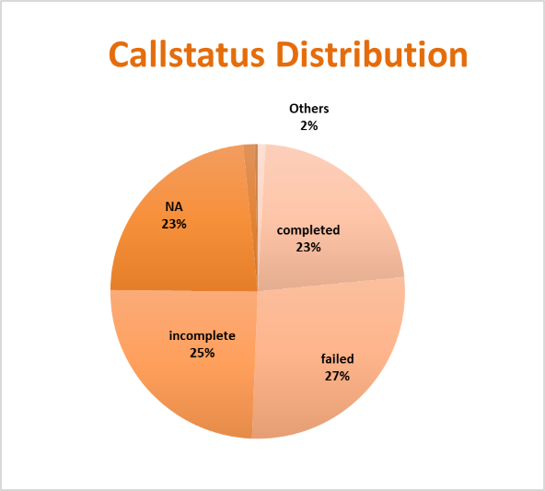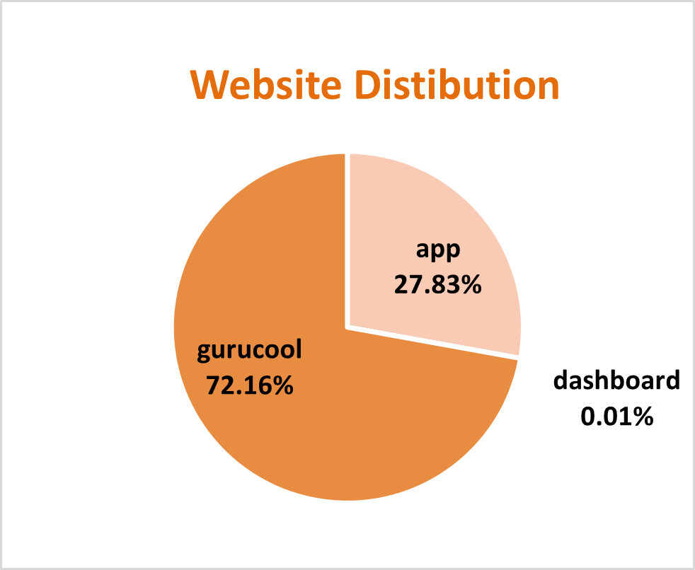

* Astro-sage should focus on call consultations to increase the revenue and installs some chatbots and virtual assistant for general chat process instead of consultants to have them available for the peak hours to reduce the operational cost.

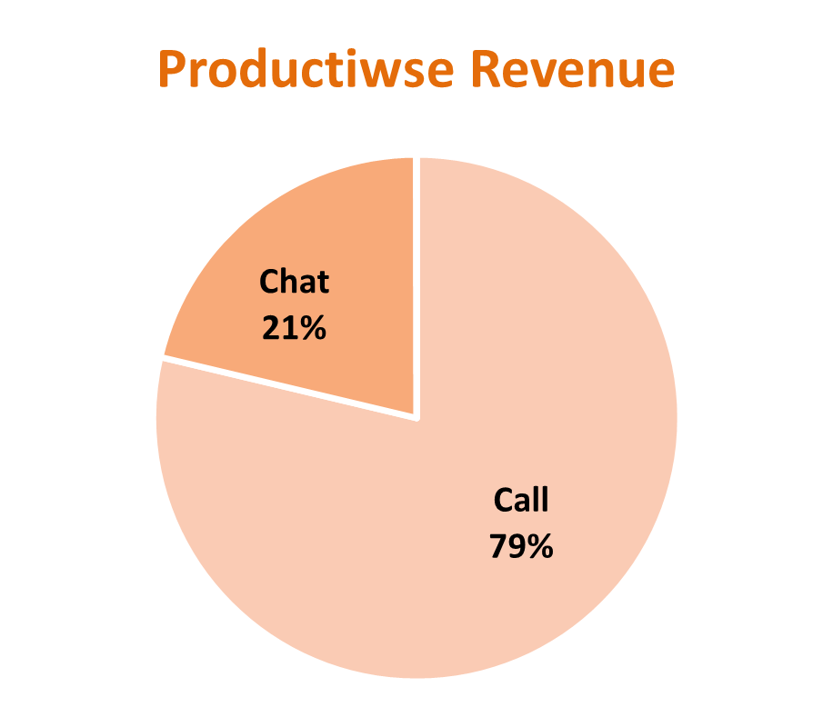

* Astro sage should focus upon the pre-booking model and include CRM Software to assign a particular client to a particular customer to increase customer satisfaction and reduce time lapse and repetitive procedure of intro sessions.
* Finally, Astro- sage must allow a customer to choose a consultant and take feedbacks of the session. And weekly distribute the most rated and most appreciated astrologer’s session recording to others and organize regular training to stay up to date and keep all the consultants on the same level , to maintain the quality and consistency of the session.

