# **Smart Health Portal — Project Documentation**

## **1. Introduction**

The **Smart Health Portal** is a web-based platform designed to help patients **book doctor appointments, manage medical records, and stay connected with healthcare providers**.  
 It addresses common challenges in healthcare, such as long waiting times, scattered patient data, and complex communication processes, making healthcare **more accessible, organized, and efficient**.

## **2. Problem Identification**

Patients, doctors, and hospital staff face several challenges:

* Long queues and delays at hospitals.
* Difficulty in finding the right doctor for specific health issues.
* Medical records are scattered, incomplete, or hard to manage.
* Online health information is often unreliable.

**Goal:** Build a single **smart platform** where patients, doctors, and hospital staff can interact seamlessly, improving healthcare accessibility and efficiency.

## **3. Project Phases**

### **Phase 1 — Problem Understanding & Industry Analysis**

* Collected requirements from **patients, doctors, and hospital administrators**.
* Performed **stakeholder analysis**: Patients, Doctors, Receptionists, Admins.
* Mapped the **healthcare workflow**: Appointment booking → Doctor assignment → Consultation → Billing → Medical Reports.
* Researched healthcare use cases: patient history management, appointment scheduling, billing.
* Explored Salesforce Health Cloud but chose a **custom solution** to fit the hospital’s specific needs.

### **Phase 2 — Org Setup & Configuration**

* Created **Salesforce Developer Org** for the project.  
  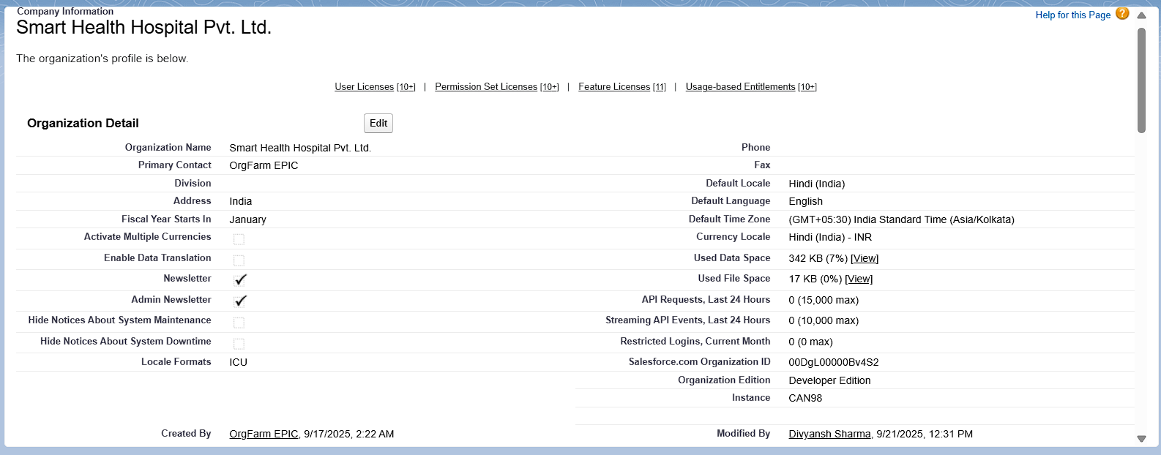
* Configured **company profile**: hospital name, time zone, currency.
* Defined **business hours and holidays** for hospital operations.
* Created user accounts for **Doctors, Receptionists, and Admins**.  
  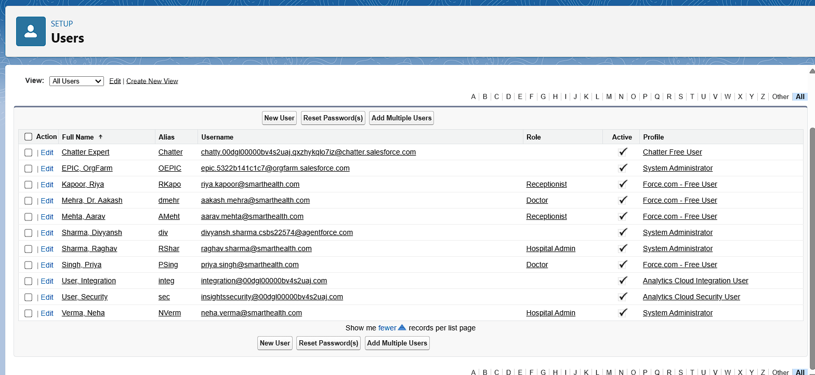
* Assigned **profiles & roles**:  
  + Receptionists → Limited access
  + Doctors → Moderate access
  + Admin → Full control
* Set **Org-Wide Defaults (OWD)** to protect patient data while sharing appointments with assigned doctors.  
    
    
  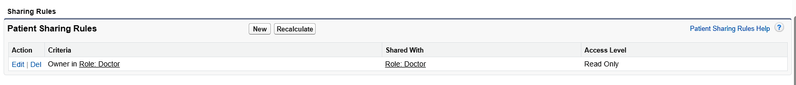  
    
    
    
    
    
    
  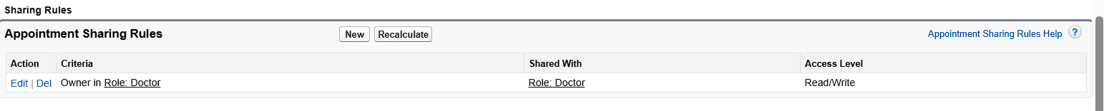
* Used **Sandbox** for testing and prepared deployment strategy via **Change Sets / VS Code (SFDX)**.