**Week 1: Jira as a project management tool**

**Aim:**

**Explore the Jira as a project management tool for the agile Development. Execute following Activity in Jira Tool.**

**1) Free Trial Setup**

**2) Create an Epic**

**3) Create an Issue**

**4) Create Story**

**5) Create Subtask**

**6) Create Sprint**

**Theory :**

JIRA is a versatile project management tool developed by Atlassian, primarily used for bug tracking, issue tracking, and project management. It is particularly popular among software development teams due to its robust features that support Agile methodologies, including Scrum and Kanban. Here’s a detailed overview of JIRA, its functionalities, and its applications**.**

**Key Features and Components**

1. **Projects**

* Projects in JIRA serve as containers for organizing and managing work. Each project can have its own set of issues, workflows, and custom fields, allowing teams to tailor their project management approach to specific needs.

1. **Issues**

* Issues are the fundamental units of work in JIRA. They can represent tasks, bugs, user stories, and other work items. Each issue can be assigned various attributes such as priority, status, and due date, facilitating effective tracking and management.

1. **Workflows**

* Workflows define the lifecycle of an issue, including its various statuses and transitions. JIRA provides default workflows, but these can be customized to meet the specific requirements of a project, ensuring that teams can adapt the tool to their processes.

1. **Boards**

* JIRA features different types of boards (Scrum, Kanban, and Agile) that visualize and manage the progress of issues. These boards help teams track work in progress and manage tasks effectively.

1. **Sprints and Epics**

* In Agile methodologies, sprints are time-boxed periods during which specific work is completed. Epics are larger bodies of work that can be broken down into smaller issues, helping teams manage and prioritize their workload effectively.

1. **Dashboards and Reporting**

* JIRA provides customizable dashboards that give teams a real-time view of project status, progress, and key metrics. It also offers various reporting tools that enable data-driven decision-making

**Screenshot / Graph / Explanation etc.**

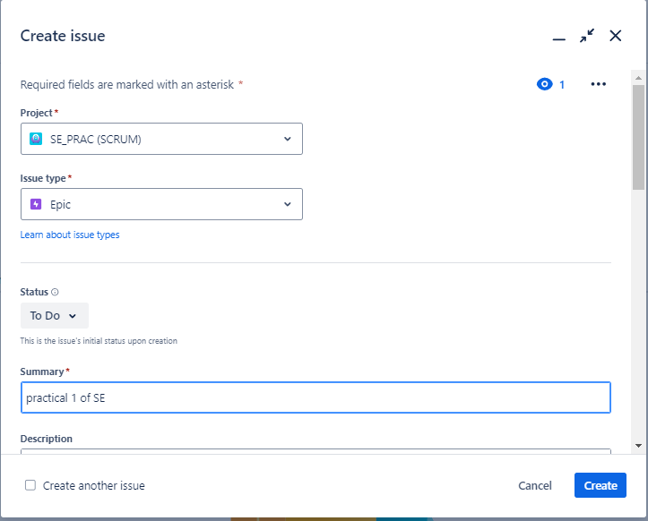

Figure 1. 1 Creating new Epic

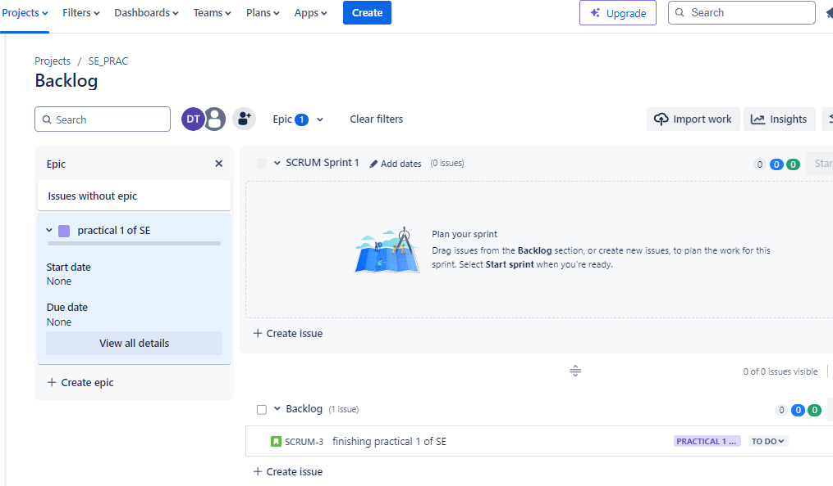

Figure 1. 2 Checking whether the Epic is created or not

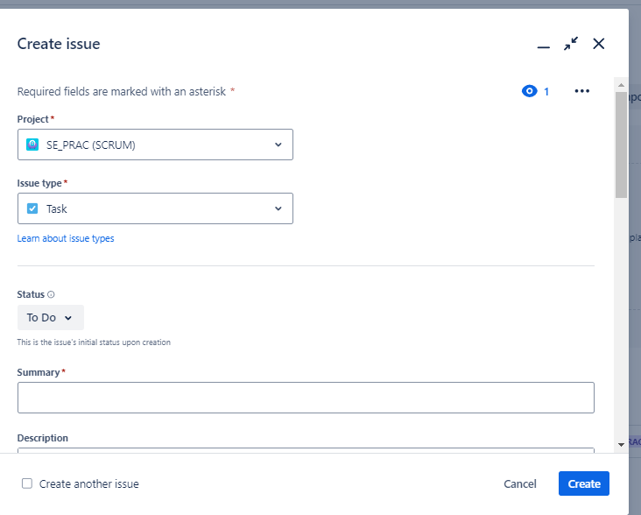

Figure 1. 3 Creating new task

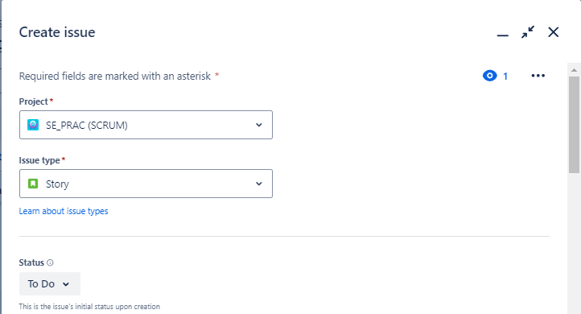

Figure 1. 4 Creating new story

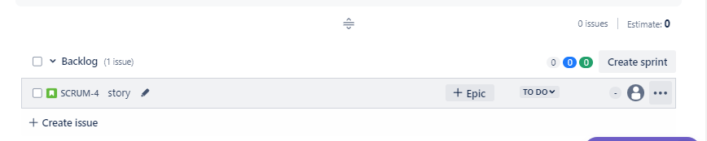

Figure 1. 5 Checking whether new story is created or not

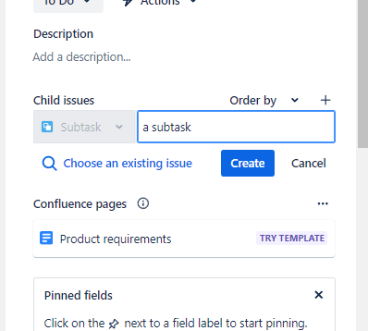

Figure 1. 6 Creating new subtask

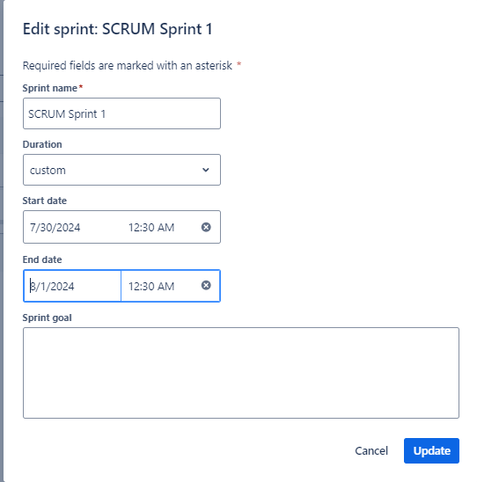

Figure 1. 7 Creating new sprint

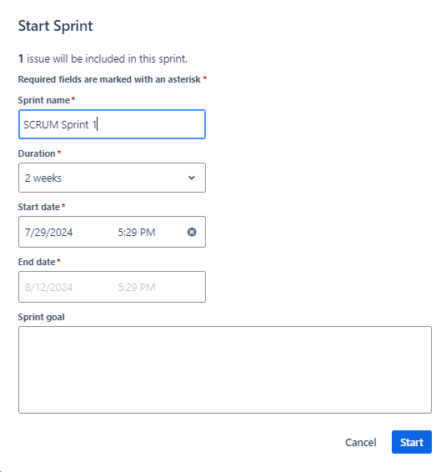

Figure 1. 8 Starting new sprint

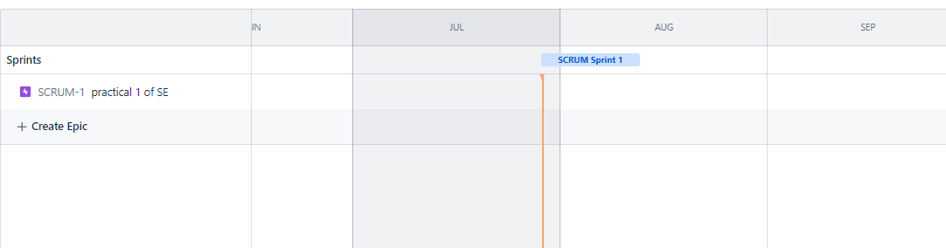

Figure 1. 9 We can see our sprint in Timeline Tab

**Conclusion :** I gained knowledge on the fundamentals of Jira and how to use it from this practical. Aside from that, I gained knowledge of Jira's Issue, Epic, Sprint, and Subtask features. By working on one project, I was also able to understand and utilize their functionality.