**Week 1: Jira as a project management tool**

**Aim:**

Explore the Jira as a project management tool for the agile Development. Execute following Activity in Jira Tool.

1) Free Trial Setup

2) Create an Epic

3) Create an Issue

4) Create Story

5) Create Subtask

6) Create Sprint

Reference link : https://www.atlassian.com/

**Screenshot / Graph / Explanation etc.**

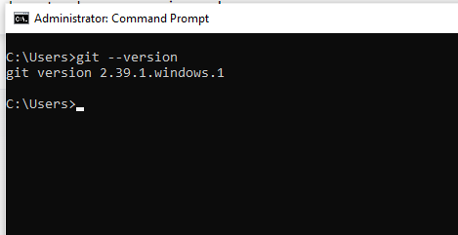

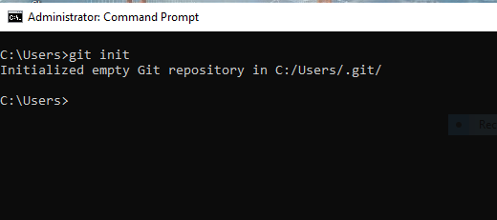

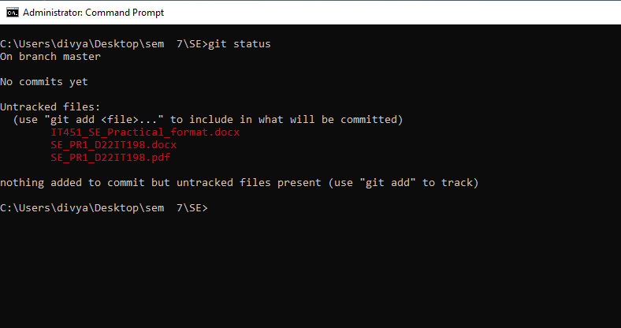

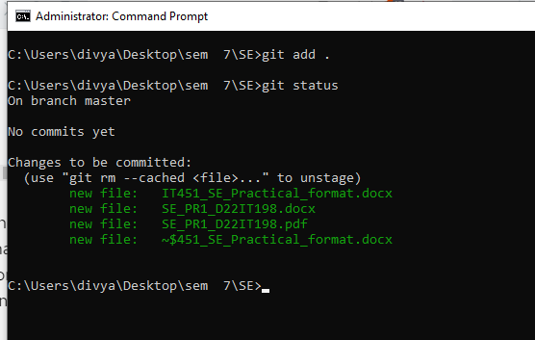

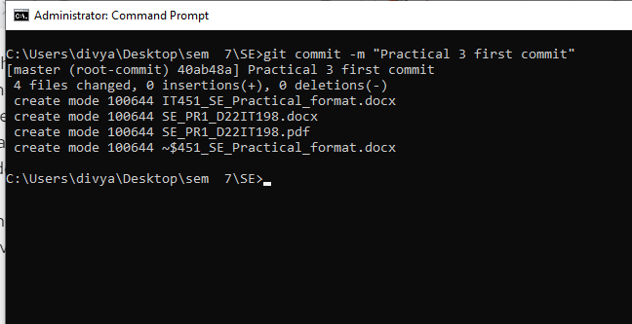

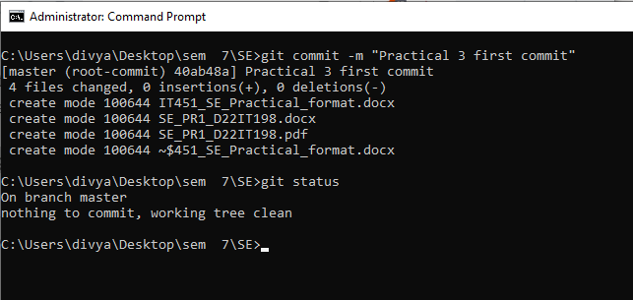

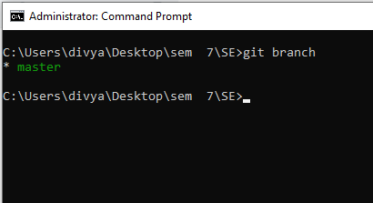

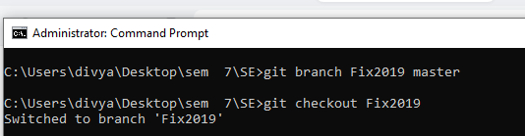

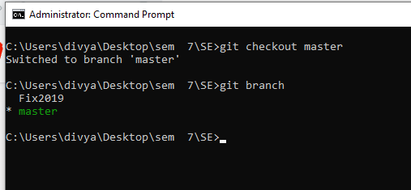

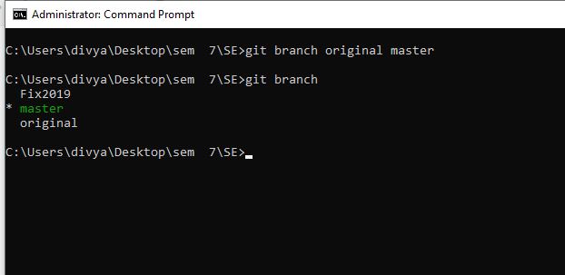

**Learning Outcome:**