**Practical – 3**

# AIM: JS scope & hoisting, Function, Operators and Loops, Date

* **Print prime Numbers up to given value in the input box**

**Source Code:**

**HTML :**

<!DOCTYPE html>

<html lang="en">

<head>

<meta charset="UTF-8">

<meta http-equiv="X-UA-Compatible" content="IE=edge">

<meta name="viewport" content="width=device-width, initial-scale=1.0">

<title>Practical 3</title>

</head>

<body>

<h1>enter the no.</h1><input type="text" id="limit">

<h1>enter the no.</h1><input type="text" id="limit2">

<button onclick="fun()">Submit</button>

<div id="result"></div>

<script src="./pra3.js"></script>

</body>

</html>

**JavaScript :**

function fun() { var i = limit; var j = limit2;

limit = document.getElementById('limit').value;

limit2 = document.getElementById('limit2').value;

for (i = limit; i <= limit2; i++)

{

c = 0; for (j = 1; j <= i; j++)

{

if (i % j == 0)

{

c++;

}

}

if (c == 2)

{

document.getElementById("result").insertAdjacentHTML('beforeend', i + '');

}

}

}

**Output:**

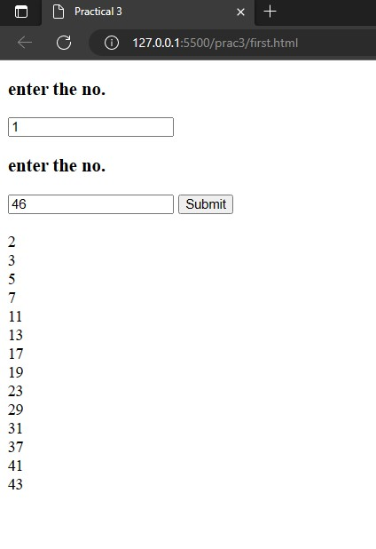

* **Write Script to reverse the given input string**

**Source Code:**

**HTML :**

<!DOCTYPE html>

<html lang="en">

<head>

<meta charset="UTF-8">

<meta http-equiv="X-UA-Compatible" content="IE=edge">

<meta name="viewport" content="width=device-width,

initial-scale=1.0">

<title>Practical 3</title>

</head>

<body>

<script src="./second.js"></script>

</body>

</html>

**JavaScript :**

function string_reverse(str) {

return str.split("").reverse().join("");

}

console.log(string_reverse("D22IT198"));

console.log(string_reverse("891TI22D"));

**Output:**

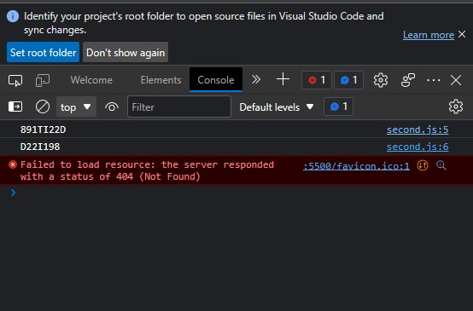

* **Create Dynamic Multiplication Table using inputs**

**Source code :**

**HTML:**

<!DOCTYPE html>

<html lang="en">

<head>

<meta charset="UTF-8">

<meta http-equiv="X-UA-Compatible" content="IE=edge">

<meta name="viewport" content="width=device-width,

initial-scale=1.0">

<title>Document</title>

</head>

<body>

<form name="tab">

<label>Rows: <input type="text" name="rows" id="rows"></label><br />

<input name="generate" type="button" value="Create

Table!" onclick='tbl();' />

<p id="p" style="font-size: 70px;"></p>

</form>

<div id="wrapper"></div>

**JavaScript:**

function tbl() {

    var p = document.getElementById('p');

    let r = document.getElementById('rows').value;

    let str = '';

    for (let i = 1; i <= 10; i++) {

    str = str + r + ' ' + i +' '+ r*i + "<br>";

    }

    // document.write(str)

    p.innerHTML = str;

    }

**Output :**

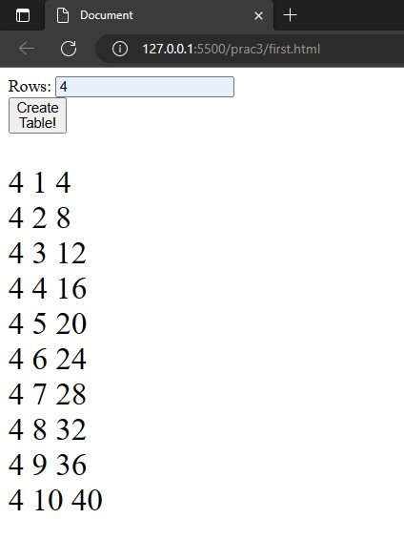

* **Find the Age from input date**

**Source code :**

**HTML :**

<!DOCTYPE html>

<html>

<head>

<title>JavaScript Age Calculator</title>

</head>

<body>

<div class="container">

<form>

<div class="base">

<div class="enter">

</div>

<div class="block">

<p class="title">Date</p>

<input type="text" name="date" id="date"

placeholder="dd" required="required" minlength="1"

maxlength="2" />

</div>

<div class="block">

<p class="title">Month</p>

<input type="text" name="month" id="month"

placeholder="mm" required="required" minlength="1"

maxlength="2" />

</div>

<div class="block">

<p class="title">Year</p>

<input type="text" name="year" id="year"

placeholder="yyyy" required="required" minlength="4"

maxlength="4" />

</div>

</div>

<div class="base">

<div class="enter">

<input type="button" name="submit" value="Submit"

onclick="age()" />

</div>

</div>

<div id="age"></div>

</form>

</div>

<script src="./fourth.js"></script>

</body>

</html>

**JavaScript :**

function age() {

var d1 = document.getElementById('date').value;

var m1 = document.getElementById('month').value;

var y1 = document.getElementById('year').value;

var date = new Date();

var d2 = date.getDate();

var m2 = 1 + date.getMonth();

var y2 = date.getFullYear();

var month = [31, 28, 31, 30, 31, 30, 31, 31, 30, 31, 30, 31];

if (d1 > d2) {

d2 = d2 + month[m2 - 1];

m2 = m2 - 1;

}

if (m1 > m2) {

m2 = m2 + 12;

y2 = y2 - 1;

}

var d = d2 - d1;

var m = m2 - m1;

var y = y2 - y1;

document.getElementById('age').innerHTML = 'Your Age is ' + y

+ ' Years ' + m + ' Months ' + d + ' Days';

}

**Output:**

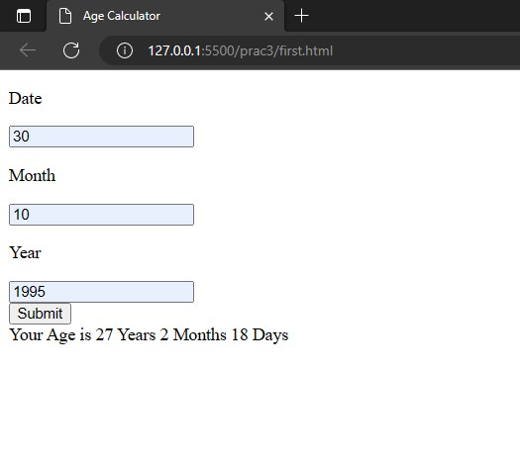

* **Find the No. of Days between two given dates**

**Source Code:**

**HTML:**

<!DOCTYPE html>

<html>

<head>

<title>days calculator</title>

</head>

<body>

<div id=" ">

<div id="fd">

<p><label class="form">first date:</label><input type="date"

id="ssd"

name="fd" </p>

</div>

<div id="sd">

<p><label class="form">second date:</label><input type="date"

id="ffd"

name="sd" /></p>

</div>

<div id="numdays"><label class="form">Number of

days:</label><input style="font-size: 30px;" type="text" class="textbox"

id="num2"

name="numdays" /></div>

<button id="r" onclick="r();">click</button>

</div>

<script src="./fifth.js">

</script>

</body>

</html>

**JavaScript:**

function r() {

var dropdatet = new Date(document.getElementById("ffd").value);

var pickdate = new Date(document.getElementById("ssd").value);

let a = parseInt((dropdatet - pickdate) / (24 * 3600 * 1000));

document.getElementById("num2").value = a;

}

**Output:**

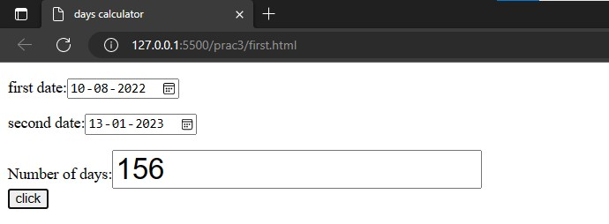

**Conclusion:** From this practical we learned about date function, created a dynamic multiplication table , reverse a string and display the prime numbers .