**Practical – 4**

**AIM: Create Javascript Object of Spoural Registration User input and Display the Object Details on Webpage(Table)**

**Source Code:**

**HTML :**

<!DOCTYPE html>

<html lang="en">

<head>

<meta charset="UTF-8">

<meta http-equiv="X-UA-Compatible" content="IE=edge">

<meta name="viewport" content="width=device-width, initial-scale=1.0">

<title>Practical 4</title>

</head>

<body>

<h1>Spoural form</h1>

<table id="tb"></table>

<button id="btn">Show details</button>

<style>

table,tr,td{

border: 2px solid black;

}

</style>

<script src="./first.js"></script>

</body>

</html>

**JavaScript :**

let eleobj = {

name : "Divyansh Trivedi",

branch : "it",

id: "D22IT198",

sem : "4th",

}

let tbl = document.getElementById("tb");

function divyansh(){

Object.entries(eleobj).forEach(([key,value]) => {

var tr = document.createElement('tr');

var td = document.createElement('td');

td.innerHTML = key;

tr.appendChild(td);

tbl.appendChild(tr);

td = document.createElement('td');

td.innerHTML = value;

tr.appendChild(td);

tbl.appendChild(tr);

});

}

let display = document.getElementById('btn');

display.onclick = () => {

divyansh()

}

**Output:**

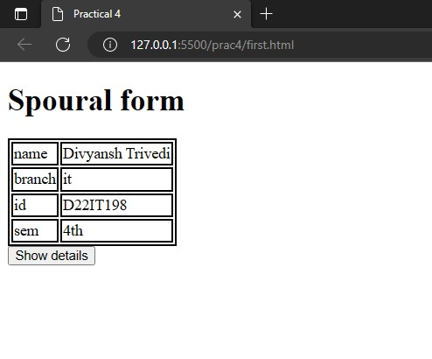

**Create Car Object and Its methods like isFuelType(CNG, Petrol, Diesel, Hybrid), isType(like SUV, Hatchback,Luxury), isBrand(like BMW, Audi, Tata, Mahindra)**

**Demonstrate : this keyword in constructor, method etc.**

**Source Code:**

**HTML :**

<!DOCTYPE html>

<html lang="en">

<head>

<meta charset="UTF-8">

<meta http-equiv="X-UA-Compatible" content="IE=edge">

<meta name="viewport" content="width=device-width, initial-scale=1.0">

<title>Practical 4</title>

</head>

<body>

<script src="./second.js"></script>

</body>

</html>

**JavaScript :**

const car = {

FuelType: "Diesel",

Type: "Sedan",

Brand: "BMW",

display() {

document.write(`<h1>Calling by object</h1>this car

use ${this.FuelType}, type of this car is ${this.Type} and brand is

${this.Brand}<br>`);

},

};

console.log(car.display())

function GetDetail(petrol, Hatchback, Audi) {

this.FuelType = petrol;

this.Type = Hatchback;

this.Brand = Audi;

this.display = function () {

document.write(`<h1>Calling by Constructor</h1>this car

use ${this.FuelType}, type of this car is ${this.Type} and brand is

${this.Brand}`);

}

};

let ans = new GetDetail("Petrol","SUV","Mahindra")

console.log(ans.display());

**Output:**

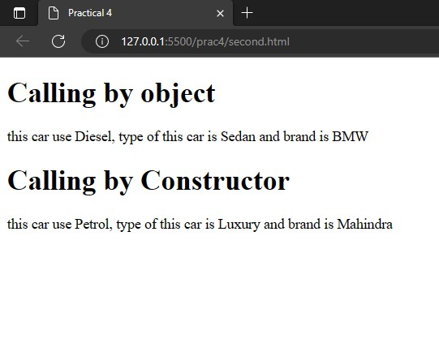

**Conclusion:** From this practical we learned how to create an object and display the values on the webpage and then we learned how to create methods for an object and also learned about this constructor.