**Practical – 5**

**AIM: Demonstrate various Ways to handle Events**

**Source Code:**

**HTML :**

<!DOCTYPE html>

<html lang="en">

<head>

    <meta charset="UTF-8">

    <meta http-equiv="X-UA-Compatible" content="IE=edge">

    <meta name="viewport" content="width=device-width, initial-scale=1.0">

    <title>Document</title>

</head>

<body>

    <button id="button1">Add event Listner in js</button>

    <button id="button2" onclick="eventfunc();">Onclick Listener</button>

    <button id="dombtn">with DOM Onclick Listener</button>

    <p id="display"></p>

    <script src="./one.js"></script>

</body>

</html>

**JavaScript :**

let obj = document.getElementById("display");

function newfunc(){

    obj.innerHTML = `Event handled by Onclick listener in Html`;

}

let btn1 = document.getElementById("button1");

let btn2 = document.getElementById("dombtn");

btn1.onclick=  ()=> {

    obj.innerHTML = `handled the event with in js`;

}

btn2.onclick = () => {

    obj.innerHTML=`Handled the event with DOM onclick property in JS`;

}

**Output**:

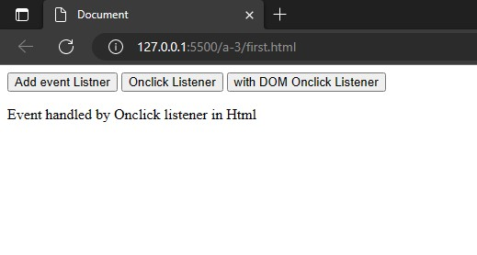

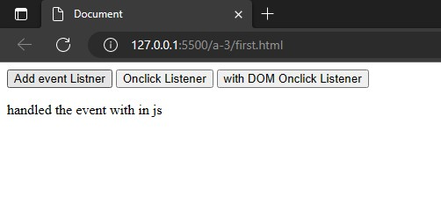

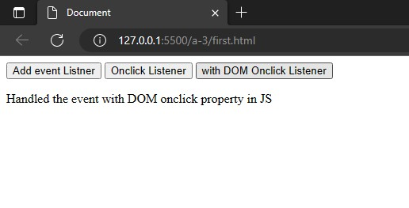

**Aim : Write the Script to Change the background color randomly after every 1 mins**

**HTML :**

<!DOCTYPE html>

<html lang="en">

<head>

    <meta charset="UTF-8">

    <meta http-equiv="X-UA-Compatible" content="IE=edge">

    <meta name="viewport" content="width=device-width, initial-scale=1.0">

    <title>Document</title>

</head>

<body>

    <script src="./second.js"></script>

</body>

</html>

**JavaScript:**

function newfunc() {

    let cl1 = Math.floor(Math.random()*100)

    let cl2 = Math.floor(Math.random()*100)

    let cl3 = Math.floor(Math.random()*100)

    console.log(cl1);

    document.body.style.background = "#" +cl1+cl2+cl3;

}

setInterval(newfunc, 1000);

**Output**:

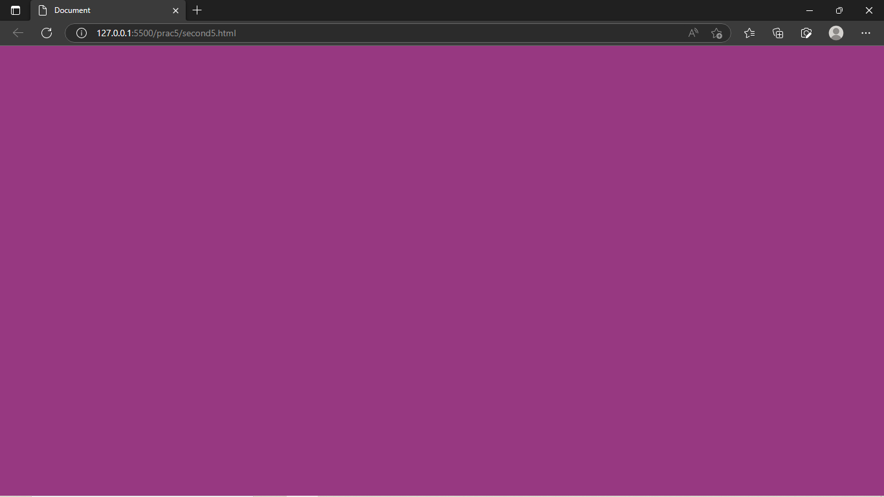

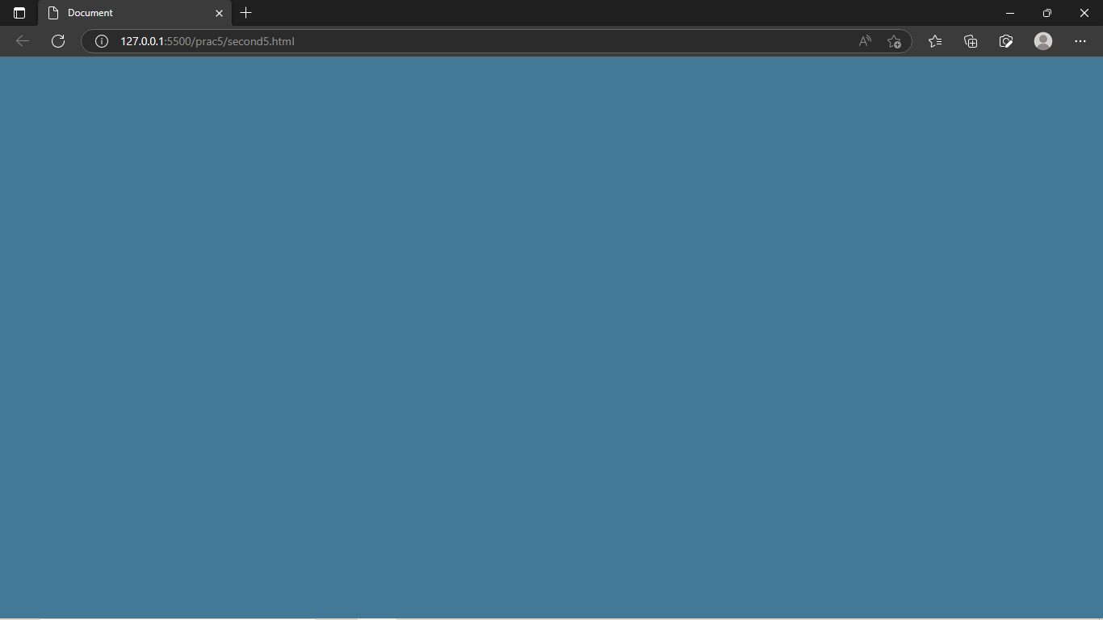

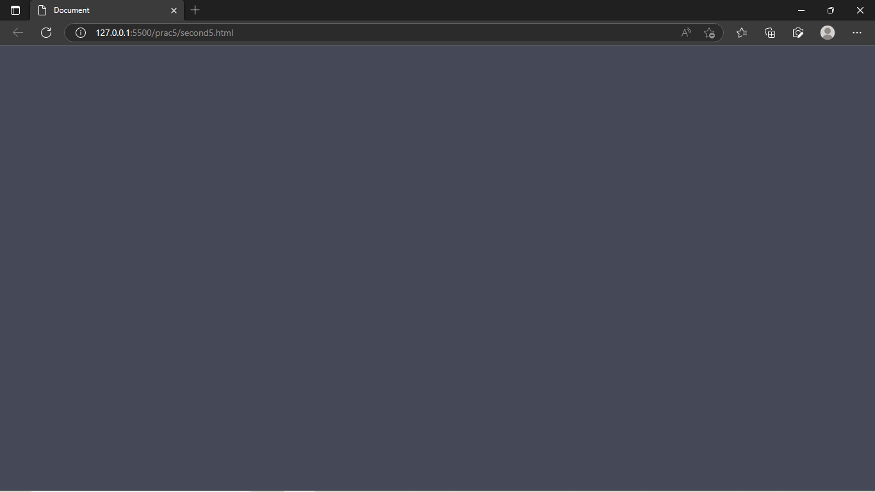

**Aim : Create Arrays of colors and apply these colors in order to tr background of table**

<!DOCTYPE html>

<html lang="en">

<head>

    <meta charset="UTF-8">

    <meta http-equiv="X-UA-Compatible" content="IE=edge">

    <meta name="viewport" content="width=device-width, initial-scale=1.0">

    <title>Practical 5</title>

</head>

<body>

<table border="2px solid gray" style="border-collapse: collapse;border-spacing: 10px; font-size: 50px;">

<tr id="tr0">

<th>blue</th>

<th> background-color</th>

<th> background-color</th>

</tr>

<tr id="tr2">

<td>orange</td>

<td>background-color</td>

<td>background-color</td>

</tr>

<tr id="tr3">

<td>red</td>

<td>background-color</td>

<td>background-color</td>

</tr>

<tr id="tr1">

<td>skyblue</td>

<td>background-color </td>

<td> background-color</td>

</tr>

</table>

<script>

var arr = ["blue","skyblue","orange","red"] ;

for (let i = 0; i < 4; i++) {

let x = document.getElementById("tr"+i) ; x.style.backgroundColor = arr[i];

}

</script>

</body>

</html>

**Output**:

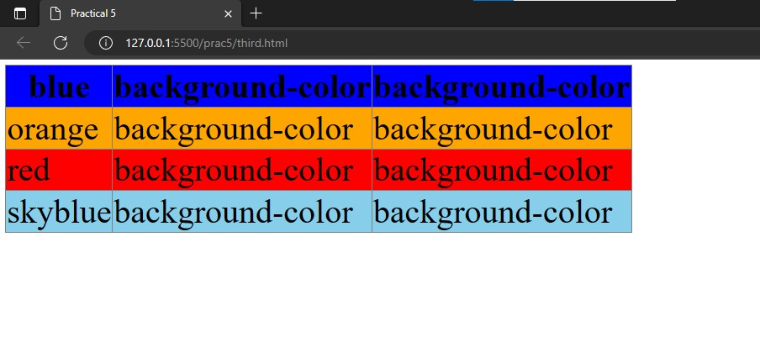

**Aim : Zoom image on mouseover and zoom out on mouse out**

<!DOCTYPE html>

<html>

<head>

<title>Practical 5 </title>

</head>

<body>

<div class="box">

<img src="./download.jpg" id="pt" onmouseover="big()" onmouseout="small()" width="500px">

</div>

</button>

<style>

button{

position: relative;; margin: 5px;

font-size: 30px; border: 2px solid black;

}

img{

cursor: zoom-in;

}

</style>

<script type="text/javascript"> add

function big() {

var x = document.getElementById("pt");

x.style.width = 1000 + "px";

}

function small() {

var x = document.getElementById("pt"); x.style.width = 500 + "px";

}

</script>

</body>

</html>

**Output**

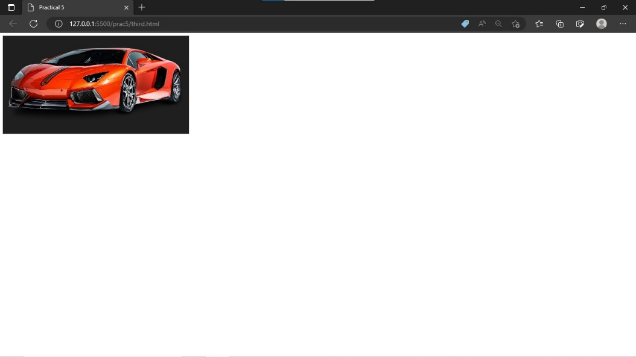

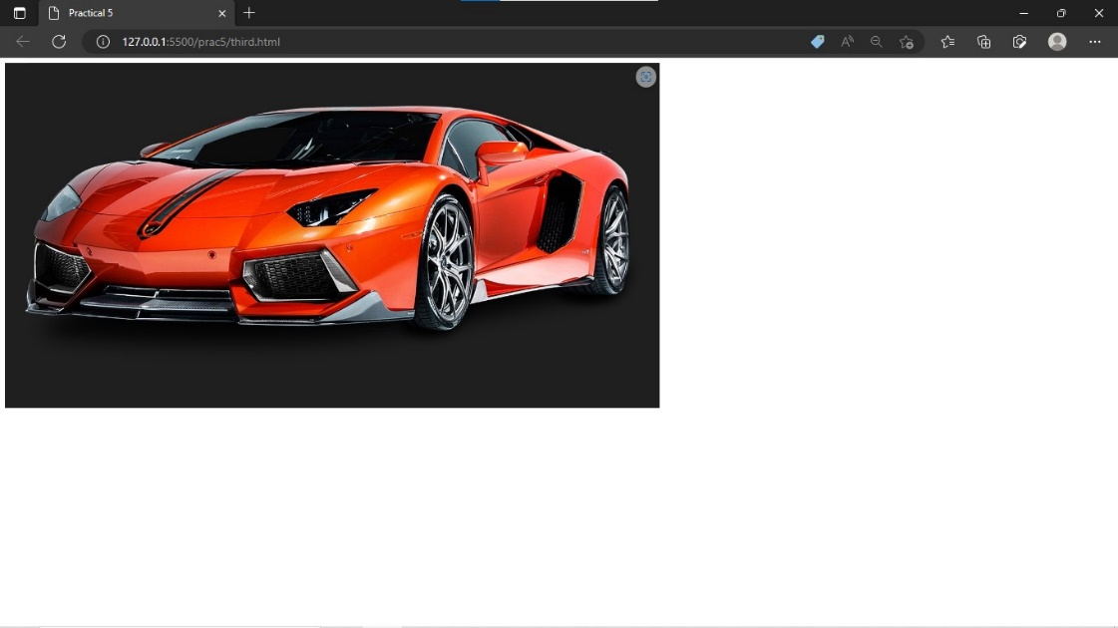

**Aim: Change the location of image based on arrow key of keyboard using callback function**

**HTML Source Code :**

<!DOCTYPE html>

<html lang="en">

<head>

<meta charset="UTF-8">

<meta http-equiv="X-UA-Compatible" content="IE=edge">

<meta name="viewport" content="width=device-width, initial-scale=1.0">

<title>Document</title>

</head>

<body>

<img src="./download.png"  id="photo" style="position: absolute; top: 0; left: 0; bottom: 0; right: 0;">

<script src="./fourth.js"></script>

</body>

</html>

**Javascript:**

document.onkeydown = checkKey; function checkKey(e) {

    let i = document.getElementById("i");

    e = e || window.event;

    if (e.keyCode == '38') {

let a = i.style.top;

    let b = parseInt(a, 10) + 10 ; i.style.top = b + "px"

     console.log(a,b)

    }

    else if (e.keyCode == '40') {

let a = i.style.top;

    let b = parseInt(a, 10) - 10 ; i.style.top = b + "px"

    }

    else if (e.keyCode == '37') { let a = i.style.left;

    let b = parseInt(a, 10) + 10 ; i.style.left = b + "px"

    }

    else if (e.keyCode == '39') { let a = i.style.left;

    let b = parseInt(x, 10) - 10 ; i.style.left = b + "px"

    }

    }

**Output :**

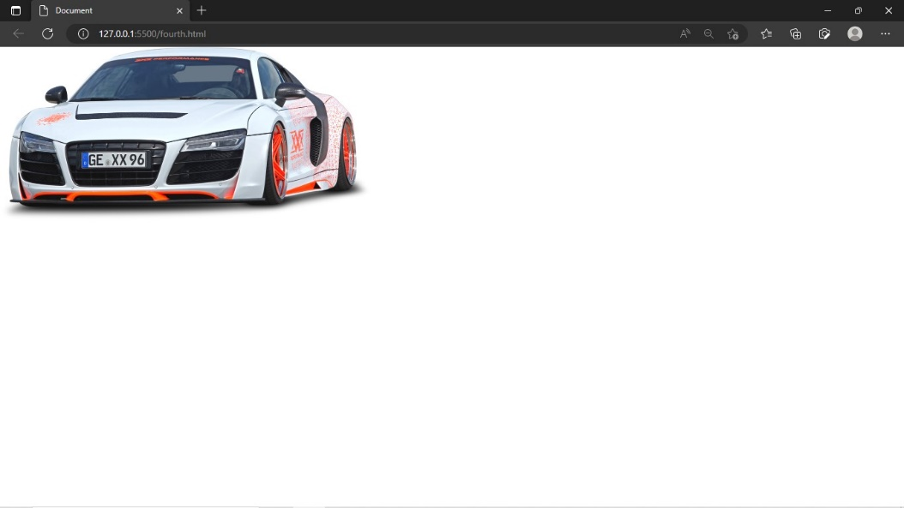

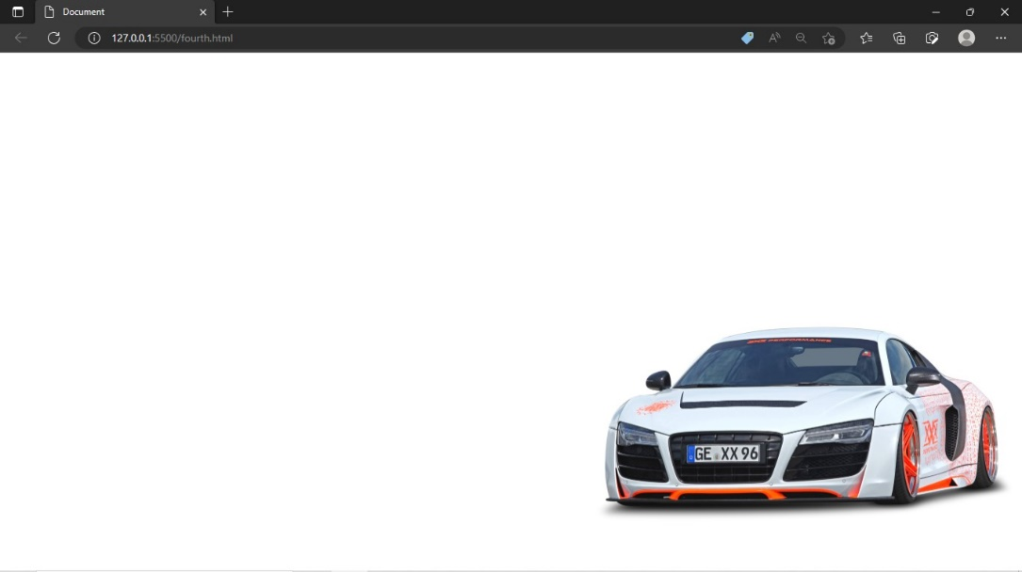

**Conclusion:**

From this practical we learned many things like how to change background color every minute , change the position of object using keys , different ways to handle an event, zoom in on object when mouse is on the object and a table with different colors.