ST. TERESA’S SCHOOL

Session 2022-2023
COMPUTER SCIENCE PROJECT
BANK MANAGEMENT SYSTEM

Submitted To :- Submitted By:-
Mrs. Kanchan Ma’am Divyansh Saxena
Class:-12’A’
ACKNOWLEDGEMENT
I Would like to express. My heartfelt thanks of gratitude to my
Computer teacher and guide Mrs. Kanchan as well as our principal Mr. Thomas who offered me precious opportunity to work on this ”Bank Management System ”.Which also helped me learn so many new and useful things while doing
Research on the project.
I would also like to thank my parents and friends who helped me immensely by providing help and support in completing the project time.
Divyansh Saxena

CERTIFICATE

This certify that Mr. Divyansh Saxena who is the student of class XII A of St Teresa’s School,Gwalior has successfully completed the Computer Science Project File for the practical
examination of class XII CBSE 2022-23.

This project work is the record of the authentic work carried out during year 2022-23. The student has submitted this file within limited time period.

Internal Signature Principal Signature External Signature
CONTENT
- About the project
- Function and modules
- Sql tables
- Source code
- Output
- Bibliography

About the project-
The project is based on “Bank Management system”,this project is developed on python with the help of Mysql.
It includes basic function which includes:
- Creating new account,
- Deposit amount,
- Withdraw amount,
- Balance enquiry,
- Display account details,
- Close an account.

Functions & Modules
- Connect():
This function establishes connection between python and Mysql.
- Cursor():
It is an object that is used to make the connection for executing SQL queries.
- Execute():
This function is used to execute the SQL query and retrieve records using python.
- Fetchone():
This function return one row from the result.
- Commit():
This function provides changes in the database .
- Mysql.connector:
By importing this module , we are able to establish the connection between SQL and PYTHON.

SQL TABLES
Database in already created in Mysql before using python.
NAME of database-“bank”.
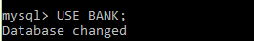
Two tables are created in bank which stored details of customer.
NAME of first table -“account”.
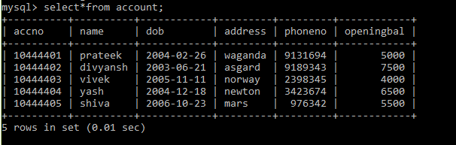

NAME of second table-“amount”.
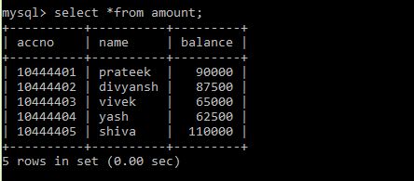

SOURCE CODE
Import mysql.connector as a
con=a.connect(host="localhost",user="root",passwd="1234",database="bank")

def openAcc():
ac = int(input("Enter Account No: "))
n = input("Enter Name: ")
db = input("Enter D.O.B: ")
ad=input("Enter address:")
p = int(input("Enter Phone :"))
ob = int(input("Enter Opening Balance :"))
data1 = (ac,n,db,ad,p,ob)
data2 = (ac,n,ob)
sql1 = 'insert into account values (%s, %s, %s, %s, %s,%s)'
sql2 = 'insert into amount values(%s,%s,%s)'
c = con.cursor()
c.execute(sql1,data1)
c.execute(sql2,data2)
con.commit()
print("Data Enter Successfully")
MainMenu()
def depoAcc():
am=int(input("Enter Amount:"))
accno=int(input("Enter Account No:"))
a="select balance from amount where accno=%s"
data = (accno,)
c = con.cursor()
c.execute(a,data)
myresult = c.fetchone()
tam = myresult[0] + am
sql = "update amount set balance = %s where accno = %s"
d = (tam,accno)
c.execute(sql,d)
con.commit()
print("Amount Deposited Successfully")
MainMenu()

def withAm():
am=int(input("Enter Amount:"))
accno=int(input("Enter Account No:"))
a="select balance from amount where accno=%s"
data = (accno,)
c = con.cursor()
c.execute(a,data)
myresult = c.fetchone()
tam = myresult[0] - am
sql = "update amount set balance = %s where accno = %s"
d = (tam,accno)
c.execute(sql,d)
con.commit()
print("Amount withdrawl Successfull")
MainMenu()

def balance():
accno = input("Enter Account No: ")
a = "select balance from amount where accno=%s"
data = (accno,)
c = con.cursor()
c.execute(a,data)
myresult = c.fetchone()
print("Balance for Account : ",accno," is ",myresult[0])
MainMenu()

def dispAcc():
accno = input("Enter Account No : ")
a = "select*from account where accno = %s"
data = (accno,)
c = con.cursor()
c.execute(a,data)
myresult = c.fetchone()
for i in myresult:
print(i, end = " ")
MainMenu()

def closeAcc():
accno = input("Enter Account No: ")
sql1="delete from account where accno = %s"
sql2="delete from amount where accno=%s"
data = (accno,)
c = con.cursor()
c.execute(sql1,data)
c.execute(sql2,data)
con.commit()
MainMenu()

def MainMenu():
print("*"*140)
print("BANK MANAGEMENT SYSTEM".center(140))
print("1.OPEN NEW ACCOUNT".center(140))
print("2.DEPOSIT AMOUNT".center(140))
print("3.WITHDRAW AMOUNT".center(140))
print("4.BALANCE ENQUIRY".center(140))
print("5.DISPLAY CUSTOMER DETAILS".center(140))
print("6.CLOSE AN ACCOUNT".center(140))
print("*"*140)

MainMenu()
choice=int(input("Enter Task No"))
if choice==1:
openAcc()
elif choice==2:
depoAcc()
elif choice==3:
withAm()
elif choice==4:
balance()
elif choice==5:
dispAcc()
elif choice==6:
closeAcc()
else:
print("wrong task no")
MainMenu()

OUTPUT
- Creating new account:
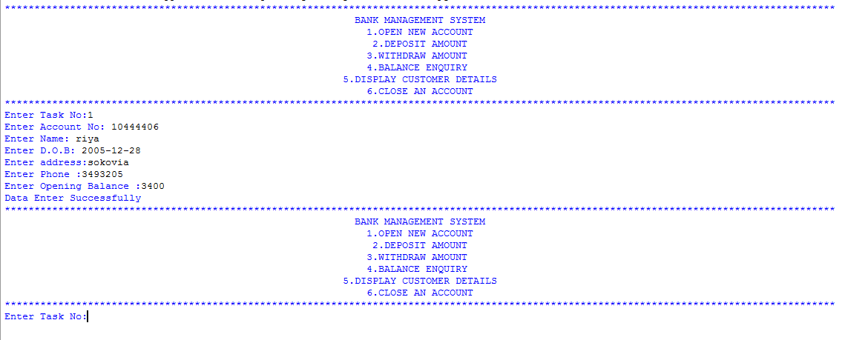
Mysql Tables:
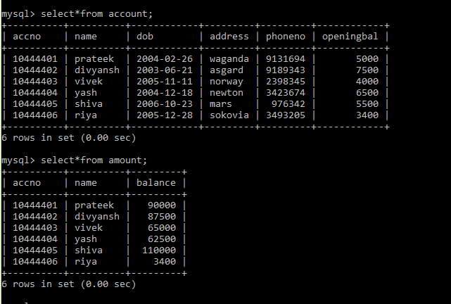
- Deposit Money
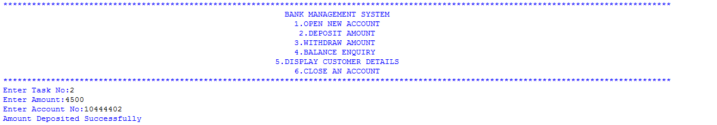
Lets check in Mysql:
Before-
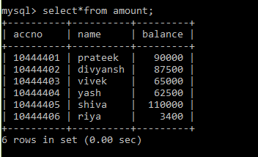
After-
Amount has been successfully deposited in account-10444402.
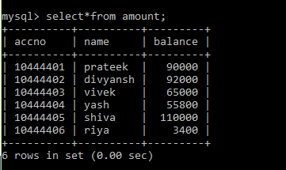
- Withdraw Account
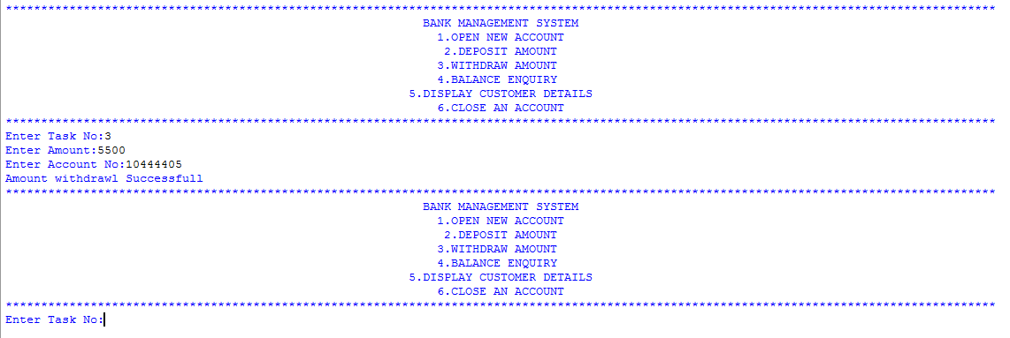
Lets check in Mysql:
Before-
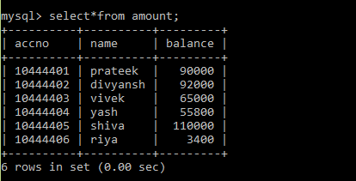
After-
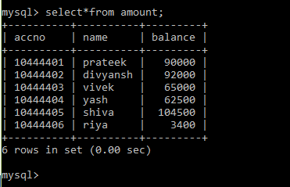
Amount has been successfully withdrawal from account-10444405.
- Balance Enquiry
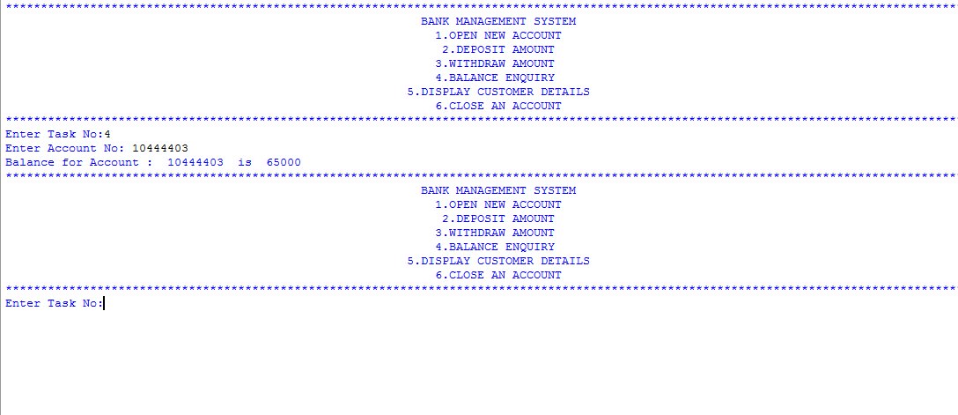
SQL Table-
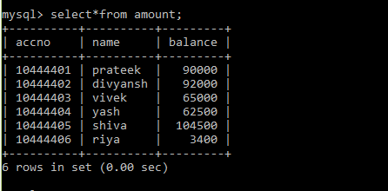
In SQL Account-10444403 has total balance=65000.

- Display Customer Details:
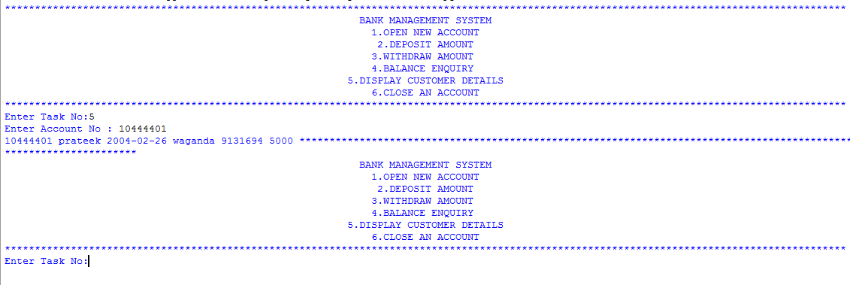

- Close an account:
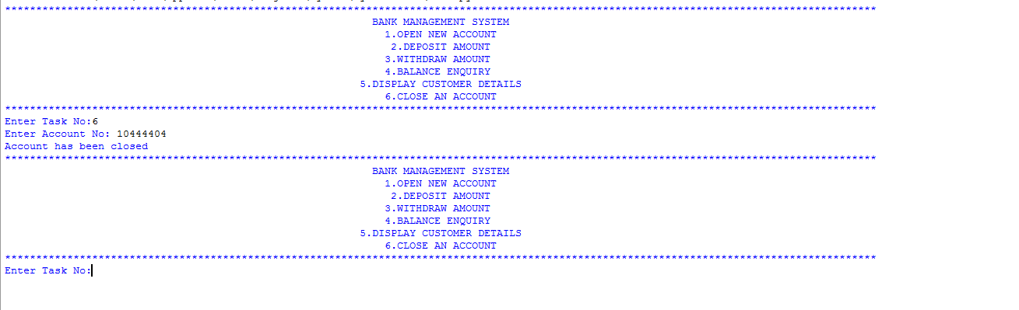
Lets check in Mysql:
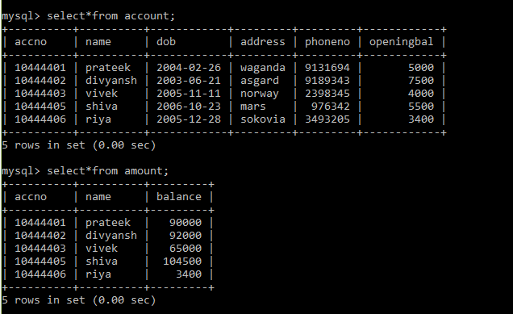
In sql the account-10444404 has been deleted.
Bibliography 

- http://youtu.be/sq76a19jAvQ
- Computer Science with python by Sumita Arora.
- Computer Science with python by Preeti Arora.

