Game Design Document

Fill up the Following document

1. Write the title of your project.

Brave Indian Army

1. What is the goal of the game?

The goal of the PC in this game is to save their country from getting invaded by the second country

1. Write a brief story of your game?

A foreign country is trying to invade our country like the britishers did

then the Indian army came up to save the country and the player is a

soldier who is fighting enemies and going through a tough time in the

battlefield

1. Which are the playing characters of this game?

* Playing characters are the ones which respond to the user based on the input from the user
* Cars, monkeys, dins, wizards etc., are the playing characters in the game.

|  |  |  |
| --- | --- | --- |
| Number | Character Name | What can this character do? |
| 1 | Soldier | Fight the enemies |
| 2 |  |  |
| 3 |  |  |
| 4 |  |  |
| 5 |  |  |
| 6 |  |  |
| 7 |  |  |
| 8 |  |  |

1. Which are the Non-Playing Characters of this game?

* Non-Playing characters are the ones which don't have an action or a behavior when the user interacts with the game.
* Hurdles, stones, bananas, coins, etc. are non-playing characters in the game.

|  |  |  |
| --- | --- | --- |
| Number | Character Name | What can this character do? |
| 1 | Enemies | Shoot bullets at the soldier |
| 2 | Robots | They will walk on the ground |
| 3 | Obstacles (like boxes) | They will come randomly |
| 4 |  |  |
| 5 |  |  |
| 6 |  |  |
| 7 |  |  |
| 8 |  |  |

Draw your imagination of this game. What does this game look like?

* Draw the game either on your computer or on paper,
* 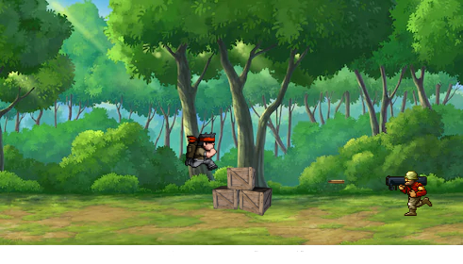
* Add images of scenes of the game to show each of the playing and non-playing characters at least once.

How do you plan to make your game engaging?

The game will be engaging because I will add sound effects, there will be

Bullets to make the game a little difficult or else the game will be too easy