NAME: Aryansh Gupta
ROLL NO: 2401331520053
ERPID: 0241csai021@niet.co.in
EMAIL: 0241csai021@niet.co.in
BRANCH: AI
SECTION:A
QUES 1
CODE:
<!DOCTYPE html>
<html>
<head>
<title>Student Registration</title>
</head>
<body>

<h2>Student Registration Form</h2>

<form id="regForm">
Name: <input type="text" id="name"><br><br>
Email: <input type="text" id="email"><br><br>
Mobile: <input type="text" id="mobile"><br><br>
Age: <input type="number" id="age"><br><br>
Course: <input type="text" id="course"><br><br>
Password: <input type="password" id="password"><br><br>

<button type="submit">Register</button>
</form>
<script>
const form = document.getElementById("regForm");
form.addEventListener("submit", function(e) {
e.preventDefault();
let name = document.getElementById("name").value.trim();
let email = document.getElementById("email").value.trim();
let mobile = document.getElementById("mobile").value.trim();
let age = document.getElementById("age").value.trim();
let course = document.getElementById("course").value.trim();
let password = document.getElementById("password").value.trim();
const emailPattern = /^[^\s@]+@[^\s@]+\.[^\s@]+$/;
const mobilePattern = /^[0-9]{10}$/;
if(!name || !email || !mobile || !age || !course || !password){
alert("All fields are required!");
return;
}
if(!emailPattern.test(email)){
alert("Invalid Email!");
return;
}
if(!mobilePattern.test(mobile)){
alert("Mobile must be 10 digits!");
return;
}
if(age <= 17){
alert("Age must be greater than 17!");
return;
}
if(confirm("Registration Successful!\nName: " + name + "\nCourse: " + course)){
alert("Data submitted successfully!");
}
});
</script>
</body>
</html>

OUTPUT:
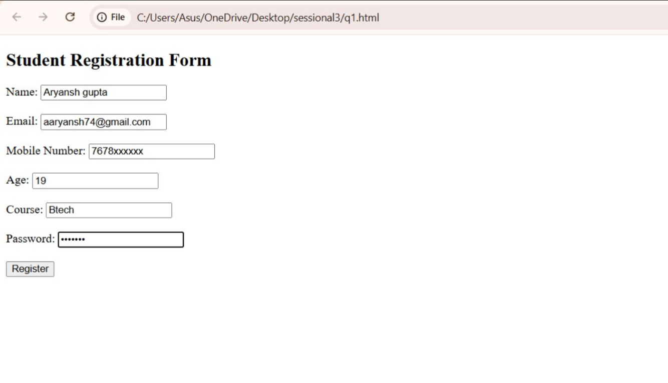

QUES 2

CODE:

let numbers = [10, 20, 30, 40, 50];
console.log("Array Elements:");
for(let i = 0; i < numbers.length; i++){
console.log(numbers[i]);
}
const findSum = arr => arr.reduce((a, b) => a + b, 0);
let sum = findSum(numbers);
let newNumbers = [...numbers, 60, 70, 80];
alert("Sum of original array = " + sum);
console.log("Updated Array:", newNumbers);

OUTPUT:


QUES 3)

CODE:

CREATE DATABASE student_db;
USE student_db;
CREATE TABLE users(
id INT AUTO_INCREMENT PRIMARY KEY,
username VARCHAR(50),
password VARCHAR(255)
);

<!DOCTYPE html>
<html>
<body>
<h2>Login</h2>
<form action="login.php" method="post">
Username: <input type="text" name="username"><br><br>
Password: <input type="password" name="password"><br><br>
<input type="submit" value="Login">
</form>
</body>
</html>

<?php
$conn = new mysqli("localhost", "root", "", "student_db");
if ($conn->connect_error) {
die("Connection Failed");
}
$username = $_POST['username'];
$password = $_POST['password'];

if(strlen($password) < 6){
echo "Password must be at least 6 characters";
exit();
}

$sql = "INSERT INTO users(username, password) VALUES('$username', '$password')";

if($conn->query($sql)){
echo "User Stored Successfully";
}
else{
echo "Error: " . $conn->error;
}

$conn->close();
?>

OUTPUT
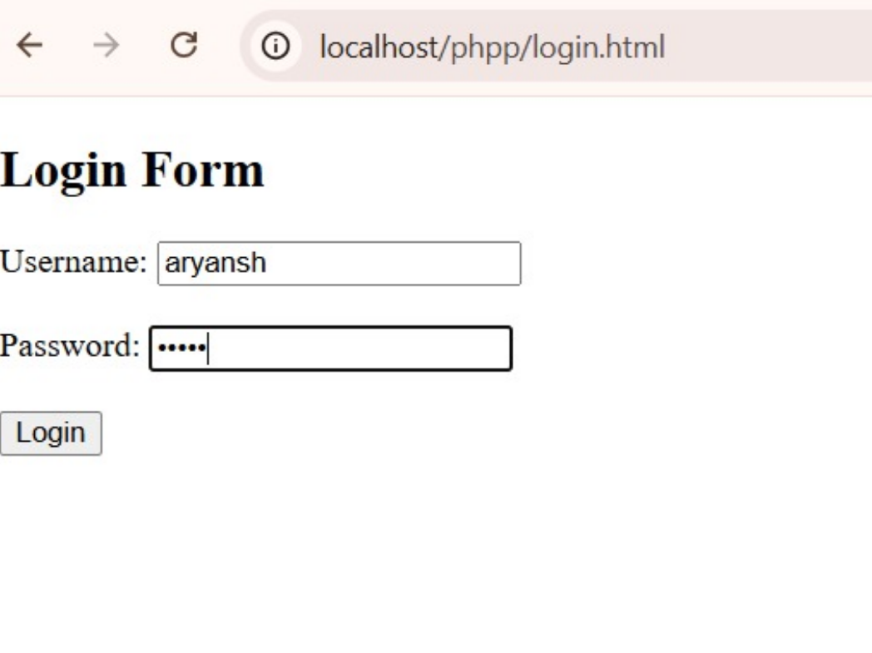
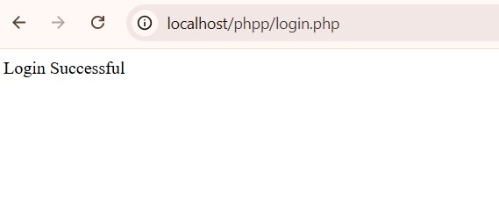

QUES 4)

CODE:
CREATE DATABASE IF NOT EXISTS college_db;
USE college_db;

CREATE TABLE students (
id INT AUTO_INCREMENT PRIMARY KEY,
name VARCHAR(100),
father_name VARCHAR(100),
mother_name VARCHAR(100),
email VARCHAR(100),
contact VARCHAR(15),
gender VARCHAR(10),
address TEXT,
roll_no VARCHAR(20),
course VARCHAR(50),
branch VARCHAR(50),
year VARCHAR(10),
semester VARCHAR(10),
college_name VARCHAR(100),
college_address TEXT,
dob DATE,
password VARCHAR(50)
);
<!DOCTYPE html>
<html>
<head>
<title>Student Registration</title>
</head>
<body>

<h2>Student Registration Form</h2>

<form action="register.php" method="post">
Name: <input type="text" name="name"><br><br>
Father Name: <input type="text" name="father"><br><br>
Mother Name: <input type="text" name="mother"><br><br>
Email: <input type="email" name="email"><br><br>
Contact: <input type="text" name="contact"><br><br>
Gender:
<input type="radio" name="gender" value="Male">Male
<input type="radio" name="gender" value="Female">Female<br><br>
Address: <textarea name="address"></textarea><br><br>

Roll No: <input type="text" name="roll"><br><br>
Course: <input type="text" name="course"><br><br>
Branch: <input type="text" name="branch"><br><br>
Year: <input type="text" name="year"><br><br>
Semester: <input type="text" name="semester"><br><br>
College Name: <input type="text" name="college"><br><br>
College Address: <textarea name="college_address"></textarea><br><br>
Date of Birth: <input type="date" name="dob"><br><br>

Password: <input type="password" name="password"><br><br>

<input type="submit" value="Register">
</form>

</body>
</html>
<?php
$conn = mysqli_connect("localhost", "root", "", "college_db");

if (!$conn) {
die("Database connection failed");
}

$name = $_POST['name'];
$father = $_POST['father'];
$mother = $_POST['mother'];
$email = $_POST['email'];
$contact = $_POST['contact'];
$gender = $_POST['gender'];
$address = $_POST['address'];
$roll = $_POST['roll'];
$course = $_POST['course'];
$branch = $_POST['branch'];
$year = $_POST['year'];
$semester = $_POST['semester'];
$college = $_POST['college'];
$college_address = $_POST['college_address'];
$dob = $_POST['dob'];
$password = $_POST['password'];

$sql = "INSERT INTO students
(name, father_name, mother_name, email, contact, gender, address, roll_no, course, branch, year, semester, college_name, college_address, dob, password)
VALUES
('$name','$father','$mother','$email','$contact','$gender','$address','$roll','$course','$branch','$year','$semester','$college','$college_address','$dob','$password')";

if (mysqli_query($conn, $sql)) {
echo "Registration Successful";
} else {
echo "Error in Registration";
}

mysqli_close($conn);
?>

OUTPUT:
