Data in database:

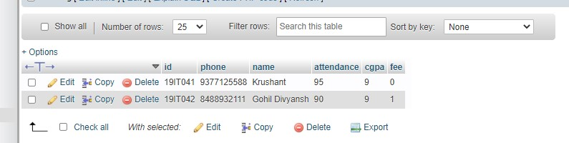

First we have to connect to twilio sandbox to get register in whatapp business account.

To join write: **join ride-it**

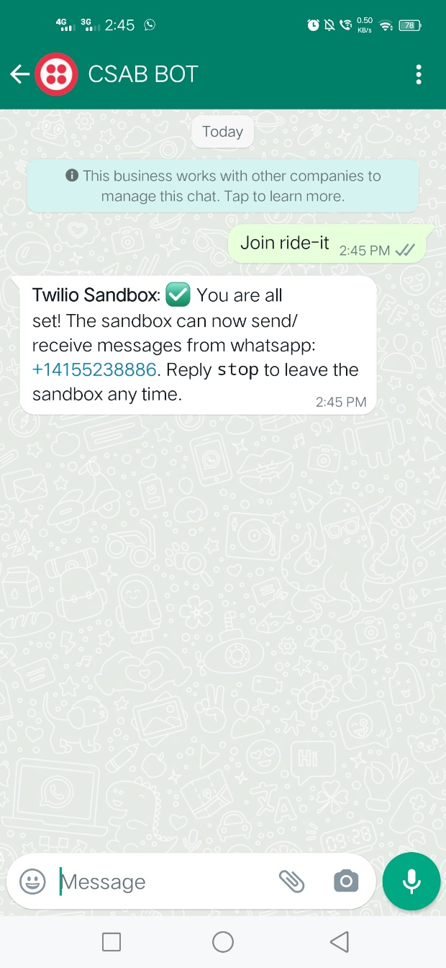

Then write Hello to get information about bot. This bot is still in development so it is not so much interactive.

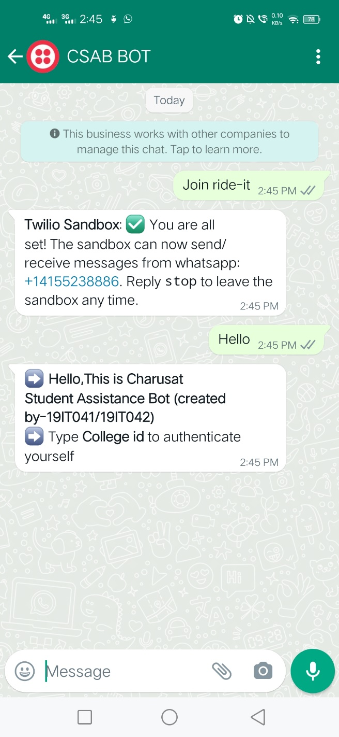

Then write your id which is link with this mobile number.

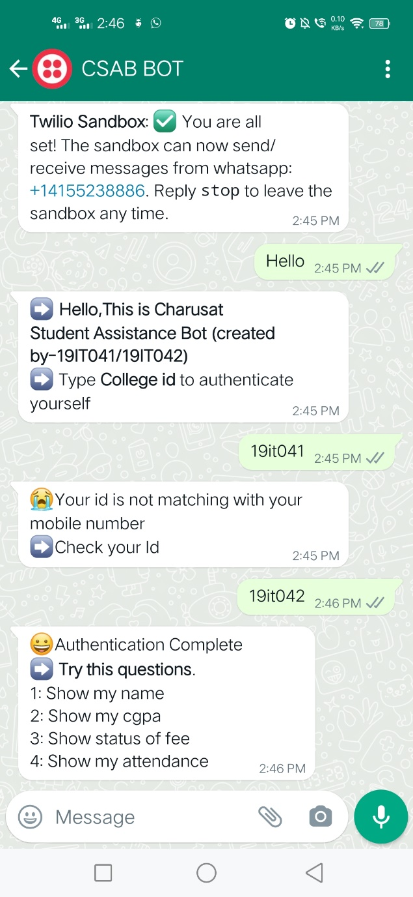

As you can see wrong id and right id will reply above messages. Because my whatapp number is linked with 19IT042.

Then you can ask any question related to your information.

