Game Design Document
Fill up the following document

- Write the title of your project.

THE GALLANT WARRIOR

- What is the goal of the game?

The goal of the game is to beat the opponent at different locations with different weapons.

- Write a brief story of your game.

“THE GALLANT WARRIOR” is a fighting and exciting game.
In this game we are named as a gallant warrior. We have got different opponents in this game. The game will automatically start as we click the play button. Both the PC( Playing character) and the NPC( Non-playing character) will be provided with a lifeline. It will keep on decreasing of the player who has been beaten. The player whose lifeline will first get over will lose the match. The level will become harder and harder for the player. We will get awards on the basis of our performance. This is the story of your game.

Some sound files are as follows:

- Which are the playing characters of this game?
- Playing characters are the ones who respond to the user based on the input from the user.
- Cars, monkeys, dinos, wizards, etc., are the playing characters in the game.

Number | Character Name | What can this character do?
1 | The Gallent Warrior | He has got some super powers. He can hit with his weapons, legs, hand,etc.  He can also attack and defend itself.
2 | The opponent avatar | We can select any of the opponent avatar.  They all will be having different types of power.
3
4
5
6
7
8

- Which are the Non-Playing Characters of this game?
- Non-Playing characters are the ones that don't have an action or behavior when the user interacts with the game.
- Hurdles, stones, bananas, coins, etc., are non-playing characters in the game.

Number | Character Name | What can this character do?
1 | Rock, Fire ,trees,grass,etc | They are just for extra effect.
2 | Weapons-sword,mace,bow & arrow,nunchaku,war hammer,etc. | They are for attacking & defence.
Draw your imagination of this game. What does this game look like?
- Draw the game either on your computer or on paper.
- Add images of the game scenes to show each of the playing and non-playing characters at least once.

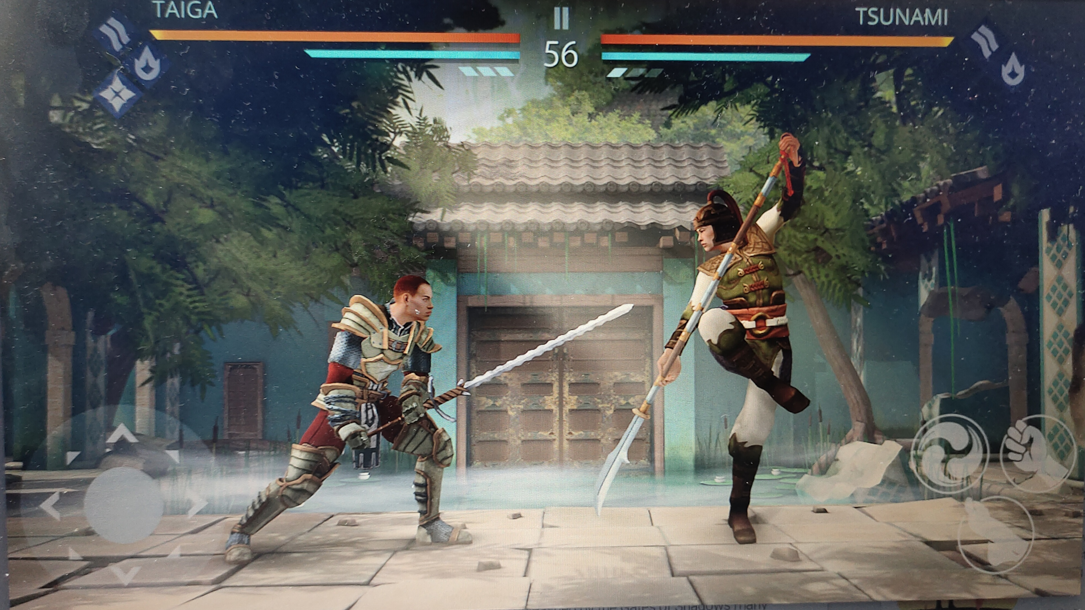

How do you plan to make your game engaging?

The person who one's play this game will be fully engaged on this game because
this game has sound effect, 3D-Effect,different locations at different levels,unleash powers,awards,etc.

