**Web Programming (BCSE203E)**

**Divyansh Mishra**

**23BCE5071**

**Assignment 3**

**Website Live:** [**Github**](https://divyanshm30.github.io/Web_Programming/)

**Image :**

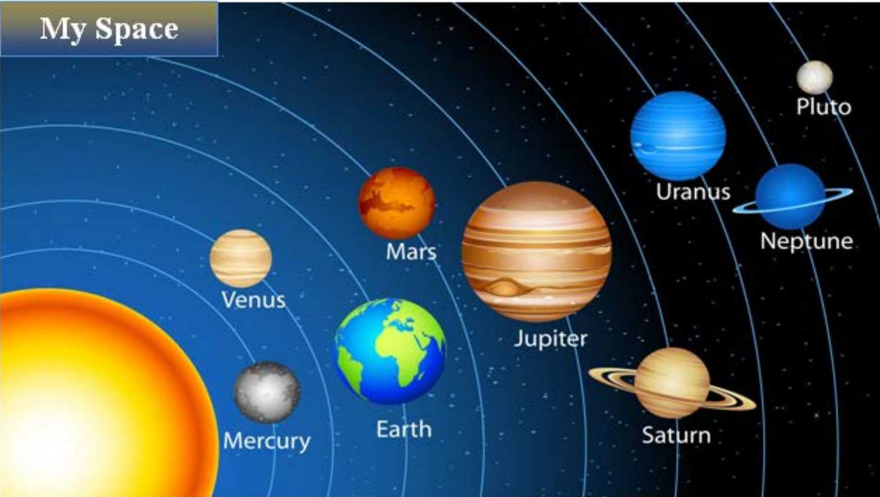

**Code :**

**Index.html**

<!DOCTYPE html>

<html lang="en">

  <head>

    <meta charset="UTF-8" />

    <meta name="viewport" content="width=device-width, initial-scale=1.0" />

    <title>Image Mapping</title>

  </head>

  <body>

    <style>

        .h{

            font-weight: bold;

            font-size: xx-large;

            text-decoration: solid;

        }

    </style>

    <header class="h"> <center>ASSIGNMENT 3 <br> Divyansh Mishra 23BCE5071 </center></header>

    <p>

        Q1. <br>

        <img src="solar.png" usemap="#image-map">

        <map name="image-map">

            <area href="me.html" alt="Divyansh Mishra 23BCE5071" title="Divyansh Mishra 23BCE5071" href="" coords="1,2,388,99" shape="rect">

            <area alt="Ball of Fire " title="Ball of Fire " href="https://en.wikipedia.org/wiki/Sun" coords="92,811,294" shape="circle">

            <area alt="Morning Star" title="Morning Star" href="https://en.wikipedia.org/wiki/Venus" coords="429,464,53" shape="circle">

            <area alt="Blue Planet" title="Blue Planet" href="https://en.wikipedia.org/wiki/Earth" coords="690,629,104" shape="circle">

            <area alt="Largest Planet" title="Largest Planet" href="https://en.wikipedia.org/wiki/Jupiter" coords="955,449,132" shape="circle">

            <area alt="Dwarf Planet" title="Dwarf Planet" href="https://en.wikipedia.org/wiki/Pluto" coords="1451,139,32" shape="circle">

            <area alt="Ring Planet" title="Ring Planet" href="https://en.wikipedia.org/wiki/Saturn" coords="1199,685,1196,620,1159,630,1141,646,1137,656,1102,657,1076,656,1058,659,1048,668,1069,682,1090,692,1117,699,1135,707,1152,733,1170,743,1191,747,1211,744,1226,740,1240,729,1264,726,1297,732,1343,731,1343,718,1323,708,1301,699,1278,691,1261,668,1250,645,1233,630,1196,617" shape="poly">

        </map>

    </p>

  </body>

</html>

**Me.html**

<!DOCTYPE html>

<html lang="en">

<head>

    <meta charset="UTF-8">

    <meta name="viewport" content="width=device-width, initial-scale=1.0">

    <title>Me</title>

</head>

<body>

    <style>

        span{

            background-color:thistle;

            border: 3px solid black;

            font-weight: bold;

            padding: 2px;

        }

    </style>

    <span>Hi! Its Me <br></span>

    <br>

    <span>DIVYANSH MISHRA 23BCE5071</span>

    <hr>

    <div>

        <article>

            Me:

            <img src="https://cdn.vectorstock.com/i/1000v/87/50/man-male-young-person-icon-vector-10458750.jpg" usemap="#image-map">

            <map name="image-map">

                <area title="Me Not really ^_^" href="https://signature.freefire-name.com/img.php?f=2&t=Divyansh" coords="387,150,386,135,396,121,412,111,435,104,451,103,474,105,485,111,499,116,510,126,516,136,517,150" shape="poly">

            </map>

        </div>

        <div>

            About Me: Lorem ipsum dolor sit amet consectetur adipisicing elit. Sequi architecto incidunt quisquam dolorem velit id quod. Rem, dolore ullam officiis unde illo accusantium temporibus. Ratione, nam deserunt! At quam repellat hic repellendus.

        </div>

</body>

</html>