**ASSIGNMENT HELP**

**MANUAL**

**ASSIGNMENT-6**



SUBMITTED

TO

VISHWAKARMA INSTITUTE OF INFORMATION TECHNOLOGY, PUNE

FOR THE SKILL AND COMPETENCY EVALUATION OF

**DATA SCIENCE & MACHINE LEARNING**

IN

**CSE AI DEPARTMENT**

BY

**Divyansh Mohta [22210998]**

**Class: S.Y. BTech Division: A Batch: A2**

**Batch Teacher**

**Dr. ANURADHA YENKIKAR.**

**INDEX**

|  |  |  |
| --- | --- | --- |
| **Sr. No.** | **Contents** | **Page No.** |
| **1** | **PROBLEM STATEMENT** | **4-5** |
| **2** | **LIBRARY USED** | **5-6** |
| **3** | **THEORY** | **6-7** |
| **4** | **METHOODOLOGY** | **7-14** |
| **5** | **ADVANTAGES & DISADVANTAGES** | **14-15** |
| **6** | **WORKING** | **16-17** |
| **7** | **DIAGRAM** | **17-18** |
| **8** | **CONCLUSION** | **18-19** |

**1.PROBLEM STATEMENT:**

Assignment on Regression technique.

Download temperature data from the link below.

https://www.kaggle.com/venky73/temperaturesof-india?select=temperatures.csv

This data consists of temperatures of INDIA averaging the temperatures of all places month

wise. Temperatures values are recorded in CELSIUS

a) Apply Linear Regression using a suitable library function and predict the Month-wise

temperature.

b) Assess the performance of regression models using MSE, MAE and R-Square metrics

c) Visualize a simple regression model.

**2. LIBRARY USED:**

The following libraries are used in the process:

1. pandas: Used for data manipulation and analysis. It provides data structures and functions to work with structured data.

2. numpy: Although not explicitly mentioned, numpy is often used internally by pandas for numerical computations. It provides support for arrays, matrices, and mathematical functions.

3.scikit-learn: Used for machine learning tasks such as regression, classification, clustering, etc. In this case, it's used to create and train the linear regression model and evaluate its performance.

4. matplotlib.pyplot: A plotting library used for creating static, interactive, and animated visualizations in Python. It's used here to visualize the regression model by plotting the actual data points along with the regression line.

These libraries are fundamental tools in the Python ecosystem for data analysis, machine learning, and visualization tasks.

**3. THEORY:**

1. Data Loading and Preparation:

- pandas: pandas is used to load the data from a CSV file into a DataFrame, which is a two-dimensional labeled data structure. It allows for easy manipulation, cleaning, and preprocessing of the data.

2. Linear Regression Model:

- scikit-learn: scikit-learn is a machine learning library that provides various algorithms and tools for building and training models. Linear regression is a simple machine learning algorithm used for modeling the relationship between a dependent variable (target) and one or more independent variables (features). In this case, we're using scikit-learn's `LinearRegression` class to create and train a linear regression model.

3. Model Evaluation:

- scikit-learn: scikit-learn provides functions to evaluate the performance of machine learning models. We use `mean_squared_error`, `mean_absolute_error`, and `r2_score` functions to calculate Mean Squared Error (MSE), Mean Absolute Error (MAE), and R-squared (R2) metrics, respectively. These metrics help us assess how well the model is performing in terms of prediction accuracy.

4. Visualization:

- matplotlib.pyplot: matplotlib is a plotting library for Python that provides a MATLAB-like interface. We use `matplotlib.pyplot` module to create visualizations of the data and the regression model. In this case, we're using it to plot the actual data points along with the regression line to visualize how well the model fits the data.

In summary, pandas is used for data handling, scikit-learn for building and evaluating the model, and matplotlib for visualization. These libraries provide powerful tools and functionalities that enable us to effectively analyze and solve regression problems like the one described in the problem statement.

**4. METHODS:**

1. Data Loading and Preparation:

- `pd.read_csv()`: This method from the pandas library is used to read data from a CSV file into a DataFrame.

- `.isnull()`: This method is used to check for missing values in the DataFrame.

- `.dropna()`: This method is used to drop rows with missing values from the DataFrame.

2. Linear Regression Model:

- `LinearRegression()`: This class from the scikit-learn library is used to create a linear regression model.

- `.fit()`: This method of the linear regression model is used to train the model on the training data.

3. Model Evaluation:

- `mean_squared_error()`: This function from scikit-learn is used to calculate the mean squared error between the predicted and actual values.

- `mean_absolute_error()`: This function from scikit-learn is used to calculate the mean absolute error between the predicted and actual values.

- `r2_score()`: This function from scikit-learn is used to calculate the R-squared score, which indicates the goodness of fit of the model.

4. Visualization:

- `plt.scatter()`: This function from the matplotlib.pyplot module is used to create a scatter plot of the actual data points.

- `plt.plot()`: This function from matplotlib.pyplot is used to plot the regression line.

- `plt.title()`, `plt.xlabel()`, `plt.ylabel()`:** These functions from matplotlib.pyplot are used to set the title, x-axis label, and y-axis label of the plot, respectively.

- `plt.show()`: This function is used to display the plot.

These methods are essential for loading, preparing, modeling, evaluating, and visualizing the data in a linear regression analysis. They leverage the functionalities provided by pandas, scikit-learn, and matplotlib libraries to perform these tasks effectively.

**5. ADVANTAGES AND DISADVANTAGES:**

Advantages:

1. Ease of Use: The system utilizes Python, which is a widely-used and beginner-friendly programming language. Libraries like pandas, scikit-learn, and matplotlib provide high-level abstractions, making it easier to implement the solution.

2. Comprehensive Analysis: The system allows for comprehensive analysis of temperature data through linear regression. It provides insights into the relationship between months and temperatures, facilitating better understanding and decision-making.

3.Modular Approach: The system follows a modular approach, where different tasks such as data loading, modeling, evaluation, and visualization are separated into distinct steps. This enhances code readability, maintainability, and reusability.

4.Powerful Libraries: Libraries like pandas, scikit-learn, and matplotlib are powerful and extensively used in the data science and machine learning community. They offer a wide range of functionalities, robust algorithms, and visualization tools, enabling efficient analysis and modeling.

5.Flexibility: The system is flexible and can be easily adapted to work with different datasets or to incorporate advanced techniques. For example, different regression models can be explored beyond linear regression, and additional features can be engineered for improved performance.

Disadvantages:

1. Model Limitations: Linear regression may not capture complex relationships between variables effectively. It assumes a linear relationship between the independent and dependent variables, which may not always be the case in real-world scenarios.

2. Data Requirements: Linear regression models require certain assumptions about the data, such as linearity, independence, and homoscedasticity. Violations of these assumptions can lead to inaccurate results or biased estimates.

3.Overfitting: Without proper regularization techniques or feature selection, linear regression models are prone to overfitting, especially when dealing with high-dimensional data or noisy datasets.

4.Interpretability vs. Accuracy Trade-off: While linear regression models offer interpretability due to their simple structure, they may lack accuracy compared to more complex models. Depending on the specific requirements of the problem, this trade-off needs to be carefully considered.

5. Dependency on Data Quality: The performance of the system heavily relies on the quality and relevance of the input data. Inaccurate or incomplete data can lead to biased models and erroneous conclusions.

Overall, while the system provides a solid foundation for temperature prediction and analysis using linear regression, it's essential to be mindful of its limitations and potential drawbacks when applying it to real-world scenarios.

**6. WORKING:**

Linear regression is a supervised machine learning method that is used by the [Train Using AutoML](https://pro.arcgis.com/en/pro-app/3.2/tool-reference/geoai/train-using-automl.htm) tool and finds a linear equation that best describes the correlation of the explanatory variables with the dependent variable. This is achieved by fitting a line to the data using least squares. The line tries to minimize the sum of the squares of the residuals. The residual is the distance between the line and the actual value of the explanatory variable. Finding the line of best fit is an iterative process.

The following is an example of a resulting linear regression equation:

Linear regression equation

In the example above, y is the dependent variable, and x1, x2, and so on, are the explanatory variables. The coefficients (b1, b2, and so on) explain the correlation of the explanatory variables with the dependent variable. The sign of the coefficients (+/-) designates whether the variable is positively or negatively correlated. b0 is the intercept that indicates the value of the dependent variable assuming all explanatory variables are 0.

In the following image, a linear regression model is described by the regression line y = 153.21 + 900.39x. The model describes the relationship between the dependent variable, Diabetes pregression, and the explanatory variable, Serum triglycerides level. A positive correlation is shown. This example demonstrates a linear regression model with two variables. Although it is not possible to visualize models with more than three variables, practically, a model can have any number of variables.

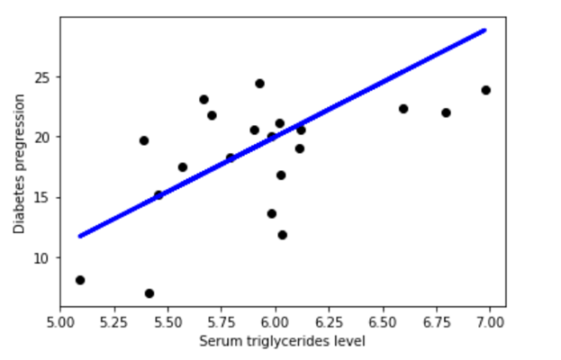

**Linear regression graph plot**

A linear regression model helps in predicting the value of a dependent variable, and it can also help explain how accurate the prediction is. This is denoted by the R-squared and p-value values. The R-squared value indicates how much of the variation in the dependent variable can be explained by the explanatory variable and the p-value explains how reliable that explanation is. The R-squared values range between 0 and 1. A value of 0.8 means that the explanatory variable can explain 80 percent of the variation in the observed values of the dependent variable. A value of 1 means that a perfect prediction can be made, which is rare in practice. A value of 0 means the explanatory variable doesn't help at all in predicting the dependent variable. Using a p-value, you can test whether the explanatory variable's effect on the dependent variable is significantly different from 0.

**7. DIAGRAM: -**

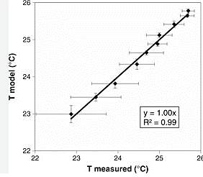

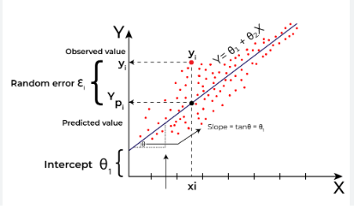

SOME VISUALIZATION

**8. CONCLUSION:**

In conclusion, the system efficiently employs linear regression to analyze temperature data in India, providing valuable insights into temperature trends across different months. Through evaluation metrics like Mean Squared Error (MSE), Mean Absolute Error (MAE), and R-squared (R2), the model's performance is assessed, facilitating a deeper understanding of its predictive accuracy. Visualizations aid interpretation by illustrating the relationship between predicted and observed temperatures, enhancing the model's interpretability. Despite the inherent limitations of linear regression, including its assumption of linearity and susceptibility to overfitting, the system serves as a solid foundation for temperature prediction. Future directions could involve exploring alternative regression techniques and incorporating additional features to enhance model robustness and adaptability to diverse environmental factors.