Fundamentals of AI and ML
(CSA2001)

Project Report: AI Travel Planner

Name: Divyansh Godghate
Registration No.: 25BAI11202
Branch: Computer Science & Engineering
Specialisation: Artificial Intelligence and Machine Learning
Year: 1st Year

Project Abstract
The AI Travel Planner is a sophisticated desktop application designed to simplify the complexity of travel itinerary creation. By leveraging a structured knowledge base of global heritage sites and cultural landmarks, the application generates comprehensive, time-blocked schedules. It provides users with a seamless transition from digital planning to a professional-grade physical or digital PDF document, ensuring all logistical details from morning excursions to evening relaxation are curated for an optimal travel experience.

Technical Specifications
- User Interface: A custom-themed Dark Mode interface built with Tkinter, featuring a gold-and-slate aesthetic for a premium user experience.
- Document Generation: Integration of the ReportLab library to programmatically generate A4-sized PDF itineraries with custom branding, table styles, and color-coded headers.
- Concurrency Management: Implementation of threading to handle intensive PDF generation and "AI simulation" steps (like route optimization and heritage mapping) without interrupting the UI responsiveness.
- Data Architecture: A multi-layered dictionary system that stores historical context, activity descriptions, and time-specific tags for over a dozen major cultural hubs.
- Intelligent Recommendation Engine (KNN): Implementation of a K-Nearest Neighbours (KNN) algorithm using scikit-learn. The system performs multi-dimensional vector matching between user preferences and a city-interest matrix. It utilizes MinMaxScaler for feature normalization and Cosine Similarity to ensure high-precision destination matching based on unique cultural and travel attributes.
- Natural Language Processing (NLP) Module: A custom-built, rule-based NLP Engine that utilizes regular expressions (re) and lexicon mapping. The engine performs entity extraction to identify city names and intent classification to map user-typed keywords.
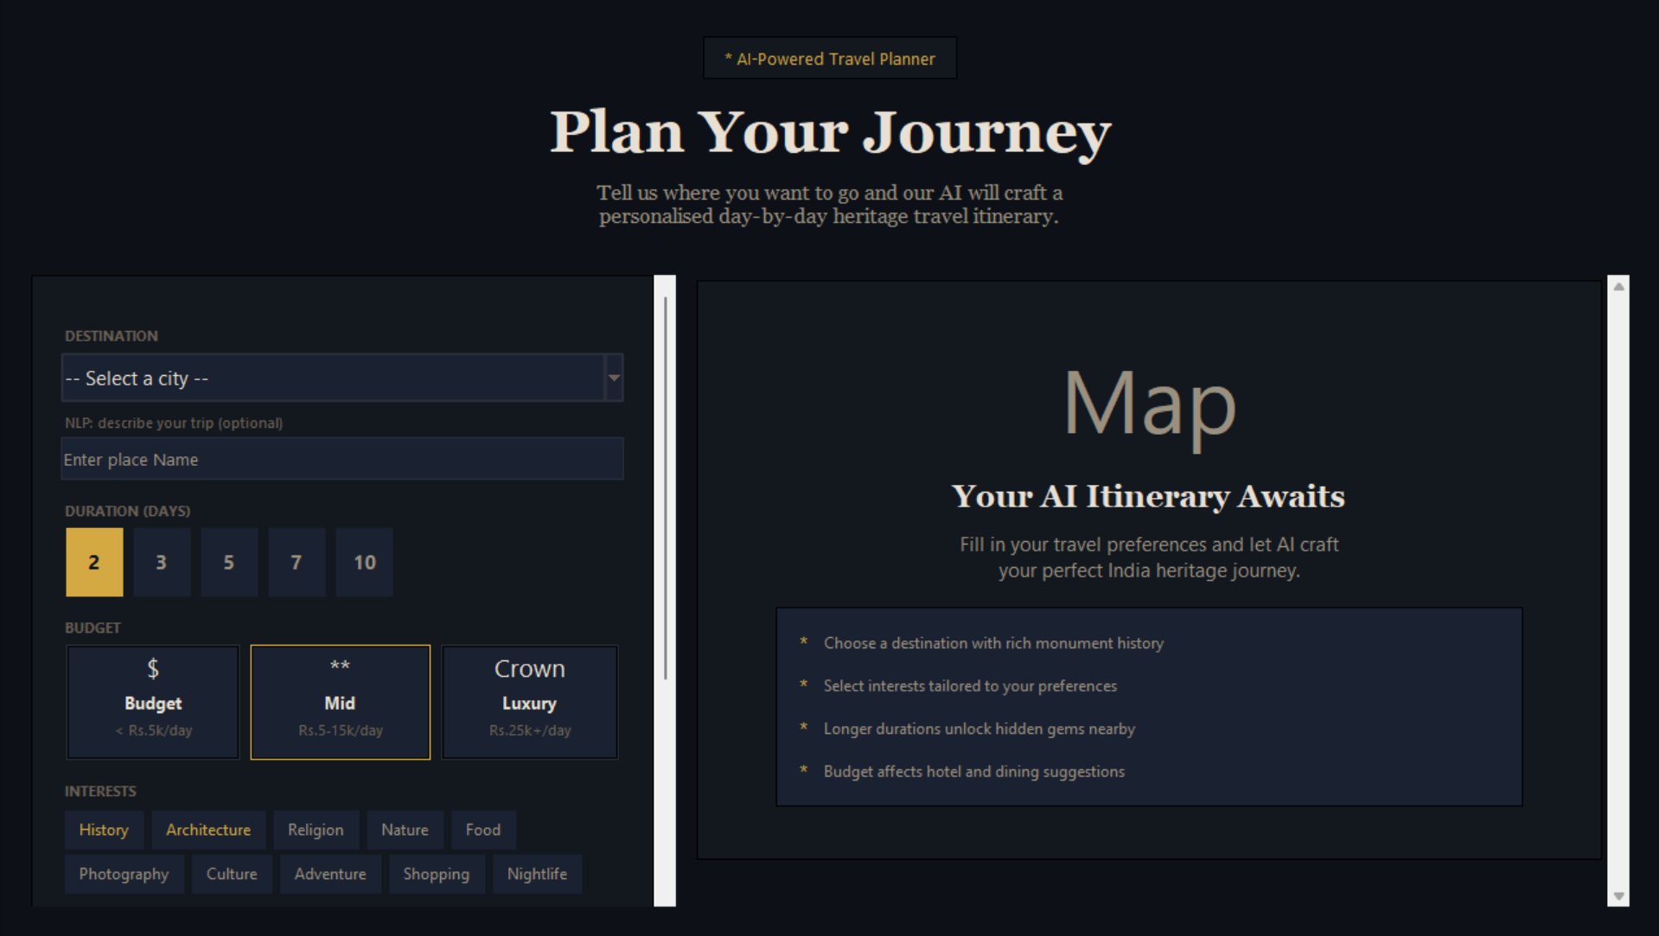
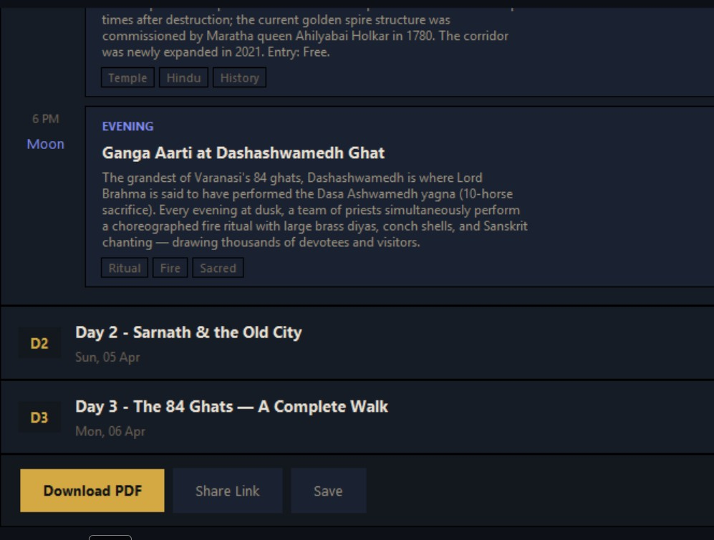

Key Features
- Intelligent Itinerary Logic: Users can define their destination, trip duration (up to 10 days), and travel pace. The system dynamically scales the content to fit the requested timeframe.
- Budget Tiering: Integrated estimation for Budget, Mid-range, and Luxury travel styles, helping users plan according to financial preferences.
- Time-Block Scheduling: Each day is divided into three distinct phases:
  - Morning (7:00 AM): High-energy heritage visits.
  - Afternoon (1:00 PM): Cultural immersion and museums. o Evening (6:00 PM): Local cuisine and leisure.
- Professional Export Options: * PDF Report: A formal document with embedded metadata and structured tables.
  - Digital Share: Generation of a temporary HTML/browser-viewable version for quick mobile access.

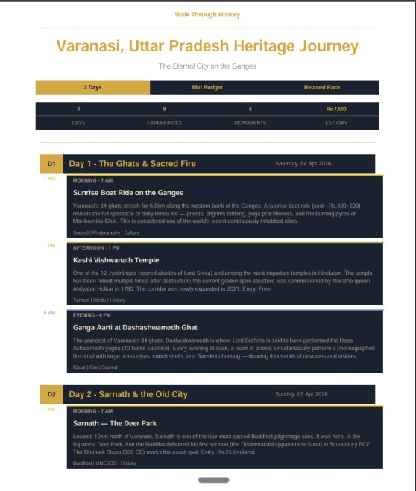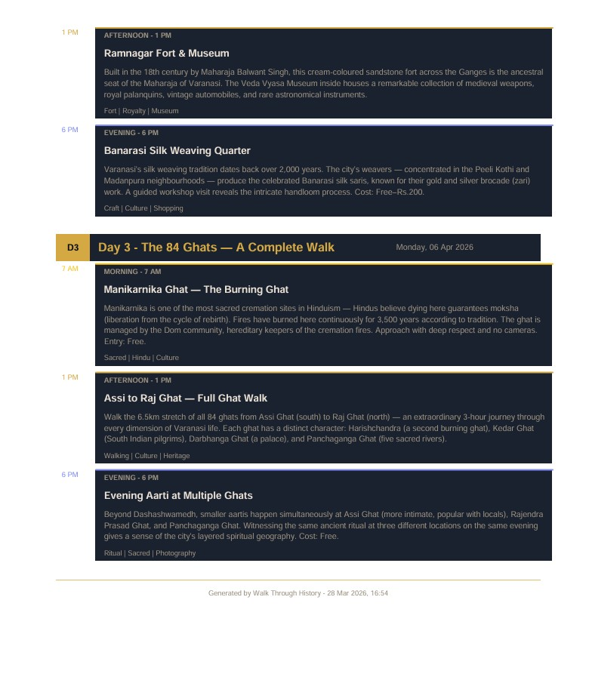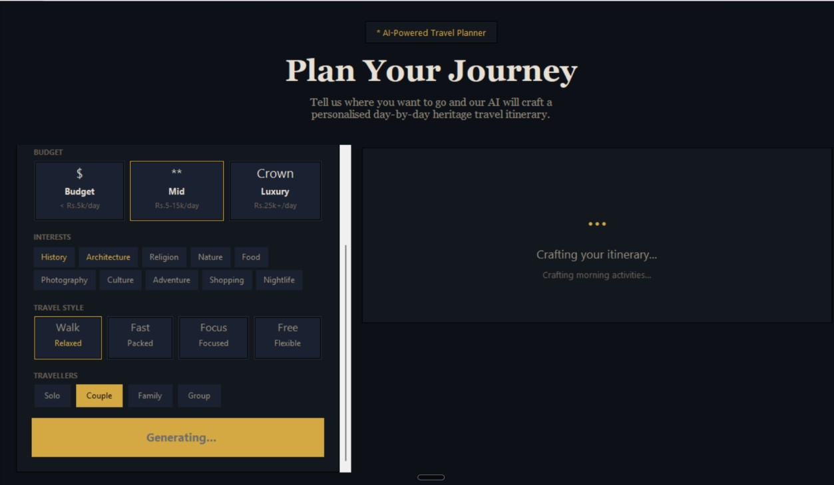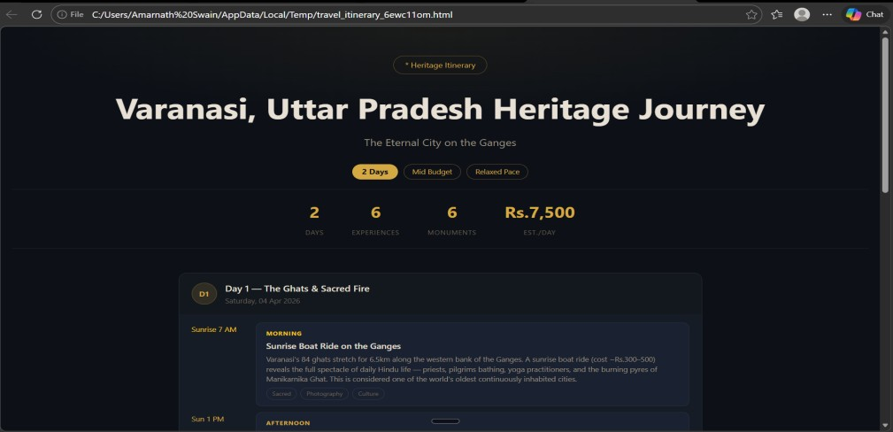

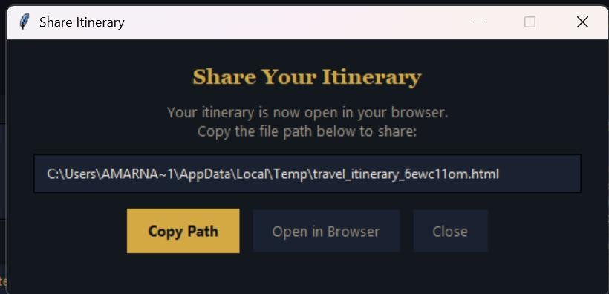

System Workflow
- Input Phase: The user selects a destination (e.g., Agra, Delhi, Jaipur) and configures trip parameters via the dashboard.
- Simulation Phase: The "AI Engine" performs a series of mock-processing steps, including mapping heritage sites by era and optimizing travel distances.
- Assembly Phase: The SimpleDocTemplate engine gathers the data, applies Paragraph Styles, and constructs the visual layout.
- Output Phase: The final report is saved to the local system and can be instantly opened for review or printing.
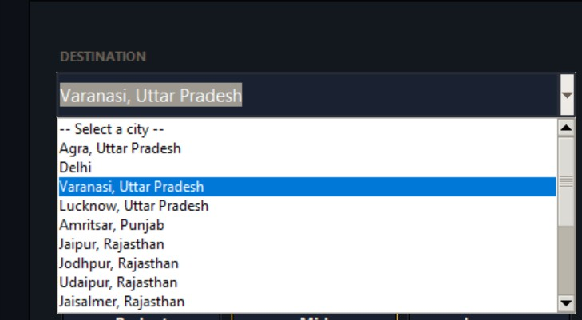

Future Enhancements
- Real-time API Integration: Connecting to live weather and Google Maps APIs for real-time travel alerts.
- Machine Learning Integration: Analysing user feedback to refine destination suggestions based on past preferences.
- Multi-Language Support: Localizing the generated reports for international travellers.

Conclusion
The AI Travel Planner successfully bridges the gap between automated data processing and usercentric design, providing a high-utility tool for modern travellers seeking structured exploration.

Thank You

