WEEK 3 TASK
Statistical Analysis and Hypothesis Testing in Python
What drives tipping in a restaurant? A hypothesis-driven study of 244 table-level observations
Item | Detail
Dataset | Restaurant Tips (public; Bryant & Smith, Practical Data Analysis, 1995; distributed with seaborn)
Sample | 244 parties served by one waiter over 4 days (Thu–Sun)
Tests | Welch t-test, one-way ANOVA + Tukey HSD, chi-square, Pearson/Spearman, OLS regression, TOST equivalence
Tools | Python 3 · pandas · SciPy · statsmodels · seaborn · matplotlib
Significance level | α = 0.05 (two-sided), Holm correction across the four primary hypotheses

Contents
1. Executive Summary
2. Introduction and Hypothesis Formulation
3. Methodology
4. Data Description and Exploratory Analysis
5. Statistical Analysis and Results (H1 – H4)
6. Robustness, Multiplicity and Sensitivity Checks
7. Conclusions and Implications
A. Appendix A: Reproducing the Analysis
B. Appendix B: References

1. Executive Summary
Restaurant managers routinely make staffing, scheduling and incentive decisions on the belief that tipping behaviour differs by shift, weekday or customer segment. This study tests that belief formally, using a public dataset of 244 restaurant bills and tips. Four pre-specified hypotheses were tested with appropriate parametric and non-parametric methods, and every result was accompanied by an effect size and a confidence interval.
Headline findings
Tip percentage does not differ meaningfully by meal time (H1), day of week (H2) or in the share of ‘generous’ tippers (H3). All three nulls were retained (p = 0.514, 0.469 and 0.546). Effects are small (d = 0.08, η² = 0.010, V = 0.039). Tip amount is strongly related to bill size (H4), r = 0.68, p < 0.001, but the relationship is not proportional: each extra $10 on the bill adds about $1.05 in tips, so the tip percentage falls as bills grow (r = -0.34).

The practical message is that bill size, not calendar or segment variables, is the only reliable predictor of tips in this data. The report also shows why a ‘not significant’ result must be read alongside power and equivalence analysis, rather than as proof of no effect.

2. Introduction and Hypothesis Formulation

2.1 Business problem
Tips form a large share of front-of-house income and are a proxy for customer satisfaction. If tipping rates differ systematically between lunch and dinner, or between weekdays and weekends, a restaurant could justify different staffing levels, training focus or incentive schemes. If they do not, such interventions would be unsupported by the evidence. The question is therefore: which observable factors are associated with how much customers tip?

2.2 Formal hypotheses
Four testable hypotheses were defined before looking at the outcomes. The outcome variable is tip percentage (tip ÷ total bill × 100), which normalises for the size of the meal.
ID | Null hypothesis (H₀) | Alternative (H₁) | Test
H1 | Mean tip % is equal at lunch and dinner | Mean tip % differs between lunch and dinner | Welch t-test
H2 | Mean tip % is equal on all four days | At least one day has a different mean tip % | One-way ANOVA
H3 | Being a ‘generous’ tipper (≥ 15%) is independent of meal time | Generosity is associated with meal time | Chi-square test of independence
H4 | Tip amount is uncorrelated with bill size (ρ = 0) | Tip amount and bill size are correlated (ρ ≠ 0) | Pearson r + OLS regression

3. Methodology

3.1 Study design and data
The study is an observational, cross-sectional analysis of an existing public dataset, so no random assignment was possible. Each row is one party’s bill. The data were loaded directly into pandas; the variables used are listed below.
Variable | Type | Description
total_bill | Continuous ($) | Bill amount
tip | Continuous ($) | Tip given
tip_pct (derived) | Continuous (%) | tip / total_bill × 100
generous (derived) | Binary | 1 if tip_pct ≥ 15, else 0
time | Categorical | Lunch or Dinner
day | Categorical | Thu, Fri, Sat, Sun
sex, smoker, size | Categorical / count | Payer’s sex, smoking section, party size

3.2 Analytical approach
- Data quality: missing values, duplicates, distribution shape and outliers were checked before any inference.
- Assumption checks: Shapiro–Wilk (normality), Levene/Brown–Forsythe (equal variances), Q-Q plots and Breusch–Pagan (heteroscedasticity).
- Primary tests: Welch t-test (no equal-variance assumption), ANOVA with Tukey HSD post-hoc, Pearson chi-square, and Pearson correlation with OLS regression.
- Robustness: a non-parametric counterpart for each test (Mann–Whitney, Kruskal–Wallis, Fisher’s exact, Spearman), bootstrap confidence intervals and heteroscedasticity-robust (HC3) standard errors.
- Effect sizes and CIs: Cohen’s d, η², Cramér’s V, r and regression slopes, each with a 95% confidence interval wherever applicable.
- Power and equivalence: power and minimum detectable effect for H1, and a TOST equivalence test, so that non-significant results can be interpreted properly.
- Multiplicity: Holm–Bonferroni adjustment across the four primary p-values.

3.3 Setup code
import numpy as np, pandas as pd
from scipy import stats
import statsmodels.api as sm, statsmodels.formula.api as smf
from statsmodels.stats.multicomp import pairwise_tukeyhsd
from statsmodels.stats.power import TTestIndPower
import matplotlib.pyplot as plt, seaborn as sns

df = pd.read_csv("tips.csv")
df["tip_pct"] = df["tip"] / df["total_bill"] * 100
df["generous"] = (df["tip_pct"] >= 15).astype(int)
df["day"] = pd.Categorical(df["day"], ["Thur","Fri","Sat","Sun"], ordered=True)

4. Data Description and Exploratory Analysis
The dataset contains 244 observations with 0 missing values. One pair of rows is identical (two $13.00 bills with a $2.00 tip, Thursday lunch, same party profile); because coincident bills are plausible they were retained. Dinner accounts for 176 parties and lunch for 68.
Table 1. Descriptive statistics
Variable | Mean | Std. dev. | Min | Median | Max
Total bill ($) | 19.79 | 8.90 | 3.07 | 17.80 | 50.81
Tip ($) | 3.00 | 1.38 | 1.00 | 2.90 | 10.00
Tip (%) | 16.08 | 6.11 | 3.56 | 15.48 | 71.03
Party size | 2.57 | 0.95 | 1.00 | 2.00 | 6.00
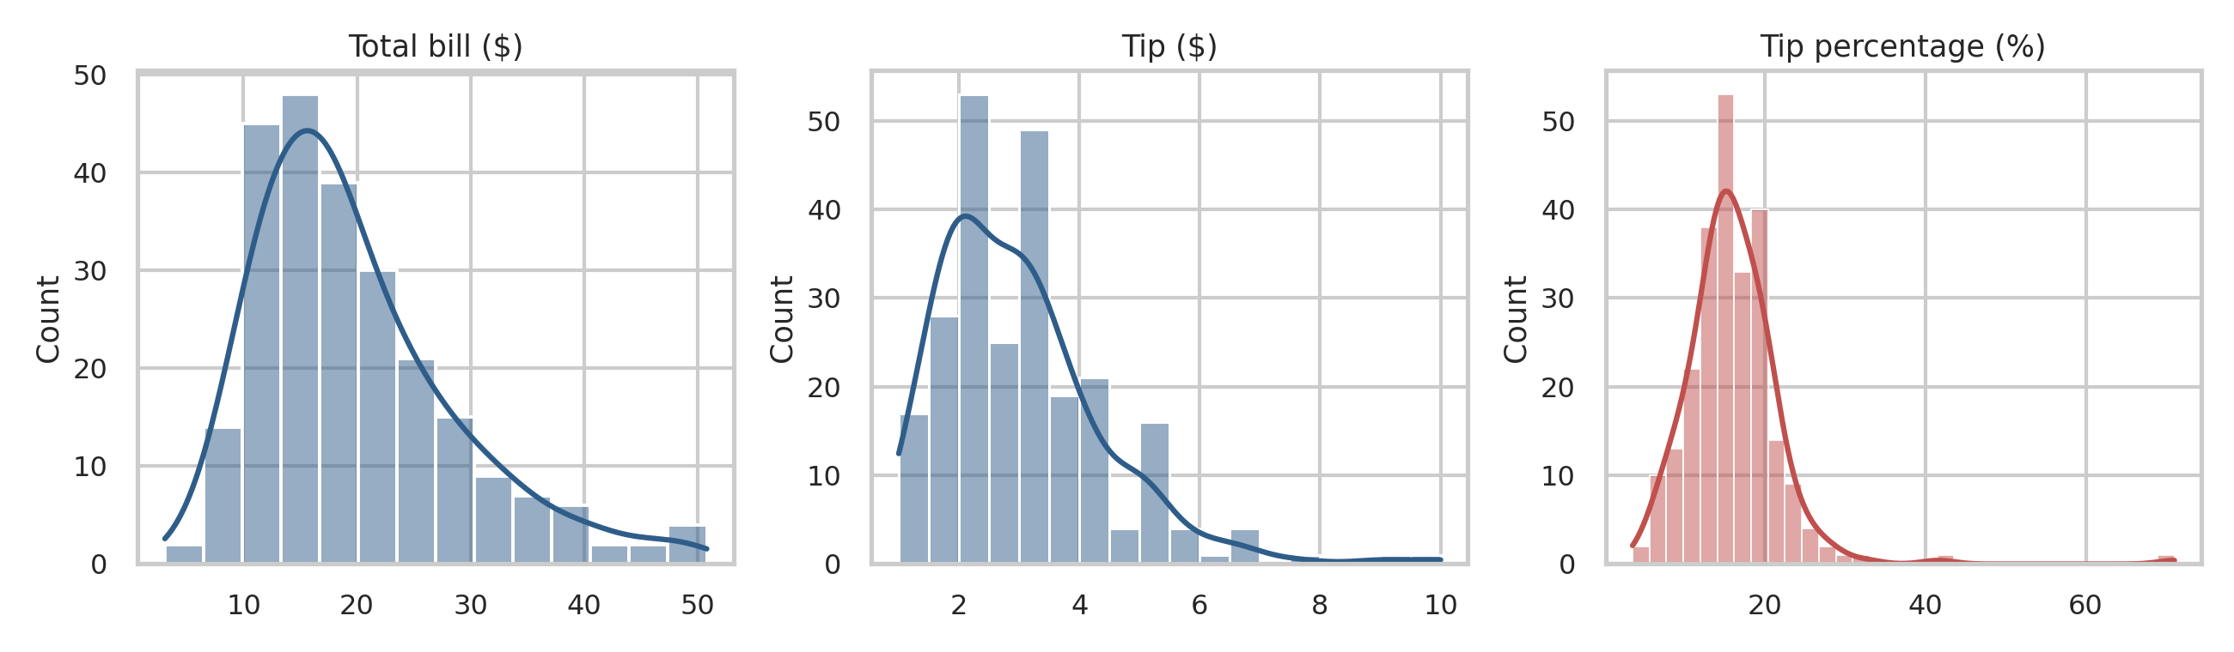
Figure 1. Distributions of bill, tip and tip percentage
Bills and tips are right-skewed, as is typical for spending data. Tip percentage is centred near 16.1% but has a heavy right tail (skewness = 3.33, excess kurtosis = 26.6), caused by a handful of very high tippers, including one party that tipped 71% on a small bill. This matters for method choice: normality-based tests on tip % need robustness checks, which is why every parametric test below is paired with a non-parametric alternative.
Design caveat: meal time and day of week are almost perfectly entangled. Lunch occurs on 61 of 62 Thursday parties and 7 of 19 Friday parties and never on weekends, while Saturday and Sunday are dinner-only. H1 and H2 therefore cannot be separated cleanly from each other, which is noted again in the limitations.

5. Statistical Analysis and Results

5.1 H1: Does tip percentage differ between lunch and dinner?
A Welch t-test was used because group sizes are unequal (68 vs 176) and variances may differ. Normality and variance assumptions were checked first.
lunch = df.loc[df.time == "Lunch", "tip_pct"]
dinner = df.loc[df.time == "Dinner", "tip_pct"]

stats.shapiro(lunch), stats.shapiro(dinner) # normality
stats.levene(lunch, dinner, center="median") # equal variances
t = stats.ttest_ind(lunch, dinner, equal_var=False) # Welch t-test
stats.mannwhitneyu(lunch, dinner) # non-parametric check
# Cohen's d with pooled SD; bootstrap CI from 10,000 resamples
boot = [rng.choice(lunch, 68).mean() - rng.choice(dinner, 176).mean()
for _ in range(10000)]
TTestIndPower().power(effect_size=d, nobs1=68, ratio=176/68, alpha=.05)

Table 2. Group summaries for H1
Statistic | Lunch (n = 68) | Dinner (n = 176)
Mean tip % | 16.41 | 15.95
Std. deviation | 4.02 | 6.75
Median tip % | 15.41 | 15.54
Shapiro–Wilk p | 0.485 | < 0.001
Table 3. Inferential results for H1
Test / quantity | Result
Levene (Brown–Forsythe) test | W = 2.43, p = 0.120
Welch t-test | t(200.9) = 0.65, p = 0.514
Mean difference (Lunch − Dinner) | 0.46 pp, 95% CI [-0.93, 1.85]
Bootstrap 95% CI of difference | [-0.94, 1.81]
Cohen’s d | 0.075 (negligible)
Mann–Whitney U | U = 6577.5, p = 0.230
Power at observed d / minimum detectable d (80% power) | 0.08 / 0.40
TOST equivalence, bounds ± 2 pp | p = 0.015
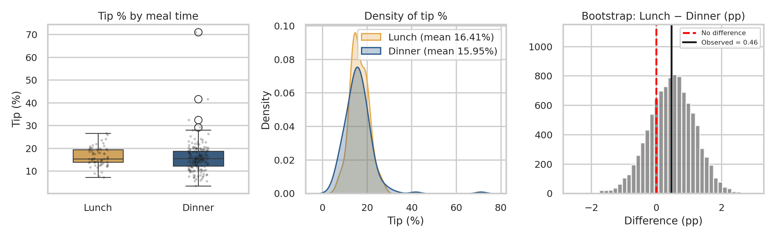
Figure 2. Tip % by meal time: box plots, density curves and bootstrap distribution of the mean difference

Interpretation
The p-value (0.514) is well above 0.05, so we fail to reject H₀. Lunch parties tipped 0.46 percentage points more on average, but the 95% CI [-0.93, 1.85] comfortably includes zero, and the bootstrap interval and Mann–Whitney test agree. Dinner tip % is clearly non-normal (Shapiro p < 0.001) because of outliers, yet with n = 176 the t-test is robust to this and the rank-based test reaches the same conclusion.
A non-significant p-value alone is not evidence of no difference. This sample could reliably (80% power) detect only d ≈ 0.40, roughly 2.4 percentage points, so smaller effects cannot be ruled out by the t-test. The TOST equivalence test addresses this directly: against a ± 2 pp margin (a difference too small to matter to a restaurant), equivalence is supported (p = 0.015). That margin is a judgement call, and the outlier sensitivity check in Section 6 shows the result is somewhat dependent on a few extreme tips.

5.2 H2: Does tip percentage differ across days of the week?
anova_m = smf.ols("tip_pct ~ C(day)", df).fit()
anova_t = sm.stats.anova_lm(anova_m, typ=2)
eta2 = anova_t.loc["C(day)","sum_sq"] / anova_t["sum_sq"].sum()

groups = [g.tip_pct.values for _, g in df.groupby("day", observed=True)]
stats.levene(*groups, center="median") # homogeneity of variance
stats.shapiro(anova_m.resid) # residual normality
stats.kruskal(*groups) # non-parametric check
pairwise_tukeyhsd(df.tip_pct, df.day.astype(str), alpha=.05) # post-hoc

Table 4. Tip percentage by day
Day | n | Mean tip % | Std. dev. | Median
Thur | 62 | 16.13 | 3.87 | 15.38
Fri | 19 | 16.99 | 4.77 | 15.56
Sat | 87 | 15.31 | 5.13 | 15.18
Sun | 76 | 16.69 | 8.47 | 16.11
Table 5. ANOVA results
Test / quantity | Result
Levene test (equal variances) | W = 1.69, p = 0.170
Shapiro–Wilk on residuals | W = 0.803, p < 0.001
One-way ANOVA | F(3, 240) = 0.85, p = 0.469
Effect size η² | 0.010 (about 1% of variance)
Kruskal–Wallis | H = 1.84, p = 0.607
Tukey HSD, smallest adjusted p | 0.481 (all six pairs non-significant)
Table 6. Tukey HSD post-hoc comparisons (reported for completeness)
Pair | Mean diff (pp) | 95% CI | Adj. p
Fri − Sat | -1.68 | [-5.68, 2.33] | 0.700
Fri − Sun | -0.30 | [-4.36, 3.75] | 0.998
Fri − Thur | -0.86 | [-5.01, 3.28] | 0.949
Sat − Sun | 1.37 | [-1.11, 3.86] | 0.481
Sat − Thur | 0.81 | [-1.82, 3.44] | 0.855
Sun − Thur | -0.56 | [-3.27, 2.14] | 0.950
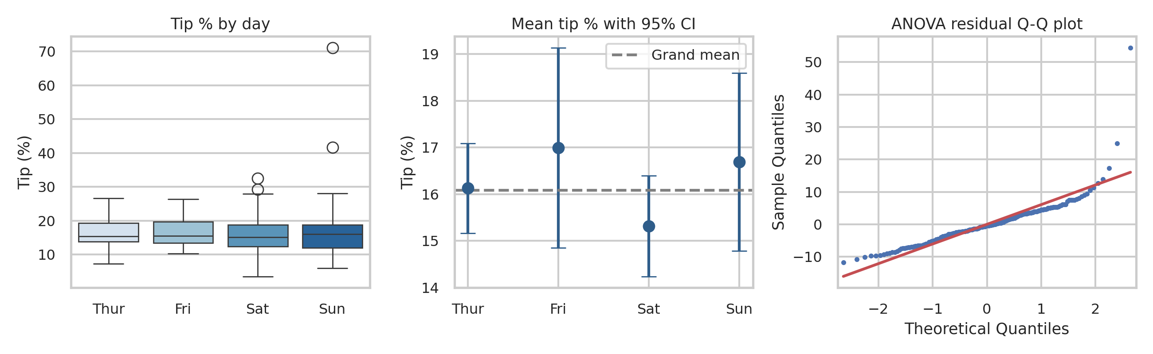
Figure 3. Tip % by day, group means with 95% CIs and residual Q-Q plot

Interpretation
The omnibus ANOVA is not significant (F = 0.85, p = 0.469), so we fail to reject H₀: there is no evidence that mean tip % varies by day. Day explains only 1.0% of the variance. The Kruskal–Wallis test (p = 0.607) agrees, which matters because residuals depart from normality (Q-Q plot shows heavy upper tail). Variances are statistically homogeneous (Levene p = 0.170), although Sunday is visibly more dispersed (SD 8.5 vs 3.9 on Thursday), driven by the extreme tips. Tukey comparisons were run for completeness; as expected after a non-significant omnibus test, no pair differs. Friday has only 19 parties so its interval is wide.

5.3 H3: Is generous tipping (≥ 15%) associated with meal time?
To complement the mean-based tests, tip percentage was dichotomised at the conventional 15% benchmark and the association with meal time tested with a Pearson chi-square test of independence. This is robust to the outliers that affect the means.
ct = pd.crosstab(df.time, df.generous)
chi2, p, dof, expected = stats.chi2_contingency(ct, correction=False)
cramers_v = np.sqrt(chi2 / (ct.values.sum() * (min(ct.shape) - 1)))
stats.chi2_contingency(ct, correction=True) # Yates continuity correction
stats.fisher_exact(ct.values) # exact test check
expected.min() # assumption: all expected counts >= 5

Table 7. Contingency table: meal time by generous tipping
Meal time | Below 15% | ≥ 15% | % generous | 95% Wilson CI
Dinner | 80 | 96 | 54.5% | [47.2, 61.7]
Lunch | 28 | 40 | 58.8% | [47.0, 69.7]
Table 8. Chi-square results for H3
Test / quantity | Result
Pearson chi-square | χ²(1) = 0.364, p = 0.546
Yates-corrected chi-square | χ² = 0.211, p = 0.646
Fisher’s exact test | p = 0.568, odds ratio = 1.19
Cramér’s V | 0.039 (negligible)
Smallest expected cell count | 30.1 (assumption of ≥ 5 satisfied)
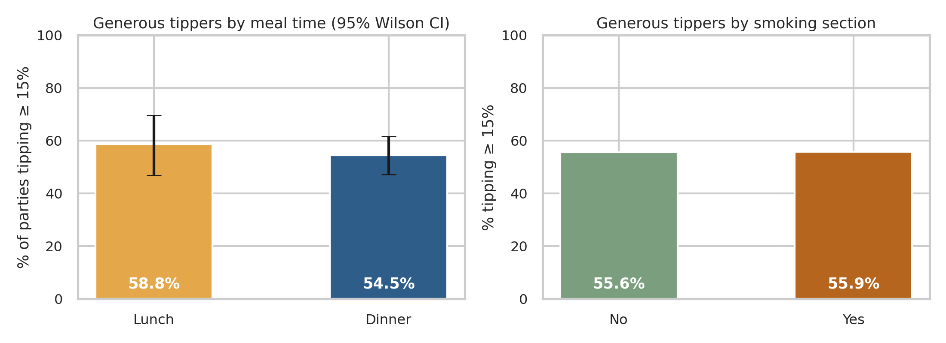
Figure 4. Share of parties tipping at least 15%, by meal time and by smoking section

Interpretation
About 58.8% of lunch and 54.5% of dinner parties tipped at least 15%. The difference is not statistically significant (χ² = 0.364, p = 0.546), and the Yates and Fisher versions agree, so we fail to reject H₀. Cramér’s V of 0.039 indicates practically no association. As exploratory follow-ups using the same method, generosity was also unrelated to smoking section (p = 0.965), payer’s sex (p = 0.225) or day (p = 0.923); these were not part of the four primary hypotheses and are not corrected for multiplicity.

5.4 H4: Is tip amount related to the size of the bill?
Correlation was used to test whether tip and bill are linearly related, and OLS regression to quantify the relationship. Because the regression residuals were found to be heteroscedastic, heteroscedasticity-robust (HC3) confidence intervals are reported alongside the classical ones.
pear = stats.pearsonr(df.total_bill, df.tip)
spear = stats.spearmanr(df.total_bill, df.tip)
stats.pearsonr(df.total_bill, df.tip_pct) # tip % vs bill

ols = smf.ols("tip ~ total_bill", df).fit()
ols_rb = smf.ols("tip ~ total_bill", df).fit(cov_type="HC3") # robust SEs
sm.stats.het_breuschpagan(ols.resid, ols.model.exog)

multi = smf.ols("tip ~ total_bill + size + C(time) + C(smoker) + C(sex)",
df).fit(cov_type="HC3")

Table 9. Correlation and simple regression results
Test / quantity | Result
Pearson r (tip vs bill) | r = 0.676, 95% CI [0.601, 0.739], p < 0.001
Spearman ρ | ρ = 0.679, p < 0.001
Simple OLS slope | $0.105 per $1 of bill, 95% CI [0.091, 0.120]
Robust (HC3) slope CI | [0.081, 0.129]
Intercept | $0.92
R² | 0.457
Breusch–Pagan test | LM = 47.9, p < 0.001 (heteroscedastic)
Tip % vs bill: Pearson r / Spearman ρ | -0.339 / -0.321, both p < 0.001
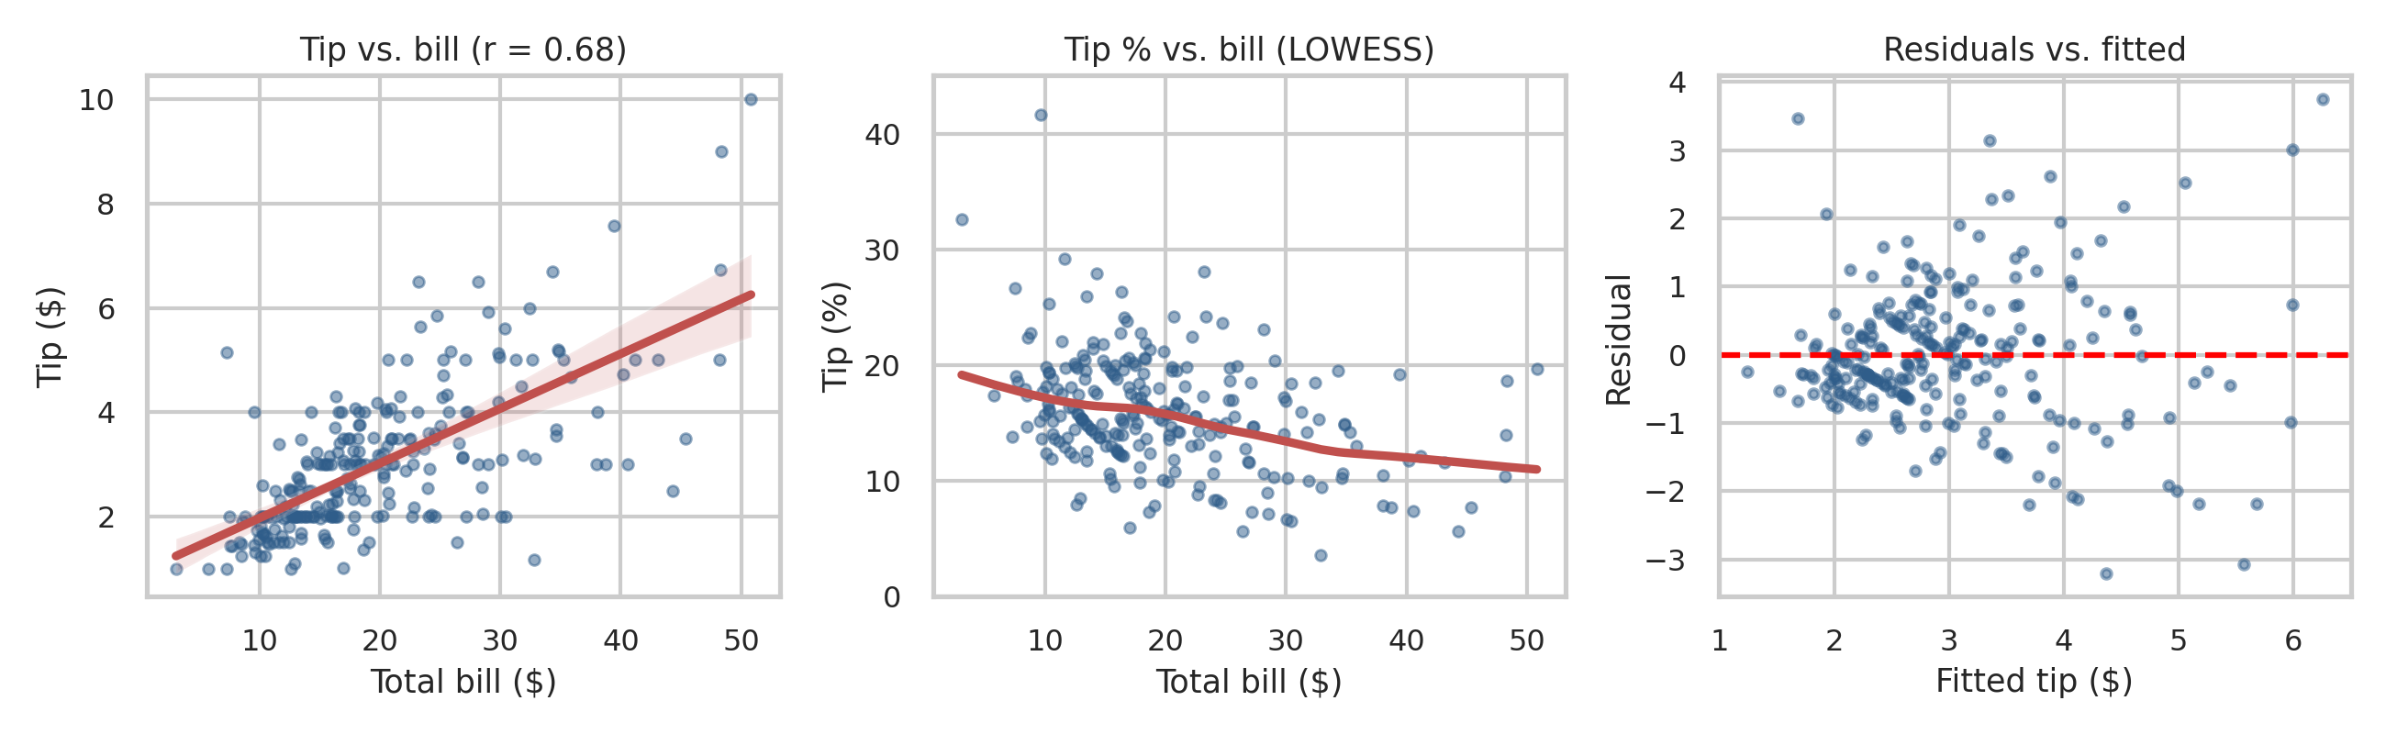
Figure 5. Tip vs bill with fitted line, tip % vs bill (LOWESS) and residuals vs fitted values
Table 10. Multiple regression of tip ($) with HC3 standard errors (R² = 0.469, adjusted R² = 0.458)
Predictor | Coefficient ($) | Robust SE | 95% CI | p
Intercept | 0.725 | 0.252 | [0.23, 1.22] | 0.004
Total bill ($) | 0.094 | 0.017 | [0.06, 0.13] | < 0.001
Party size | 0.180 | 0.117 | [-0.05, 0.41] | 0.124
Lunch (vs dinner) | -0.005 | 0.123 | [-0.25, 0.24] | 0.968
Smoker (vs non-smoker) | -0.084 | 0.151 | [-0.38, 0.21] | 0.578
Male payer (vs female) | -0.028 | 0.130 | [-0.28, 0.23] | 0.829

Interpretation
The tip–bill correlation is strong and positive (r = 0.68, p < 0.001), so we reject H₀. Each additional $1 on the bill is associated with about 10.5 cents more in tips, and bill size alone explains 45.7% of tip variance. The slope’s CI is stable whether classical or robust errors are used, so the heteroscedasticity detected by the Breusch–Pagan test (the spread of tips grows with the bill, visible in the residual plot) does not threaten the conclusion.
The relationship is not proportional. A positive intercept (about $0.92) combined with a slope near 10 cents per dollar means small bills receive proportionally larger tips, so tip % falls as the bill grows (r = -0.34, p < 0.001; LOWESS curve in Figure 5, middle). In the multiple regression, total bill is the only significant predictor (p < 0.001) once party size, meal time, smoking section and sex are accounted for; the others have CIs spanning zero, consistent with H1–H3. Party size is not significant once bill is controlled for (p = 0.124), probably because the two are strongly correlated.
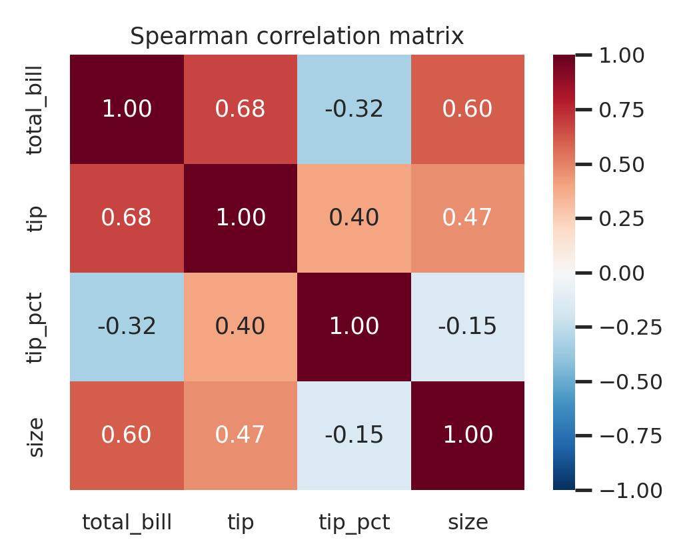
Figure 6. Spearman correlation matrix of the numeric variables

6. Robustness, Multiplicity and Sensitivity Checks

6.1 Multiple-testing correction
Testing four hypotheses inflates the chance of a false positive. Holm–Bonferroni adjustment was applied to the four primary p-values.
Table 11. Holm correction across the four primary hypotheses
Hypothesis | Raw p | Holm-adjusted p | Decision at α = 0.05
H1 Welch t-test (time) | 0.514 | 1.000 | Retain H₀
H2 ANOVA (day) | 0.469 | 1.000 | Retain H₀
H3 chi-square (time) | 0.546 | 1.000 | Retain H₀
H4 Pearson (bill~tip) | < 0.001 | < 0.001 | Reject H₀
The correction does not change any decision: the three nulls stay retained and H4 remains overwhelmingly significant.

6.2 Outlier sensitivity
Tukey’s 1.5 × IQR rule flags 4 observations (tip % of 32.6%, 71.0%, 41.7%, 29.2%; upper fence 28.5%). The tests were rerun without them:
Table 12. Sensitivity of results to extreme tips
Test | Full data | Excluding outliers
H1 Welch t-test (Lunch − Dinner) | diff = 0.46 pp, p = 0.514 | diff = 1.10 pp, p = 0.070
H2 one-way ANOVA | F = 0.85, p = 0.469 | F = 1.47, p = 0.222
H4 tip % vs bill (Pearson) | r = -0.339, p < 0.001 | r = -0.327, p < 0.001
Conclusions for H2 and H4 are unchanged. For H1, removing the extremes shrinks the variance and moves the p-value to 0.070, close to the threshold, with lunch about 1.1 pp higher. This does not overturn the result at α = 0.05, but it signals that a small lunch advantage cannot be excluded and should be revisited with more data.

7. Conclusions and Implications

7.1 Verdict on each hypothesis
Hypothesis | Outcome | Key evidence
H1: lunch vs dinner tip % | Not supported | p = 0.514, d = 0.08, CI for diff [-0.93, 1.85]
H2: tip % varies by day | Not supported | p = 0.469, η² = 0.010
H3: generosity linked to meal time | Not supported | p = 0.546, V = 0.039
H4: tip related to bill size | Supported | r = 0.68, p < 0.001, R² = 0.46

7.2 Business implications
- Tips behave as an almost fixed fraction of the bill, around 15–16% on average, regardless of shift, weekday or section. Scheduling or incentive plans built on the assumption that dinner or weekend servers earn a higher tipping rate are not supported by this data.
- Tip income is driven by revenue per table. Strategies that raise average check size (menu design, upselling, table turnover) will raise tip income more reliably than strategies targeting a particular segment.
- Because tip % declines as bills grow, large-party or high-check tables should not be expected to deliver proportionally larger tips.

7.3 Limitations
- Single server, single venue, observational data. Results describe one waiter’s experience and are not a random sample of restaurants; causal claims are not warranted.
- Confounding of time and day. Lunch occurs almost only on Thursday, so H1 and H2 partly measure the same contrast. A balanced design would be needed to separate them.
- Sample size and power. Effects smaller than about 2.4 pp cannot be reliably detected for H1, and Friday has only 19 observations.
- Independence. Repeat customers could make observations correlated; the dataset has no customer identifier to check this.
- Measurement. It is unknown whether the bill includes tax, and the data are decades old, so tipping norms may have changed.

7.4 Future work
Useful extensions are a mixed-effects model with multiple servers and venues, a prospective experiment that randomises an intervention (for example, a suggested-tip prompt on the payment screen) and a Bayesian analysis to quantify evidence for no effect directly.

Appendix A. Reproducing the Analysis
The complete script (analysis.py) that produces every number, table and figure in this report is supplied alongside this document. It uses a fixed random seed (42) for the bootstrap, so results are reproducible. To run it:
pip install pandas scipy statsmodels seaborn matplotlib
curl -O https://raw.githubusercontent.com/mwaskom/seaborn-data/master/tips.csv
python analysis.py # writes fig1..fig6 PNGs and results.json

The outlier-sensitivity and equivalence checks in Section 6 use the following additional code:
from statsmodels.stats.weightstats import ttost_ind
tost = ttost_ind(lunch, dinner, -2, 2, usevar="unequal") # TOST, margin +/- 2 pp

q1, q3 = df.tip_pct.quantile([.25, .75]); iqr = q3 - q1
mask = df.tip_pct.between(q1 - 1.5*iqr, q3 + 1.5*iqr) # Tukey fences
d2 = df[mask] # 4 rows removed
stats.ttest_ind(d2[d2.time=="Lunch"].tip_pct,
d2[d2.time=="Dinner"].tip_pct, equal_var=False)
stats.f_oneway(*[g.tip_pct for _, g in d2.groupby("day", observed=True)])
stats.pearsonr(d2.total_bill, d2.tip_pct)

from statsmodels.stats.multitest import multipletests
multipletests([p_h1, p_h2, p_h3, p_h4], method="holm") # Section 6.1

Appendix B. References
- Bryant, P. G. and Smith, M. A. (1995). Practical Data Analysis: Case Studies in Business Statistics. Richard D. Irwin.
- Welch, B. L. (1947). The generalization of Student’s problem when several different population variances are involved. Biometrika, 34, 28–35.
- Holm, S. (1979). A simple sequentially rejective multiple test procedure. Scandinavian Journal of Statistics, 6, 65–70.
- Lakens, D. (2017). Equivalence tests: a practical primer for t tests, correlations, and meta-analyses. Social Psychological and Personality Science, 8, 355–362.
- Virtanen, P. et al. (2020). SciPy 1.0. Nature Methods, 17, 261–272. Seabold, S. and Perktold, J. (2010). Statsmodels. Proc. 9th Python in Science Conf.

