WEEK 4 TASK
Machine Learning Model Development and Evaluation
Predicting passenger survival on the Titanic with logistic regression, decision trees and random forests
Item | Detail
Dataset | Titanic passenger data, 891 records, public (distributed with seaborn)
Task | Binary classification: did the passenger survive (1) or not (0)?
Algorithms | Logistic regression (primary), decision tree (unpruned and tuned), random forest, majority-class baseline
Validation | 80/20 stratified hold-out split, 5-fold stratified cross-validation, grid search on the training set only
Tools | Python 3 · pandas · scikit-learn · matplotlib · seaborn

Contents
1. Executive Summary
2. Problem Definition and Approach
3. Data Preparation
4. Model Selection and Training
5. Evaluation
6. Overfitting and Underfitting Analysis
7. Interpretation and Error Analysis
8. Sources of Error and Suggested Improvements
9. Conclusion
A. Appendix A: Reproducing the Analysis
B. Appendix B: References

1. Executive Summary
This report documents the full development of a supervised machine learning model: cleaning and preparing the data, choosing and justifying algorithms, training and tuning them without leaking test information, and evaluating them with several metrics and visualisations. The task is to predict whether a Titanic passenger survived, using age, sex, class, fare, family and embarkation information.
Headline results
Final model: logistic regression. On 179 held-out passengers it reached 82.1% accuracy, ROC AUC 0.844, precision 82.5% and recall 68.1%, against 61.5% accuracy for a majority-class baseline. Complex models did not clearly win. A tuned random forest scored similarly (AUC 0.837), and the differences between models are well within sampling noise (McNemar p = 0.54). Overfitting was demonstrated and controlled: an unpruned decision tree scored 98.3% on training data but only 79.9% on test data.

The model recognises the well-known pattern that sex and passenger class dominate survival, and it makes more errors by missing survivors (22 false negatives) than by wrongly predicting survival (10 false positives). Section 8 discusses sources of error and concrete ways to improve it.

2. Problem Definition and Approach
Survival prediction is a binary classification problem with a moderately imbalanced target: 342 of 891 passengers (38.4%) survived. The practical aim is not the prediction itself, which is historical, but to demonstrate a sound modelling workflow that transfers to business problems such as churn, fraud or credit risk, where the same steps apply.
The workflow follows five principles that protect against over-optimistic results:
- Hold out a test set first and touch it only once, for final reporting.
- Fit all preprocessing inside a pipeline, so imputation values and scaling statistics are learned from training folds only (no data leakage).
- Compare against a baseline so that accuracy numbers have a reference point.
- Tune with cross-validation, never with the test set.
- Report several metrics with uncertainty, because one number on a small test set can mislead.

3. Data Preparation

3.1 Data audit
The raw file has 891 rows and 15 columns. Missing values appear in four columns, and 107 rows are exact duplicates of another row. Because the file has no passenger identifier, identical rows (for example two third-class men of the same age, fare and family) can be genuinely different people, so duplicates were kept and their effect is tested as a sensitivity check in Section 8.
Column | Missing | Action
deck | 688 (77.2%) | Dropped: too sparse to impute reliably
age | 177 (19.9%) | Median imputation inside the pipeline (age is skewed and correlated with class)
embarked / embark_town | 2 (0.2%) | Most-frequent imputation inside the pipeline; embark_town dropped as a duplicate

3.2 Feature selection and engineering
- Removed redundant columns: class (same as pclass), who and adult_male (derived from age and sex), embark_town (same as embarked), alive (the target in words, which would leak the answer) and alone.
- family_size and is_alone: family_size = sibsp + parch + 1, and is_alone = 1 when family_size is 1, since travelling with family appeared to matter in exploratory plots.
- log_fare = log(1 + fare). Raw fare is heavily right-skewed (skewness 4.8); the log transform reduces this to 0.4, which helps the linear model.
- Encoding and scaling: categorical variables (pclass, sex, embarked) are one-hot encoded; numeric variables are standardised for logistic regression only, since tree models do not need scaling.
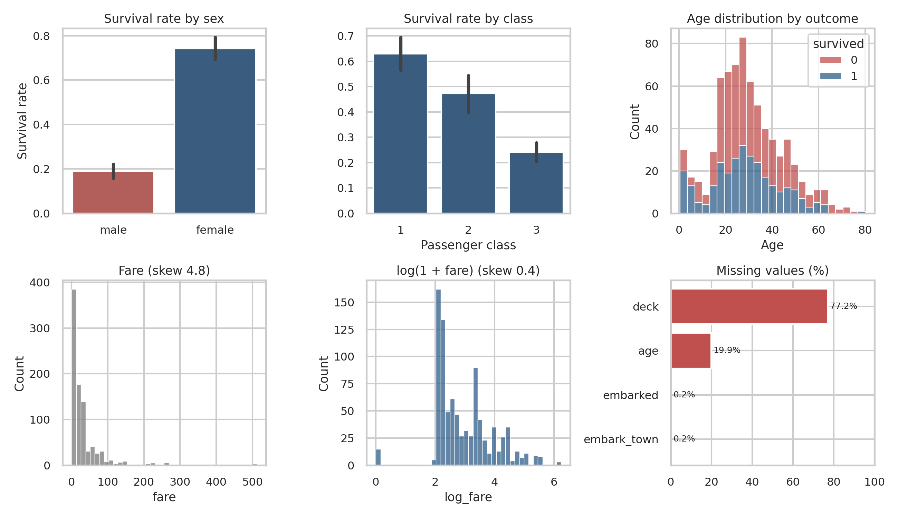
Figure 1. Exploratory analysis: survival by sex and class, age distribution, fare before and after log transform, and missing values
Exploration shows strong signals: 74% of women survived versus 19% of men, and survival fell from 63% in first class to 24% in third class. Passengers travelling alone survived less often (30%) than those with family (51%). Age and class are correlated (r = -0.37), which is one reason median imputation on the whole column is only an approximation.

3.3 Train/test split and preprocessing pipeline
The data were split 80/20 with stratification, giving 712 training and 179 test passengers with almost identical survival rates (38.3% and 38.5%). The random seed is fixed at 42 for reproducibility.
df["family_size"] = df.sibsp + df.parch + 1
df["is_alone"] = (df.family_size == 1).astype(int)
df["log_fare"] = np.log1p(df.fare)

X_tr, X_te, y_tr, y_te = train_test_split(
X, y, test_size=0.2, stratify=y, random_state=42)

def make_pre(scale=True):
num = [("imp", SimpleImputer(strategy="median"))]
if scale: num.append(("sc", StandardScaler()))
cat = [("imp", SimpleImputer(strategy="most_frequent")),
("oh", OneHotEncoder(drop="first", handle_unknown="ignore"))]
return ColumnTransformer([("num", Pipeline(num), num_cols),
("cat", Pipeline(cat), cat_cols)],
remainder="passthrough")

4. Model Selection and Training

4.1 Algorithms and justification
Model | Why it was chosen | Main risk
Majority-class baseline | Reference point: any useful model must beat it | Ignores all features
Logistic regression (primary) | Simple, fast, stable on ~700 rows, outputs calibrated probabilities and interpretable odds ratios | Assumes linear effects on the log-odds; cannot capture interactions unless engineered
Decision tree | Captures non-linearities and interactions; easy to visualise; used to demonstrate over-fitting | High variance; overfits if depth is not restricted
Random forest | Averages many trees to cut variance; a strong off-the-shelf benchmark for tabular data | Less interpretable; can still overfit small data

4.2 Hyperparameter tuning
Hyperparameters were tuned by grid search with 5-fold stratified cross-validation on the training set only, optimising ROC AUC (threshold-independent and robust to the 38/62 class imbalance). The unpruned tree was deliberately left untuned to serve as an over-fitting example.
Model | Search space | Best setting | CV AUC
Logistic regression | C ∈ {0.01, 0.1, 1, 10, 100} | C = 1 | 0.859
Decision tree (tuned) | max_depth ∈ {2,3,4,5,6,8}; min_samples_leaf ∈ {1,5,10,20} | depth 4, leaf 10 | 0.846
Random forest | n_estimators ∈ {200,400}; max_depth ∈ {4,6,8,None}; min_samples_leaf ∈ {1,3,5} | 400 trees, depth null, leaf 3 | 0.880

pipe = Pipeline([("pre", make_pre()),
("clf", LogisticRegression(max_iter=1000, random_state=42))])

cv = StratifiedKFold(n_splits=5, shuffle=True, random_state=42)
gs = GridSearchCV(pipe, {"clf__C": [0.01, 0.1, 1, 10, 100]},
cv=cv, scoring="roc_auc", n_jobs=-1).fit(X_tr, y_tr)
best_lr = gs.best_estimator_

# test set is used exactly once, after all choices are made
proba = best_lr.predict_proba(X_te)[:, 1]
pred = best_lr.predict(X_te)

5. Evaluation

5.1 Metrics used
- Accuracy: share of correct predictions; easy to read, but misleading under imbalance (the baseline already reaches 61.5%).
- Precision: of those predicted to survive, how many did.
- Recall (sensitivity): of those who survived, how many were found.
- F1: harmonic mean of precision and recall.
- ROC AUC and PR AUC: ranking quality across all thresholds. PR AUC is more informative when the positive class is the minority.
- Brier score: mean squared error of predicted probabilities (lower is better).

5.2 Test-set results
Table 1. Hold-out test results (n = 179)
Model | Accuracy | Precision | Recall | F1 | ROC AUC | PR AUC | Brier
Baseline (majority) | 61.5% | 0.0% | 0.0% | 0.000 | 0.500 | 0.385 | 0.385
Logistic regression | 82.1% | 82.5% | 68.1% | 0.746 | 0.844 | 0.796 | 0.142
Decision tree (unpruned) | 79.9% | 75.4% | 71.0% | 0.731 | 0.771 | 0.647 | 0.207
Decision tree (tuned) | 77.7% | 80.9% | 55.1% | 0.655 | 0.822 | 0.773 | 0.159
Random forest | 79.9% | 78.9% | 65.2% | 0.714 | 0.837 | 0.816 | 0.145
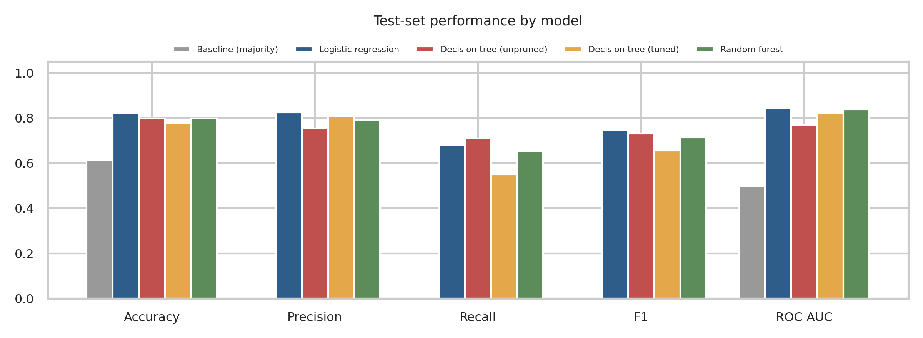
Figure 2. Test-set metrics for every model

5.3 Confusion matrices
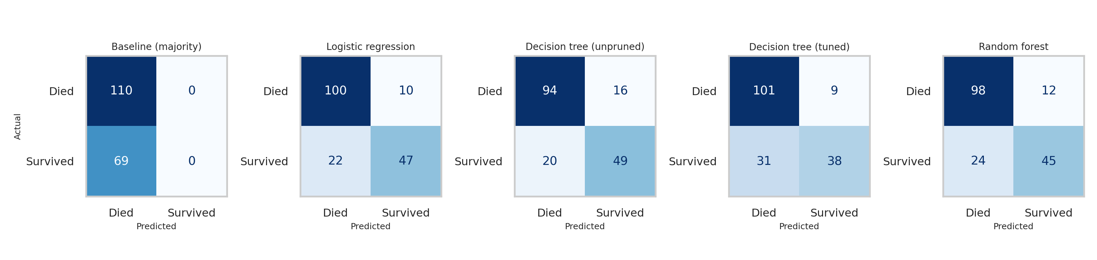
Figure 3. Confusion matrices on the test set
For the logistic regression model, 100 deaths and 47 survivals were classified correctly, with 10 false positives (predicted survivor, actually died) and 22 false negatives (survivor missed). The error rate is 17.9%. The model is conservative: it favours predicting death, giving high precision (82.5%) but lower recall (68.1%). The baseline never predicts survival, so its recall is zero, which shows why accuracy alone is a weak yardstick.

5.4 ROC and precision–recall curves
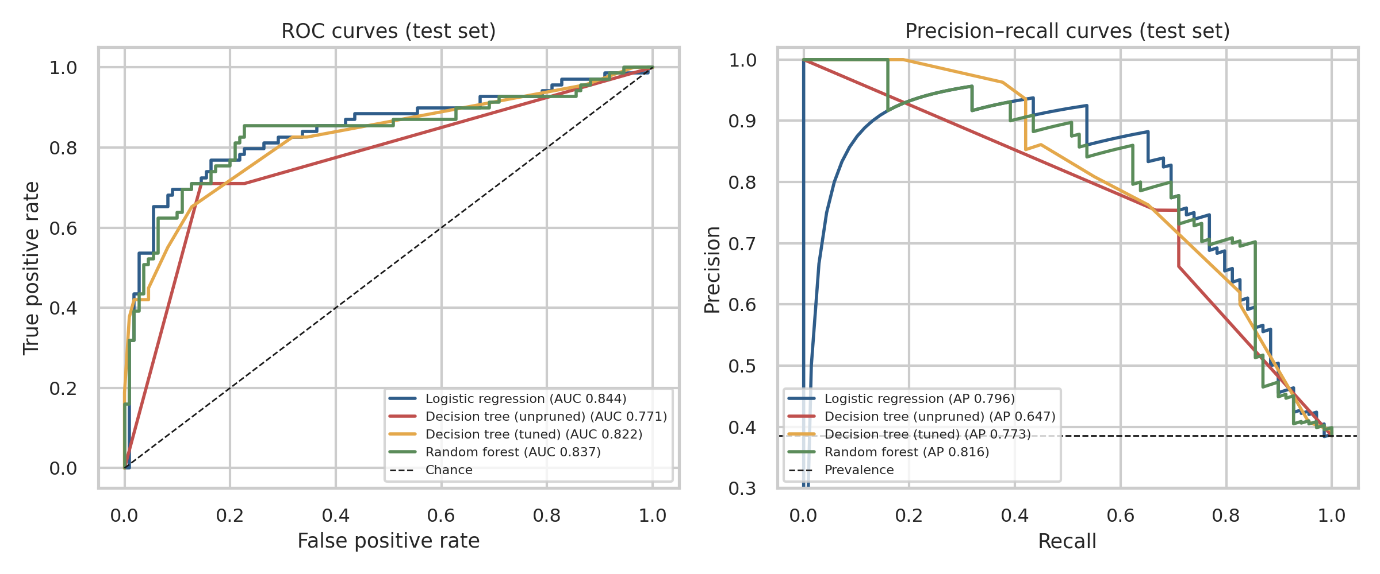
Figure 4. ROC and precision–recall curves on the test set
All three tuned models rank passengers similarly well (AUC 0.82 to 0.84), and all are far above chance (0.5). The unpruned tree’s ROC curve is the lowest (AUC 0.771) with a visibly jagged shape, typical of a model that outputs only a few distinct probabilities.

5.5 Cross-validation and uncertainty
Table 2. Cross-validation (training data) and bootstrap uncertainty (test data)
Model | CV accuracy | CV F1 | CV AUC (mean ± SD) | Test AUC 95% bootstrap CI
Logistic regression | 79.5% ± 1.7% | 0.722 | 0.859 ± 0.023 | [0.775, 0.906]
Decision tree (tuned) | 80.9% ± 1.6% | 0.724 | 0.846 ± 0.021 | [0.755, 0.887]
Random forest | 82.7% ± 2.7% | 0.757 | 0.880 ± 0.019 | [0.768, 0.902]
The test set is small (179 passengers), so single-number differences between models are not trustworthy. The bootstrap interval for the logistic regression test AUC runs from 0.77 to 0.91, and the intervals of the three models overlap almost entirely. A paired McNemar-type test comparing logistic regression and the random forest finds no significant difference in their errors (14 cases only logistic regression was right, 10 only the forest, p = 0.54). Repeated 5×5 cross-validation on all data gives AUCs of 0.856 (logistic), 0.855 (tree) and 0.873 (forest), a similar picture.

5.6 Final model choice
Logistic regression was selected as the final model. The random forest had a slightly higher cross-validated AUC (0.880 vs 0.859), but the gap is smaller than one standard deviation of the fold scores, the models were statistically indistinguishable on the test set, and logistic regression is simpler, better calibrated (Brier 0.142), gives interpretable coefficients and shows almost no train–validation gap. Where equal accuracy is available, the simpler and more explainable model is the more defensible choice. One honest caveat is that the test results were examined while writing this section, so the final claim of generalisation should be treated as an estimate rather than a fully untouched verdict.

6. Overfitting and Underfitting Analysis
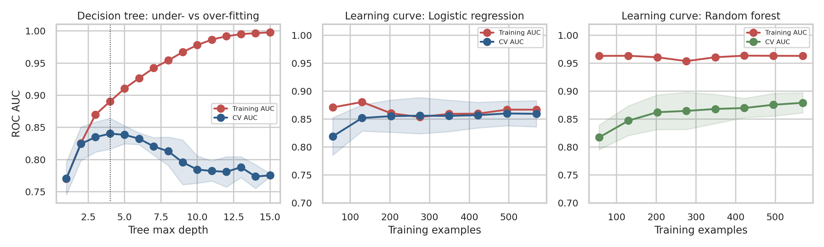
Figure 5. Validation curve for tree depth and learning curves for logistic regression and random forest
Decision tree: bias–variance trade-off. At depth 1 the tree underfits: training and validation AUC are both low (0.77). As depth grows, training AUC climbs to nearly 1.0 while cross-validated AUC peaks at depth 4 (0.840) and then falls to about 0.78, the classic signature of overfitting: the tree memorises noise in the training data. The unpruned tree shows this directly, with 98.3% training accuracy but 76.5% cross-validated accuracy and 79.9% on test data. Restricting depth and leaf size (the tuned tree) closes the gap: training accuracy 83.3%, test accuracy 77.7%, and cross-validated AUC improves from 0.758 to 0.846.
Logistic regression: well fitted, mild bias. Training and validation curves converge at about 0.86 with a gap of only 0.007. There is no overfitting, and adding more data of the same type would not help; a plateau at this level with a small gap suggests the limit comes from the model’s bias and the available features, not variance.
Random forest: moderate variance. Training AUC stays near 0.96 while validation AUC is about 0.88, a gap of 0.08. Trees are individually deep, so the forest fits training data closely, yet averaging keeps validation performance solid. The validation curve is still slowly rising, so more data would likely help the forest more than logistic regression.

7. Interpretation and Error Analysis

7.1 What the model learned
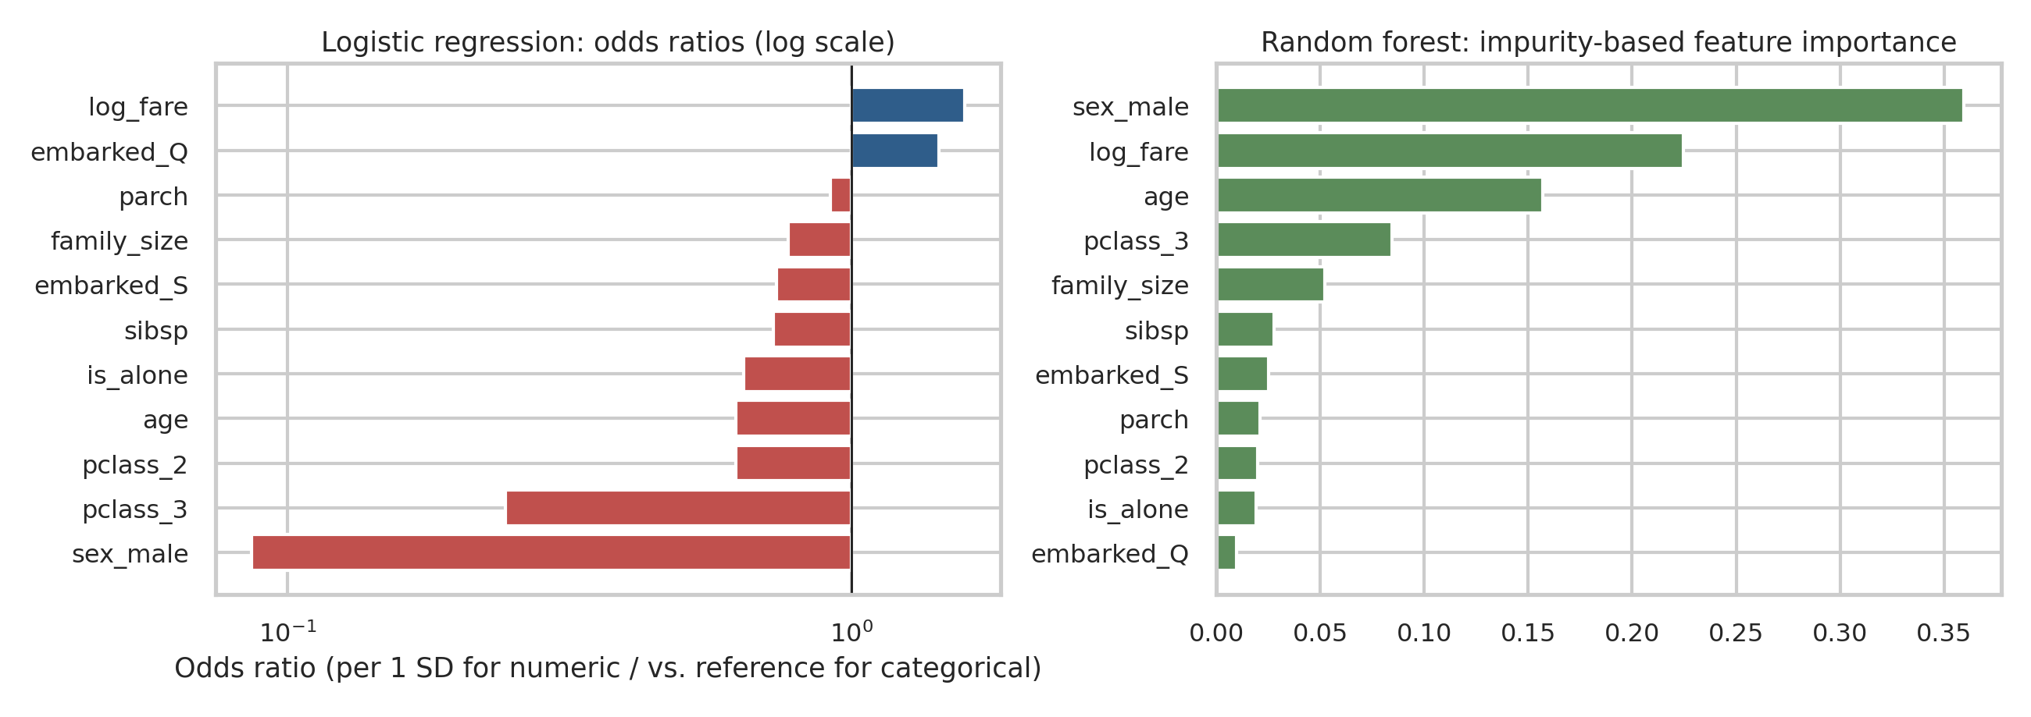
Figure 6. Logistic regression odds ratios and random forest feature importances
Both models agree on what matters. In the logistic regression, being male multiplies the odds of survival by 0.09 (a 91% reduction) and third class by 0.24, holding other variables fixed. Each standard deviation of age reduces the odds by about 38%. The random forest ranks sex, log-fare, age and third class as its top features. Family variables carry smaller and partly overlapping effects (family_size, sibsp and is_alone are strongly related), so individual coefficients for them should not be over-interpreted. Removing sex from the model reduces repeated-CV AUC from 0.856 to 0.768, confirming it is the single most important predictor.

7.2 Threshold and calibration
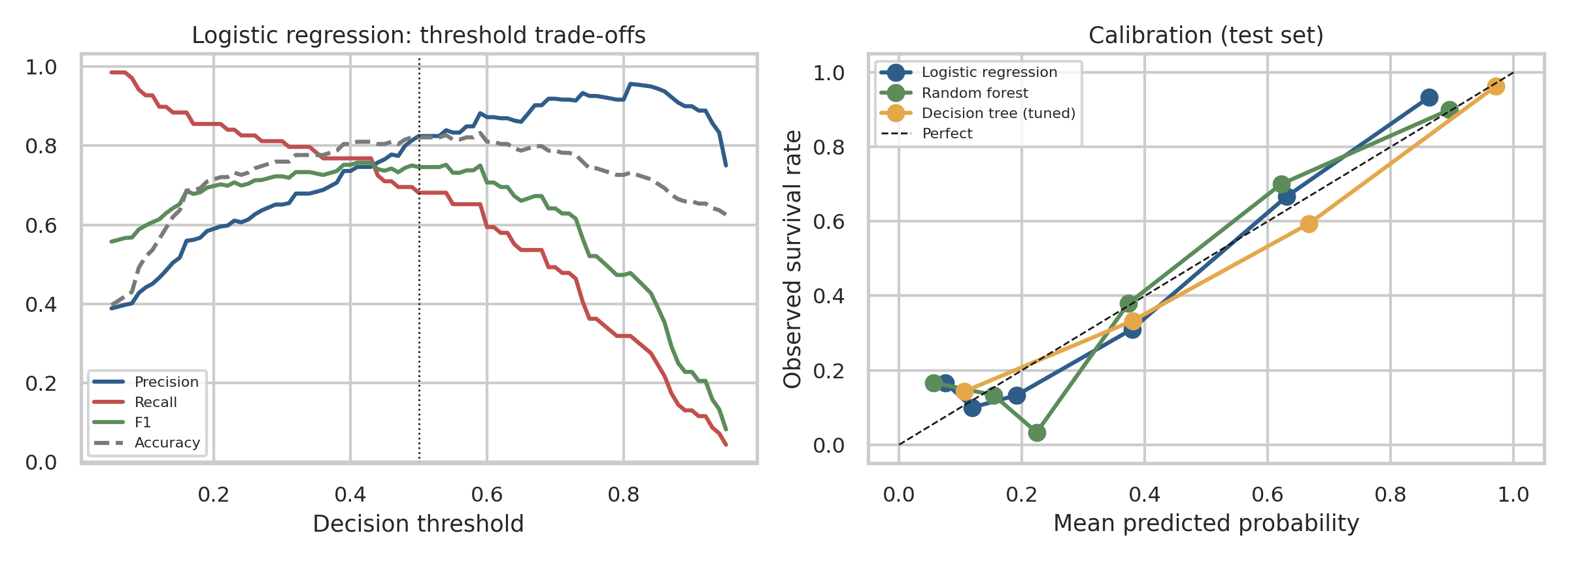
Figure 7. Precision, recall, F1 and accuracy as the decision threshold moves; probability calibration
The default threshold of 0.5 gives high precision but misses survivors. Lowering the threshold raises recall at the cost of precision, and F1 peaks near 0.41 (F1 0.757 vs 0.746 at 0.5), a modest gain. The right threshold depends on costs: if missing a survivor were far worse than a false alarm, a lower threshold would be justified. The calibration plot shows logistic regression probabilities track observed rates reasonably well, whereas the tree’s coarse leaves produce stepwise probabilities.

7.3 Where the model makes mistakes
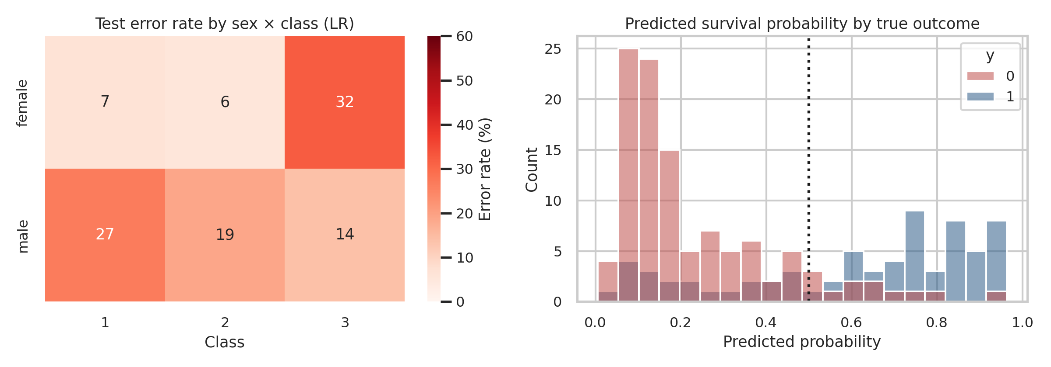
Figure 8. Error rate by sex and class, and predicted probability distributions by true outcome
Overall errors are balanced by sex (18% for women, 18% for men), but they concentrate in specific subgroups. Third-class women are classified correctly only 68% of the time (n = 28), because the model leans on class and sex separately and cannot see that this group survived at close to a coin-flip rate. First-class men are also harder (73%). Passengers with missing age have a similar error rate to the rest (20% vs 17%), so the median imputation does not appear to cause large harm. The probability histogram shows substantial overlap between the two outcome groups in the 0.3 to 0.6 range, where the available features simply do not separate survivors from non-survivors.

8. Sources of Error and Suggested Improvements

8.1 Sources of error
Source | Evidence in this study | Effect
Small sample | Only 179 test cases; bootstrap AUC CI width about 0.13 | Model comparisons are statistically inconclusive
Missing and imputed data | 20% of ages imputed with the median | Adds noise; may blur age effects, especially for children
Limited features | No cabin location, ticket group, title or lifeboat access | A ceiling of about 80–85% accuracy for simple models
Linear, additive assumption | Errors concentrate in sex × class subgroups | Interactions are missed by logistic regression
Overfitting risk | Unpruned tree: 98% train vs 80% test accuracy | Controlled by pruning and cross-validation
Possible duplicate leakage | 107 duplicate rows; AUC drops to 0.838 after removal (n = 780) | Slightly optimistic estimates; identical rows can fall in both train and test folds
Class imbalance | 38% positive class; default 0.5 threshold gives recall of 68% | More false negatives than false positives
Historical, non-random data | A single event in 1912 | Results do not generalise to other populations

8.2 Suggested improvements
- Richer feature engineering. Extract the title (Mr, Mrs, Miss, Master) from the name column, which proxies age and marital status and is known to be very predictive; group by ticket to capture travelling parties; add a sex × class interaction.
- Better imputation. Impute age by class and title groups, or with iterative or k-nearest-neighbour imputation, and add a ‘missing age’ indicator.
- More expressive models. Gradient boosting (for example HistGradientBoosting or XGBoost) with careful tuning, or logistic regression with interaction and spline terms, then compare using repeated cross-validation.
- Group-aware validation. Use GroupKFold on ticket or family groups so that related passengers never appear in both training and validation data.
- Threshold and cost tuning. Choose the decision threshold from a cost matrix or a target recall rather than defaulting to 0.5; consider class weights.
- Probability calibration. Apply Platt or isotonic calibration if probabilities (rather than labels) will be used in decisions.
- Statistical power. Use nested cross-validation or repeated splits instead of a single 179-row hold-out for model comparison.

9. Conclusion
A carefully preprocessed logistic regression model predicts Titanic survival with about 82% accuracy and an AUC of 0.84, a large improvement over the 61% baseline. More complex models did not deliver a reliable gain on this small dataset, while an unpruned decision tree provided a clear example of overfitting. The most important lessons for real projects are to use a baseline, keep preprocessing inside the cross-validation loop, report uncertainty, examine errors by subgroup, and favour the simplest model that performs as well as the alternatives. The largest remaining gains are likely to come from better features and validation design rather than from more complicated algorithms.

Appendix A. Reproducing the Analysis
The complete script (ml.py) that produces every number, table and figure in this report is supplied alongside this document. The random seed is fixed at 42. To run it:
pip install pandas scikit-learn seaborn matplotlib scipy
curl -o titanic.csv https://raw.githubusercontent.com/mwaskom/seaborn-data/master/titanic.csv
python ml.py # writes m_fig1..m_fig8 PNGs and ml_results.json

Core evaluation code used for the metrics and plots:
from sklearn.metrics import (accuracy_score, precision_score, recall_score, f1_score,
roc_auc_score, average_precision_score, confusion_matrix, roc_curve)

for name, est in fitted.items():
p = est.predict_proba(X_te)[:, 1]
yh = est.predict(X_te)
print(name, accuracy_score(y_te, yh), precision_score(y_te, yh),
recall_score(y_te, yh), f1_score(y_te, yh), roc_auc_score(y_te, p))
print(confusion_matrix(y_te, yh))
fpr, tpr, _ = roc_curve(y_te, p) # ROC curve points

# over-fitting diagnostics
validation_curve(tree_pipe, X_tr, y_tr, param_name="clf__max_depth",
param_range=range(1, 16), cv=cv, scoring="roc_auc")
learning_curve(best_lr, X_tr, y_tr, cv=cv, scoring="roc_auc",
train_sizes=np.linspace(0.1, 1, 8))

Appendix B. References
- Pedregosa, F. et al. (2011). Scikit-learn: Machine Learning in Python. Journal of Machine Learning Research, 12, 2825–2830.
- Hastie, T., Tibshirani, R. and Friedman, J. (2009). The Elements of Statistical Learning, 2nd ed. Springer.
- Breiman, L. (2001). Random Forests. Machine Learning, 45, 5–32.
- Saito, T. and Rehmsmeier, M. (2015). The precision-recall plot is more informative than the ROC plot when evaluating binary classifiers on imbalanced datasets. PLoS ONE, 10(3).
- Waskom, M. (2021). seaborn: statistical data visualization. Journal of Open Source Software, 6(60), 3021.

