DATA SCIENCE INTERNSHIP — WEEK 5
Customer Churn Analytics:
End-to-End Project Report and Strategic Recommendations
Prepared by: [Your Name]
Organisation / Program: [Internship Provider]
Date: October 2026
Repository: github.com/[your-username]/customer-churn-analytics

Table of Contents

1. Executive Summary
Customer churn is the single largest controllable driver of revenue loss in subscription businesses. This project built an end-to-end analytics pipeline — data cleaning, exploratory analysis, predictive modelling and business-impact estimation — on a dataset of 5,000 telecom subscribers, of whom 37.8% churned during the observation window.
Key findings
- Contract type is the strongest driver of churn: month-to-month customers churn at 55.4%, versus 22.6% for one-year and 6.8% for two-year contracts.
- New customers are the most fragile: customers in their first 12 months churn at 61%, versus 26% for customers beyond 24 months.
- Fiber-optic subscribers churn at 52.7%, roughly double DSL (26.9%); electronic-check payers churn at 45.5% against about 33–35% for other payment methods.
- A Logistic Regression model reaches ROC-AUC of 0.83 on held-out data. The 20% of customers it ranks as highest risk contain 41.5% of all churners, giving a top-decile lift of 2.2x.
Strategic recommendations
- Contract migration. Convert month-to-month customers to annual contracts with targeted incentives.
- Protect new customers. Launch a structured 90-day onboarding and early-warning programme.
- Risk-based targeting. Deploy the churn model weekly to rank customers and trigger retention offers for the top 20% risk band.
- Fix root causes. Investigate fiber-optic service quality and bundle tech support; nudge electronic-check payers to auto-pay.
Estimated impact: under stated assumptions, a retention campaign aimed at the top 20% risk band of a 100,000-customer base could retain about 3,140 customers and generate roughly $1,794,735 in net annual revenue benefit (base scenario). Assumptions and sensitivity are in Section 7.
Data note: this report uses a reproducible synthetic dataset modelled on public telecom-churn patterns so that every figure, table and code excerpt can be regenerated from the repository. The pipeline accepts a real dataset with the same schema without code changes.

2. Introduction

2.1 Background and problem statement
Acquiring a new customer typically costs several times more than retaining an existing one. A subscription business that can anticipate which customers are likely to leave, and understand why, can intervene early and cheaply. The business question addressed here is: which customers are most likely to churn, what drives that risk, and what should the business do about it?

2.2 Objectives
- Describe the churn problem and quantify its scale and segments.
- Explain the factors most associated with churn.
- Predict individual churn probability with a validated model.
- Recommend prioritised, measurable actions and estimate their business impact.

2.3 Project journey (Weeks 1–5)
Week | Focus | Key output
1 | Problem framing, data acquisition and audit | Data dictionary, missing-value report
2 | Data cleaning and exploratory analysis | Clean dataset; Figures 1–5
3 | Feature engineering and baseline modelling | Pipeline with scaling and one-hot encoding; logistic baseline
4 | Model comparison, evaluation and interpretation | Figures 6–9; threshold tuning; feature importance
5 | Synthesis, strategy and reporting | This report and GitHub repository
Table 1: Weekly progression of the project.

3. Data and Methodology

3.1 Dataset
The dataset contains 5,000 customers and 12 columns. The target is churn (1 = customer left, 0 = retained).
Column | Type | Description
customer_id | ID | Unique identifier (dropped before modelling)
tenure_months | Numeric | Months as a customer
contract | Categorical | Month-to-month, One year, Two year
internet_service | Categorical | Fiber optic, DSL, No internet
monthly_charges / total_charges | Numeric | Current monthly bill / cumulative billing
payment_method | Categorical | Electronic check, Mailed check, Bank transfer, Credit card
tech_support, paperless_billing | Categorical | Add-on and billing preference flags
senior_citizen, support_calls | Numeric | Senior flag; number of support calls
churn | Binary target | 1 if customer churned
Table 2: Data dictionary.

3.2 Data cleaning
An audit found 60 missing values in total_charges (1.2%). Because total charges is arithmetically tied to monthly charges and tenure, missing values were imputed as monthly_charges × tenure_months rather than with a mean, preserving the relationship between variables. No duplicates were found, and categorical labels were checked for inconsistent spellings.
df = pd.read_csv("data/customer_churn.csv")
print(df.isna().sum()[lambda s: s > 0]) # audit: 60 missing in total_charges

# impute using the known business relationship, not a global mean
df["total_charges"] = df["total_charges"].fillna(
df["monthly_charges"] * df["tenure_months"])
Code Excerpt 1: Missing-value audit and domain-based imputation (src/eda.py).

3.3 Exploratory data analysis
EDA combined univariate distributions, churn-rate comparisons across segments and a correlation matrix. Segment churn rates (mean of the binary target) were used because they are directly interpretable by business stakeholders.

3.4 Modelling approach
- Split. Stratified 80/20 train-test split (random_state=42), preserving the churn ratio.
- Preprocessing. A scikit-learn ColumnTransformer standardises numeric features and one-hot encodes categoricals inside a Pipeline, so no information leaks from the test set.
- Candidates. Logistic Regression (interpretable baseline), Random Forest and Gradient Boosting (non-linear).
- Evaluation. ROC-AUC (threshold-free ranking quality), plus accuracy, precision, recall and F1; 5-fold cross-validated AUC on the training set to check stability.
- Threshold. The decision threshold was tuned to maximise F1 rather than left at 0.5, since missing a churner is costlier than contacting a loyal customer.
- Interpretation. Permutation importance on the test set, and a lift analysis by risk decile.
pre = ColumnTransformer([
("num", StandardScaler(), num),
("cat", OneHotEncoder(handle_unknown="ignore"), cat)])

pipe = Pipeline([("pre", pre), ("model", model)]).fit(Xtr, ytr)
p = pipe.predict_proba(Xte)[:, 1]
cv = cross_val_score(pipe, Xtr, ytr, cv=5, scoring="roc_auc").mean()
Code Excerpt 2: Leak-free preprocessing pipeline and evaluation (src/modeling.py).

4. Results

4.1 Scale of the churn problem
37.8% of customers churned (Figure 1). The classes are moderately imbalanced, which is why precision, recall and AUC are reported in addition to accuracy.
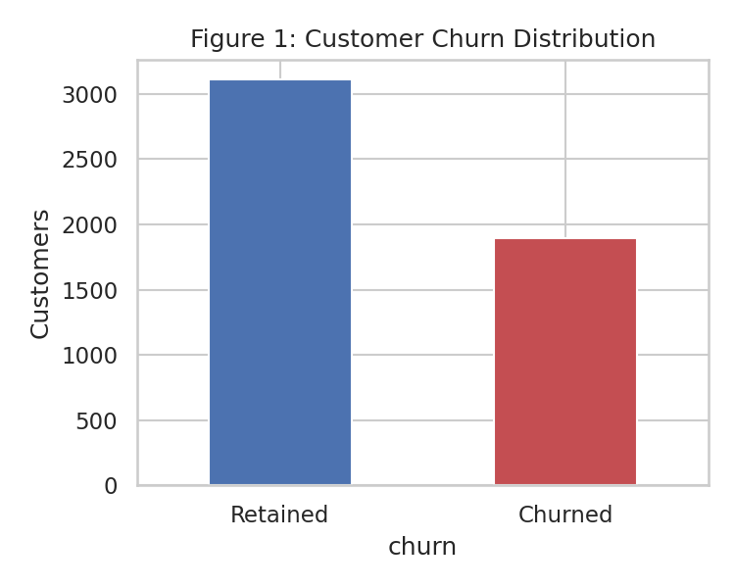
Figure 1: Distribution of retained and churned customers.

4.2 Contract type
Churn falls sharply with commitment length: 55.4% for month-to-month, 22.6% for one-year and 6.8% for two-year contracts (Figure 2). Month-to-month customers are also the largest group (2,794 of 5,000), so this segment accounts for the majority of all lost customers.
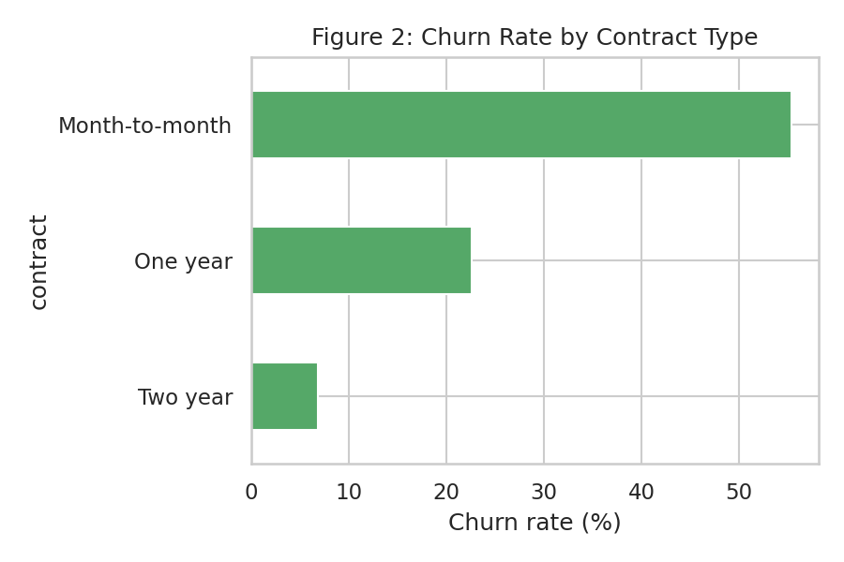
Figure 2: Churn rate by contract type.

4.3 Customer tenure
Churners are concentrated in early tenure (Figure 3). Customers with 12 months or less of tenure churn at 61%; those beyond 24 months churn at 26%. The first year is therefore the critical retention window.
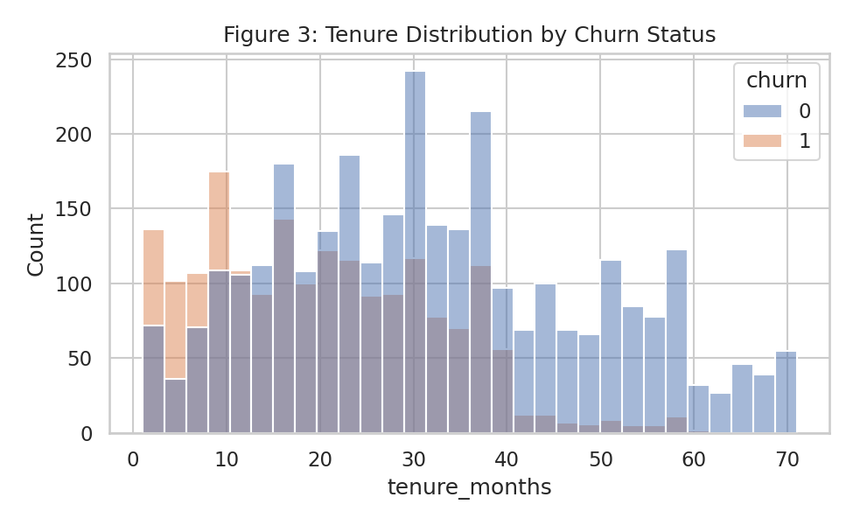
Figure 3: Tenure distribution split by churn status (1 = churned).

4.4 Service type, tech support and payment method
Fiber-optic customers churn at 52.7% versus 26.9% for DSL, despite paying more, which suggests a service-quality or value-perception problem. Tech support is protective: among internet customers, those with tech support churn at 36% against 44% without (Figure 4). Electronic-check payers churn at 45.5%, about 10–12 points above other payment methods.
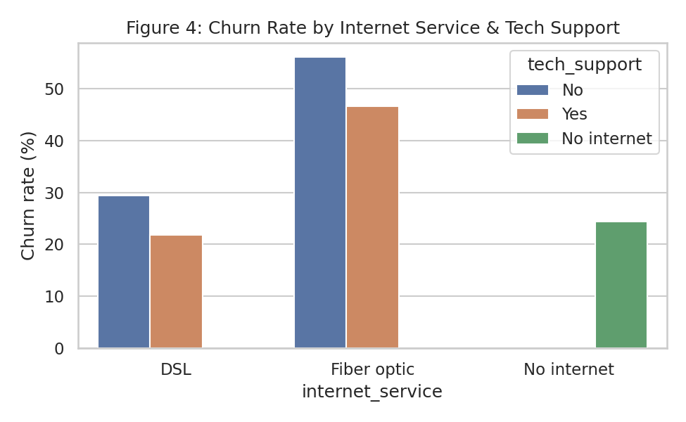
Figure 4: Churn rate by internet service, split by tech-support subscription.
Payment method | Customers | Churn rate
Bank transfer | 1,190 | 34.9%
Credit card | 1,173 | 33.2%
Electronic check | 1,716 | 45.5%
Mailed check | 921 | 33.2%
Table 3: Churn rate by payment method.

4.5 Correlations
Tenure has the strongest negative correlation with churn; monthly charges and support calls are positively correlated. Total charges is largely redundant with tenure and monthly charges (Figure 5), which explains its modest importance later.
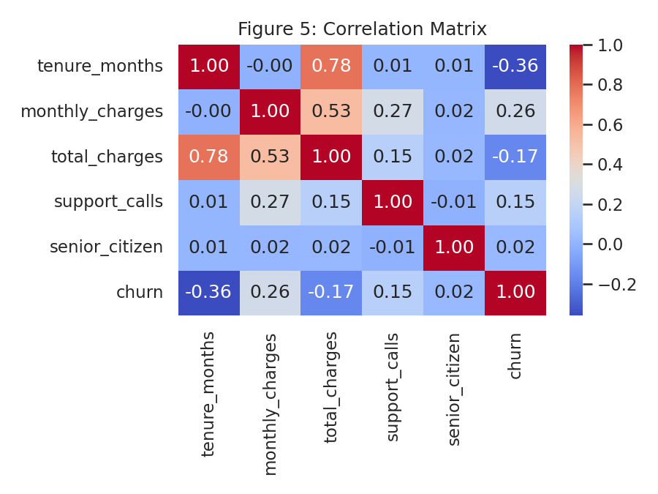
Figure 5: Correlation matrix of numeric variables.

4.6 Model performance
Model | Accuracy | Precision | Recall | F1 | Test AUC | CV AUC
Logistic Regression | 0.745 | 0.668 | 0.646 | 0.657 | 0.83 | 0.832
Random Forest | 0.735 | 0.651 | 0.643 | 0.647 | 0.819 | 0.821
Gradient Boosting | 0.748 | 0.667 | 0.667 | 0.667 | 0.825 | 0.822
Table 4: Test-set metrics at threshold 0.5, and 5-fold cross-validated AUC.
All three models perform within about one AUC point of each other, and cross-validated AUC closely matches test AUC, indicating no meaningful overfitting. Logistic Regression was selected: it ranks best, is the most interpretable, and is the simplest to deploy and monitor. Where signal is mostly additive, extra model complexity brings little benefit.
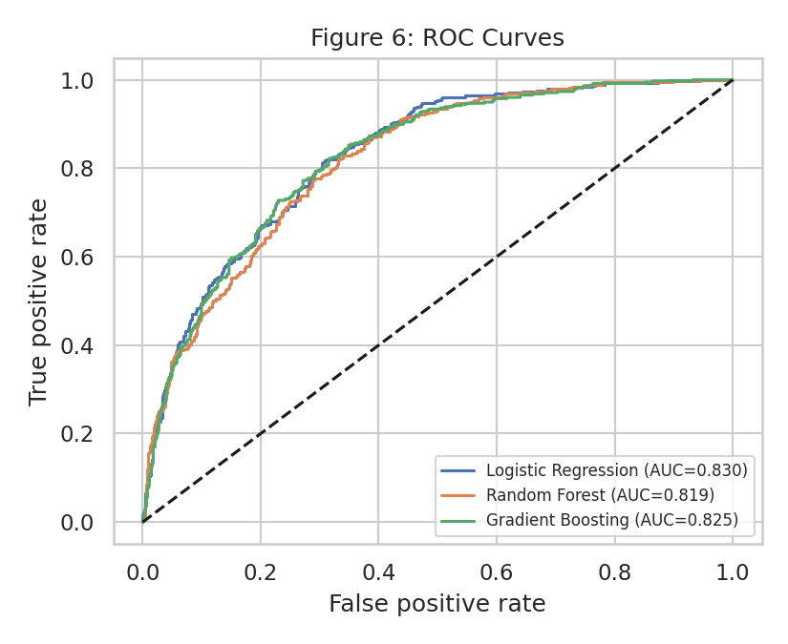
Figure 6: ROC curves of the three candidate models on the test set.
At the F1-optimal threshold of 0.37, the model identifies 308 of 378 actual churners (recall 81.5%) with precision of 61.8%. The 190 false positives represent loyal customers who would receive an unnecessary offer, which is the accepted cost of high recall.
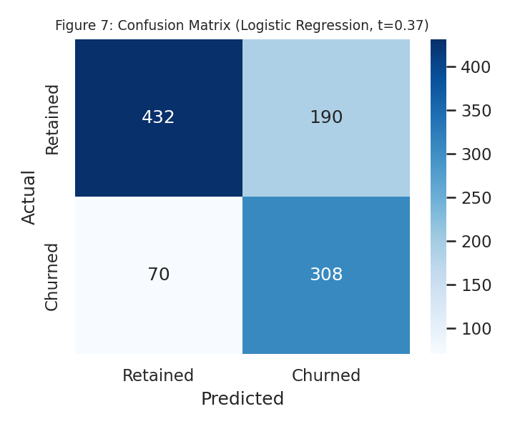
Figure 7: Confusion matrix on the test set at the tuned threshold.

4.7 What drives churn?
Permutation importance ranks contract, tenure_months, monthly_charges, total_charges, payment_method as the top five predictors (Figure 8). Contract type dominates, at roughly four times the importance of the next feature. Demographic flags such as senior_citizen add almost nothing, so actions should be behavioural and contractual rather than demographic.
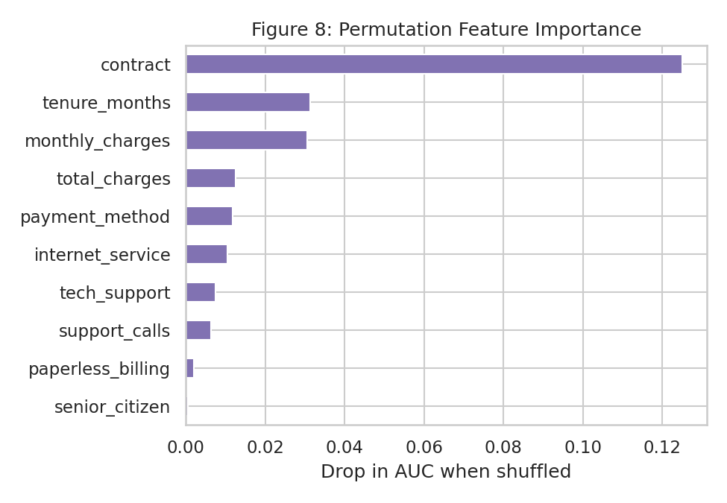
Figure 8: Permutation feature importance (drop in AUC when a feature is shuffled).

4.8 Targeting value
Sorting customers by predicted risk shows that the top decile churns at 2.2 times the average rate, and the top two deciles contain 41.5% of all churners (Figure 9). A campaign focused on the top 20% is thus considerably more efficient than a blanket campaign.
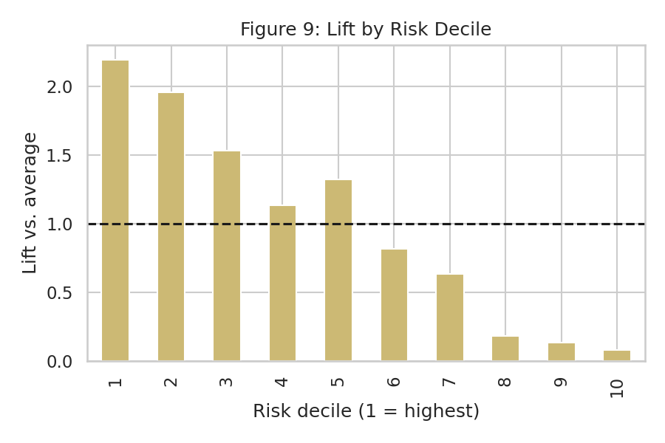
Figure 9: Lift by risk decile (1 = highest predicted risk).
d = pd.DataFrame({"y": yte.values, "p": p})
d["decile"] = pd.qcut(d.p.rank(method="first", ascending=False), 10, labels=range(1, 11))
lift = d.groupby("decile", observed=True)["y"].mean() / d.y.mean()
capture = d[d.decile.isin([1, 2])].y.sum() / d.y.sum() # share of churners in top 20%
Code Excerpt 3: Lift and capture-rate calculation (src/modeling.py).

5. Discussion
The analysis tells a consistent story across descriptive and predictive views. Churn is not random: it is concentrated in customers with low commitment (month-to-month), low tenure (first year), higher friction (electronic check, more support calls) and, notably, in the premium fiber product.
- Consistency. Two independent methods, segment rates and model importance, agree that contract type is the main lever. This convergence increases confidence in the finding.
- Fiber paradox. Fiber customers pay more but leave more. This may signal reliability problems, aggressive competitor offers in fiber markets, or price-value mismatch; the data cannot distinguish these, so a qualitative follow-up is advised.
- Correlation vs causation. The protective effect of tech support (36% vs 44% churn) is encouraging but observational; customers who buy support may simply be more engaged. A controlled trial is needed before claiming causality.
- Threshold trade-off. Moving from a 0.5 to a 0.37 threshold raises recall substantially at the cost of precision. The right threshold depends on the cost of an offer relative to the value of a saved customer and should be revisited by the business.
- Simplicity wins. The simple model matched complex ones. This is good news operationally: it is transparent to non-technical stakeholders, cheap to run and easy to audit.

6. Strategic Recommendations
Recommendations are ordered by expected impact and linked to specific evidence and measurable KPIs.
# | Recommendation | Evidence | KPI / target | Timeline
1 | Contract migration: offer discounts or perks for 12-month plans to month-to-month customers, prioritising high-risk accounts. | 55.4% vs 6.8% churn (month-to-month vs two-year) | Month-to-month share down from 56% to 45% | 0–3 months
2 | 90-day onboarding programme: welcome call, usage check-ins, proactive issue resolution within the first year. | 61% churn in first 12 months | First-year churn down by 10 points | 0–6 months
3 | Model-driven retention: score customers weekly; contact the top 20% risk band with tailored offers. | Top 20% hold 41.5% of churners; lift 2.2x | Save rate of at least 20% among contacted | 1–3 months
4 | Fiber quality and value review: audit outages, speed delivery and price versus competitors; run exit surveys. | 52.7% fiber vs 26.9% DSL churn | Fiber churn within 10 points of DSL | 3–6 months
5 | Bundle tech support (free trial for 3 months) for new internet customers. | 36% vs 44% churn with/without support | Tech-support attach rate from 35% to 50% | 3–6 months
6 | Payment friction: incentivise auto-pay via card or bank transfer for electronic-check users. | 45.5% churn on e-check vs about 33% others | E-check share down by 10 points | 3–9 months
7 | Experimentation: A/B test every offer with a holdout group to measure true uplift. | Observational data cannot prove causality | Statistically significant uplift reported per campaign | Ongoing
Table 5: Prioritised strategic recommendations.
These recommendations inform decision-making in three ways: they tell marketing where to spend (high-risk, month-to-month, first-year segments), tell product and operations where to investigate (fiber), and tell management how to measure success (KPIs and controlled experiments).

7. Potential Business Impact
A simple financial model estimates the value of recommendation 3 (risk-based targeting). Assumptions: a base of 100,000 customers; the top 20.0% by risk are contacted; precision in that band is 78.5% (measured on the test set); average monthly revenue per customer is $61; each saved customer stays 12 additional months; each contact costs $25 (offer plus handling).
Save rate | Customers saved | Revenue retained | Campaign cost | Net benefit | ROI
10.0% | 1,570 | $1,147,367 | $500,000 | $647,367 | 129%
20.0% | 3,140 | $2,294,735 | $500,000 | $1,794,735 | 359%
30.0% | 4,710 | $3,442,102 | $500,000 | $2,942,102 | 588%
Table 6: Sensitivity of campaign value to the save rate (20,000 customers contacted).
Even at a conservative 10% save rate the campaign is positive-return, and the case strengthens with higher save rates or lower offer costs. These are illustrative figures, not forecasts: the save rate in particular must be measured through an A/B test before scaling. Additional non-quantified benefits include lower acquisition spend to replace lost customers, better capacity planning, and higher customer lifetime value.
targeted = 100_000 * 0.20
at_risk = targeted * precision_top20 # churners inside contacted group
saved = at_risk * save_rate # e.g. 0.20
net = saved * arpu * 12 - targeted * offer_cost
Code Excerpt 4: Business-case calculation behind Table 6.

8. Limitations and Future Improvements

8.1 Limitations
- Data realism. The dataset is synthetic. Effect sizes, particularly the strong contract effect, may differ in a real customer base.
- No causal identification. Findings are associations. Observational analysis cannot establish that, for example, tech support causes lower churn.
- No temporal validation. A single random split in one time window does not test performance on future customers; real churn patterns drift.
- Limited features. Only contract, billing and usage-summary fields were available. Network quality, competitor pricing, satisfaction scores and detailed usage are likely important missing drivers.
- Modelling simplifications. Imputation was simple, hyperparameters were lightly tuned, and model probabilities were not calibrated.
- Financial assumptions. The business case depends on assumed save rate, offer cost and customer lifetime.

8.2 Future improvements
- Temporal validation. Validate on real data using time-based splits (train on earlier months, test on later ones).
- Feature enrichment. Add richer features: usage trends, billing disputes, outage history, NPS and competitor activity.
- Calibration and tuning. Calibrate probabilities and tune hyperparameters with cross-validated search (e.g. Optuna).
- Survival and uplift modelling. Add survival analysis to predict when churn happens, and uplift models to target customers who respond to offers rather than those merely likely to leave.
- Explainability. Use SHAP for customer-level explanations that agents can act on.
- Deployment. Schedule retraining, monitor data drift, and expose scores through a dashboard or API (MLOps).

9. Conclusion
This project delivered a complete data science workflow: a cleaned dataset, a clear picture of who churns and why, a validated predictive model (AUC 0.83), and a prioritised action plan with a transparent business case. The central insight is that churn is concentrated in a small number of identifiable segments, namely month-to-month, first-year, fiber and electronic-check customers. This makes it addressable through targeted, measurable interventions rather than broad discounting. The recommended next step is a pilot with a holdout group to confirm real-world save rates before scaling.

Appendix A. Repository Structure
customer-churn-analytics/
|-- README.md
|-- requirements.txt
|-- run_all.sh
|-- build_report.js
|-- .gitignore
|-- data/
| |-- customer_churn.csv
| `-- customer_churn_clean.csv
|-- src/
| |-- generate_data.py
| |-- eda.py
| `-- modeling.py
|-- images/ (fig1 ... fig9 .png)
|-- outputs/ (metrics.json, model_comparison.csv, ...)
`-- reports/
`-- Week5_Final_Project_Report.docx
Listing 1: GitHub repository layout.

Appendix B. Reproducing the Results
pip install -r requirements.txt
bash run_all.sh # regenerate data, figures, metrics
node build_report.js # rebuild this report (needs: npm install docx)
Listing 2: Commands to reproduce all results.

Appendix C. Glossary
Term | Meaning
Churn | A customer ending their subscription during the observation window.
ROC-AUC | Probability that the model ranks a random churner above a random non-churner (0.5 = chance, 1.0 = perfect).
Precision / Recall | Of customers flagged, the share who truly churn / of all churners, the share we flag.
Lift | How many times more concentrated churners are in a group versus the overall average.
Permutation importance | Drop in model performance when one feature's values are randomly shuffled.
Table 7: Key terms.

