Data Preparation & Exploratory Data Analysis
Week 1 Project Report
Dataset: Titanic Passenger Data (public)
Tools: Python, Pandas, NumPy, Matplotlib, Seaborn
Date: 26 October 2026

Table of Contents

1. Introduction

1.1 Objective
The goal of this Week 1 task is to simulate the data preparation stage that precedes any data science project: acquire a public dataset, clean and pre-process it, explore it with statistics and visualisations, and document every decision with its rationale. This report describes each step, includes the Python code used, presents six visualisations, and closes with the main insights and suggestions for further analysis.

1.2 Why the Titanic dataset?
The Titanic passenger dataset is a well-known public dataset in the domain of social and historical analytics. It was chosen because it realistically mirrors the problems seen in real projects: it has a mix of numeric and categorical variables, missing values of very different severity (0.2%, 20% and 77%), skewed distributions, outliers, and text fields from which new features can be extracted. It also has a clear target variable (Survived), which makes the exploratory findings easy to interpret.

1.3 Workflow overview
- Data acquisition: download the CSV directly from a public GitHub repository.
- Data audit: inspect shape, data types, missing values and duplicates.
- Data cleaning: impute or drop missing values, fix data types, handle outliers, remove duplicates.
- Feature engineering: derive Title, FamilySize, IsAlone, Has_Cabin, Deck, AgeGroup and log-Fare.
- Exploratory data analysis: summary statistics, distributions, box plots, survival comparisons, correlations.
- Insights and next steps.

2. Data Acquisition

2.1 Source
Source: Data Science Dojo public datasets repository on GitHub (titanic.csv), originally compiled from the Kaggle “Titanic: Machine Learning from Disaster” competition.
URL: https://raw.githubusercontent.com/datasciencedojo/datasets/master/titanic.csv
Size: 891 rows × 12 columns (one row per passenger).

2.2 Code
import pandas as pd, numpy as np
import matplotlib.pyplot as plt, seaborn as sns

URL = "https://raw.githubusercontent.com/datasciencedojo/datasets/master/titanic.csv"
df = pd.read_csv(URL) # direct download over HTTP
df.to_csv("titanic.csv", index=False) # keep a local raw copy
print(df.shape) # (891, 12)
df.head()

2.3 Data dictionary
Column | Type (raw) | Description
PassengerId | int64 | Unique row identifier
Survived | int64 | Target: 0 = died, 1 = survived
Pclass | int64 | Ticket class: 1 = upper, 2 = middle, 3 = lower
Name | object | Passenger name (contains a title such as Mr, Mrs, Miss)
Sex | object | male / female
Age | float64 | Age in years (fractional for infants)
SibSp | int64 | Number of siblings / spouses aboard
Parch | int64 | Number of parents / children aboard
Ticket | object | Ticket number
Fare | float64 | Ticket price in pounds
Cabin | object | Cabin number (mostly missing)
Embarked | object | Port: C = Cherbourg, Q = Queenstown, S = Southampton

3. Initial Data Audit
Before changing anything, the raw data was audited so that every cleaning decision could be tied to a measured problem.
df.info()
df.isna().sum()
(df.isna().mean() * 100).round(1)
df.duplicated().sum()
df[["Age","Fare","SibSp","Parch"]].describe()

3.1 Missing values
Column | Missing count | Missing % | Severity
Cabin | 687 | 77.1% | Severe
Age | 177 | 19.9% | Moderate
Embarked | 2 | 0.2% | Negligible

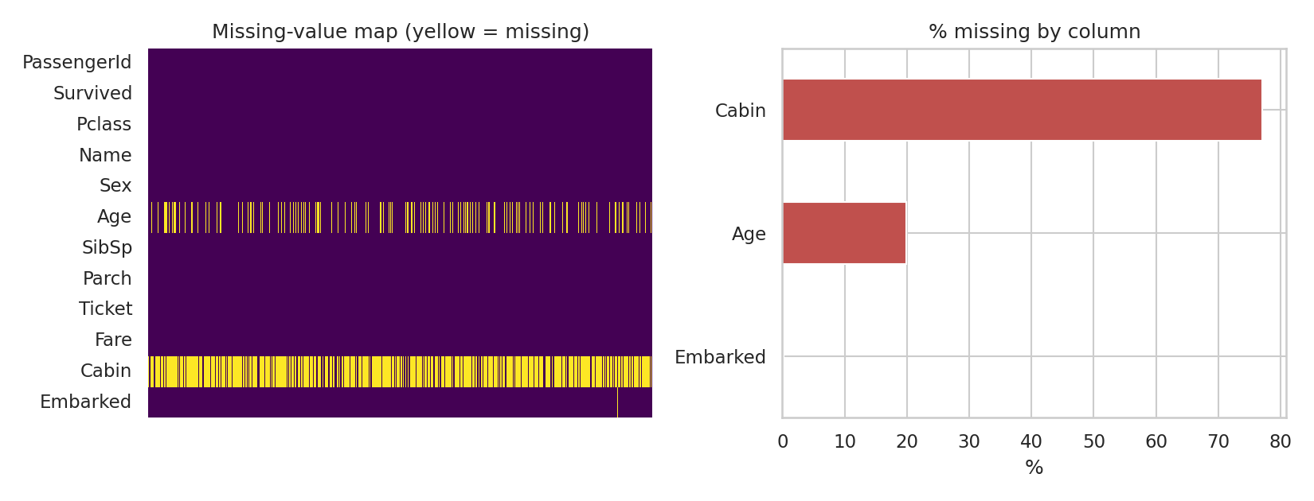
Figure 1: Missing-value map (left) and percentage missing per column (right).
Figure 1 shows that missingness is concentrated in three columns. The Age gaps are scattered randomly across rows, whereas Cabin is missing in most rows and is strongly related to ticket class (lower-class passengers rarely have a recorded cabin). Embarked has only two gaps.

3.2 Duplicates and data types
- Duplicates: 0 fully duplicated rows were found. PassengerId is unique, so no rows needed removing. 210 rows share a Ticket number with another row; this is expected because families and groups travelled on shared tickets, so these are not true duplicates.
- Data types: Survived, Pclass, Sex and Embarked are stored as integers or strings but are really categorical variables. Age is a float and Fare is a float, which is appropriate.

3.3 Summary statistics (raw)
Statistic | Age | Fare | SibSp | Parch
count | 714 | 891 | 891 | 891
mean | 29.7 | 32.2 | 0.52 | 0.38
std | 14.53 | 49.69 | 1.1 | 0.81
min | 0.42 | 0 | 0 | 0
25% | 20.12 | 7.91 | 0 | 0
50% | 28 | 14.45 | 0 | 0
75% | 38 | 31 | 1 | 0
max | 80 | 512.33 | 8 | 6

Fare is heavily right-skewed: the mean (32.2) is more than double the median (14.45), and the maximum is 512.33. 15 passengers have a fare of exactly zero, which most likely reflects crew members, staff or complimentary tickets rather than data errors.

4. Data Cleaning
Each cleaning step below follows the same pattern: the problem, the chosen method, the code, and the justification.

4.1 Feature extraction needed for imputation: Title
Problem: Age is missing for 177 passengers, and a plain mean or median would ignore the fact that age differs a lot between groups.
Approach: Names contain a social title (Mr, Mrs, Miss, Master, etc.) that is a strong proxy for age and sex. Extract it with a regular expression and group rare titles together.
df["Title"] = df["Name"].str.extract(r",\s*([^\.]+)\.")[0].str.strip()
df["Title"] = df["Title"].replace({"Mlle": "Miss", "Ms": "Miss", "Mme": "Mrs"})
common = ["Mr", "Mrs", "Miss", "Master"]
df["Title"] = df["Title"].where(df["Title"].isin(common), "Rare")

The median age differs sharply by title, which confirms that Title is informative:
Title | Passengers | Median age (known) | Comment
Master | 40 | 3.5 | Young boys
Miss | 185 | 21 | Unmarried women / girls
Mr | 517 | 30 | Adult men
Mrs | 126 | 35 | Married women
Rare | 23 | 48.5 | Dr, Rev, Col, Countess, etc.

4.2 Missing Age: grouped median imputation
Method: Fill each missing Age with the median Age of passengers who share the same Title and Pclass. A fallback to the global median covers any empty group. An indicator column Age_missing is kept so later models can learn whether missingness itself carries signal.
df["Age_missing"] = df["Age"].isna().astype(int)
df["Age"] = df["Age"].fillna(df.groupby(["Title", "Pclass"])["Age"].transform("median"))
df["Age"] = df["Age"].fillna(df["Age"].median()) # safety net

Justification: Dropping 177 rows would discard 20% of the data and could bias the sample. Global mean imputation would shrink the variance and misplace children and elderly passengers. The median is preferred over the mean because Age has a right tail and the median is robust to it. Grouped imputation preserves between-group differences. The mean age moved only from 29.70 to 29.14 and the distribution shape stayed similar (Figure 2, top row).

4.3 Missing Cabin: indicator and deck features, then drop
Problem: 77.1% of Cabin values are missing. Imputing so much would be fabricating data.
Method: Instead of filling the gaps, the information that is available was preserved. Has_Cabin is a binary flag, and Deck is the first letter of the cabin code with “Unknown” for missing values. The original Cabin column was then dropped.
df["Has_Cabin"] = df["Cabin"].notna().astype(int)
df["Deck"] = df["Cabin"].str[0].fillna("Unknown")
df = df.drop(columns=["Cabin"])

Justification: Whether a cabin was recorded is itself informative (it correlates with class and, as shown later, with survival). Treating “missing” as its own category keeps this signal without inventing values.

4.4 Missing Embarked: mode imputation
Only two values are missing (0.2%). They were filled with the most frequent port, Southampton (S). At this scale the choice has no measurable effect, and mode imputation is the standard approach for a low-cardinality categorical column.
df["Embarked"] = df["Embarked"].fillna(df["Embarked"].mode()[0])

4.5 Correcting data types
Survived, Pclass, Sex, Embarked, Title and Deck were converted to the category dtype. This documents the variables’ true nature, reduces memory use, and prevents accidental arithmetic on codes such as Pclass.
for col in ["Survived", "Pclass", "Sex", "Embarked", "Title", "Deck"]:
df[col] = df[col].astype("category")
df["Age"] = df["Age"].round(1)

4.6 Duplicates
A check for fully duplicated rows returned zero, so nothing was removed. The check is retained in the pipeline so that it protects against duplicates if the source is refreshed.
n_dup = df.duplicated().sum() # 0
df = df.drop_duplicates()

4.7 Outlier handling
Outliers were detected with the 1.5 × IQR rule:
def iqr_outliers(s):
q1, q3 = s.quantile([.25, .75]); iqr = q3 - q1
return ((s < q1 - 1.5*iqr) | (s > q3 + 1.5*iqr)).sum()

{c: iqr_outliers(df[c]) for c in ["Age", "Fare", "SibSp", "Parch"]}

Variable | Outliers (IQR) | Decision
Age | 22 | Kept: genuine elderly passengers and infants
Fare | 116 | Kept, but log-transformed (see below)
SibSp | 46 | Kept: large families are real
Parch | 213 | Kept: real family structures

Justification: None of the extreme values are errors. A fare of 512 corresponds to the most expensive first-class suites, and a family of 11 is documented. Deleting them would remove real information. Because Fare has a skewness of 4.79, a log(1 + Fare) transformation was added as a new column; it reduces skewness to 0.39 (Figure 2, bottom row) so that it is better suited to linear or distance-based models. The original Fare is retained for interpretation.
df["FareLog"] = np.log1p(df["Fare"])

4.8 Feature engineering
df["FamilySize"] = df["SibSp"] + df["Parch"] + 1
df["IsAlone"] = (df["FamilySize"] == 1).astype(int)
df["AgeGroup"] = pd.cut(df["Age"], [0, 12, 18, 35, 60, 100],
labels=["Child", "Teen", "Young Adult", "Adult", "Senior"])

FamilySize and IsAlone combine two weak variables into more interpretable ones. AgeGroup bins age into life stages so that non-linear effects (for example “women and children first”) are easy to see.

4.9 Result of cleaning
Metric | Before | After
Rows | 891 | 891
Columns | 12 | 19
Missing cells (Age, Cabin, Embarked) | 866 | 0 (Cabin column replaced by flags)
Duplicate rows | 0 | 0

After cleaning, the dataset has 891 rows and 19 columns, with 0 missing values. No rows were lost.

5. Exploratory Data Analysis

5.1 Distributions
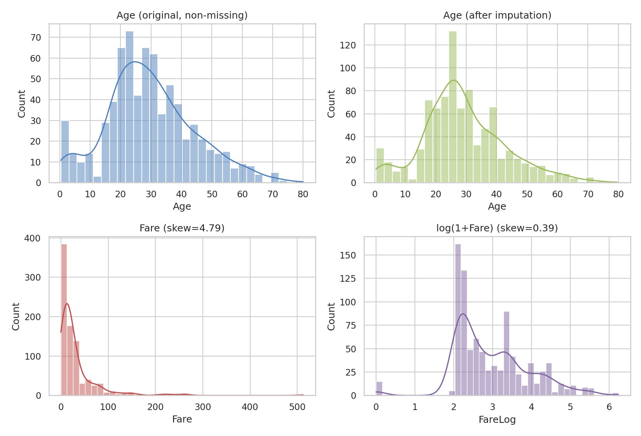
Figure 2: Age before and after imputation (top); Fare before and after log transform (bottom).
- Age is roughly bell-shaped with a peak around 20–30 and a smaller spike for infants and toddlers. The imputed distribution keeps this shape but has a slightly taller centre, a known side effect of median imputation.
- Fare is extremely right-skewed (skew 4.79); most tickets cost under 30, with a handful above 200. After the log transform the distribution is nearly symmetric (skew 0.39).

5.2 Class, age and fare relationships
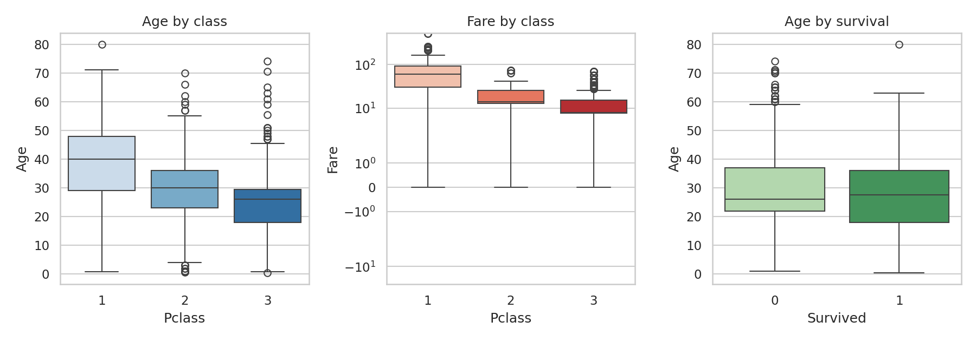
Figure 3: Box plots of Age and Fare by passenger class, and Age by survival outcome.
- Passengers in higher classes were older: median age 40 (1st), 30 (2nd) and 26 (3rd).
- Median fare drops sharply across classes: 60.29 (1st), 14.25 (2nd), 8.05 (3rd). First class also contains nearly all of the extreme fare outliers. Fare is plotted on a symmetric log scale.
- The age distributions of survivors and non-survivors overlap heavily; survivors show a slightly lower lower-quartile because of the large number of children who survived.

5.3 Survival patterns
The overall survival rate is 38.4%. Breaking this down shows very large differences between groups.
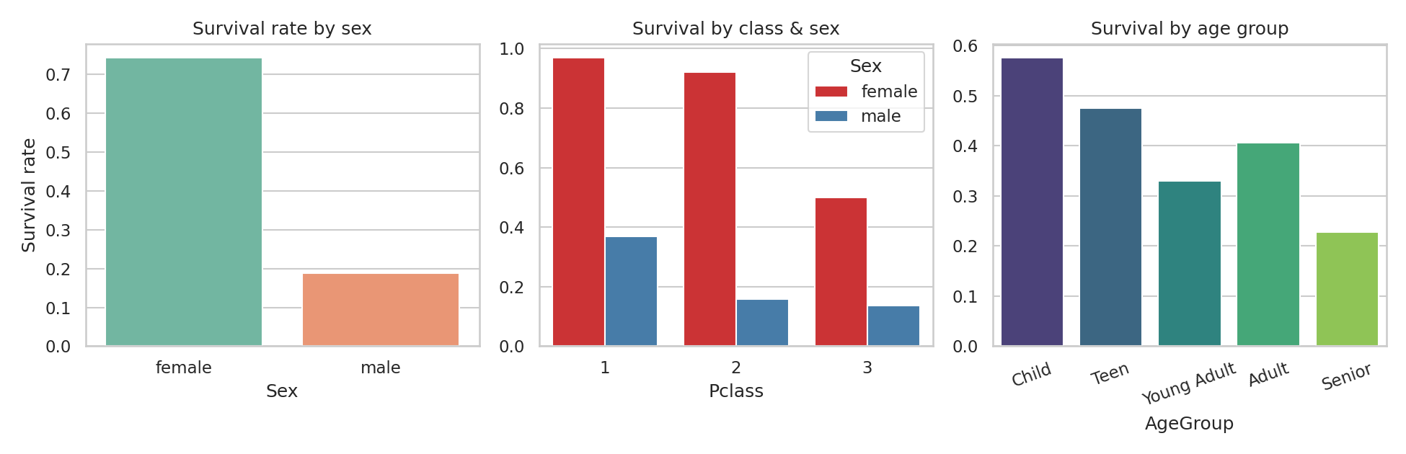
Figure 4: Survival rate by sex, by class and sex, and by age group.
Group | Survival rate | Note
Female | 74.2% | Strongest single factor
Male | 18.9%
1st class | 63%
2nd class | 47.3%
3rd class | 24.2%
1st-class female | 96.8% | Highest-surviving group
3rd-class male | 13.5% | Lowest-surviving large group
Children (0–12) | 57.5% | Highest of age groups
Seniors (60+) | 22.7% | Lowest of age groups
Has cabin recorded | 66.7% | vs 30% without
Travelling alone | 30.4% | vs 50.6% with family

5.4 Correlations
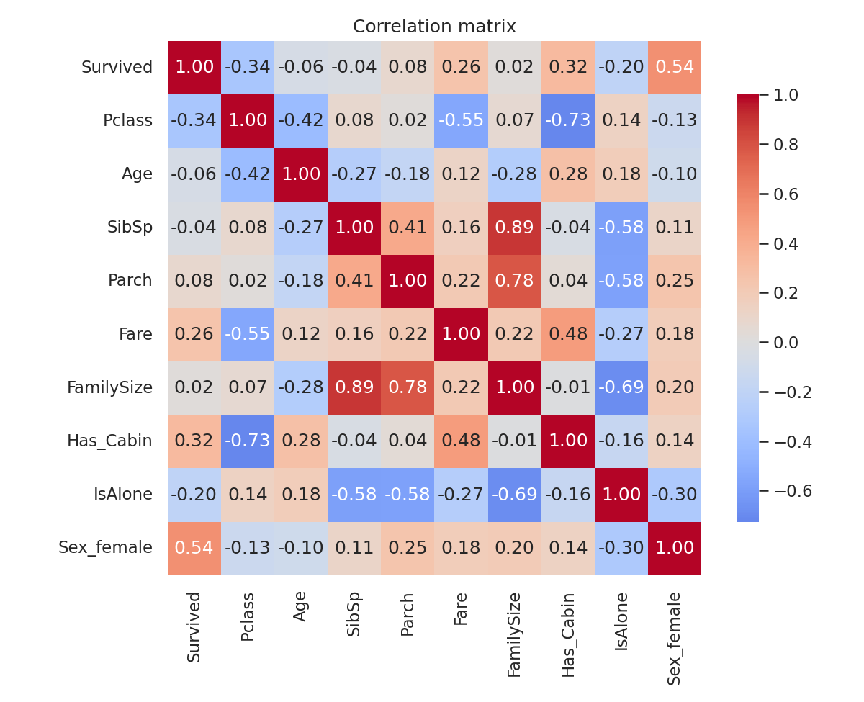
Figure 5: Correlation matrix of numeric and encoded variables.
- Sex (female) has the strongest correlation with survival (r = 0.54), followed by Has_Cabin (0.32), Fare (0.26) and Pclass (-0.34, negative because lower class number means higher status).
- Fare and Pclass are strongly negatively correlated (r = -0.55), meaning they partly carry the same information; this multicollinearity matters if a linear model is built later.
- Age has almost no linear correlation with survival (r = −0.06), yet the age-group chart shows a clear effect for children. This is a non-linear relationship that a correlation coefficient misses.

5.5 Age versus fare
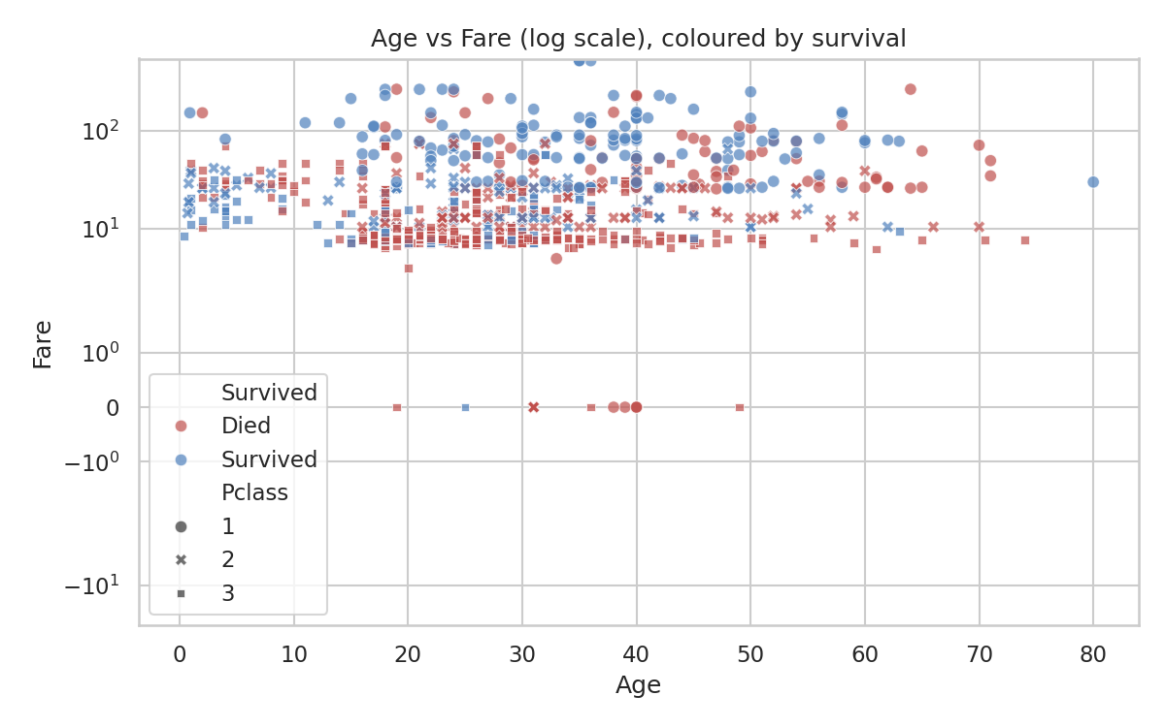
Figure 6: Age vs Fare (symmetric log scale), coloured by survival and styled by class.
The scatter plot shows no tight relationship between age and fare. High-fare passengers (first class) are mostly survivors across the age range, whereas the dense cluster of low-fare third-class passengers is dominated by non-survivors. Many points lie on horizontal lines at the same fare because group tickets were shared.

5.6 Family size and port of embarkation
- Survival rises with small families (55.3% for 2 people, 57.8% for 3, 72.4% for 4) but collapses for families of five or more (20% for 5, 13.6% for 6, and 0% for 8 and 11). Solo travellers sit in between at 30.4%.
- Passengers who boarded at Cherbourg survived more often (55.4%) than those from Queenstown (39%) or Southampton (33.9%). This is probably a proxy for class mix, since Cherbourg had a higher share of first-class passengers, rather than a direct effect of the port.

6. Summary of Insights
- Gender was the dominant factor. About 74% of women survived compared with about 19% of men, consistent with the “women and children first” evacuation rule.
- Class mattered, and it interacted with gender. Almost all first- and second-class women survived (97% and 92%), but only about half of third-class women did, and men of every class fared poorly.
- Children had a clear advantage (about 58% survival), while seniors had the worst outcome (about 23%). Because the relationship is non-linear, age needs to be binned or modelled non-linearly.
- Family size has a sweet spot. Small groups of 2–4 did best; solo travellers and large families (5+) did worse.
- Missingness was informative. Having a cabin recorded was linked with 67% survival versus 30% without, so replacing Cabin with a flag preserved useful signal that blind imputation would have destroyed.
- The data-quality work was worthwhile: grouped imputation, type correction, log-scaling and engineered features gave a complete, analysis-ready table of 891 rows with no missing values and no row loss.

7. Limitations and Further Analysis

7.1 Limitations
- Imputed ages are estimates; they reduce variance slightly and should be treated with caution when the focus is on age-specific effects.
- The dataset contains 891 of roughly 1,300 passengers, so findings describe this sample and not necessarily everyone aboard.
- Findings are associations. Class, sex, fare and cabin are intertwined, so effects cannot be separated without a controlled model.
- Zero-fare records were kept without verification; they may be crew or data-entry issues.

7.2 Suggested next steps
- Fit a baseline logistic regression and a tree-based model (random forest or gradient boosting) to predict survival, using stratified cross-validation.
- Run formal significance tests (chi-square for categorical associations, Mann–Whitney for age differences) to complement the descriptive findings.
- Extract more from the Ticket column (group size by shared ticket) and from surname (family groups).
- Compare imputation strategies (median, KNN, iterative/MICE) and measure their effect on model performance.
- Check multicollinearity between Fare and Pclass with variance inflation factors before using linear models.

8. Conclusion
This project took a raw public dataset with moderate and severe missing data, skew and outliers, and turned it into a clean, well-documented table through justified, reproducible steps. The exploratory analysis then showed that survival on the Titanic was strongly structured by sex, class, age and family context. The cleaned data and engineered features are ready to be used for statistical testing and predictive modelling in the following weeks.

Appendix A: Complete Reproducible Script
import pandas as pd, numpy as np
import matplotlib.pyplot as plt, seaborn as sns

# 1. Acquire
URL = "https://raw.githubusercontent.com/datasciencedojo/datasets/master/titanic.csv"
df = pd.read_csv(URL)

# 2. Audit
print(df.shape, df.isna().sum(), df.duplicated().sum())

# 3. Clean
df["Title"] = df["Name"].str.extract(r",\s*([^\.]+)\.")[0].str.strip()
df["Title"] = df["Title"].replace({"Mlle":"Miss","Ms":"Miss","Mme":"Mrs"})
df["Title"] = df["Title"].where(df["Title"].isin(["Mr","Mrs","Miss","Master"]), "Rare")

df["Age_missing"] = df["Age"].isna().astype(int)
df["Age"] = df["Age"].fillna(df.groupby(["Title","Pclass"])["Age"].transform("median"))
df["Age"] = df["Age"].fillna(df["Age"].median())

df["Has_Cabin"] = df["Cabin"].notna().astype(int)
df["Deck"] = df["Cabin"].str[0].fillna("Unknown")
df = df.drop(columns=["Cabin"])
df["Embarked"] = df["Embarked"].fillna(df["Embarked"].mode()[0])
df = df.drop_duplicates()

for col in ["Survived","Pclass","Sex","Embarked","Title","Deck"]:
df[col] = df[col].astype("category")

# 4. Feature engineering
df["FamilySize"] = df["SibSp"] + df["Parch"] + 1
df["IsAlone"] = (df["FamilySize"] == 1).astype(int)
df["AgeGroup"] = pd.cut(df["Age"], [0,12,18,35,60,100],
labels=["Child","Teen","Young Adult","Adult","Senior"])
df["FareLog"] = np.log1p(df["Fare"])

# 5. EDA
sns.heatmap(df.isna().T, cbar=False) # missing map
sns.histplot(df["Fare"], kde=True) # distribution
sns.boxplot(data=df, x="Pclass", y="Age") # box plot
sv = df["Survived"].astype(int)
sns.barplot(data=df, x="Pclass", y=sv, hue="Sex") # survival rates
sns.heatmap(df.select_dtypes("number").corr(), annot=True) # correlations

df.to_csv("titanic_clean.csv", index=False)

