**NAME : DIVYANSHI AGARWAL**

**ROLL NO : 21UCS074**

Issues in dockerfile of nginx

Here's a concise breakdown of the issues and their resolutions:

1. **Image Version**: nginx:latests → corrected to nginx:latest.
2. **File Path**: nginix.conf → corrected to nginx.conf.
3. **HTML Directory Path**: htmll → corrected to html.
4. **Port Expose**: "eighty" → corrected to 80.
5. **Daemon Command**: daemon of; → corrected to daemon off;.

Issues in nginx.config

Here’s a concise list of issues in the original nginx.conf file and how they were resolved:

1. **worker_process typo**: worker_process auto → corrected to worker_processes auto;
2. **worker_connection typo**: worker_connection 1024; → corrected to worker_connections 1024;
3. **MIME Types Path**: include /etc/nginx/mime.typess; → corrected to include /etc/nginx/mime.types;
4. **default_typ typo**: default_typ application/octet-stream; → corrected to default_type application/octet-stream;

Issues in dockerfile of python

Here’s a list of issues in the original Dockerfile (commented lines) and how they were resolved:

1. **Incorrect WORKDIR**: WORKDIR /appp → corrected to WORKDIR /app.
2. **Typo in file path**: COPY appy.py /app → corrected to COPY app.py /app/.
3. **Typo in port**: EXPOSE "eight thousand" → corrected to EXPOSE 8000.
4. **Typo in command**: CMD ["pythn", "app.py"] → corrected to CMD ["python", "app.py"].

Issues in docker-compose.yaml

Here’s a summary of the issues in the original docker-compose file and the resolutions:

1. **Image name typo**: local-nginx and local-python-app → corrected to nginx-server:latest and python-app:latest.
2. **Incorrect file path**: nginx.conf → corrected path from /etc/nginx/nginx.confi to /etc/nginx/nginx.conf.
3. **Typo in exposed port**: "eight thousand" → corrected to "8000".
4. **Network driver typo**: bridg → corrected to bridge.
5. **Misnamed option**: compelex_option in network options was removed as it was unused.

**A screenshot of the application running in the browser.**

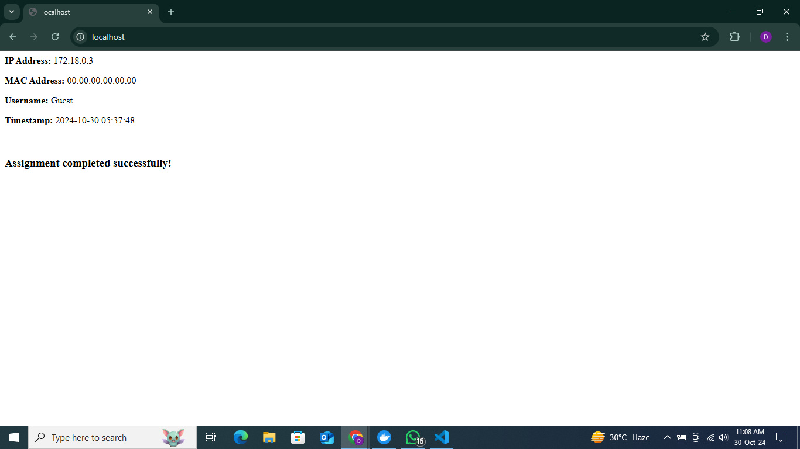

**A screenshot showing Nginx access logs that confirm a successful request**.

