Security Assessment Report: IIoT Security & Optimization
Industrial Internet of Things systems connect sensors, controllers, gateways, industrial networks, and cloud or enterprise applications to improve visibility, automation, and operational efficiency. The same interconnection increases cyber risk because devices, protocols, remote access paths, and data flows create many points where confidentiality, integrity, or availability can be compromised.
This security assessment report focuses on four core areas required for security vulnerabilities, secure communication, authentication, and encryption methods.
Overview of IIoT Security
IIoT security is the set of policies, technologies, and engineering controls used to protect connected industrial devices, communication channels, control systems, and industrial data from unauthorized access, manipulation, disruption, or destruction.
Importance of Security in Industrial IoT
Security is important in Industrial IoT because cyber incidents can do more than leak information; they can stop production, alter process values, damage assets, and create unsafe conditions for workers and equipment.
NIST guidance for OT security emphasizes that threats to industrial systems affect mission and business functions directly, which is why cyber risk management in IIoT must be treated as an operational requirement rather than just an IT concern.
CIA Triad in IIoT
The CIA triad remains a useful framework for understanding IIoT security goals.
- Confidentiality means sensitive process data, credentials, firmware, and maintenance sessions should not be exposed to unauthorized parties.
- Integrity means sensor values, commands, logs, firmware, and alarms should not be altered without detection.
- Availability means industrial processes, communication links, and control systems should remain usable and resilient even during failures or attacks.
In IIoT, integrity and availability often receive special attention because false readings or unavailable control channels can directly affect safety and production continuity.
Security Vulnerabilities
A strong assessment should identify not only common cyber threats but also the industrial conditions that make them dangerous.
1.Weak Authentication
Weak authentication allows unauthorized users, devices, or applications to enter the IIoT environment by exploiting default passwords, reused credentials, shared accounts, or poorly managed remote access. In OT systems, shared engineering credentials and vendor access accounts are especially risky because they reduce accountability and can give broad control over critical assets.
2.Insecure Firmware
Firmware is a major trust anchor in IIoT devices, but it is often poorly protected in low-cost or legacy systems. If firmware updates are unsigned, unverified, or distributed without integrity checks, attackers may install malicious code or tamper with device behavior while remaining difficult to detect.
3.Unencrypted Communication
When data is sent in plaintext, attackers can intercept telemetry, credentials, commands, and maintenance traffic on internal or external networks. This creates direct exposure to eavesdropping, manipulation, session hijacking, and intelligence gathering by adversaries.
4.DDoS Attacks
Distributed denial-of-service attacks target the availability part of the CIA triad by overwhelming gateways, brokers, APIs, or cloud endpoints with excessive traffic. In IIoT, even partial service disruption can delay alarms, interrupt monitoring, or block legitimate device communication.
5.Man-in-the-Middle Attacks
A man-in-the-middle attacker places itself between communicating systems to intercept, modify, or relay data without authorization. MITM attacks become more likely when certificate validation is weak, encryption is absent, or devices trust insecure networks during onboarding or remote access.
6.Replay Attacks
Replay attacks occur when valid communication is captured and resent later to trigger unauthorized behavior. This is dangerous in IIoT because replayed sensor readings or control messages can produce false process states or repeated actions even when the attacker cannot fully decrypt the original traffic.
7.Malware and Ransomware
NIST OT guidance identifies malware as a major threat to industrial systems. Malware may spread through engineering workstations, maintenance laptops, third-party software, removable media, or remote access channels, while ransomware may disrupt industrial operations by encrypting business systems, plant servers, or supporting infrastructure.
8.Insider Threats
Insider threats include intentional abuse and accidental mistakes by employees, contractors, integrators, or vendors with legitimate access. In IIoT, insiders may misconfigure gateways, disable protections for convenience, leak credentials, or introduce unauthorized hardware and software into the plant environment.
9.Additional Causes of Vulnerability
Several underlying conditions increase the chance that the above threats will succeed.
- Legacy devices with weak built-in security controls.
- Flat networks instead of segmented zones and conduits.
- Poor asset visibility and limited log collection.
- Weak patch and vulnerability management for industrial devices.
- Overly permissive vendor or remote maintenance access.
Secure Communication Methods
Secure communication protects the movement of telemetry, commands, updates, and management traffic across IIoT systems.The goal is not only encryption, but also endpoint trust, integrity protection, resilience, and traceability.
- MQTT over TLS
MQTT is widely used in IoT and IIoT because it is lightweight and efficient for publish-subscribe communication. When used over TLS, MQTT gains protection against eavesdropping and tampering in transit, while broker-side authentication and topic authorization help restrict which clients can publish or subscribe to specific data streams.
- HTTPS
HTTPS is useful for device management panels, APIs, dashboards, firmware delivery, and cloud integration points. It provides transport encryption and server authentication when implemented with valid certificates and proper configuration.
- VPN
A virtual private network creates an encrypted tunnel for remote maintenance, site-to-site communication, or access to plant services across untrusted networks. VPNs improve confidentiality and integrity, but they should still be paired with strong identity checks, network segmentation, logging, and session control because a VPN alone does not guarantee least privilege.
- OPC UA Security
OPC UA is an important industrial communication technology because it supports interoperable data exchange with built-in security capabilities, including application authentication, signing, encryption, and certificate-based trust models. For this reason, OPC UA is often preferred over older industrial protocols that lack strong native security properties.
- DTLS for Constrained Devices
Datagram Transport Layer Security is suitable for constrained or UDP-based environments where TLS-style protection is needed but connection conditions differ from standard web traffic.It is relevant for lightweight device communication where reliability, performance, and resource limits must be balanced against security needs.
Authentication Methods
Authentication verifies the identity of users, devices, gateways, and services before they are allowed to participate in the IIoT system. Strong authentication reduces unauthorized access, improves accountability, and supports secure automation.
- Password-Based Authentication
Passwords are still common in local configuration interfaces and operator accounts, but they are the weakest method when used alone. Shared credentials, predictable passwords, and lack of rotation make password-only authentication unsuitable for high-risk industrial access paths.

- Multi-Factor Authentication
Multi-factor authentication combines two or more proof types, such as a password plus a token, approval app, or hardware key. It is especially important for remote access, administrative accounts, and vendor sessions because those paths are common targets for compromise.
- Digital Certificates (X.509)
X.509 certificates support scalable identity and trust for devices, gateways, servers, and users in certificate-based systems. They are widely used in TLS and OPC UA environments to enable mutual authentication and stronger machine-to-machine trust than shared secrets can provide.

- OAuth 2.0
OAuth 2.0 is useful for modern API and application ecosystems where delegated authorization is needed between services and users. In IIoT cloud integrations, it can help manage application-level access to dashboards, analytics, and APIs, although it usually complements rather than replaces device identity controls.

- Public Key Infrastructure (PKI)
PKI is the management framework behind certificate-based trust, including issuance, validation, renewal, and revocation of digital certificates. Without a properly managed PKI, certificate-based security becomes difficult to scale and maintain over the full IIoT device lifecycle.

- Device Identity Management
Each IIoT device should have a unique and verifiable identity rather than a shared credential pool. Device identity management improves onboarding security, access control, auditability, and incident response because operators can trace actions to specific endpoints.
Encryption Methods
Encryption methods protect data confidentiality and, when combined with integrity mechanisms, strengthen trusted communication. The chosen method should match device capability, latency constraints, and operational criticality.
- Symmetric Encryption
Symmetric encryption uses one shared secret key for both encryption and decryption. AES-128 and AES-256 are common examples because they are efficient for protecting data in transit or at rest and are practical for many industrial communication and storage use cases.
- Asymmetric Encryption
Asymmetric encryption uses a public-private key pair rather than one shared secret. RSA and ECC are common examples used for key exchange, certificate systems, digital signatures, and secure session establishment in distributed environments.
- Hashing
Hashing converts data into a fixed-size digest and is used for integrity verification, password storage schemes, and digital signature workflows. SHA-256 is widely used because it provides a strong digest suitable for modern security applications.
- Digital Signatures
Digital signatures allow a receiver to verify both integrity and sender authenticity. They are especially valuable in IIoT for signed firmware, secure updates, message authenticity, and non-repudiation in critical communications.
Risk Assessment
The table below uses a simple qualitative model based on impact, likelihood, and mitigation.
Threat | Impact | Likelihood | Risk Level | Mitigation
DDoS Attack | High | High | Critical | Firewall, IDS/IPS, rate limiting, resilient architecture
MITM Attack | High | Medium | High | TLS, certificate validation, mutual authentication
Weak Password | Medium | High | High | MFA, strong password policy, account review
Firmware Tampering | High | Medium | High | Secure boot, signed firmware, controlled updates
Replay Attack | Medium | Medium | Medium | Nonces, timestamps, session validation, integrity protection
Malware/Ransomware | High | Medium | High | Segmentation, endpoint protection, backups, monitoring
Insider Threat | High | Medium | High | Least privilege, logging, approvals, role-based access control

Risk Interpretation
The highest-priority risks are the ones that can quickly affect plant availability, trust in control commands, or firmware integrity. That is why DDoS, MITM, weak authentication, and firmware tampering should usually be treated as front-line assessment items in an IIoT environment.
Security Architecture Diagram
The following architecture shows where major controls are applied in a typical IIoT system.
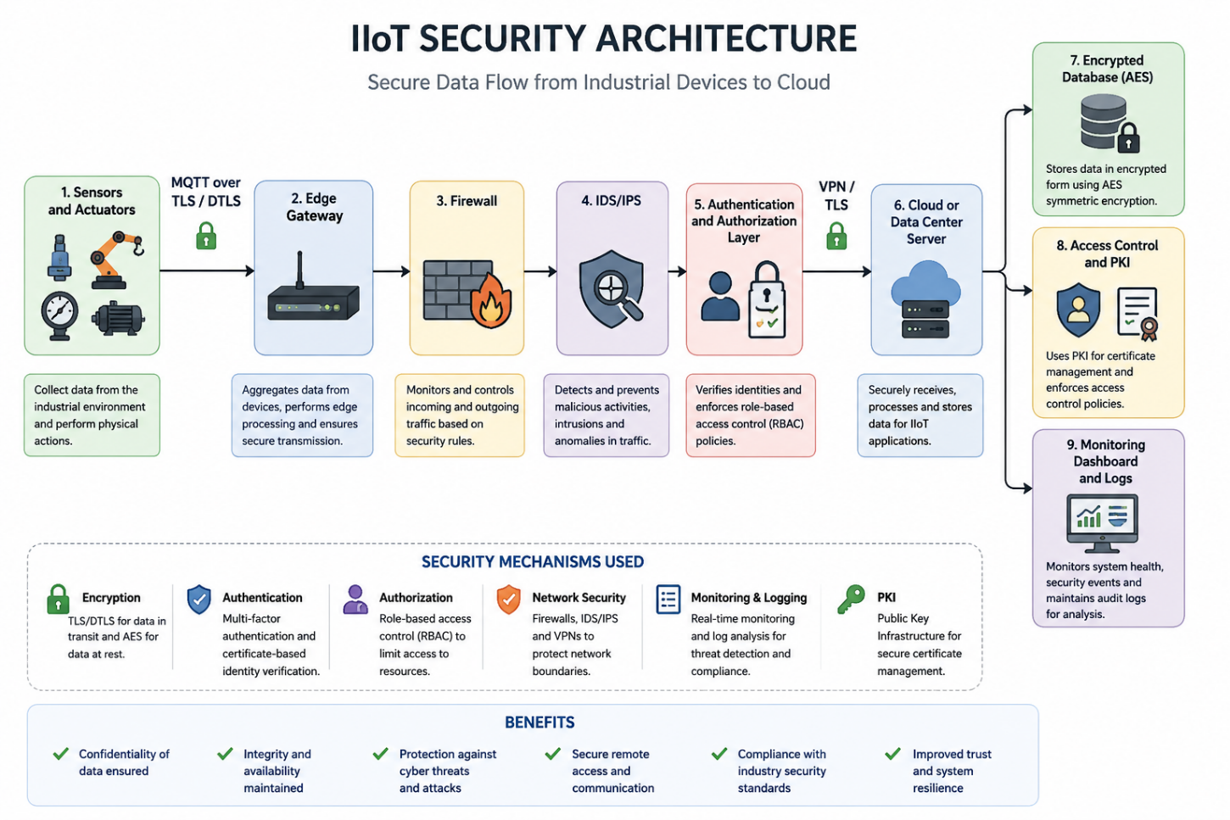
Security Recommendations
- Sensors and actuators collect operational data from industrial equipment.
- Data is securely transmitted using MQTT over TLS/DTLS, ensuring encryption and integrity.
- The Edge Gateway aggregates, filters, and preprocesses the data while authenticating connected devices.
- Traffic passes through a Firewall, which filters unauthorized connections and enforces network policies.
- An IDS/IPS monitors the traffic, detecting and blocking malicious activity such as malware, port scanning, or DDoS attacks.
- The Authentication and Authorization Layer verifies the identity of users and devices and grants access based on predefined roles (RBAC/ABAC).
- Authenticated data is transmitted to the Cloud/Data Center through a secure VPN/TLS tunnel.
- The cloud platform processes, analyzes, and stores industrial data while hosting analytics, dashboards, and applications.
- Sensitive information is protected in an AES-encrypted database, safeguarding data at rest.
- PKI and Access Control manage digital certificates, cryptographic keys, and secure device identities for trusted communication.
- A Monitoring Dashboard and Logging System continuously tracks system health, records security events, generates alerts, and supports incident response.

