INDEX

IIOT ARCHITECTURES 2
M2M ARCHITECTURE 3
SIMPLIFIED IOT ARCHITECTURE 5
LAYER 1: THINGS: SENSORS AND ACTUATORS LAYER 5
LAYER 2: COMMUNICATIONS NETWORK LAYER 6
LAYER-3: IOT DATA MANAGEMENT AND COMPUTE STACK 8

MQTT 8
FEATURES 9

SENSORS 10
TYPES OF SENSORS 11
APPLICATIONS OF SENSORS 11
ADVANTAGES OF SENSORS 12
LIMITATIONS 12
FUTURE TRENDS IN SENSOR TECHNOLOGY 12

EDGE COMPUTING 13
CLOUD COMPUTING 13

INDUSTRIAL USE CASES OF IOT 14
MANUFACTURING INDUSTRY 14
OIL AND GAS INDUSTRY 15
SMART UTILITIES AND SMART GRID 15
SMART AND CONNECTED CITIES 15
TRANSPORTATION INDUSTRY 16
MINING INDUSTRY 16
PUBLIC SAFETY AND EMERGENCY RESPONSE 16
LIMITATIONS 17

IIOT ARCHITECTURES
NEED OF SEPARATE ARCHITECTURE
Challenge | Description | IoT Architectural Change Required
Scale | The massive scale of IoT endpoints (sensors) is far beyond that of typical IT networks. | The IPv4 address space has reached exhaustion and is unable to meet IoT’s scalability requirements. Scale can be met only by using IPv6. IT networks continue to use IPv4 through features like Network Address Translation (NAT).
Security | IoT devices, especially those on wireless sensor networks (WSNs), are often physically exposed to the world. | Security is required at every level of the IoT network. Every IoT endpoint node on the network must be part of the overall security strategy and must support device-level authentication and link encryption. It must also be easy to deploy with some type of a zero-touch deployment model.
Devices and networks constrained by power, CPU, memory, and link speed | Due to the massive scale and long distances, the networks are often constrained, lossy, and capable of supporting only minimal data rates (tens of bps to hundreds of Kbps). | New last-mile wireless technologies are needed to support constrained IoT devices over long distances. The network is also constrained, meaning modifications need to be made to traditional network-layer transport mechanisms.
The massive volume of data generated | The sensors generate a massive amount of data on a daily basis, causing network bottlenecks and slow analytics in the cloud. | Data analytics capabilities need to be distributed throughout the IoT network, from the edge to the cloud. In traditional IT networks, analytics and applications typically run only in the cloud.
Support for legacy devices | An IoT network often comprises a collection of modern, IP-capable endpoints as well as legacy, non-IP devices that rely on serial or proprietary protocols. | Digital transformation is a long process that may take many years, and IoT networks need to support protocol translation and/or tunnelling mechanisms to support proprietary protocols over standards-based protocols, such as Ethernet and IP.
The need for data to be analysed in real time | Whereas traditional IT networks perform scheduled batch processing of data, IoT data needs to be analysed and responded to in real-time. | Analytics software needs to be positioned closer to the edge and should support real-time streaming analytics. Traditional IT analytics software (such as relational databases or even Hadoop) are better suited to batch-level analytics that

M2M ARCHITECTURE
OneM2M is developing standards that allow interoperability at all levels of the IoT stack. The problem is that the LoRaWAN network and the BACnet system that your HVAC and BMS run on are completely different systems and have no natural connection point. This is where the oneM2M common services architecture comes in. oneM2M’s horizontal framework and RESTful APIs allow the LoRaWAN system to interface with the building management system over an IoT network, thus promoting end-to-end IoT communications in a consistent way, no matter how heterogeneous the networks. The oneM2M architecture divides IoT functions into three major domains: the application layer, the services layer, and the network layer.

■ Applications layer: This domain includes the application-layer protocols and attempts to standardize northbound API definitions for interaction with business intelligence (BI) systems. Applications tend to be industry-specific and have their own sets of data models.

■ Services layer: This layer is shown as a horizontal framework across the vertical industry applications. At this layer, horizontal modules include the physical network that the IoT applications run on, the underlying management protocols, and the hardware. Examples include backhaul communications via cellular, MPLS networks, VPNs, and so on. Riding on top is the common services layer. This conceptual layer adds APIs and middleware supporting third-party services and applications. One of the stated goals of oneM2M is to “develop technical specifications which address the need for a common M2M Service Layer that can be readily embedded within various hardware and software nodes, and rely upon connecting the myriads of devices in the field area network to M2M application servers, which typically reside in a cloud or data centre.” A critical objective of oneM2M is to attract and actively involve organizations from M2M-related business domains, including telematics and intelligent transportation, healthcare, utility, industrial automation, and smart home applications.

■Network layer: This is the communication domain for the IoT devices and endpoints. It includes the devices themselves and the communications network that links them. Embodiments of this communications infrastructure include wireless mesh technologies, such as IEEE 802.15.4, and wireless point-to-multipoint systems, such as IEEE 801.11ah. Also included are wired device connections, such as IEEE 1901 power line communications. Chapter 4 provides more details on these connectivity technologies.
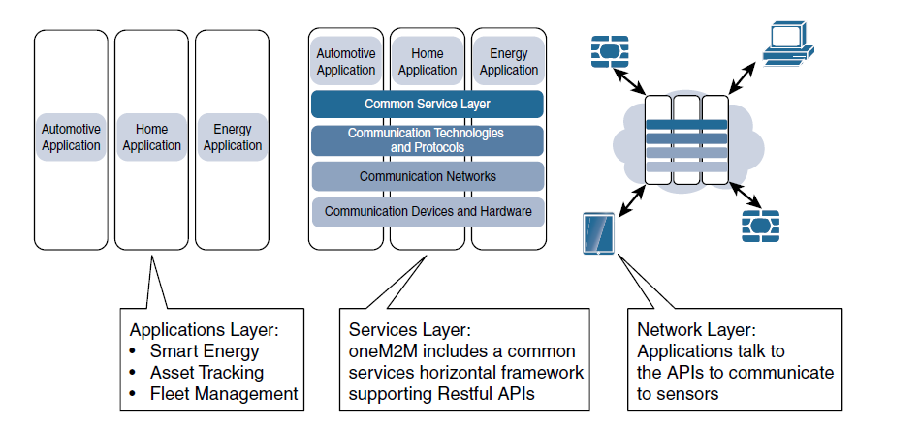

THE IOT WORLD FORUM (IOTWF) STANDARDIZED ARCHITECTURE
In 2014 the IoTWF architectural committee (led by Cisco, IBM, Rockwell Automation, and others) published a seven-layer IoT architectural reference model. While various IoT reference models exist, the one put forth by the IoT World Forum offers a clean, simplified perspective on IoT and includes edge computing, data storage, and access.

IoT Reference Model Layer | Functions
Layer 1: Physical Devices and Controllers Layer | The first layer of the IoT Reference Model consists of physical devices and controllers. Their primary function is generating data and being capable of being queried and/or controlled over a network.
Layer 2: Connectivity Layer | The second layer focuses on connectivity. Its functions are: -  • Communications Between Layer 1 Devices  • Reliable Delivery of Information Across the Network  • Switching and Routing  • Translation Between Protocols  • Network Level Security  This layer encompasses all networking elements of IoT and does not distinguish between the last-mile network gateway and backhaul networks.
Layer 3: Edge Computing Layer | One of the basic principles of the IoT Reference Model is that information processing is initiated as early and as close to the edge of the network as possible. At this layer, the data is aggregated, evaluated, and filtered before sending it to higher layers.
Layer 4: Data Accumulation Layer | Captures data and stores it so it is usable by applications when necessary. Converts event-based data to query-based processing.
Layer 5: Data Abstraction Layer | Reconciles multiple data formats and ensures consistent semantics from various sources. Confirms that the dataset is complete and consolidates data into one place or multiple data stores using virtualization.
Layer 6: Applications Layer | Interprets data using software applications. Applications may monitor, control, and provide reports based on the analysis of the data.
Layer 7: Collaboration and Processes Layer | Consumes and shares the application information. Collaborating on and communicating IoT information often requires multiple steps, and this layer makes IoT useful. It can change business processes and deliver the benefits of IoT.

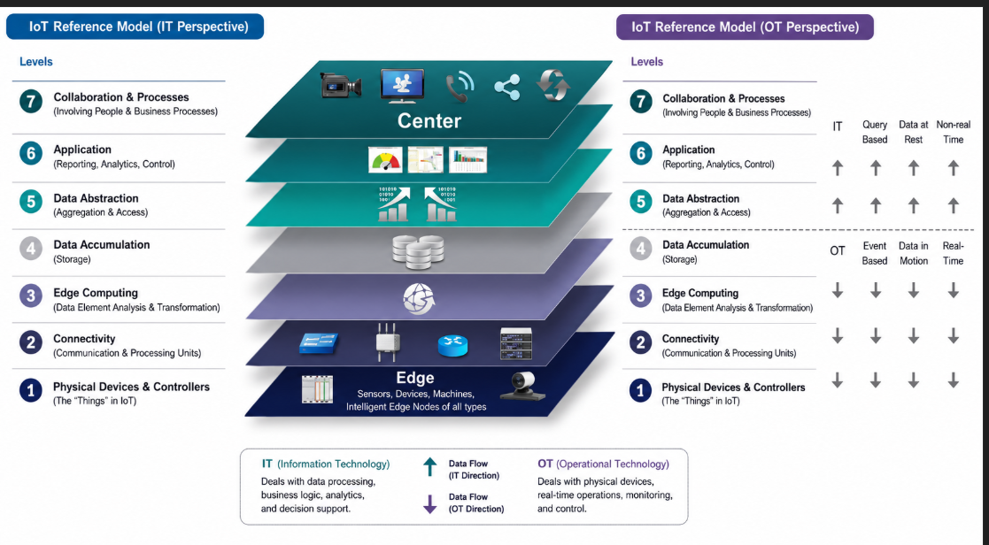

SIMPLIFIED IOT ARCHITECTURE

An IoT framework that highlights the fundamental building blocks that are common to most IoT
systems and which is intended to help you in designing an IoT network. This framework
is presented as two parallel stacks: The IoT Data Management and Compute Stack and the
Core IoT Functional Stack.

Unlike with most IT networks, the applications and analytics layer of IoT doesn't
necessarily exist only in the data centre or in the cloud. Due to the unique challenges
and requirements of IoT, it is often necessary to deploy applications and data management
throughout the architecture in a tiered approach, allowing data collection, analytics,
and intelligent controls at multiple points in the IoT system.

LAYER 1: THINGS: SENSORS AND ACTUATORS LAYER
From an architectural standpoint, the variety of smart object types,
shapes, and needs drive the variety of IoT protocols and architectures. There are myriad
ways to classify smart objects.
Architectural Classifications

LAYER 2: COMMUNICATIONS NETWORK LAYER
There is a direct relationship between the IoT network technology chosen and the type of connectivity topology this technology allows.

1.Network Access Sublayer
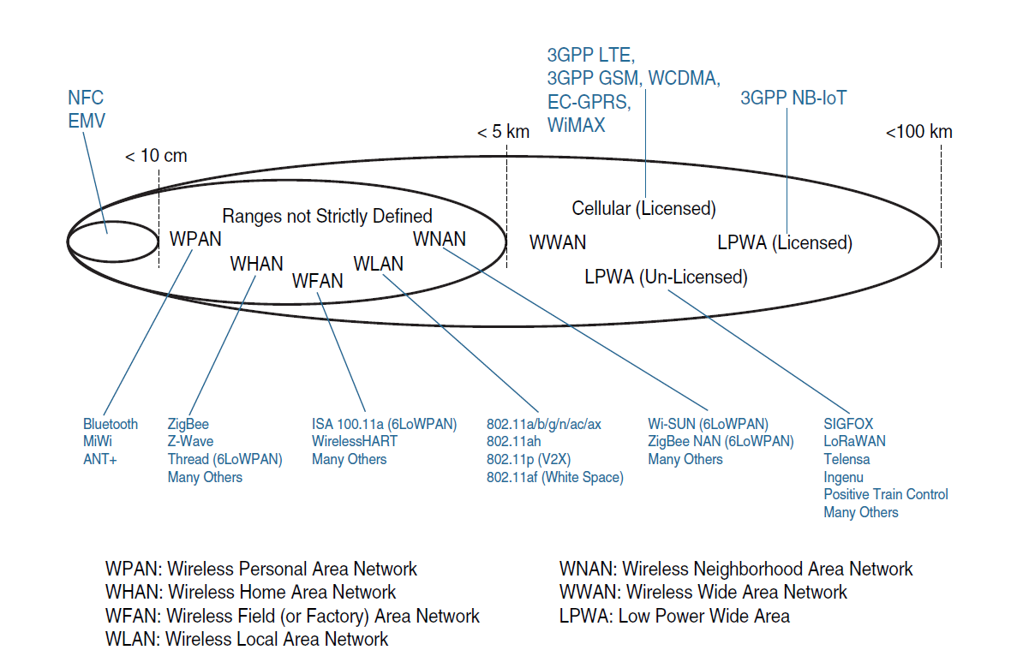
One key parameter determining the choice of access technology is the range between the smart object and the information collector for the access network sublayer.

Other factors combine cost, range, power consumption, and typical available bandwidth for common IoT access technologies.
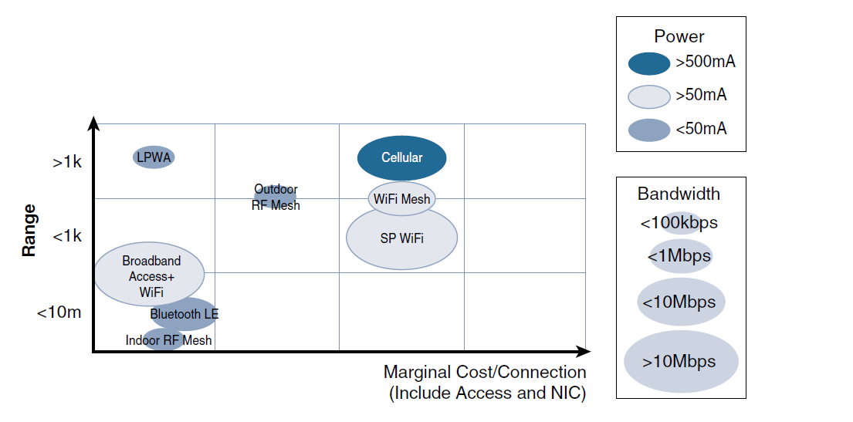
Comparison Between Common Last-Mile Technologies in Terms of Range versus Cost, Power, and Bandwidth
2. Gateways and Backhaul Sublayer
This layer acts as a bridge between IoT devices and the internet/cloud. Its functions include: -
- Collects data from sensors and smart devices.
- Converts different communication protocols (Bluetooth, Zigbee, RFID, etc.) into internet-compatible protocols.
- Sends data to cloud servers through Wi-Fi, Ethernet, cellular networks, or satellite links.

3. Network Transport Sublayer
This layer is responsible for moving data reliably across networks from gateways to cloud applications and back.
- Transfers data packets over the internet.
- Ensures secure and reliable communication.
- Uses networking protocols like TCP/IP, UDP, MQTT, CoAP

The transport layer protocols built above IP (UDP and TCP) can easily be leveraged
to decide whether the network should control the data packet delivery (with TCP)
or whether the control task should be left to the application (UDP). UDP is a much lighter
and faster protocol than TCP. However, it does not guarantee packet delivery. Both TCP
and UDP can be secured with TLS/SSL (TCP) or DTLS (UDP).

4.IoT Network Management Sublayer
Upper-layer protocols need to take care of data transmission between the smart objects and other systems. Multiple protocols have been leveraged or created to solve IoT data communication problems.
Following the IP logic, some IoT implementers have suggested HTTP for the data transfer
phase. After all, HTTP has a client and server component. But HTTP
was not designed to operate in constrained environments with low
memory, low power, low bandwidth, and a high rate of packet failure. Despite these limitations, web-derived protocols like WebSocket (part of the HTML5 specification) have been introduced with other protocols such as MQTTT for IoT space for providing a bidirectional connection over a single connection line. Another common IoT protocol utilized in this middle to upper layers is Message Queue Telemetry Transport (MQTT) which uses a broker-based architecture.
another protocol was created by the
IETF Constrained Restful Environments (CoRE) working group: Constrained Application Protocol (CoAP) with features of HTTP and additionally the feature of “Observation” allows the streaming of state changes as they occur, without requiring the receiver to query for these changes.

LAYER-3: IOT DATA MANAGEMENT AND COMPUTE STACK
Fog Computing
Fog computing extends edge services in IoT by enabling computation, storage, and networking near data sources. Fog nodes such as routers, gateways, switches, and embedded servers perform local analytics and control, reducing latency, bandwidth usage, and cloud dependency while supporting real-time monitoring and decision-making.
Edge Computing
Edge computing processes IoT data directly at or near end devices, enabling fast local computation, filtering, and response. It minimizes latency, reduces bandwidth consumption, and improves reliability for real-time applications such as industrial automation, healthcare, and smart surveillance.
Cloud Computing
Cloud computing provides centralized storage, large-scale processing, advanced analytics, and remote IoT management over the internet. It supports scalability, machine learning, and long-term data analysis for enterprise-level IoT applications using platforms such as Amazon Web Services, Microsoft Azure, and Google Cloud.
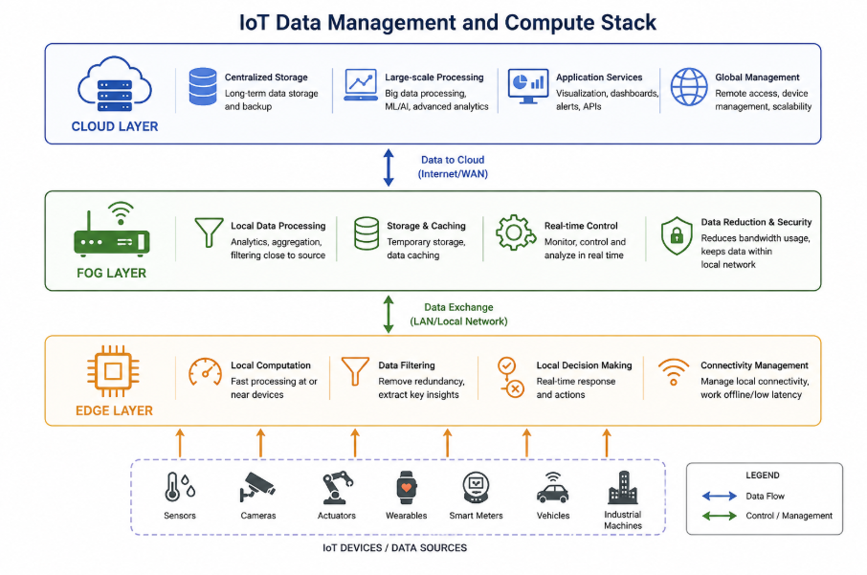

MQTT

MQTT (Message Queuing Telemetry Transport) is a lightweight messaging protocol designed for machine-to-machine (M2M) communication and Internet of Things (IoT) applications. According to research literature, MQTT is specifically developed for low-bandwidth, high-latency, and unreliable networks, making it highly suitable for IoT environments where devices have limited power, memory, and processing capability. It follows a publish–subscribe communication model and uses a central broker/server to manage communication between devices.

FEATURES
- Publish–Subscribe Model
An MQTT client can act as a publisher to send data to an MQTT broker, while another client can act as a subscriber that receives information from publishers.
- Topic-Based Communication
Devices communicate through topics, allowing subscribers to receive only the specific data they need.
- Reliable Communication
The MQTT broker stores and forwards messages, ensuring data delivery even during temporary network failures.
- Lightweight Protocol
MQTT uses a very small 2-byte header, making it suitable for low-power and resource-constrained IoT devices.
- Transport Layer Support
MQTT operates over TCP using ports 1883 and 8883 and can also use TLS and WebSocket for secure communication.
- Scalability and Flexibility
Because publishers and subscribers are decoupled, MQTT systems can easily scale to support many devices.
- Efficient Data Delivery
MQTT minimizes bandwidth usage while enabling fast and efficient real-time message transmission.
- QoS (Quality of Service) Levels
MQTT provides different QoS levels to control message delivery reliability according to application needs.
- Offline Message Buffering
The broker can buffer messages so subscribers can receive missed data after reconnecting.
- Wide IoT Applicability
MQTT is widely used in smart homes, industrial IoT, healthcare, and sensor monitoring applications due to its simplicity and efficiency.
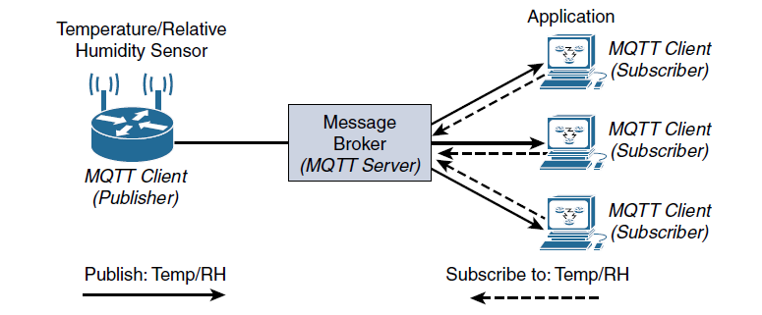
MQTT Publish/Subscribe
Framework

The MQTT protocol offers three levels of quality of service (QoS). QoS for MQTT is implemented when exchanging application messages with publishers or subscribers, and it is different from the IP QoS.
The delivery protocol is concerned solely with the delivery of an application message from a single sender to a single receiver. These are the three levels of MQTT QoS:
■ QoS 0: The publisher sends its message one time to a server, which transmits it once to the subscribers. No response is sent by the receiver, and no retry is performed by the sender. The message arrives at the receiver either once or not at all.
■ QoS 1: This QoS level ensures that the message delivery between the publisher and server and then between the server and subscribers occurs at least once. In PUBLISH and PUBACK packets, a packet identifier is included in the variable header. If the message is not acknowledged by a PUBACK packet, it is sent again.
■ QoS 2: This is the highest QoS level, used when neither loss nor duplication of messages is acceptable. There is an increased overhead associated with this QoS level because each packet contains an optional variable header with a packet identifier.
Confirming the receipt of a PUBLISH message requires a two-step acknowledgement process. The first step is done through the PUBLISH/PUBREC packet pair, and the second is achieved with the PUBREL/PUBCOMP packet pair. This level provides a “guaranteed service” known as “exactly once” delivery, with no consideration for the number of retries as long as the message is delivered once
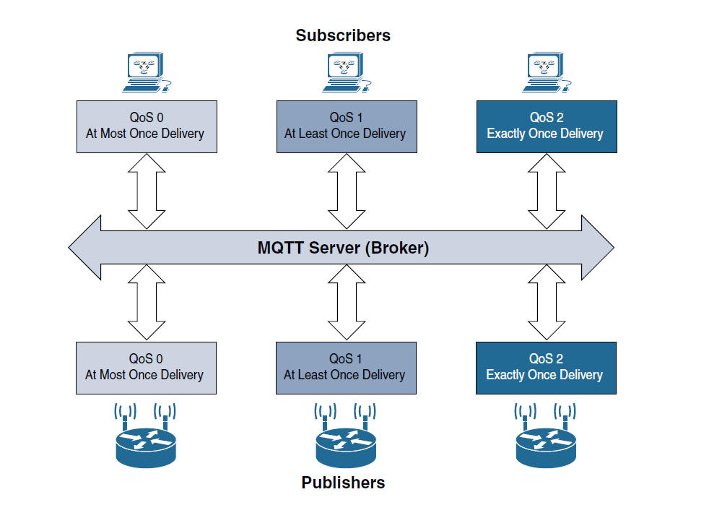

Sensors

Sensors are fundamental components of modern electronic and industrial systems. They are widely used in automation, healthcare, smart devices, robotics, industrial Internet of Things (IIoT), environmental monitoring, and communication systems. A sensor detects physical, chemical, or biological changes in the environment and converts them into measurable electrical signals. This report discusses the concept, working principles, types, applications, advantages, challenges, and future trends of sensors in modern technology.

A sensor is a device that detects changes in physical conditions such as temperature, pressure, humidity, motion, light, sound, gas concentration, or proximity and converts them into electrical signals that can be processed by electronic systems. Sensors play a vital role in automation and intelligent systems because they act as the interface between the physical world and digital systems.
With the rapid growth of technologies such as the Internet of Things (IoT), Artificial Intelligence (AI), robotics, and smart infrastructure, sensors have become an essential part of modern engineering systems. In industrial environments, sensors help monitor machinery performance and improve operational efficiency. In healthcare, sensors are used in wearable devices and medical instruments to monitor patient health.

Types of Sensors
Sensors are classified based on the quantity they measure and their operating principles.
1. Temperature Sensors
Temperature sensors measure heat or temperature changes. Common examples include thermistors, thermocouples, and RTDs (Resistance Temperature Detectors). They are widely used in industrial systems, weather monitoring, and medical devices.
2. Pressure Sensors
Pressure sensors detect force applied by gases or liquids. These sensors are commonly used in automobiles, industrial machinery, and aerospace systems.
3. Humidity Sensors
Humidity sensors measure the moisture content in the air. They are used in smart homes, agricultural systems, HVAC systems, and environmental monitoring.
4. Motion Sensors
Motion sensors detect movement within a specified area. Passive Infrared (PIR) sensors are commonly used in security systems, automatic lighting systems, and smart devices.
5. Proximity Sensors
Proximity sensors detect nearby objects without physical contact. These sensors are used in smartphones, robotics, parking systems, and manufacturing industries.
6. Gas Sensors
Gas sensors identify the presence of harmful or combustible gases in the environment. They are important in industrial safety systems and pollution monitoring.
7. Optical and Light Sensors
Light sensors detect the intensity of light. Examples include photodiodes and LDRs (Light Dependent Resistors), which are used in automatic street lights, cameras, and solar systems.

Applications of Sensors
Sensors are widely used across multiple industries and applications.
1.Industrial Automation
In industries, sensors monitor temperature, pressure, vibration, and machine performance. They improve productivity, safety, and efficiency.
2.Healthcare Systems
Medical sensors are used in heart rate monitors, glucose monitoring devices, ECG machines, and wearable health trackers.
3. Smart Homes
Sensors are used in smart lighting, smart security systems, fire alarms, and home automation systems.
4. Automotive Industry
Modern vehicles use sensors for airbag systems, parking assistance, engine monitoring, fuel management, and autonomous driving.
5. Environmental Monitoring
Sensors help monitor air quality, water quality, temperature, humidity, and pollution levels.
6. Internet of Things (IoT)
IoT systems heavily depend on sensors for collecting real-time data from connected devices and transmitting it to cloud platforms for analysis.

Advantages of Sensors
Sensors provide several benefits in modern systems:
- High accuracy and precision in measurement
- Real-time monitoring and data collection
- Improved automation and efficiency
- Reduced human effort and operational cost
- Enhanced safety and reliability
- Support for remote monitoring and control

Limitations
Despite their advantages, sensors also face certain challenges:
- Calibration and maintenance requirements
- Sensitivity to environmental conditions
- Limited battery life in wireless sensors
- Signal noise and interference
- High cost for advanced sensor systems
- Data security and privacy issues in IoT applications

Future Trends in Sensor Technology
Sensor technology is continuously evolving with advancements in AI, IoT, nanotechnology, and wireless communication. Future sensors are expected to become smaller, smarter, more energy-efficient, and highly accurate.
Some emerging trends include:
- Smart sensors with embedded AI capabilities
- Wireless sensor networks (WSNs)
- Nano-sensors for biomedical applications
- Flexible and wearable sensors
- Self-powered sensors using energy harvesting
- Integration with cloud computing and big data analytics
These developments will further improve automation, healthcare, industrial monitoring, and smart city infrastructure.

Feature | Edge Computing | Cloud Computing
Definition | Processes data near the IoT devices or network edge | Processes data in centralized remote data centers
Processing Location | Local gateways, routers, sensors, or edge servers | Remote cloud servers over the internet
Latency | Very low latency | Higher latency due to internet transmission
Speed | Faster real-time response | Slower compared to edge
Bandwidth Usage | Reduces bandwidth usage by processing locally | Requires more bandwidth to send all data to cloud
Internet Dependency | Can work with limited internet connectivity | Strongly depends on internet connectivity
Storage Capacity | Limited storage | Very large storage capacity
Computing Power | Moderate computing capability | Very high computing capability
Scalability | Limited compared to cloud | Highly scalable
Security & Privacy | Better privacy since data stays local | Data travels over internet, increasing exposure risk
Cost | Lower communication cost but requires local hardware | Lower local hardware cost but higher cloud service cost
Reliability | Continues working during network interruptions | Service may be affected if internet fails
Main Purpose | Real-time processing and quick decision-making | Long-term storage, analytics, and large-scale processing
Common Technologies | Fog nodes, gateways, embedded servers | AWS, Microsoft Azure, Google Cloud
Best Suited For | Industrial automation, autonomous vehicles, smart healthcare | Big data analytics, machine learning, enterprise applications
Example | Smart traffic signal processing locally | Cloud-based traffic analysis dashboard
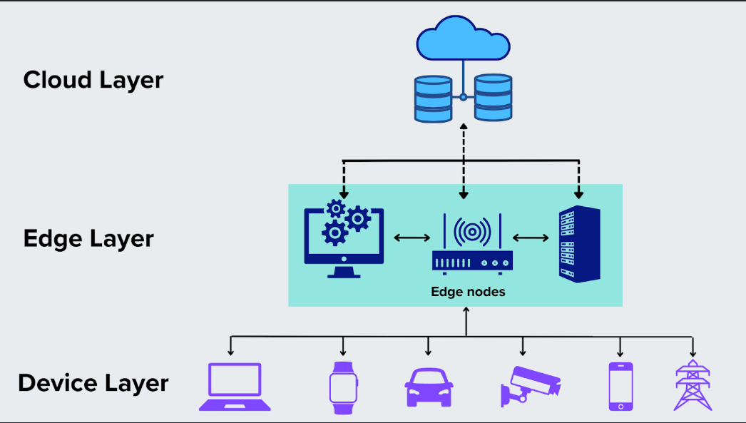
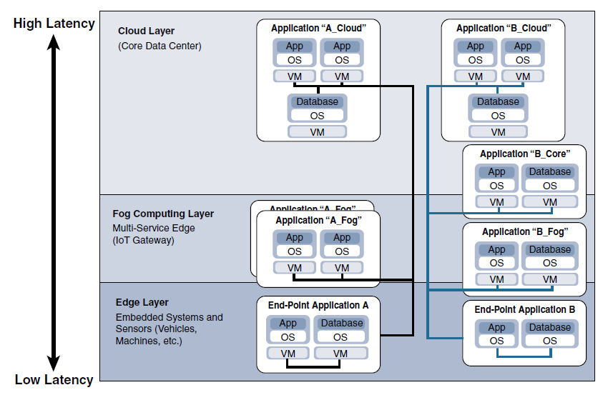

Industrial Use Cases of IoT

1. Manufacturing Industry
The manufacturing sector is one of the largest adopters of IoT technology. IoT enables connected factories where machines, robots, sensors, and control systems continuously exchange data in real time. Smart manufacturing improves productivity, reduces downtime, and enhances operational safety. IoT eliminates the requirement of manual documentation during manufacturing. It reduces the risk of expenditure due to mismanagement in an organization. In Industry 4.0, IoT will provide the backbone of manufacturing, which complete a change in the manufacturing scenario.
Industrial IoT systems monitor machine temperature, vibration, pressure, and production efficiency. Predictive maintenance techniques use sensor data analytics to detect equipment failures before they occur. IoT also supports industrial automation protocols such as EtherNet/IP, PROFINET, and Modbus/TCP for machine communication.
Manufacturing Use Cases
- Predictive maintenance
- Real-time production monitoring
- Industrial robotics automation
- Asset tracking and management
- Energy consumption optimization
- Worker safety monitoring

2. Oil and Gas Industry
IoT has become essential in oil and gas operations because of the need for remote monitoring, operational efficiency, and worker safety. Connected pipelines and refineries use sensors to monitor pressure, temperature, gas leakage, and equipment performance in real time.
IoT enables predictive asset monitoring, wireless communication in remote locations, and cybersecurity management for process control networks. Real-time monitoring reduces operational risks and improves production efficiency.
Oil and Gas Use Cases
- Pipeline leakage detection
- Remote refinery monitoring
- Predictive asset maintenance
- Hazardous gas detection
- Wireless field communication
- Worker safety systems

3. Smart Utilities and Smart Grid
Utility companies use IoT for smart grid implementation, energy monitoring, and automated power distribution systems. IoT-based Advanced Metering Infrastructure (AMI) allows smart meters to send electricity consumption data automatically to utility providers.
IoT improves energy efficiency, grid reliability, and fault detection. Sensors and SCADA systems help utility providers monitor substations, transmission lines, and distribution systems.
Utilities Use Cases
- Smart metering
- Distribution automation
- Power consumption monitoring
- Remote fault detection
- Demand response systems
- Substation automation

4. Smart and Connected Cities
IoT technologies are widely used in smart city infrastructure to improve urban management and public services. Smart cities use connected sensors, cameras, wireless communication systems, and cloud analytics to optimize city operations.
Applications include smart street lighting, smart parking systems, intelligent traffic management, waste management, and environmental monitoring.
Smart City Use Cases
- Smart parking systems
- Intelligent traffic control
- Smart street lighting
- Waste management systems
- Environmental pollution monitoring
- Water management systems

5. Transportation Industry
IoT is revolutionizing transportation systems through connected vehicles, fleet management, and intelligent roadway infrastructure. Connected vehicles communicate with transportation systems using wireless technologies such as LTE, Bluetooth, DSRC, and WAVE protocols.
IoT improves roadway safety, vehicle tracking, fuel management, and real-time traffic optimization.
Transportation Use Cases
- Connected vehicles
- Smart traffic systems
- Fleet management
- Railway monitoring systems
- Vehicle diagnostics
- Autonomous transportation systems

6. Mining Industry
Mining environments are harsh and dangerous, making IoT highly valuable for safety and operational efficiency. IoT systems in mining monitor environmental conditions, equipment health, worker locations, and hazardous gases.
Wireless mesh networks and LTE systems are commonly used in mining communication systems.
Mining Use Cases
- Hazardous gas detection
- Worker location tracking
- Autonomous mining vehicles
- Environmental monitoring
- Equipment health monitoring
- Slope stability monitoring

7. Public Safety and Emergency Response
Public safety organizations use IoT to improve emergency response systems and enhance communication between agencies. IoT devices such as surveillance cameras, wearable sensors, GPS trackers, and connected emergency vehicles enable faster and more coordinated emergency operations.
IoT also supports school bus safety systems, disaster management, and public surveillance.
Public Safety Use Cases
- Emergency response systems
- Smart surveillance systems
- School bus safety monitoring
- Disaster management systems
- GPS-enabled emergency vehicles

Limitations
- The major limitation of this technology in manufacturing is the complexity of storing internet-enabled devices. Sometimes there is a risk of failure of complex systems due to improper connectivity.
- Privacy of the data is also the major issue in IoT, and sometimes personal information can be misused. There is also a risk to software hacking, and safety risk becomes a major responsibility for the industry.

