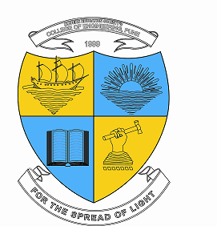

Department of Computer Engineering

MES’s Wadia College Engineering,

19 , Bund Garden, V. K. Joag Path, Pune-411 001

Certificate of Internship

This is to certify that **Jayesh Rajesh Chordiya** a student of the MES’s Wadia College of Engineering, Pune has completed a Research internship in the field of Computer Engineering from **18/03/2024** to **13/04/2024**, entitled **Skin Cancer Detection** under the guidance of **Prof . Bhagyashri More.**

During the period of her/his internship program with us, she/he had been exposed to different processes and was found diligent, hardworking and inquisitive.

We wish her/his every success in his life and career.

Research Internship Guide Internship Coordinator HOD