|  |
| --- |
|  |
| MADHAV SALES |
| E-Commerce Dashboard |
|  |
| **(Made using- POWER BI, DAX, POWER QUERY, MS-EXCEL)** |
|  |

|  |
| --- |
| OBJECTIVE: Creating a responsive dashboard to analyze sales performance, customer behaviour and product trends for an e-commerce shop using the concepts of DAX and power query to customize the collected tables. |

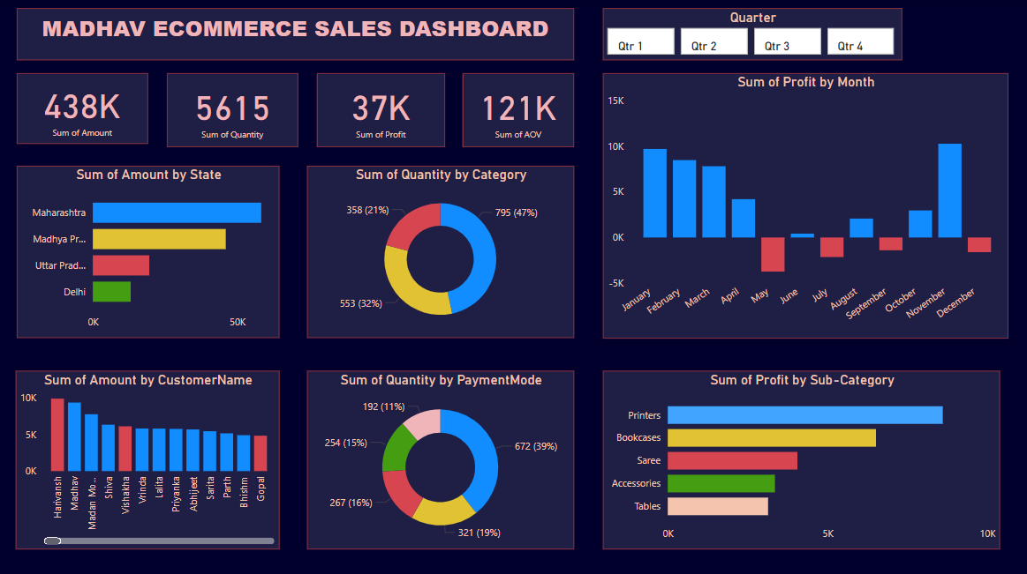

STEP-1: Collected required data to into an Excel worksheet.

STEP-2: Data cleaning to identify duplicacy or null values.

STEP-3: Loading the dataset on Power BI and creating charts and cards which show comparisons between categories.

Summary Keypoints:

* DATA Overview-

1. Total Sales amount- 438K INR
2. Total Profit - 37K INR
3. Total quantity sold- 5.6K units

* Focus on the top profit making products(Printers, Bookcases) for inventory management.
* Improve marketing for low-performing product categories (Tables, Accessories).
* As the bar chart shows top customers, target can be made to provide some additional incentives to them with personalised promotions.
* Maharashtra and Madhya Pradesh were the regions recording highest sales.
* High profits were typically seen in the first half of the year in months from JAN-APR.
* Cash on deleivery was the most favoured mode of payment followed by UPI.
* ‘Clothing’(47%) was the maximum return generating category, while ‘Electronics’ (32%) was second most.