AEM

AEM Installation :



AEM Author

AEM Publish

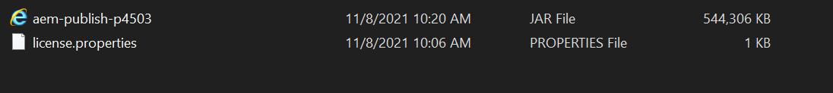

AEM User and Group

Group

Permission :

Creating JEWELBID Project with maven archetype

