**WEBSITE ON E-COMMERCE**

End Term Report

*By*

**Name** of the student: Atul

**Section**: K17MD

**Roll No.** : 14

**Name of the student:** Divyansh Lohumi

**Section:** K17MD

**Roll No. :** 24

**Name of the student:** Ashish Singh

**Section**: K17MD

**Roll No.** : 02



**Department of Intelligent Systems**

**School of Computer Science and Engineering**

**Lovely Professional University, Jalandhar**

**Student Declaration**

This is to declare that this report has been written by us. No part of the report is copied from other sources. All information included from other sources has been duly acknowledged. We aver that if any part of the report is found to be copied, we shall take full responsible for it.

Signature of Student:

Name: Atul

Roll no. : 14

Signature of Student:

Name: Divyansh Lohumi

Roll no. : 24

Signature of Student:

Name: Ashish Singh

Roll no. : 2

Date: 15/04/2018

**Table of contents**

**TITLE: E-COMMERCE PAGE NO.: 1**

**1.Background and objectives of the project assigned………………....1**

**2. Description of the project…………………………………………….2**

**3. Description of work division…………………………………………3**

**4.Implementation of scheduled work of project………………………4**

**5.Technology Used in the Project………………………………………5**

**6.SWOT analysis achieved in project………………………………….6**

**BONAFIDE CERTIFICATE**

Certified that this project report “**Website on E-commerce**” is the bonafide work of “**Atul** , **Divyansh Lohumi** , **Ashish Singh**” Who carried the project work under my supervision.

**Signature of the supervisor:**

**Name of the supervisor:**

**Academic designation:**

**ID of the supervisor:**

**Department of the supervisor:**

**Background and Objectives of the Project**

The project’s background and objective provides a user-friendly environment for the user to deal with.

**E-commerce** is the activity of buying or selling of products and services online or over the internet. Electronic commerce draws on technologies such as mobile commerce, electronic funds transfer, supply chain management, Internet marketing, online transaction processing, electronic data interchange (EDI), inventory management systems, and automated data collection systems.

Modern electronic commerce typically uses the World Wide Web for at least one part of the transaction's life cycle although it may also use other technologies such as e-mail. Typical e-commerce transactions include the purchase of online books (such as Amazon) and music purchases (music download in the form of digital distribution such as iTunes Store), and to a less extent, customized/personalized online liquor store inventory services. There are three areas of e-commerce: online retailing, electric markets, and online auctions. E-commerce is supported by electronic business.

E-commerce businesses may also employ some or all of the followings:

* Online shopping for retail sales direct to consumers via Web sites and mobile apps, and conversational commerce via live chat, chatbots, and voice assistants[[3]](https://en.wikipedia.org/wiki/E-commerce#cite_note-venturebeat.com-3)
* Providing or participating in online marketplaces, which process third-party business-to-consumer or consumer-to-consumer sales
* Business-to-business buying and selling;
* Gathering and using demographic data through web contacts and social media
* Business-to-business (B2B) electronic data interchange
* Marketing to prospective and established customers by e-mail or fax (for example, with newsletters)
* Engaging in pretail for launching new products and services
* Online financial exchanges for currency exchanges or trading purposes.

**DESCRIPTION OF THE PROJECT**

E-commerce is fast gaining ground as an accepted and used business paradigm. More and more business houses are implementing web sites providing functionality for performing commercial transactions over the web. It is reasonable to say that the process of shopping on the web is becoming commonplace.

The objective of this project is to develop a general purpose e-commerce store where any product (such as books, CDs, computers, mobile phones, electronic items, and home appliances) can be bought from the comfort of home through the Internet. However, for implementation purposes, this paper will deal with an online book store.

An online store is a virtual store on the Internet where customers can browse the catalog and select products of interest. The selected items may be collected in a shopping cart. At checkout time, the items in the shopping cart will be presented as an order. At that time, more information will be needed to complete the transaction. Usually, the customer will be asked to fill or select a billing address, a shipping address, a shipping option, and payment information such as credit card number. An e-mail notification is sent to the customer as soon as the order is placed

**DIVISION OF PROJECT**

We divided the work for the project as follows:-

* **Atul**-The user gets information about the need of E-commerce and how it is helpful to the people in need.
* We have included discussion forums for the user and merchants where it serves as a platform to interact with the merchant to the user so that he may get direct access if he/she faces any problem.
* **Divyansh Lohumi**-There is a registration form for the users where they can register themselves and get connected to the website the registration lets the user enter their information.
* In case of emergency the user is able to search for the products in on the website , the website offers the an option where the user can click and get help what to do next.
* **Ashish Singh-** The website also offers the user to know about the products available on the website where the user can get the complete description of the product.
* The merchant also has the information about the sold products’ record as this information is very important and the website should provide it to the recipient before he/she receives the product he/she ordered.

**TECHNOLOGY USED IN THE PROJECT**

A **text editor** is a type of computer program that edits plain text. Such programs are sometimes known as "**notepad++**" software, following the Microsoft Notepad++.Text editors are provided with operating systems and software development packages, and can be used to change configuration files, documentation files and programming language source code.

The technology used in the project are some source code editors such as “BRACKETS , NOTEPAD++, NOTEPAD” which provide a very user-friendly interface. We used the web-development languages like HTML,CSS and JAVASCRIPT.

**Features:**

* **Find and replace** – Text editors provide extensive facilities for searching and replacing text, either on groups of files or interactively. Advanced editors can use regular expressions to search and edit text or code.
* **Cut, copy, and paste** – most text editors provide methods to duplicate and move text within the file, or between files.
* Ability to handle UTF-8 encoded text.
* **Text formatting** – Text editors often provide basic formatting features like line wrap, auto-indentation, bullet list formatting using ASCII characters, comment formatting, syntax highlighting and so on.
* **Undo and redo** – As with word processors, text editors provide a way to undo and redo the last edit. Often—especially with older text editors—there is only one level of edit history remembered and successively issuing the undo command will only "toggle" the last change. Modern or more complex editors usually provide a multiple level history such that issuing the undo command repeatedly will revert the document to successively older edits. A separate redo command will cycle the edits "forward" toward the most recent changes. The number of changes remembered depends upon the editor and is often configurable by the user.
* **Data transformation** – Reading or merging the contents of another text file into the file currently being edited. Some text editors provide a way to insert the output of a command issued to the operating system's shell.

**SWOT analysis achieved by the project**

**What is SWOT analysis?** – It is a structured planning method used to evaluate the Strengths, Weaknesses, Opportunities, and Threats in a business. The key to a SWOT analysis is to identify the internal and external factors to achieve a company’s objective. Strengths and Weaknesses are the internal factors that are measured with a comparative benchmark, while Weaknesses and Opportunities are the external factors which are measured with a competitor in the same industry.

Typically, the objectives of a SWOT analysis is to build the company strengths and minimize on weaknesses. In an industry like ecommerce, you will want to take advantage of opportunities quickly so that you can break away from your competitors or other threats before they can neutralize it. A SWOT analysis does not take a small period of time and while you could often do it on your own, it is best to get an outsourced consultant from a better perspective to do it for you. Your customers or clients would also be a source of information for you. They can easily spot weaknesses and perhaps give feedback on areas where improvements are needed.

**Strengths** – An ecommerce company’s strengths are the unique points that differentiate them from their competitors. It can be a wider selection of products, better customer support, quicker shipping, lower prices, better terms and conditions, etc. These are competitive advantages that can increase a company’s strengths.

Ecommerce vendors also benefit from lower operational costs and a 24-7 shopping experience, compared to a ‘brick and mortar’ business.

**Weaknesses** – One of the top problems that all ecommerce merchants will face are excessive Chargebacks. With security and fraud lurking in every corner, customers are often reluctant to use their credit cards for online purchases.

Shipping of products is another issue, where heavy, large, and perishable goods are often a pain and very expensive. Shipping duration could also open the customer’s options to purchase the products elsewhere.

**Opportunities** – Technology is a perfect example to expand a company’s growth and take advantage of areas where the competitor’s vulnerable. In the ecommerce world, changes happens every single day, and technology has help level the industry with traditional retailers.

For example, the online shopping cart softwares has been improved for a smoother, quicker, and more customer-friendly experience. Live customer support chat has increased the level of support the customers need. Social media is an excellent platform for free or low cost promotions to increase product awareness.

**Threats** – A business must take note of the broad industry shifts that can affect their business and company growth. Legal and regulatory changes for instance, may force all ecommerce businesses to collect sales tax. New laws from card associations may also be a problem, especially for the higher risked industries.

Competition from ecommerce giants like eBay and Amazon often undercut smaller merchants on price. Lower barriers for entry into ecommerce is also a threat, allowing almost anyone to sell via social media without the need of a website or a company.

<html>

<head>

<title>Sticky.com - India's biggest e-commerce platform</title>

<link rel="stylesheet" href="dropdown.css">

</head>

<body>

<nav>

<header><ul>

<li class="logo"><h1>Sticky<br>

<li><a href="dropdown.html">Home</a></li>

<li><a href="#" class="word">Products</a>

<ul>

<li><a href="#" class="item">Electronics</a>

<ul>

<li><a href="#">Mobile Phones</a></li>

<li><a href="#">Laptops</a></li>

<li><a href="#">Accesories</a></li>

</ul>

</li>

<li><a href="#" class="item">Clothes</a>

<ul>

<li><a href="#">Mens</a></li>

<li><a href="#">Womens</a></li>

<li><a href="#">Kids</a></li>

</ul>

</li>

<li><a href="#">Kitchen</a></li>

<li><a href="#">Home Appliances</a></li>

<li><a href="sports.html">Sports</a></li>

<li><a href="#">Beauty</a></li>

</ul>

</li>

<li><a class="join" href="Login.html">Login</a></li>

<li><a href="Signup.html">Sign Up</a></li>

<li><a href="contactform.html">Contact Us</a></li>

<li><a href="AboutUS.html">About Us</a></li>

</h1>

</ul>

</header>

</nav>

<footer><a href="/HTML/Help%20and%20customer%20service.html">Conditions of Use &amp; Sale</a> <a href="/HTML/Privacy%20Notice.html">Privacy Notice</a> &copy; 1996-2018, Sticky.com, Inc. or its affiliates</footer>

</body></html>

<!DOCTYPE html>

<html>

<head>

<title>Payment Mode</title>

<link rel="stylesheet" href="https://cdnjs.cloudflare.com/ajax/libs/font-awesome/4.7.0/css/font-awesome.min.css">

<link rel="stylesheet" href="Payment%20gateway.css">

<script>

function abc(){

window.alert("Your payment is successful!");

}

</script>

</head>

<body>

<h1 class="pay">Payment</h1>

<h1 class="cart">Skart</h1>

<div class="row">

<div class="col-75">

<div class="container">

<form>

<div class="row">

<div class="col-50">

<h3>Billing Address</h3>

<label><i class="fa fa-user"></i> Full Name</label>

<input type="text" id="fname" name="firstname" placeholder="John M. Doe" required>

<label><i class="fa fa-envelope"></i> Email</label>

<input type="text" id="email" name="email" placeholder="john@example.com" required>

<label><i class="fa fa-address-card-o"></i> Address</label>

<input type="text" id="adr" name="address" placeholder="542 W. 15th Street" required>

<label><i class="fa fa-institution"></i> City</label>

<input type="text" id="city" name="city" placeholder="Phagwara" required>

<div class="row">

<div class="col-50">

<label>State</label>

<input type="text" id="state" name="state" placeholder="Punjab" required>

</div>

<div class="col-50">

<label>Zip</label>

<input type="text" id="zip" name="zip" placeholder="144411" required>

</div>

</div>

</div>

<div class="col-50">

<h3>Payment Options</h3>

<label>Accepted Cards</label>

<div class="icon-container">

<i class="fa fa-cc-visa" style="color:navy;"></i>

<i class="fa fa-cc-amex" style="color:blue;"></i>

<i class="fa fa-cc-mastercard" style="color:red;"></i>

<i class="fa fa-cc-discover" style="color:orange;"></i>

</div>

<label>Name on Card</label>

<input type="text" id="cname" name="cardname" placeholder="John More Doe" required>

<label>Credit card number</label>

<input type="text" id="ccnum" name="cardnumber" placeholder="1111-2222-3333-4444" required>

<label>Expiry Month</label>

<input type="text" id="expmonth" name="expmonth" placeholder="September" required>

<div class="row">

<div class="col-50">

<label>Expiry Year</label>

<input type="text" id="expyear" name="expyear" placeholder="2018" required>

</div>

<div class="col-50">

<label>CVV</label>

<input type="text" id="cvv" name="cvv" placeholder="352" required>

</div>

</div>

</div>

</div>

<label>

<input type="checkbox"> Shipping address same as billing

</label>

<a href="#"><input type="submit" value="Continue to checkout" class="btn" onclick="abc()"></a>

</form>

</div>

</div>

<div class="col-25">

<div class="container">

<h4>Cart <span class="price" style="color:black"><i class="fa fa-shopping-cart"></i> <b>4</b></span></h4>

<p><a href="#">Product 1</a> <span class="price">$100</span></p>

<p><a href="#">Product 2</a> <span class="price">$70</span></p>

<p><a href="#">Product 3</a> <span class="price">$88</span></p>

<p><a href="#">Product 4</a> <span class="price">$42</span></p>

<hr>

<p>Total <span class="price" style="color:black"><b>$300</b></span></p>

</div>

</div>

</div>

</body>

</html>

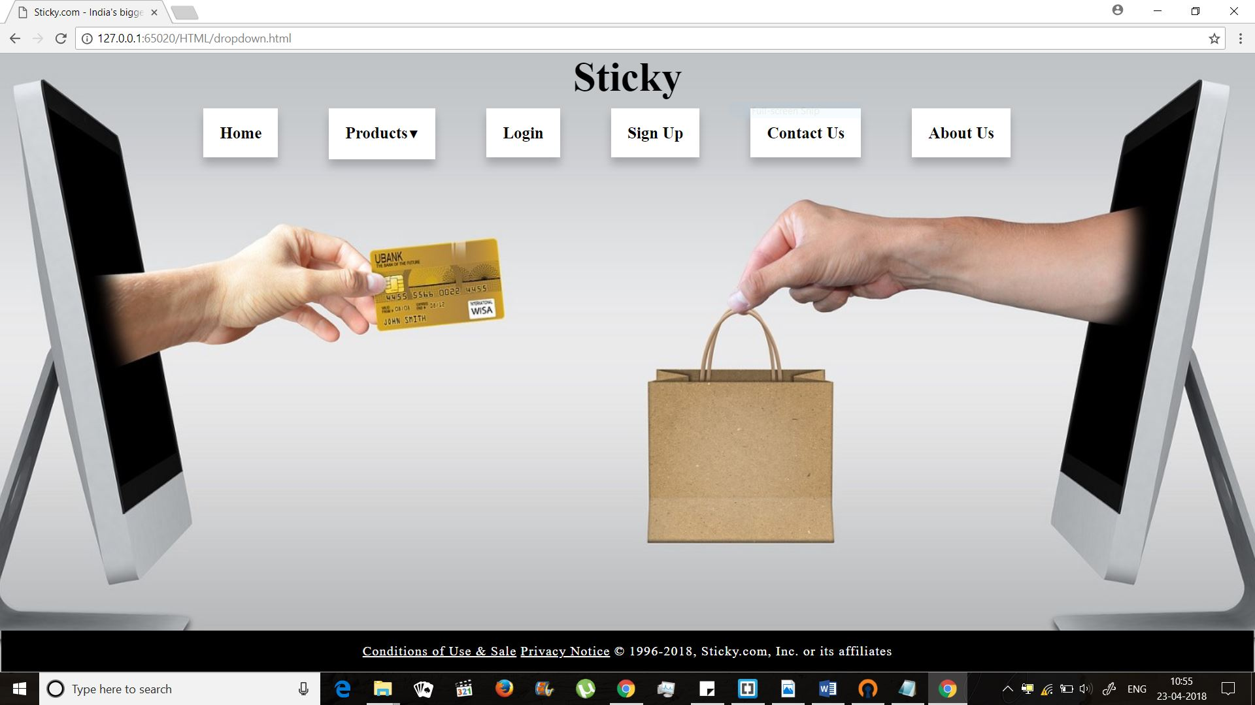

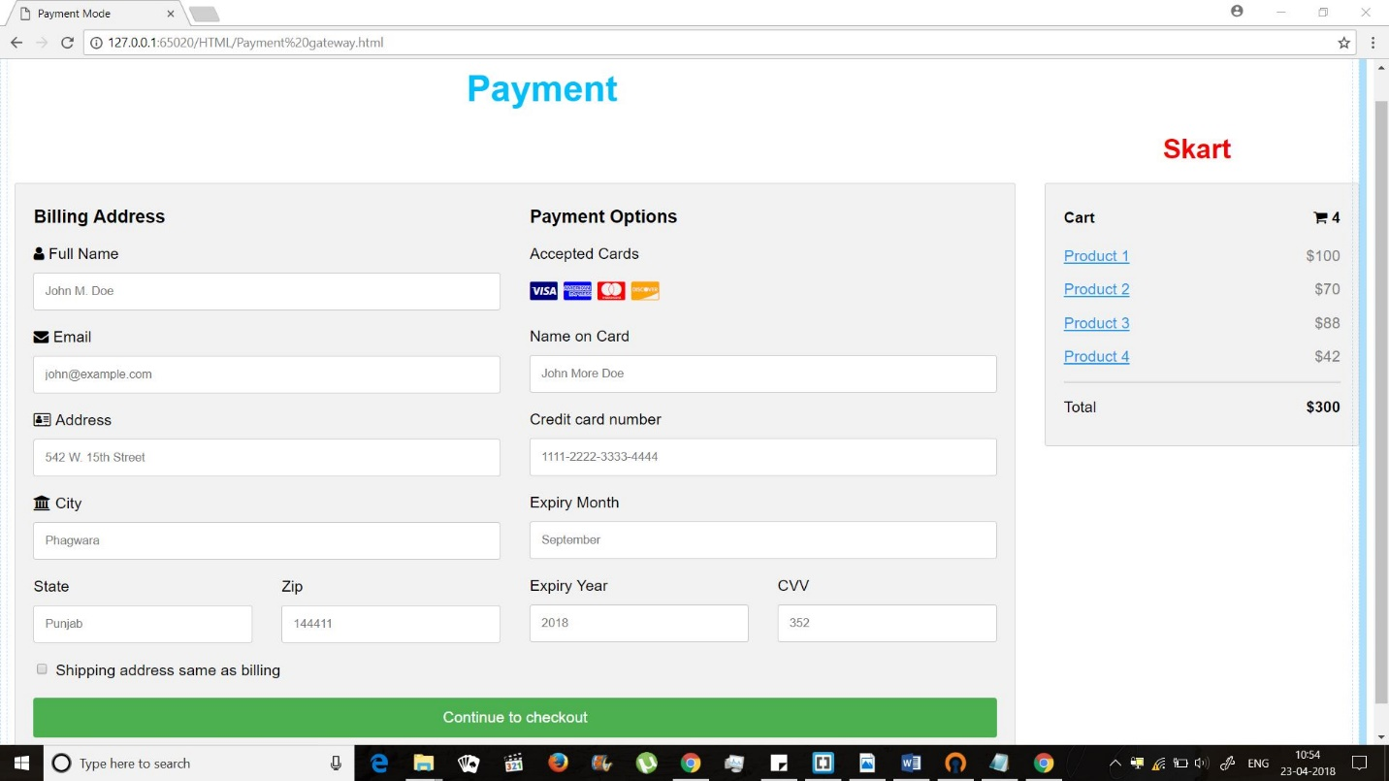

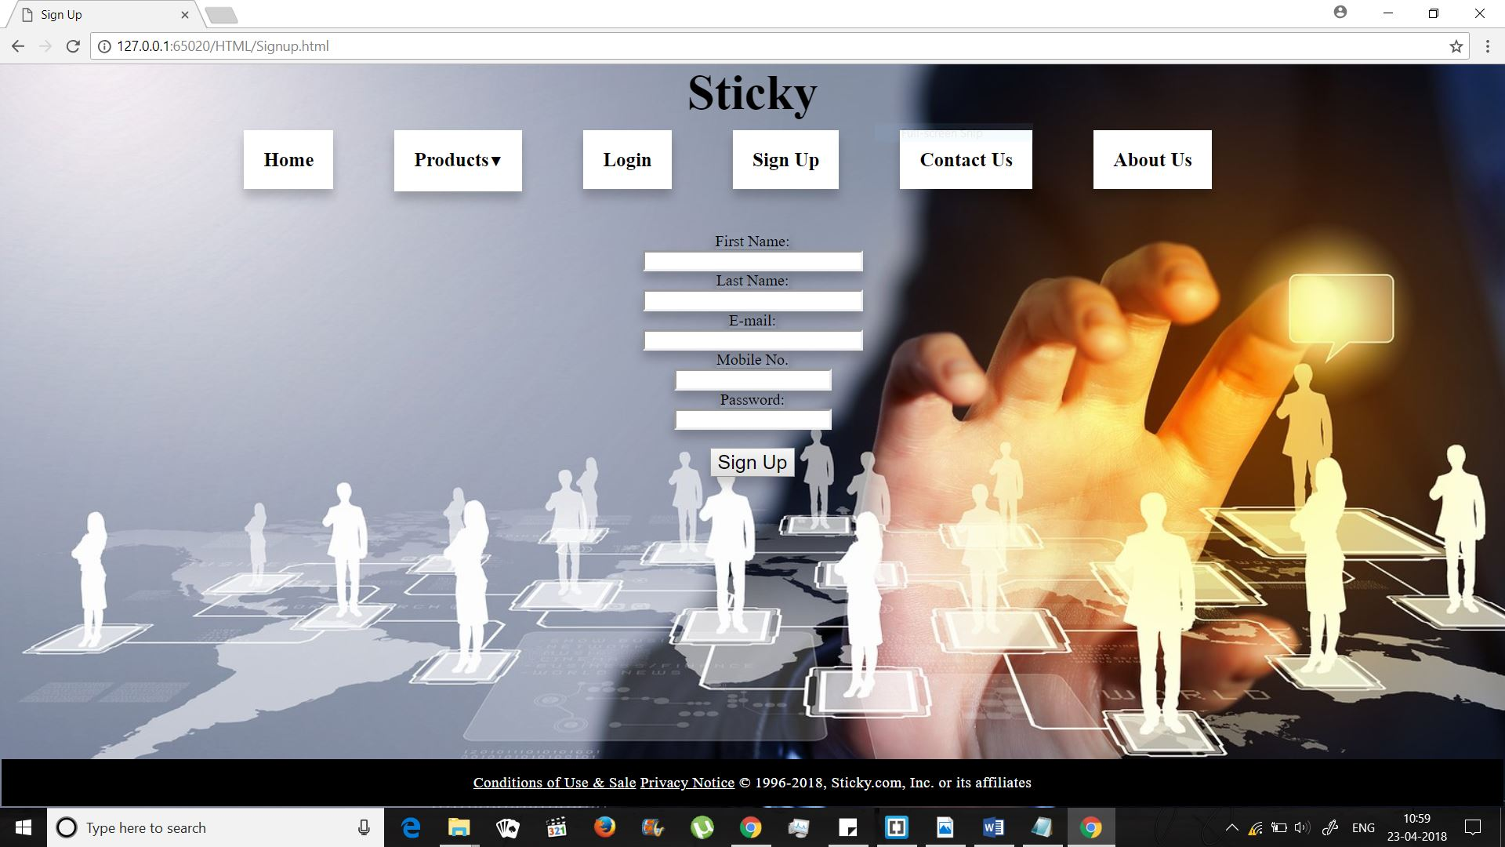

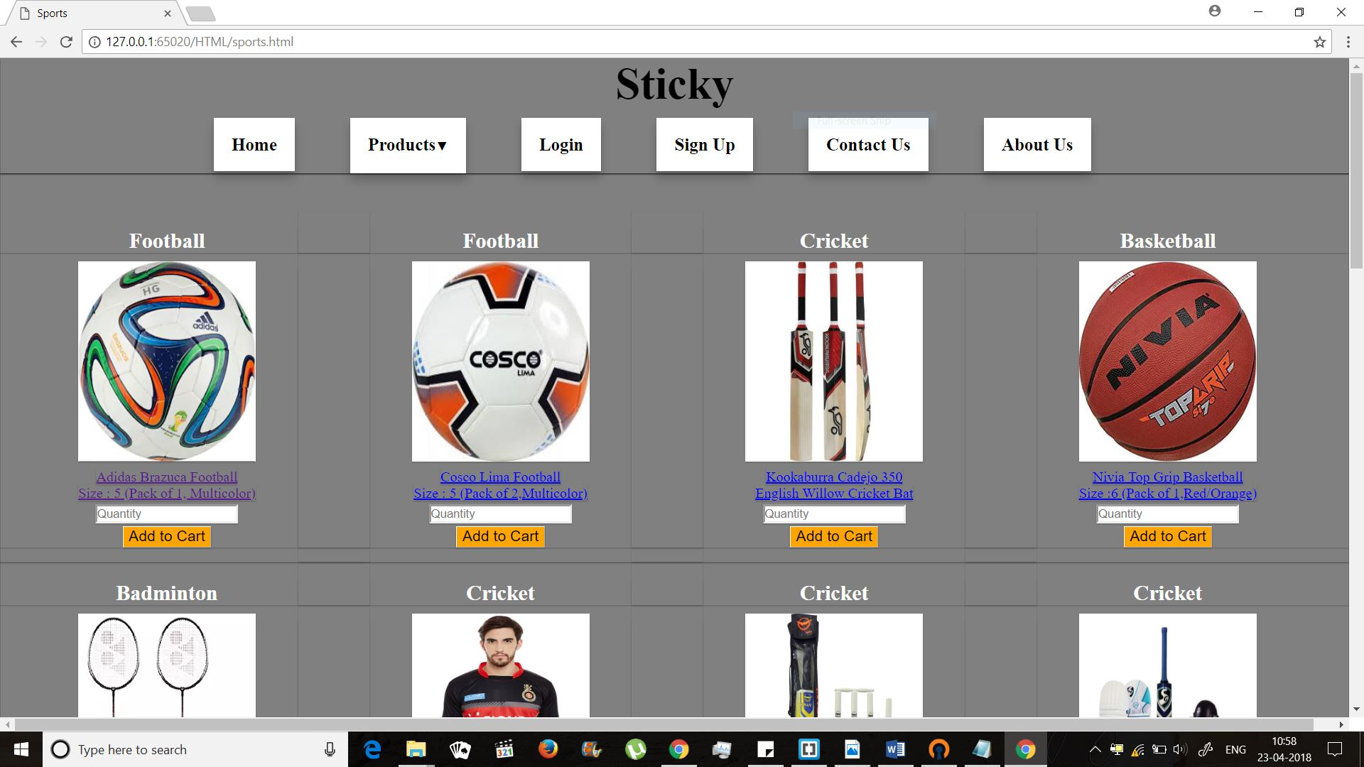

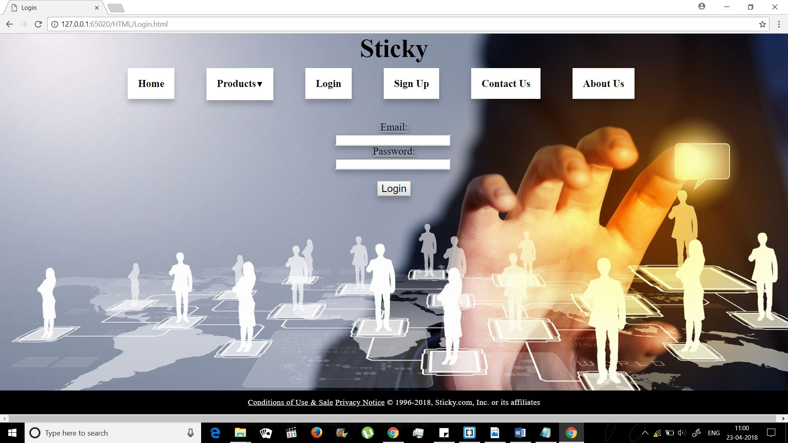

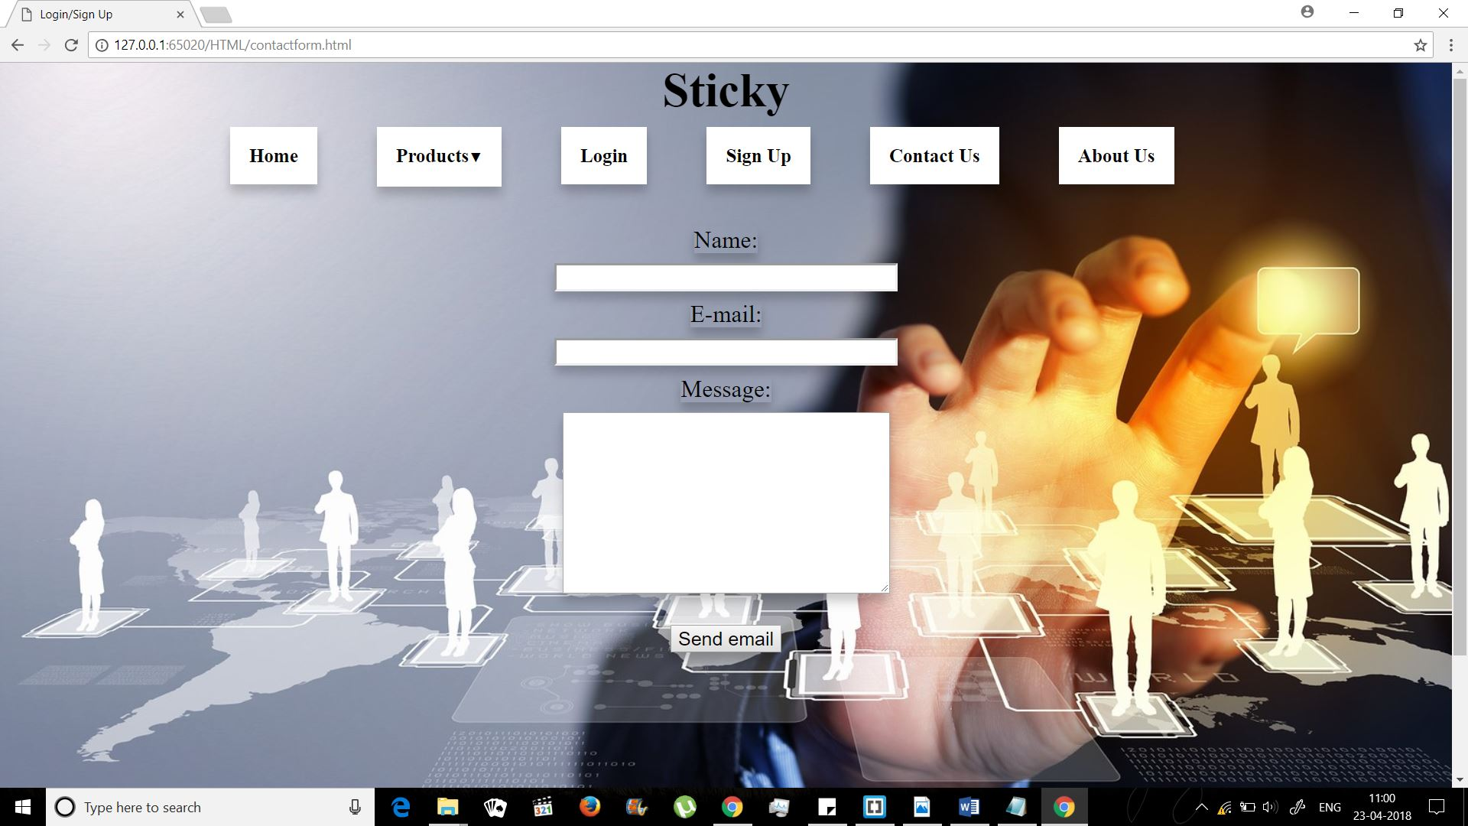

**CONCLUSION**

E-commerce, or the act of selling goods or services online as opposed to selling at brick and mortar establishments, has reshaped the modern marketplace in recent years, but this new form of trade comes with its own sets of advantages and disadvantages over traditional methods.

It's important, then, for businesses to look beyond the hype and develop their own perspectives on the true value of e-commerce—to business and to consumers—because interestingly, there are many advantages for consumers that might actually be a disadvantage for e-commerce businesses.