Smart PG & Hostel Management System: A Role-Based, Workflow-Driven Web Platform Using Spring Boot, Spring Security, JPA/Hibernate and MySQL
Dhruvraj Shekhawat, Divyansh Paliwal, Divyanshu Kumar, Garvit Sharma and Harsh Sharma
Team Nexus, Department of Artificial Intelligence & Data Science
Arya College of Engineering & I.T., Kukas, Jaipur, Rajasthan, India (affiliated to Rajasthan Technical University, Kota)
Project guide: Er. Ram Babu Buri, Assistant Professor | Course: Advanced Java – Project Based Learning (Session 2026-27)

Abstract—Hostels and Paying Guest (PG) residences are still administered in many institutions through paper registers, spreadsheets and verbal communication, which makes room availability, fee collection, maintenance complaints and gate passes slow to handle and hard to audit. This paper presents the Smart PG & Hostel Management System, a web application that places student records, room and bed allocation, monthly fee invoicing and payment, complaint handling, leave and visitor passes, notices and the mess menu on one role-based platform for four actors: warden, student, accountant and maintenance staff. The system is built with Java 17, Spring Boot 3.3.4, Spring MVC with Thymeleaf, Spring Security 6 (form login, HttpSession, BCrypt and URL-level role rules), Spring Data JPA/Hibernate 6 and a 14-table MySQL 8 schema, and it also exposes a JWT-secured REST API. Each business process is modelled as a state machine and enforced in transactional service methods: allocation checks bed capacity and prevents double allocation, payments block over-payment and payment of another student’s invoice, and every complaint is routed automatically to maintenance with a priority-based SLA deadline (4, 8, 24 or 48 hours) and a two-step closure by warden verification and student feedback. The application is containerised with Docker and deployed on Render with an Aiven-hosted MySQL database. We describe the requirements, architecture, data model, algorithms and security design, and report the evidence actually available: 24 manual functional scenarios covering all four roles, all of which produced the expected behaviour, together with qualitative performance observations. Automated tests, load tests and a user study were not performed and are listed with other limitations.
Index Terms—hostel management, PG management, Spring Boot, Spring Security, role-based access control, JPA/Hibernate, MySQL, workflow automation, REST API, JWT, cloud deployment.
I. Introduction
A. Background and motivation
Every year a large number of students leave their homes to study in colleges and universities, and hostels and PG accommodations have become an essential part of the campus ecosystem. Running such a residence involves many parallel tasks: maintaining student records, allotting rooms and beds, collecting rent and mess charges, handling maintenance problems, approving leave and visitors, publishing notices and planning the weekly mess menu. In many hostels these tasks are carried out with paper registers, spreadsheets and verbal instructions.
Such practice has clear weaknesses. The same data is entered more than once, the number of free beds is not known in real time, fee dues are discovered late, a student has no way to see the status of a complaint or a leave request, visitor entry is weakly controlled, and nobody can later show who approved what. These problems motivate a single, integrated and auditable platform.
B. Problem statement
The problem addressed in this paper is the design and implementation of a web-based hostel and PG management system in which each administrative process is represented as an explicit workflow with role-restricted actions, validated business rules and a persistent record, so that the warden, students, accountant and maintenance staff all work on the same live data.
C. Objectives
- Provide a secure, role-based application for four user roles using Spring Boot and MySQL.
- Keep digital records of students, rooms, bed capacity and allocations, and prevent over-allocation of beds.
- Automate monthly invoicing, partial and full payment, pending-balance calculation and fee-status tracking (Pending, Partial, Paid, Overdue).
- Provide a transparent complaint workflow with automatic routing, SLA deadlines, warden verification and student feedback.
- Digitise leave passes and visitor gate passes with approval, rejection, check-in and check-out.
- Offer dashboards, notices, a weekly mess timetable, PDF receipts and an audit trail, and deploy the system on the cloud.
D. Contributions
The paper contributes: (1) an end-to-end, four-role hostel workflow implemented on a standard Spring stack; (2) a state-machine formulation of room allocation, fee payment and complaint handling together with the transactional rules that enforce it; (3) a 14-table, third-normal-form relational schema with unique constraints that prevent duplicate invoices and menu entries; (4) a dual interface consisting of server-rendered MVC pages and a JWT-secured REST API over the same service layer; (5) a container-based cloud deployment on Render and Aiven; and (6) an evidence-based account of testing in which the executed scenarios are reported as they were observed and the missing evidence is stated explicitly.
E. Organisation
Section II reviews background and related approaches. Section III gives the requirements. Sections IV to VI describe the architecture, workflows and modules. Sections VII and VIII present the data model and the main algorithms. Section IX analyses security, Section X covers deployment, and Sections XI and XII report testing and results. Limitations, future work and the conclusion follow in Sections XIII to XV.
II. Background and Related Approaches
A. Approaches to hostel administration
Three broad approaches are commonly seen. The first is the manual approach of paper registers and verbal communication, which needs no infrastructure but offers no real-time view, no validation and no audit trail. The second is the spreadsheet approach, which allows totals and simple lookups but has no workflow, no role separation and no protection against concurrent or conflicting edits. The third is a purpose-built information system, either a module of a wider campus or ERP suite or a dedicated hostel application. The present work belongs to the third class and concentrates on the hostel domain with explicit workflows for allocation, fees, complaints and passes.
B. Layered architecture and the Spring ecosystem
Enterprise applications are conventionally organised into presentation, domain and data-access layers [1], [2]. Spring Boot [3] supplies auto-configuration, an embedded servlet container and externalised configuration; Spring Security [4] provides authentication, authorisation and session handling; Spring Data JPA [5] with Hibernate [6] maps Java entities to relational tables; Thymeleaf [7] renders server-side views; and Bootstrap [8] provides a responsive interface. Data is stored in MySQL [9], whose relational model [10], [11] supports the keys, constraints and transactions needed for fee and occupancy consistency.
C. Security building blocks
Passwords should be stored with a salted, adaptive function such as bcrypt [12] and handled according to current identity guidance [13]. For stateless API access the system uses JSON Web Tokens [14]. Common web risks such as broken access control are catalogued by OWASP [15]. The REST style [16] is used for the API, and the JJWT [17] and OpenPDF [18] libraries provide token signing and PDF generation respectively.
D. Gaps in current practice and the resulting design responses
The weaknesses of manual and spreadsheet administration are not independent defects; each one corresponds to a missing property of the underlying information system. Duplicate entry arises because no single authoritative record exists, late discovery of dues arises because balances are not computed from transactions, and the absence of an audit trail arises because actions are not recorded at the moment they happen. Table I maps every weakness identified in the introduction to the design response adopted in this work, and thereby provides the rationale for the requirements of Section III.
TABLE I. Identified weaknesses and design responses
Weakness of manual practice | Design response in the system
Duplicate data entry | One relational store; students, rooms and fees linked by foreign keys
Unknown free beds | Live occupied counter and automatic AVAILABLE/FULL status
Late discovery of dues | Computed total, paid, remaining and status per invoice
Untracked complaints | Ticket with SLA deadline, status trail and feedback step
Weak visitor control | Pre-registered pass, warden approval, check-in and check-out
No record of approvals | Approver and time stored; audit_logs for key actions
Unclear responsibility | Four roles with URL-level and service-level checks

E. Why a workflow-oriented design
Hostel processes share a common shape: a request is created by one actor, examined by another and finally closed, and at each step only certain next steps are legitimate. Representing every process as a finite set of states with explicit guard conditions has three practical advantages. First, the permitted behaviour is stated in one place and can be checked by inspection, as in Table VI. Second, illegal transitions can be rejected centrally in the service layer instead of being prevented only by hiding buttons in the user interface. Third, each test scenario can be written as a path through the state graph, which keeps manual testing systematic even without an automated suite. This workflow orientation, rather than any single technology, is the central idea carried through the remaining sections.
III. Requirements Analysis
Requirements were gathered following a conventional software-engineering process [19] and organised around four actors. The warden is the administrator who manages students, rooms, allocations, notices, the mess menu, leave and visitor requests and the final verification of complaints. The student is the resident who views the allotted room, pays fees, lodges complaints and requests leave and visitor passes. The accountant generates invoices, records payments and views collection reports. The maintenance staff receive complaint tickets, accept them and submit the resolution. Table II lists the functional requirements and Table III the non-functional requirements, interpreted using the quality characteristics of ISO/IEC 25010 [20].
TABLE II. Functional requirements
ID | Requirement | Actor
FR01 | Authenticate by e-mail and password; redirect by role | All
FR02 | Register students and maintain student profiles | Warden
FR03 | Create and maintain rooms (block, floor, type, capacity, rent, status) | Warden
FR04 | Request, approve, reject and vacate room allocation | Student, Warden
FR05 | Generate monthly fee invoice (rent, mess, electricity, maintenance) | Accountant
FR06 | Pay online or record counter payment; recompute status | Student, Accountant
FR07 | Lodge complaint; auto-route with SLA deadline | Student
FR08 | Accept, resolve, verify, return and close complaints | Staff, Warden, Student
FR09 | Apply for leave; approve or reject with remarks | Student, Warden
FR10 | Pre-register visitor; approve; check-in and check-out | Student, Warden
FR11 | Publish notices; manage 7-day mess menu | Warden
FR12 | Role dashboards with live counts; PDF receipts and reports | All
FR13 | Audit trail and in-app notifications for key events | System
FR14 | REST API with JWT for the same business services | Clients

TABLE III. Non-functional requirements
Attribute | Project interpretation
Security | BCrypt hashes, role-based URL rules, ownership checks, 60-min session
Integrity | Transactional services; unique constraints; BigDecimal for money
Usability | Common layout, status badges, validation messages, Dark Mode
Maintainability | Controller, Service, Repository and Entity layers
Portability | Docker image; configuration through environment variables
Observability | Audit log table; custom 403, 404 and 500 pages
Performance | Qualitative observation only; no load measurements

Feasibility was assessed qualitatively. The stack consists entirely of open-source Java technologies; the practical costs are development effort and hosting. No operating-cost measurement or return-on-investment figure exists for this prototype and none is claimed.
A. Usage scenarios
Three scenarios illustrate how the requirements interact. In the admission scenario the warden registers a new resident, who is created as a user account with a BCrypt-hashed password and a linked student profile; the resident then requests a room, the warden approves a specific bed, and the room status changes to AVAILABLE or FULL without any manual bookkeeping. In the month-end billing scenario the accountant generates one invoice per resident from the four fee components, residents see the pending amount on their dashboard and pay in full or in part, and the invoice status moves through PENDING, PARTIAL and PAID. In the maintenance scenario a resident lodges a high-priority ceiling-fan complaint, the system routes it to the maintenance queue with an 8-hour deadline, the staff member accepts and resolves it with remarks, the warden verifies the work and the resident closes the ticket with feedback.
B. Assumptions and constraints
The design assumes that one administration manages one or more hostel blocks, that staff accounts are created by the warden, that every user has a modern browser and internet access, and that the payment step in this version only records a payment instead of contacting a bank. The main technical constraint is the Java 17 baseline required by Spring Boot 3, and the main operational constraint is the free-tier hosting used for the demonstration deployment, which limits memory and introduces cold starts.
IV. System Architecture
A. Use cases
Fig. 1 shows the four actors and their use cases; login and logout are common to all. Table IV summarises the role-wise functional matrix that results.
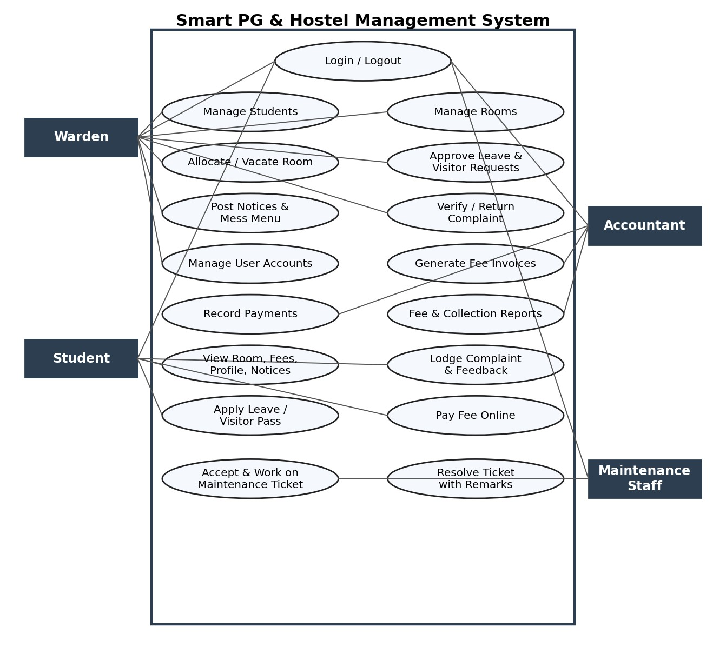
Fig. 1. Use-case diagram of the four actors.
TABLE IV. Role-wise functional matrix
Function | Warden | Student | Acct. | Staff
Student & room CRUD | Yes | View own | - | -
Room allocation | Approve/Vacate | Request | - | -
Fee invoices | View | View own | Create/Edit | -
Payments, reports | View | Pay | Record | -
Complaints | Verify/Return | Lodge | - | Accept/Resolve
Leave, visitor | Approve | Apply | - | -
Notices, mess menu | Create/Edit | Read | - | -
User accounts | Yes | - | - | -

B. Layers and request flow
The system follows a layered (N-tier) architecture (Fig. 2). A browser request first passes through the Spring Security filter chain, which checks authentication and the role of the user. The request is then mapped to a controller, which calls a service; the service applies the business rules inside a transaction and uses Spring Data repositories to read or write data through JPA/Hibernate in MySQL. The result is rendered by a Thymeleaf template. A second set of REST controllers under /api/ serves JSON to other clients and is protected by a JWT filter.
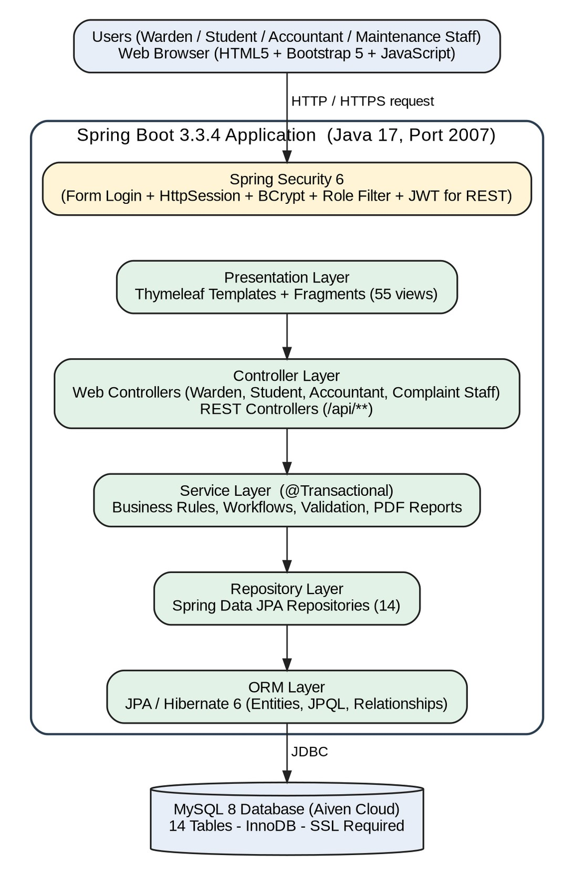
Fig. 2. Layered architecture of the system.
C. Technology stack and code organisation
TABLE V. Technology stack
Component | Implementation
Language | Java 17 (LTS)
Framework | Spring Boot 3.3.4, Spring MVC (embedded Tomcat, port 2007)
Security | Spring Security 6; HttpSession (60 min); BCrypt; JJWT 0.12.6 (HMAC-SHA256)
Persistence | Spring Data JPA, Hibernate 6, MySQL 8 with SSL (Aiven)
Views | Thymeleaf (55 templates), Bootstrap 5, icons, Dark Mode toggle
Utilities | Maven, Lombok, Jakarta Bean Validation, OpenPDF 2.0.3
Delivery | Multi-stage Dockerfile, Render, GitHub, Postman collection
Optional client | React 18 + Vite single-page client using the REST API

The project repository [21] contains approximately 12,000 lines of Java and 7,500 lines of Thymeleaf/HTML. The code defines 14 JPA entities and 14 repositories, and each module follows the same pattern of Entity, Repository, Service, Controller and view. A global exception handler maps errors to custom 403, 404 and 500 pages.
D. Data flow view
Fig. 3 presents the context-level data flow diagram, in which the whole system is a single process exchanging data with the four actors: approvals, notices, room and mess data flow from the warden; login, complaints, leave, visitor and fee payments flow from the student; invoices and payment entries flow from the accountant; and resolution notes flow from the maintenance staff, while dashboards, reports, assigned tickets and statuses flow back. Fig. 4 decomposes the system into seven processes and seven data stores. Authentication and access control (1.0) reads the user and staff store (D1); student and room management (2.0) maintains D2; allocation (3.0) maintains the allocation history D3; fee and payment processing (4.0) maintains invoices and payments D4; the complaint workflow (5.0) maintains tickets and notifications D5; leave and visitor passes (6.0) maintain D6; and the notice, mess and report process (7.0) maintains notices, the mess menu and the audit trail D7.
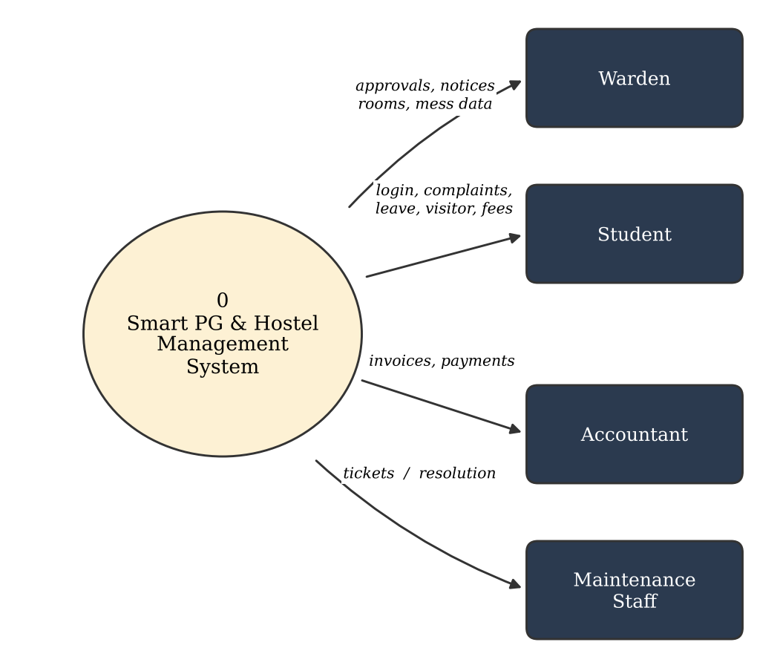
Fig. 3. Level-0 data flow diagram (context diagram).
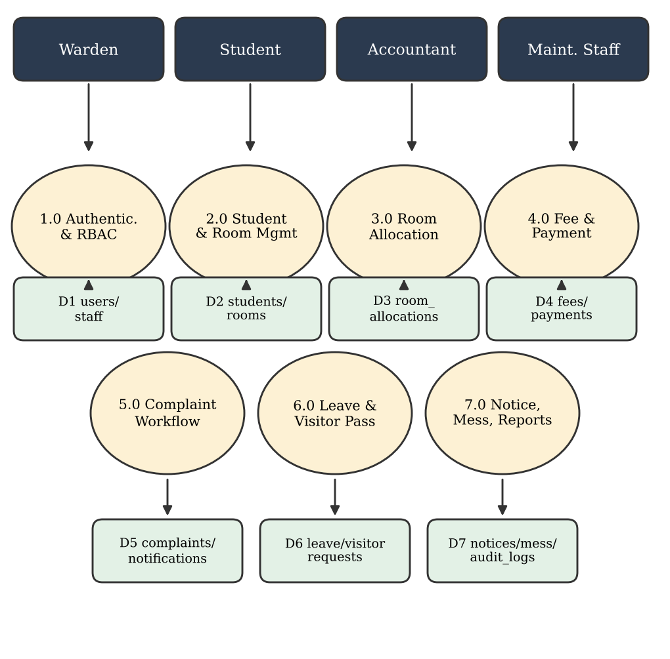
Fig. 4. Level-1 data flow diagram with seven processes and data stores.
The decomposition mirrors the module structure of the code, so every process of the diagram has a service class and one or more controllers, and every data store corresponds to one or two JPA entities. This one-to-one mapping is the reason why a new module can be added without disturbing the existing ones.
V. Workflow Framework
The central design principle is role-based workflow automation. Every process is modelled as a sequence of states; a user with the proper role moves a record to the next state, the service layer validates the rule, the change is stored in one database transaction, and the other roles see the result immediately on their dashboards.
A. Room allocation
A student requests a room, which creates an allocation in the PENDING state. When the warden approves, the service verifies that the student has no ACTIVE allocation, that the room is not under maintenance and that a bed is free (Fig. 5). It then increments the occupied count, sets the room status to AVAILABLE or FULL, stores the bed number and marks the allocation ACTIVE. Vacating decrements the count and marks the allocation VACATED. The occupancy ratio shown on the warden dashboard is
ρ = (Σ occupied) / (Σ capacity) (1)
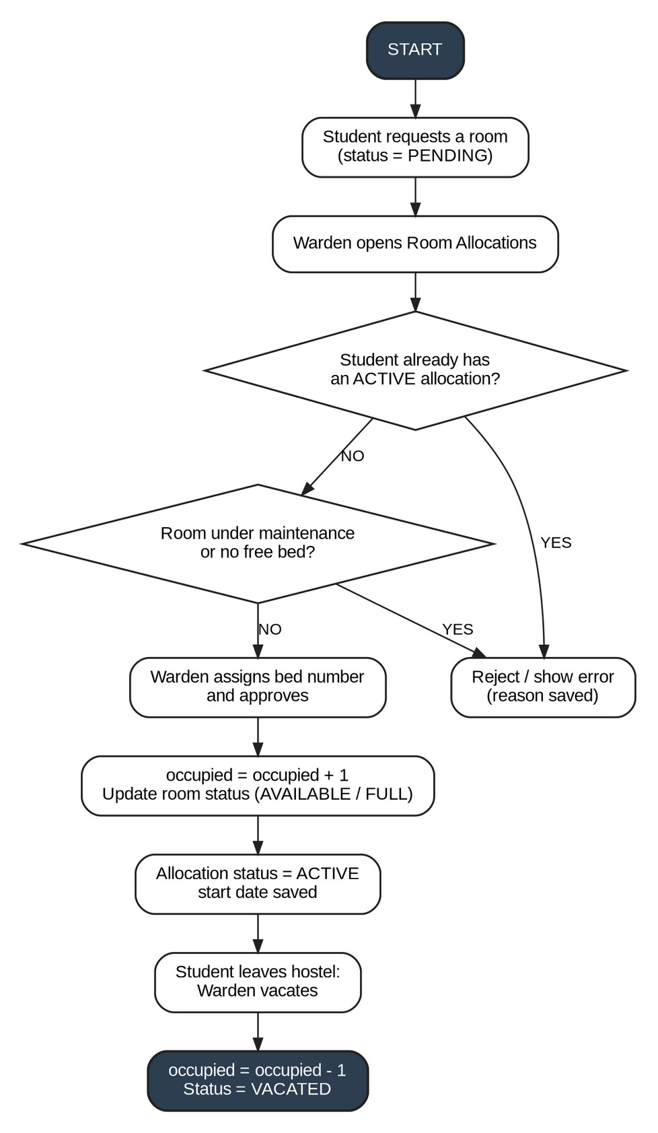
Fig. 5. Room allocation flowchart.
B. Fee invoicing and payment
The accountant generates one invoice per student per month. With rent R, mess M, electricity E and maintenance C, the total T and the pending amount are
T = R + M + E + C; pending = T − paid (2)
The status is PENDING when nothing has been paid, PARTIAL when 0 < paid < T, PAID when paid = T, and OVERDUE when the due date has passed with a balance outstanding. A unique constraint allows only one invoice per student per month.
C. Complaint lifecycle
A student lodges a complaint with category, priority and room. The system routes it automatically to the Maintenance Department with status SUBMITTED and computes the SLA deadline
t_SLA = t_created + h(priority) (3)
where h maps the four priority levels to 4, 8, 24 and 48 hours (a high-priority complaint received an 8-hour SLA in the tests). The complaint then follows the state machine of Fig. 6 and Table VI; transitions not listed in Table VI are rejected by the service layer.
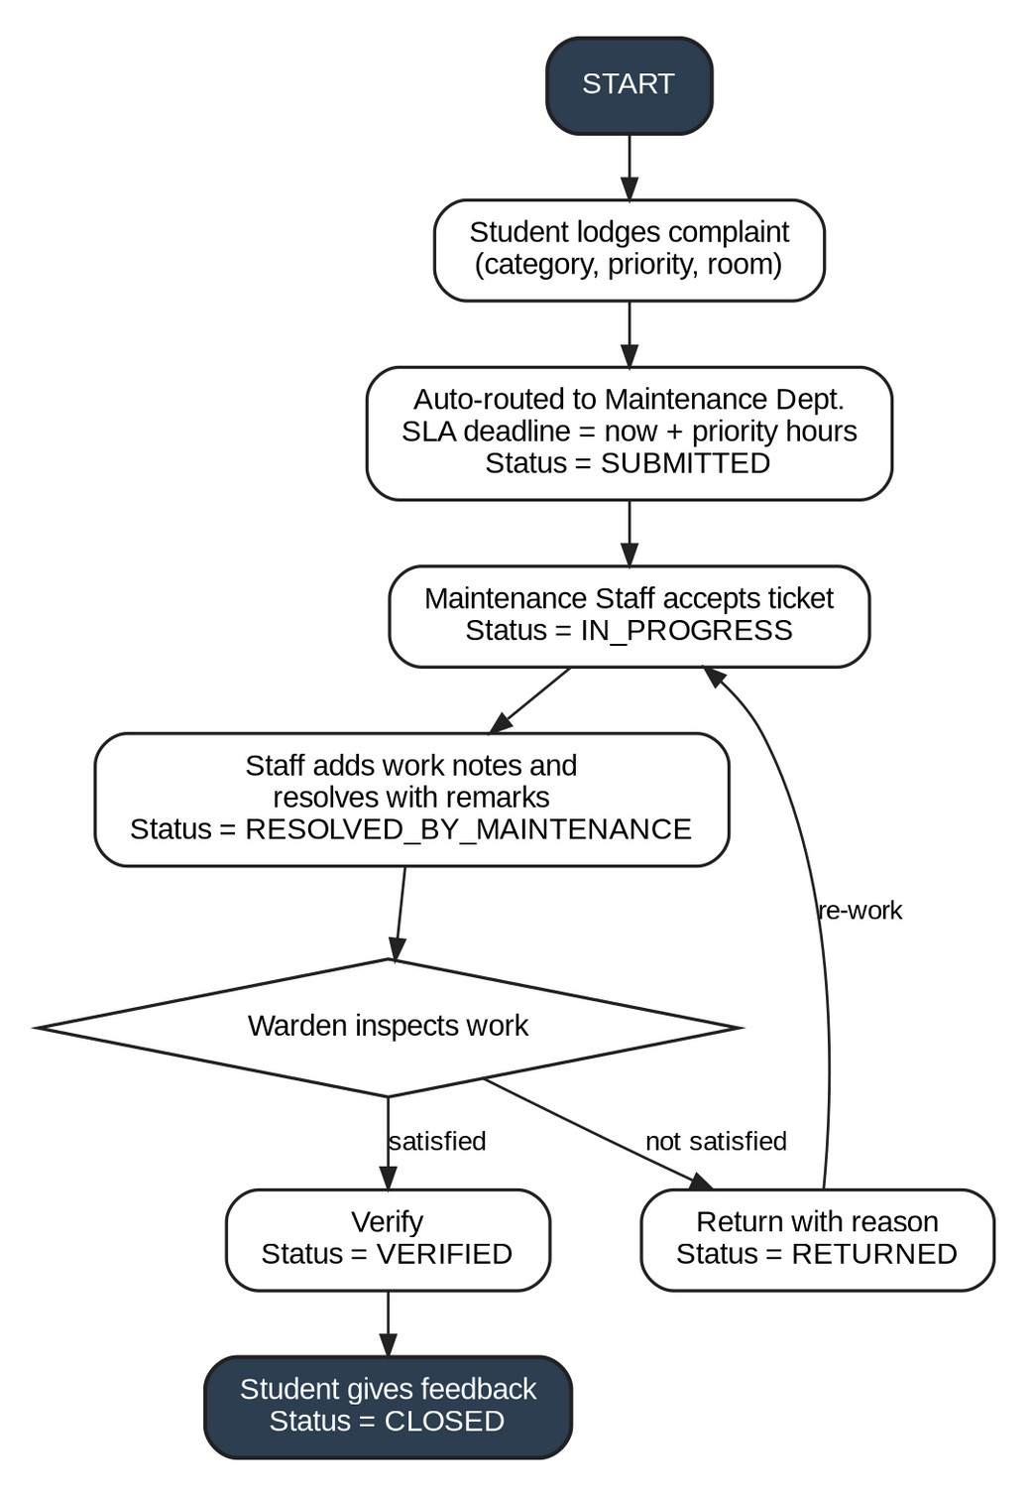
Fig. 6. Complaint lifecycle flowchart including the rework loop.
TABLE VI. Permitted complaint transitions
From | To | Actor
SUBMITTED | IN_PROGRESS | Maint. staff
IN_PROGRESS | RESOLVED_BY_MAINTENANCE | Maint. staff
RESOLVED_BY_MAINT. | VERIFIED | Warden
RESOLVED_BY_MAINT. | RETURNED | Warden
RETURNED | IN_PROGRESS (rework) | Maint. staff
VERIFIED | CLOSED (after feedback) | Student

D. Leave and visitor passes
A leave request (type, dates, reason) or a visitor pre-registration is validated (for example, the from-date may not be later than the to-date) and saved as PENDING. The warden approves or rejects it with remarks; approval records the approver and time. A visitor pass is completed by check-in and check-out, giving the states PENDING, APPROVED and COMPLETED.
E. Summary of the state machines and guards
Table VII collects the five workflows of this section. Every guard is evaluated inside the service method that performs the transition, and the resulting writes to the entity, to the dependent record (for example the room counter) and to the audit log belong to one transaction.
TABLE VII. Workflows, states and guard conditions
Process | States | Principal guards
Allocation | PENDING, ACTIVE, VACATED, rejected | No other ACTIVE allocation; room not under maintenance; free bed exists
Fee | PENDING, PARTIAL, PAID, OVERDUE | Amount not above pending; student pays own invoice only; one invoice per month
Complaint | SUBMITTED, IN_PROGRESS, RESOLVED_BY_MAINT., VERIFIED or RETURNED, CLOSED | Only listed transitions; staff accept and resolve; warden verifies; student closes
Leave | PENDING, APPROVED, rejected | From-date not later than to-date; warden decision with remarks
Visitor | PENDING, APPROVED, COMPLETED | Warden approval before check-in; check-out completes the pass

Two cross-cutting services complement the workflows. The audit service writes one row with user, role, action, module and record identifier whenever an important action is performed, and the notification service creates an in-app message for the concerned role when a complaint is submitted or its status changes. Because both are called from the same transactional method as the business change, a rolled-back operation leaves neither a stale audit row nor a spurious notification.
VI. System Modules
A. Authentication and role redirection
The user submits e-mail and password at /login. Spring Security loads the account and compares the password with the stored BCrypt hash; on success an HttpSession named SMART_HOSTEL_SESSION is created (60-minute idle timeout) and a success handler redirects to /warden, /student, /accountant or /complaint-staff. On failure no session is created. Logout invalidates the session and deletes the session cookies. URL rules such as hasRole("WARDEN") guard each path group, so a student opening a warden URL receives the Access Denied page.
B. Student and room management
The warden registers a student by creating a user account and a linked student profile (admission number, college, course, guardian details) with a BCrypt-hashed password, and maintains rooms with block, floor, type, capacity, monthly rent and status. Jakarta Bean Validation annotations (@NotBlank, @Email, @Size) validate every request on the server.
C. Fees and payments
Invoices carry the four fee components, total, paid, remaining and status. A student may pay online or the accountant may record a counter payment. Each payment receives a unique transaction identifier and is stored as a Payment record linked to the invoice and the student. Money values use BigDecimal. Online payment in the current version is recorded by the application itself; integration with a licensed payment gateway is future work.
D. Complaints, leave and visitors
These modules implement the workflows of Section V. Complaint events additionally create in-app notifications for the concerned role, and important actions are written to the audit log with user, role, module and record identifier.
E. Notices, mess menu, dashboards and reports
The warden publishes notices with priority, target audience and expiry date and edits a 7-day mess timetable (unique per day and meal), which students see on their dashboard. Each role dashboard is built from live database counts. OpenPDF generates fee receipts and financial and occupancy reports.
F. REST API
The same services are exposed under /api/ for authentication, dashboards, rooms, allocations, fees, payments, complaints, visitors, leaves, mess menu, notices and reports. A JWT filter validates HMAC-SHA256-signed tokens, which are valid for 24 hours. The API allows a decoupled React client or a future mobile application to reuse the business logic.
G. REST API catalogue
The REST interface exposes the same service classes as the web pages, which avoids duplicating business rules. Table VIII summarises the endpoint groups. A client first obtains a token from the authentication endpoint and sends it as a bearer token; the JWT filter validates the signature and expiry and sets the security context, after which the same role rules apply as for the browser interface. A decoupled React 18 client built with Vite exists in the repository as a proof of this separation.
TABLE VIII. REST API endpoint groups
Area | Endpoints | Purpose
Auth | POST /api/auth/login, /register; GET /api/auth/me | Token, profile
Dashboard | GET /api/dashboard/admin, /student | Role statistics
Rooms | GET/POST /api/rooms; GET /api/rooms/available | Room CRUD, availability
Allocation | POST /api/allocations/request, approve, reject, vacate | Allocation workflow
Fees | GET /api/fees, /fees/my; POST /api/fees/bulk | Invoices, bulk generation
Payments | POST /api/payments; GET /api/payments/transaction/{id} | Payment, lookup
Complaints | POST /api/complaints; PUT /api/complaints/{id}/status | Ticket lifecycle
Passes | POST /api/visitors/request, approve; POST /api/leaves/apply, approve | Visitor, leave
Mess, notices | GET /api/mess-menu/today, weekly; GET/POST /api/notices | Menu, announcements
Reports | GET /api/reports/fee-receipt/{id}, /financial/monthly, /occupancy | PDF documents

H. Validation and error handling
Every request body is validated on the server with Jakarta Bean Validation (@NotBlank, @Email, @Size and similar constraints), so client-side checks are a convenience and not a security measure. Business-rule violations are raised as typed exceptions such as a bad-request, not-found or unauthorised exception, which a global exception handler converts into a field-level message on the same page for form requests or into a structured error body for API calls. Unmapped addresses, forbidden access and unexpected failures are shown on custom 404, 403 and 500 pages that hide stack traces from the user. Together with the audit log, this makes failures visible to the administrator without exposing implementation details.
VII. Database Design
The relational schema is normalised up to third normal form [10], [11] and uses auto-generated primary keys and foreign keys. Tables are created by Hibernate (ddl-auto = update). Fig. 7 shows the core entities, and Table IX lists all 14 tables. Unique constraints enforce one user e-mail per account, one invoice per student per month and one mess entry per day and meal; the 1:1 relation between users and students (and staff) separates credentials from profile data. Index and query design follow established JPA guidance [22].
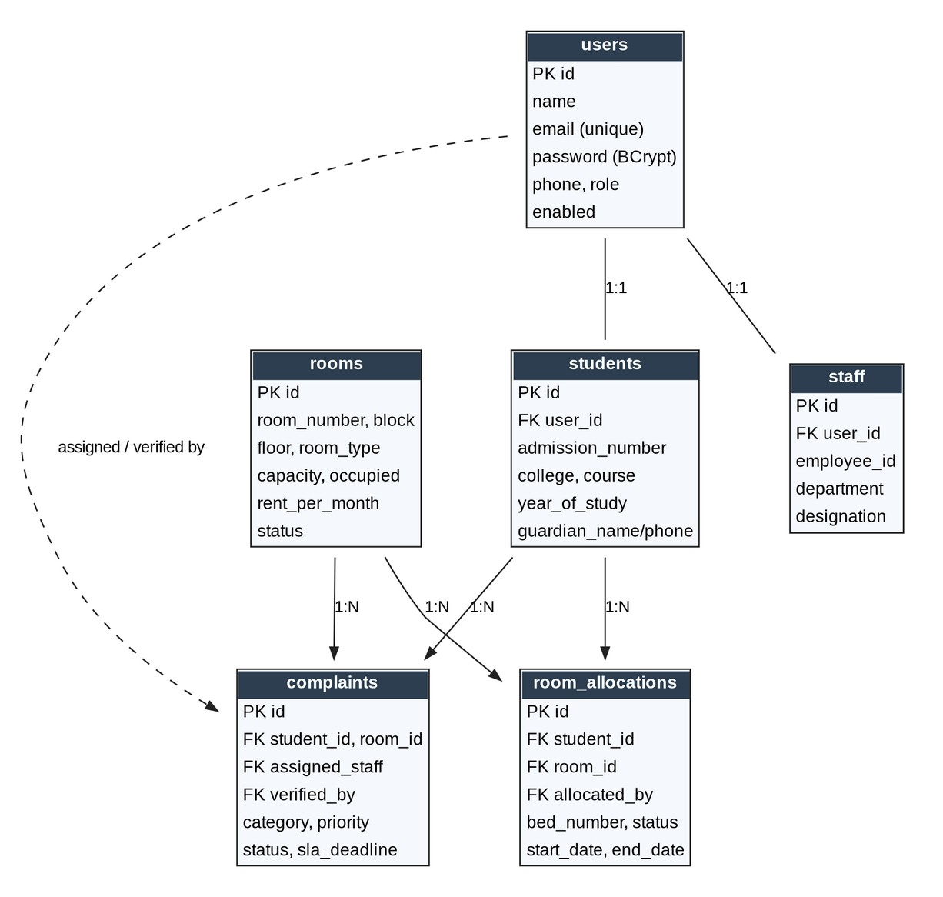
Fig. 7. ER diagram of the core entities.
TABLE IX. Database tables
Table | Purpose and key columns
users | Login accounts of all roles; unique e-mail, BCrypt password, role, enabled
students | Resident profile (1:1 with user): admission number, college, course, guardian
staff | Warden, accountant, maintenance staff: employee ID, department, designation
rooms | Room number, type, capacity, occupied, rent per month, status
room_allocations | Student, room, bed number, status, start and end date
fees | Monthly invoice: four components, total, paid, remaining, status
payments | Transaction ID, amount, method, status, date
complaints | Category, priority, status, SLA deadline, resolution remarks
leave_requests | Leave type, dates, status, admin remarks
visitor_requests | Visitor name, visit date, check-in/out time, status
notices | Title, content, priority, target audience, expiry date
mess_menus | Day, meal type, items, timing (unique per day and meal)
notifications | Recipient role, title, message, read flag
audit_logs | User, role, action, module, record ID

Table X lists the integrity mechanisms that the schema and the entity model contribute. The central idea is to let the database refuse states that the application should never produce, so that an error in one service method cannot silently corrupt the data of another. Credentials are separated from profile data through the one-to-one links from users to students and staff, which allows a student record to be archived without losing the account history and limits the number of tables that contain password hashes to one.
TABLE X. Integrity mechanisms in the data model
Mechanism | Where | Effect
Unique e-mail | users | One account per address; login key
Unique (student, month) | fees | Prevents duplicate invoices for a month
Unique (day, meal) | mess_menus | One menu entry per slot
1:1 user link | students, staff | Credentials separate from profile
Foreign keys | allocations, fees, payments, complaints | No orphan records; navigable history
BigDecimal amounts | fees, payments | No floating-point rounding of money
Enum status columns | all workflows | Only defined states can be stored

The schema is created by Hibernate from the entity classes, which keeps the Java model and the tables synchronised during development; a production roll-out should replace this with versioned migration scripts, as noted in Section XIII. Relationships are mapped with @OneToOne, @ManyToOne and @OneToMany, and queries use derived repository methods and JPQL, for instance to test whether a student already has an ACTIVE allocation or to count tickets per status for the dashboards.
VIII. Business Rules and Algorithms
The pseudocode below abstracts the service-layer logic of the repository. Each data-changing method runs inside a @Transactional boundary, so a failed step rolls back the whole operation.
Algorithm 1. Approve room allocation
INPUT allocationId, bedNumber
a = find(allocationId) or NOT_FOUND
IF a.status != PENDING: ERROR
IF student has ACTIVE allocation: ERROR
r = a.room
IF r.status == UNDER_MAINTENANCE: ERROR
IF r.capacity - r.occupied <= 0: ERROR
r.occupied = r.occupied + 1
r.status = FULL or AVAILABLE; save(r)
a.status = ACTIVE; a.bed = upper(bed)
a.startDate = today; save(a)

Algorithm 2. Process fee payment
INPUT feeId, amount, method, user
IF user is STUDENT AND not fee owner:
ERROR unauthorised
IF fee.status == PAID OR pending <= 0:
ERROR already paid
IF amount > pending: ERROR
txn = "TXN-" + millis + "-" + rand6
fee.paid = fee.paid + amount
recompute remaining and status
save(fee); save Payment(txn, SUCCESS)

Algorithm 3. Create complaint with routing and SLA
p = request.priority OR MEDIUM
deadline = now + slaHours(p)
c = Complaint(student, room, p,
status=SUBMITTED, dept=MAINTENANCE,
slaDeadline=deadline)
save(c)
audit(COMPLAINT_SUBMITTED)
notify(Maintenance, c.id)

Algorithm 2 contains the ownership and over-payment rules, so a student cannot pay another student’s invoice and the paid amount can never exceed the total. Algorithm 1 keeps the occupied count and the room status consistent with the allocation records.
Listing 1 shows the central authorisation rules in abridged form and Listing 2 the guards of the payment method, which realise the ownership and over-payment checks of Algorithm 2 in the repository code.
Listing 1. Role rules (abridged)
.requestMatchers("/", "/login", "/register",
"/css/**", "/js/**").permitAll()
.requestMatchers("/warden/**",
"/api/warden/**").hasRole("WARDEN")
.requestMatchers("/accountant/**")
.hasRole("ACCOUNTANT")
.requestMatchers("/student/**",
"/api/student/**").hasRole("STUDENT")
.requestMatchers("/complaint-staff/**",
"/maintenance/**")
.hasRole("COMPLAINT_STAFF")
.anyRequest().authenticated()
.logout(l -> l.logoutUrl("/logout")
.invalidateHttpSession(true)
.deleteCookies("SMART_HOSTEL_SESSION"))

Listing 2. Payment guards (abridged)
if (user.getRole() == Role.STUDENT &&
!fee.getStudent().getUser().getId()
.equals(user.getId()))
throw new UnauthorizedException(..);
if (fee.getStatus() == FeeStatus.PAID ||
fee.getPendingAmount()
.compareTo(BigDecimal.ZERO) <= 0)
throw new BadRequestException(..);
if (req.getAmount().compareTo(
fee.getPendingAmount()) > 0)
throw new BadRequestException(..);
fee.setPaidAmount(fee.getPaidAmount()
.add(req.getAmount()));
fee.recalculateTotalsAndStatus();

Invariants and cost
The rules above are intended to preserve four invariants: (I1) 0 ≤ occupied ≤ capacity for every room; (I2) 0 ≤ paid ≤ total for every invoice; (I3) a student has at most one ACTIVE allocation; and (I4) at most one invoice exists per student and month. I2 and I4 follow directly from the amount check and the unique constraint, I1 and I3 from the guards of Algorithm 1. Under sequential execution these arguments are straightforward; under concurrent requests only I4 is enforced by the database itself, which is why Section XIII lists concurrency testing and locking as open work. Each algorithm performs a constant number of indexed look-ups and writes, so its database cost does not grow with the number of residents, although this has not been confirmed by measurement.
IX. Access Control and Security Analysis
A. Access control model
Authorisation is declared in one place as URL rules: /warden/** and /api/warden/** require ROLE_WARDEN; /accountant/** requires ROLE_ACCOUNTANT; /student/** requires ROLE_STUDENT; /complaint-staff/** and /maintenance/** require ROLE_COMPLAINT_STAFF; all other requests require authentication, and only the login, register and static-resource paths are public. Thymeleaf’s Spring Security dialect additionally shapes menus by role, but server-side rules govern processing. Ownership checks in the service layer add a second level of protection to data that belongs to a particular student.
B. Threat analysis
TABLE XI. Threats, mitigations and residual risk
Threat | Mitigation in the system | Residual risk
Unauthorised page access | URL role rules; custom 403 page | Rules must be kept in sync with new routes
Credential theft | BCrypt hashes; no plain text [12], [13] | Default demo passwords must be changed
Paying another’s invoice | Ownership check in service | None observed in tests
Over-payment | Amount ≤ pending check | None observed in tests
Session misuse | 60-min timeout; logout invalidates session | HTTPS-only access needed
CSRF on forms | Not enabled in the demo build | Enable for production [15]
API token abuse | HMAC-SHA256 JWT, 24 h [14] | Secret must come from env.; no revocation described
Log tampering | Audit rows with user and role | Table not cryptographically protected

The analysis shows that the main protections against unauthorised actions are implemented at the URL and service levels, while production hardening (HTTPS, CSRF, secret management, credential rotation) is still required. These items are also given as recommendations in the project report.
X. Implementation Environment and Deployment
A. Build and cloud deployment
The application is packaged as a single executable JAR by Maven. A multi-stage Dockerfile [23] builds the JAR with Maven and a JDK 17 image and runs it on a smaller JRE 17 image. The container is deployed on Render [24] directly from the GitHub repository (git push triggers a build), and the database is a MySQL 8 service hosted on Aiven [25] accessed over JDBC with SSL. The server port (PORT, default 2007), the database URL, user and password (DB_URL, DB_USER, DB_PASSWORD) and the JWT secret are supplied as environment variables, so the same image can move between environments. A DataInitializer seeds rooms, demonstration accounts and the mess menu at start-up. Development needs JDK 17, Maven, Git and MySQL on a machine with at least 4 GB of RAM (8 GB recommended); end users need only a modern browser.
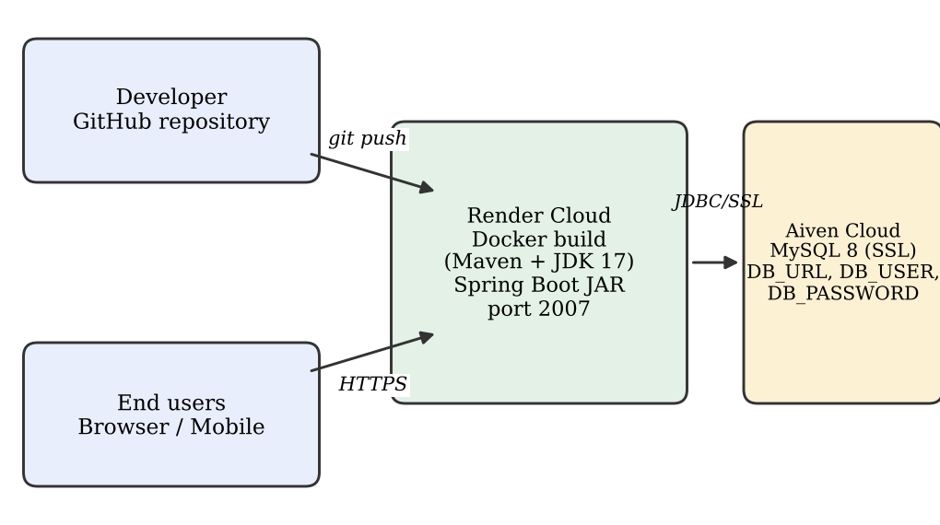
Fig. 8. Deployment path from the repository to the cloud.
B. Development process and team organisation
The system was developed by a five-member team in a ten-week Project Based Learning schedule, with each member owning one primary module and taking part in integration and testing. Work followed an agile, module-wise approach: requirement analysis and the software requirement specification came first, then use-case, class, activity and sequence diagrams, the entity-relationship diagram and interface mock-ups, followed by four coding weeks organised by module and a final integration and deployment phase. Table XII lists the plan. Source control used a stable main branch, a develop branch for integration and feature branches per module, and each member committed several times a week; this is a process record, not a quality claim.
TABLE XII. Ten-week execution plan
Week | Activity
1–2 | Team formation, abstract, repository; software requirement specification
3–4 | UML design; database design and Bootstrap mock-ups
5 | Coding: authentication, students, rooms
6 | Coding: allocation, complaints, fees
7 | Coding: payments, visitors, leave
8 | Coding: notices, mess menu, reports, dashboards
9 | Integration, end-to-end testing and bug fixing
10 | Report, presentation, demonstration and viva

C. Runtime configuration
All environment-specific values are externalised, which is what allows one image to run on a developer machine and in the cloud (Table XIII). Secrets are never written into the repository.
TABLE XIII. Principal runtime settings
Setting | Value or source | Note
server.port | PORT (default 2007) | Embedded server
datasource url, user, password | DB_URL, DB_USER, DB_PASSWORD | Aiven MySQL, SSL
jpa.hibernate.ddl-auto | update | Schema from entities
servlet.session.timeout | 60 minutes | Idle expiry
jwt expiration | 86 400 000 ms | 24-hour API token

XI. Testing and Evaluation
A. Strategy and scope
The application was tested end to end on the deployed instance and on a local environment for all four roles. The testing reported here is manual, black-box functional testing driven by 24 scenarios (Table XIV); each scenario was run with a stated input and the observed behaviour was compared with the expected behaviour. No automated unit or integration test suite, load test or usability study is reported for this version.
TABLE XIV. Functional test scenarios and results
Group (test nos.) | Scenario and observed behaviour | Result
Login (1–5) | Valid credentials of each role redirect to its dashboard; wrong password shows error and creates no session | 5/5
Security (6–7) | Student opening a warden URL gets Access Denied; logout invalidates session | 2/2
Room, student (8–9) | Room and student records are saved and listed | 2/2
Allocation (10–11) | Free bed: occupied +1, ACTIVE; full or maintenance room rejected with message | 2/2
Fee, payment (12–15) | Total computed, PENDING; partial → PARTIAL; full → PAID with transaction ID; over-payment rejected | 4/4
Complaint (16–19) | SUBMITTED with 8 h SLA; IN_PROGRESS, RESOLVED_BY_MAINTENANCE; VERIFIED or RETURNED; CLOSED after feedback | 4/4
Leave, visitor (20–22) | Date validation error; approval stores approver and time; visitor PENDING, APPROVED, COMPLETED | 3/3
Notice, mess (23) | New notice and edited mess item visible to students immediately | 1/1
Errors (24) | Invalid URL shows custom 404 page | 1/1
Total |  | 24/24

B. Evidence from the demonstration database
Screens captured from the running system confirm the dashboards (Table XV). The warden dashboard shows 4 registered students, 4 rooms with 8 beds, 4 beds occupied and 4 available, i.e. ρ = 4/8 = 50 %, and three complaint tickets of which one was verified. The student dashboard shows allocation to room A-101, Bed 1 (double sharing), no pending dues and a complaint summary of three tickets (two open, one closed). The maintenance dashboard lists two new tickets in the queue. The accountant dashboard was captured before any invoice had been generated, so all amounts appear as zero; the fee logic itself is covered by test scenarios 12–15.
TABLE XV. Demonstration database snapshot
Dashboard | Observed values
Warden | 4 students; 4 rooms, 8 beds; 4 occupied; 50 % occupancy; 3 tickets, 1 verified
Student | Room A-101, Bed 1, double; dues Rs. 0; 3 complaints (2 open, 1 closed)
Maintenance | 2 new (SUBMITTED), 2 active, 0 in progress; ticket CMP-0003 closed
Accountant | No invoice generated at capture time; all totals Rs. 0

Fig. 9 to Fig. 11 show captured screens of the running system and agree with the values of Table XV: the warden dashboard with occupancy and complaint counters, the maintenance queue with a closed ticket and two new tickets, and the student portal with the allotted room, dues and complaint summary.
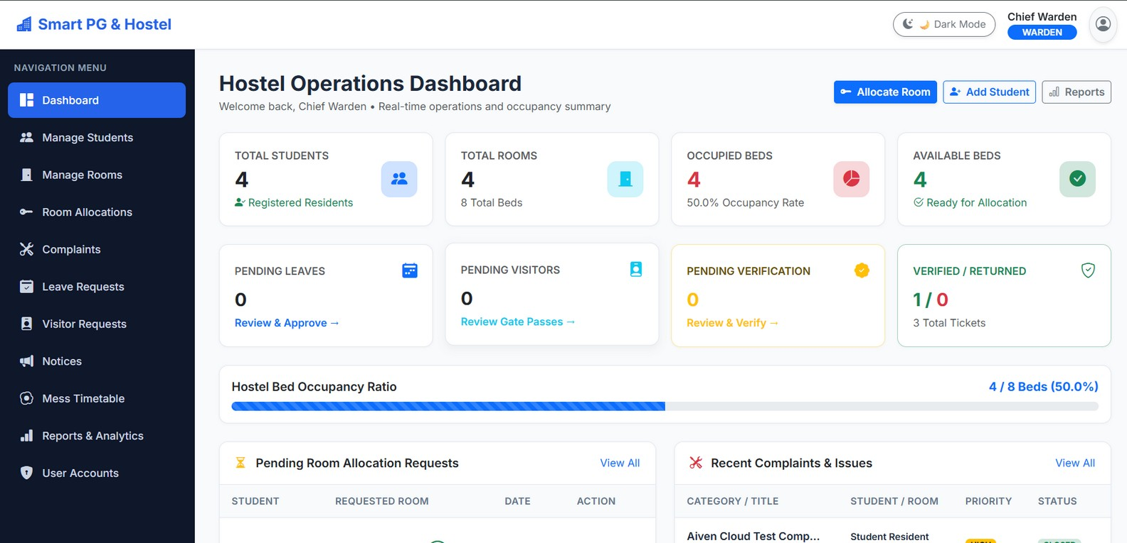
Fig. 9. Warden dashboard: 4 students, 8 beds, 4 occupied (50 %).
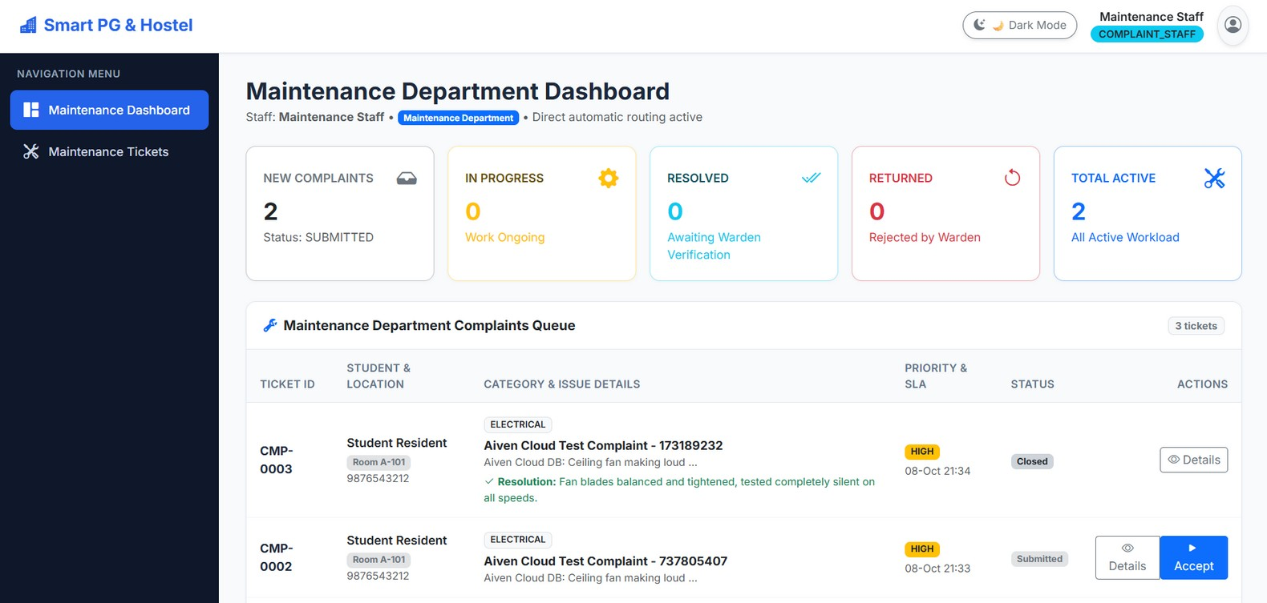
Fig. 10. Maintenance department dashboard and complaint queue.
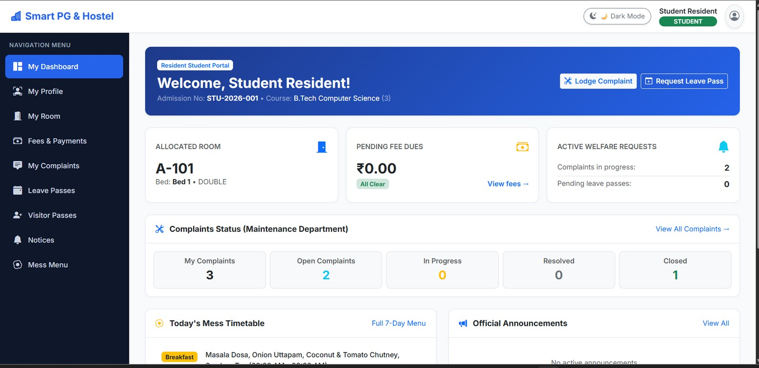
Fig. 11. Student portal: room A-101, Bed 1, no pending dues.
C. Requirements-to-test traceability
To show which requirements the executed scenarios actually exercise, Table XVI relates the functional requirements of Table II to the test numbers of Table XIV. Requirement FR12 is supported by the dashboard evidence of Table XV but not by a numbered scenario, and FR13 and FR14 (audit trail and notifications, and the REST API) are not covered by any of the 24 scenarios; they were exercised informally during development only. Reporting this gap is deliberate: the 100 % pass rate applies to the scenarios listed and must not be read as full coverage of all fourteen requirements.
TABLE XVI. Traceability between requirements and tests
Requirement | Test numbers | Coverage
FR01 | 1–7 | Covered (login, redirect, logout, access)
FR02, FR03 | 8, 9 | Covered (create and list)
FR04 | 10, 11 | Approve and reject paths; vacate not listed
FR05 | 12 | Covered
FR06 | 13–15 | Partial, full and over-payment
FR07, FR08 | 16–19 | Full lifecycle with feedback
FR09, FR10 | 20–22 | Validation, approval, visitor flow
FR11 | 23 | Covered
FR12 | Snapshot table only | Dashboards observed; PDFs not tested
FR13, FR14 | none | Not covered by numbered scenarios

XII. Results and Discussion
A. Functional results
All 24 scenarios produced the expected behaviour (100 % pass). The system enforced authentication, role-based access, allocation capacity limits, fee calculation and the multi-step complaint workflow, and the dashboard values agreed with the data changed during allocation, payment and complaint handling. Because allocation, vacating, payment and complaint-status changes run in @Transactional methods, a failed step rolls back the entire operation and occupancy and fee balances stay consistent. Table XVII contrasts the design with a paper-register process; it describes design intent and is not the result of a survey of any hostel.
TABLE XVII. Manual process and the proposed system
Dimension | Manual / spreadsheet | This system
Room availability | Checked in registers | Live occupied count, auto status
Fee tracking | Manual totals | Computed total, paid, remaining, status
Complaints | Verbal, untracked | Ticket, SLA, verification, feedback
Passes | Gate register | Request, approval, check-in/out
Audit | Rarely kept | audit_logs and notifications
Access | Office hours | Browser, any time, role-based

B. Qualitative performance observations
Server-rendered pages loaded quickly in manual use because each request performs a few indexed look-ups through Spring Data JPA and static assets are served directly; navigation felt smooth for all roles on desktop and mobile screens. On free cloud instances the first request after a long idle period may take longer while the container restarts. These are observations, not measurements: no response-time, throughput or concurrency figures were recorded, so no quantitative performance claim is made.
C. Usability and maintainability
A common layout with a dark sidebar, status badges, statistic cards and a Dark Mode switch gives a consistent look; Bootstrap alerts and field-level validation messages guide users, and the exception handler hides technical details. The layered structure and the REST API next to the MVC pages make it straightforward to add new modules. No formal user study was conducted.
D. Assessment against the objectives
Table XVIII compares the objectives of Section I with the evidence presented in this paper, using three levels: demonstrated by a scenario, implemented but not independently tested, and not evaluated.
TABLE XVIII. Objectives and the evidence available
Objective | Status | Evidence
Secure role-based access | Demonstrated | Tests 1–7
Bed capacity, no over-allocation | Demonstrated | Tests 10–11
Invoicing and payment tracking | Demonstrated | Tests 12–15
Complaint workflow with SLA | Demonstrated | Tests 16–19
Leave and visitor passes | Demonstrated | Tests 20–22
Dashboards, PDFs, audit trail | Partly | Dashboards observed; PDFs, audit not tested
Cloud deployment | Demonstrated | Live instance used for testing
Performance and scalability | Not evaluated | Qualitative remarks only

E. Threats to validity
Several factors limit how far the results can be generalised. The tests were designed and executed by the same team that implemented the system, so they reflect the intended behaviour and may overlook misunderstandings that an independent tester would expose. The demonstration database is small (four students and four rooms), so effects that depend on volume, such as slow queries or large report generation, cannot appear. Each scenario was executed once and not repeated under varying data, and no scenario involved two users acting at the same instant. Finally, no hostel staff or residents evaluated the interface, so statements about usability describe design features and not measured user satisfaction. These threats do not invalidate the functional results but define the evidence that a stronger evaluation would add: an automated regression suite for the service layer, repeated runs on larger synthetic data, concurrency tests for allocation and payment, and a short usability study with a warden and a group of residents.
F. Design decisions and lessons learned
Four design decisions shaped the result. First, keeping all business rules in the service layer and not in controllers or templates meant that the MVC pages and the REST API could share one implementation, and a rule changed once applied to both interfaces. Second, representing statuses as enumerations and money as BigDecimal removed two common sources of silent errors, misspelt status strings and rounding differences. Third, maintaining the room counter by explicit increment and decrement keeps the dashboard cheap to compute, but it creates a second copy of information that is also present in the allocation records; the concurrency limitation of Section XIII is the price of this choice, and recomputing the counter from ACTIVE allocations is an alternative that trades speed for robustness. Fourth, the in-app notification and audit services were wired into the existing transactional methods with little change, which supports the claim that the layered structure makes cross-cutting features inexpensive to add.
The practical lessons concern process more than technology. Writing the state machines before coding exposes missing transitions, such as the rework loop after a returned complaint, at design time instead of during testing. Seeding demonstration data at start-up makes every scenario repeatable on the cloud instance and on a developer machine. Finally, producing screens and test tables as part of the work, and not afterwards, forces a team to state what has actually been observed, which is the habit that the evidence-based reporting of this paper tries to preserve.
XIII. Limitations
- Evidence: testing is manual and functional only; there is no automated test suite, load or concurrency test, or user study, and performance is described qualitatively.
- Concurrency: the allocation algorithm reads and increments the occupied count inside a transaction, but the reviewed logic shows no explicit locking or versioning; two simultaneous approvals for the last bed should be tested and, if needed, protected by optimistic or pessimistic locking.
- Payments: online payments are recorded by the application and are not processed by a real payment gateway.
- Security hardening: CSRF protection and HTTPS-only access are recommended but not enabled in the demonstration build; demonstration accounts use default passwords; a public /register route is permitted by the security rules and its production policy should be reviewed; the audit log is not tamper-protected.
- Operations: schema evolution relies on ddl-auto = update instead of migration scripts; the system runs as a single instance on a free tier with cold starts; notifications are in-app only.
- Scope: one administration with one or more blocks; biometric attendance, IoT locks and multi-tenant operation are outside the present scope.
XIV. Future Work
TABLE XIX. Proposed extensions
Extension | Purpose
Payment gateway | Razorpay/UPI with automatic receipt and status update
Mobile app / PWA | Reuse the REST API for students and wardens
SMS, e-mail, WhatsApp | Reminders for dues, approvals, complaint status
QR or biometric gate pass | Verify leave and visitor passes at the gate
IoT features | Smart meters for electricity billing; smart locks
AI and analytics | Room-demand prediction, failing-asset detection, chatbot
Multi-tenant support | Many hostels with separate data and branding
Advanced reports | Excel export, revenue and occupancy graphs
Security | 2FA, CSRF everywhere, login-attempt limiting, permission editor
Engineering | Automated tests, load tests, DB migrations, locking, React client

The most valuable near-term work is to add automated unit and integration tests for the service layer, to test allocation and payment under concurrent requests, and to measure response times under load before any institutional roll-out.
Production-readiness checklist
Combining the limitations with the recommendations of the project report, Table XX lists the minimum actions before an institution uses the system for real residents and real money.
TABLE XX. Actions before production use
Area | Action
Credentials | Change demonstration passwords and the JWT secret; review the public /register route
Transport and forms | Enforce HTTPS; enable CSRF protection for form pages
Secrets and backup | Keep database credentials in environment variables; schedule automated MySQL backups
Payments | Integrate a licensed gateway before accepting online money
Data integrity | Add locking for the last-bed case; replace ddl-auto by migrations
Quality | Add automated tests and a load test; train warden, accountant and staff

Extending the system
Because every module follows the same pattern, a new feature such as a mess-feedback form or a laundry booking is added in five steps: define the entity and its enumerations, add a Spring Data repository, write a transactional service that contains the guards and the state transitions, expose it through an MVC controller and, if needed, a REST controller under /api/, and add a Thymeleaf view and a URL rule for the roles that may use it. Audit and notification calls are added to the service method, and a matching scenario is added to the test table. Following this recipe keeps new code consistent with the rest of the system and keeps the security rules in one place.
XV. Conclusion
This paper presented the Smart PG & Hostel Management System, a role-based web application built with Spring Boot, Spring Security, JPA/Hibernate and MySQL and deployed on the cloud with Docker. By modelling allocation, fees, complaints and passes as validated state machines inside transactional services, the system gives the warden, students, accountant and maintenance staff a single, auditable source of truth. All 24 manual functional scenarios behaved as expected, and the demonstration dashboards matched the underlying data. The paper has also stated what is not yet shown: automated and load testing, concurrency protection for allocation, a real payment gateway and production security hardening. Within these bounds the system is a practical, extensible foundation for digitising hostel and PG administration.
Acknowledgment
The authors thank their project guide, Er. Ram Babu Buri, the Head of Department, Dr. Ashok Kumar Kajla, the Department of Artificial Intelligence & Data Science and Arya College of Engineering & I.T., Jaipur, for academic support during the Advanced Java Project Based Learning programme (session 2026-27).
References
[1] M. Fowler, Patterns of Enterprise Application Architecture. Boston, MA, USA: Addison-Wesley, 2002.
[2] C. Walls, Spring in Action, 6th ed. Shelter Island, NY, USA: Manning Publications, 2022.
[3] VMware/Broadcom, “Spring Boot Reference Documentation.” [Online]. Available: https://spring.io/projects/spring-boot
[4] VMware/Broadcom, “Spring Security Reference.” [Online]. Available: https://docs.spring.io/spring-security/reference/
[5] VMware/Broadcom, “Spring Data JPA Reference Documentation.” [Online]. Available: https://spring.io/projects/spring-data-jpa
[6] Red Hat, “Hibernate ORM Documentation.” [Online]. Available: https://hibernate.org/orm/documentation/
[7] Thymeleaf Team, “Thymeleaf Documentation.” [Online]. Available: https://www.thymeleaf.org/documentation.html
[8] Bootstrap Team, “Bootstrap 5.3 Documentation.” [Online]. Available: https://getbootstrap.com/docs/5.3/
[9] Oracle, MySQL 8.0 Reference Manual. [Online]. Available: https://dev.mysql.com/doc/refman/8.0/en/
[10] E. F. Codd, “A relational model of data for large shared data banks,” Commun. ACM, vol. 13, no. 6, pp. 377–387, 1970.
[11] R. Elmasri and S. B. Navathe, Fundamentals of Database Systems, 7th ed. Pearson, 2016.
[12] N. Provos and D. Mazières, “A future-adaptable password scheme,” in Proc. USENIX Annu. Tech. Conf., 1999.
[13] P. A. Grassi et al., “Digital identity guidelines: Authentication and lifecycle management,” NIST SP 800-63B, 2017.
[14] M. Jones, J. Bradley and N. Sakimura, “JSON Web Token (JWT),” RFC 7519, IETF, May 2015.
[15] OWASP Foundation, “OWASP Top Ten Web Application Security Risks.” [Online]. Available: https://owasp.org/www-project-top-ten/
[16] R. T. Fielding, “Architectural styles and the design of network-based software architectures,” Ph.D. dissertation, Univ. California, Irvine, CA, USA, 2000.
[17] JJWT Project, “Java JWT library (JJWT).” [Online]. Available: https://github.com/jwtk/jjwt
[18] LibrePDF, “OpenPDF library.” [Online]. Available: https://github.com/LibrePDF/OpenPDF
[19] I. Sommerville, Software Engineering, 10th ed. Pearson Education, 2015.
[20] ISO/IEC 25010:2011, “Systems and software engineering – Systems and software Quality Requirements and Evaluation (SQuaRE) – System and software quality models,” 2011.
[21] D. Shekhawat, D. Paliwal, D. Kumar, G. Sharma and H. Sharma, “Smart PG & Hostel Management System,” GitHub repository, 2026. [Online]. Available: https://github.com/Divyanshp63/smart-hostel-management. Live demo: https://smart-hostel-management-9j3u.onrender.com/login
[22] V. Mihalcea, High-Performance Java Persistence. Vlad Mihalcea, 2016.
[23] Docker Inc., “Docker Documentation.” [Online]. Available: https://docs.docker.com/
[24] Render, “Render Documentation.” [Online]. Available: https://render.com/docs
[25] Aiven, “Aiven for MySQL Documentation.” [Online]. Available: https://aiven.io/docs/products/mysql

