PROJECT PART 2

Name – Srishti Kumari

Roll No. - 210040155

1. Mass of Column = 2500 x 0.4 x 0.4 x 5 = 2000 Kg (Considering density of RC as 2500Kg/m3)

Stiffness of Column = 384 x E x I / 5 L3 = 35895.55 kN/m (where E = 27386.13MPa, I =bd3/12)

Elastic Section Modulus of square steel section = bd2/6

Plastic Section Modulus of square steel section = bd2/4

Since hinge formation at support/mid- point is assumed after complete yielding of the section, the plastic capacity shall be used here, Mp = Mn = Zfy = (bd2/4) x fy = 8000kN-m

Shape Function (ψ(x)): 16( $\frac{x^{2}}{L^{2}}$-2 $\frac{x^{3}}{L^{3}}$ + $\frac{x^{4}}{L^{4}}$)

Me = = = 2.032M/5 = 812.698kg

KM = Me/M = 812.692/2000 = 0.4063

Ke = =

Ke = 95720 kN/m

KL = Ke/K = 95720/35895.55 = 2.667

Time period = 2 $π\sqrt{\frac{Me}{Ke}}$ = 2π $\sqrt{\frac{812.698}{95720x1000}}$ = 0.0183sec

Table 2: SDOF parameters and modal properties

|  |  |  |  |
| --- | --- | --- | --- |
|  | Real System | Equivalent SDOF system | SDOF factor |
| Mass (kg) | 2000 | 812.698 | KM = 0.4063 |
| Stiffness (N/m) | 35895550 | 95720000 | KL = 2.667 |
| Time-period (sec) | N.A. | 0.0183 | N.A. |



|  |  |  |  |
| --- | --- | --- | --- |
|  | Elastic (ke) | Elastic-Plastic (kep) | Plastic (kp) |
| Mass factor (KM) | 0.41 | 0.5 | 0.33 |
| Load Factor (KL) | 0.53 | 0.64 | 0.5 |
| Load Mass Factor (KLM) | 0.77 | 0.78 | 0.66 |
| Equivalent SDOF mass in Kg (KM x M) | 820 | 1000 | 660 |
| Stiffness in kN/m | 384EI/L3 = 179477.75 | 384EI/5L3 =  35895.55 | 0 |
| Equivalent SDOF stiffness in kN/m (KL x k) | 95123.21 | 22973.152 | 0 |
| Equivalent load in kN (KL x Fr) | 5.3 | 6.4 | 5.0 |
| Maximum Resistance in MN | 12Mn/L = 19.2 | 8(Mp + Mn)/L = 25.6 | 8(Mp + Mn)/L = 25.6 |

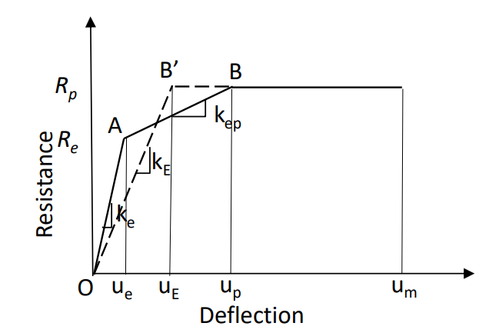To use SDOF methods of analysis, the trilinear resistance deflection curve must be simplified to equivalent bilinear curve.

ke = 384EI/L3 = 179477.75 kN/m

kE = 307EI/L3 = 143488.72 kN/m

35895.55

Re = 12Mp/L = 19.2 MN

143488.72

Rp = 16Mp/L = 25.6 MN

179477.75

ue = Re/ke = 19.2/179477.75 = 106.98 mm

uE = ue + up (1-Re/Rp) = 5Rp/4ke = 178.295 mm

up = 2Rp/ke = 285.272mm

So bilinear representation with stiffness of 307EI/L3 and maximum resistance of

8(Mp + Mn)/L SDOF system with equivalent stiffness of 0.64 x 307EI/L3 = 91832.781 kN/m

Time period of equivalent system = T = 2 $π\sqrt{\frac{Me}{Ke}}$ = 2π $\sqrt{\frac{812.698}{95720000}}$ = 0.0183 sec

td = 2.22msec (From Project part 1)

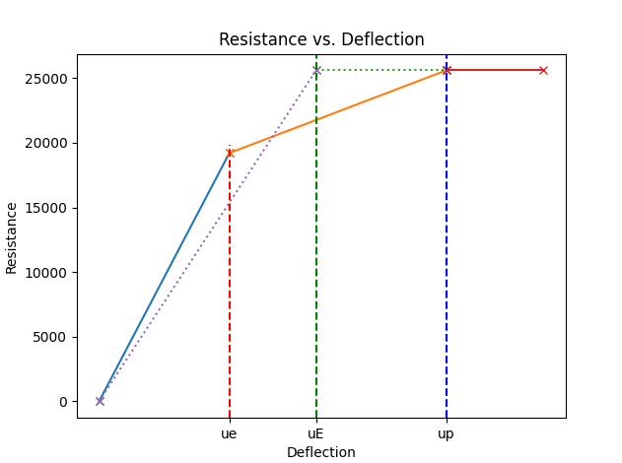td/Tn = 2.22/18.3 = 0.121 (Response will be Impulsive)

179477.75

35895.55

143488.72

B’

B

A

1. 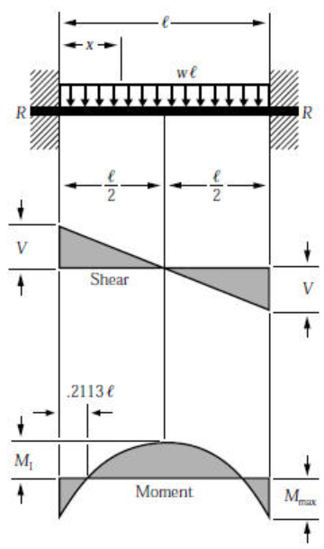

= wl/2

= -wl/2

= wl2/24

= -wl2/12

Table 3: Analytical Response of RC column to static load

|  |  |  |  |  |  |
| --- | --- | --- | --- | --- | --- |
| Location | Section | Forces | Peak | Bending | stress(kPa) |
|  | Shear Force (kN) | Bending moment (kN-m) | Comp. fiber | Neutral axis | Tension fiber |
| Bottom | -25 | -20.83 | 24413.97 | 0 | 24413.97 |
| Mid-height | 0 | +10.417 | 12209.33 | 0 | 12209.33 |
| Top | +25 | -20.83 | 24413.97 | 0 | 24413.97 |

Peak Bending Stress(σ) = My / I (where M is the bending moment, y is the distance from the neutral axis, and I is the moment of Inertia.)

I = bd3/12 = 0.4x0.43/12 = 2.133x10-3m4

In compression fiber,

At top and bottom,

M = wl2/12 = 20.83 kNm

σ = 20.83x2.5/2.133x10-3 = 24413.97 kPa

At mid-height,

σ = 10.417x2.5/2.133x10-3 = 12209.33 kPa

1. 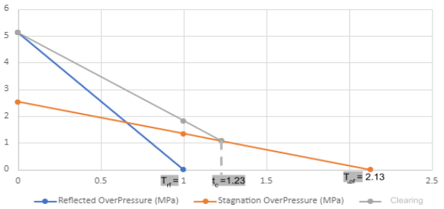

Peak Overpressure = 5MPa

Exposed Area = 0.4x5 =2m2

Peak force = 5x2 = 10MN

td/Tn = 2.22/18.3 = 0.121

ust = Fr0 / keq = 10x103/143488.72 = 69.692 mm

Considering elastic response DLF from Elastic response plot for SDOF system = 0.4

um = DLF x ust = 69.692x0.4 = 27.877 mm

Yield deformation of the column,

uE = Rp/ke = 142.636 mm > 27.877 mm

Hence, assumption of elastic response is valid.

Maximum Reaction = k x um = = 35895.55 x 27.877 x 10-3 = 1000.66 kN

The equation of motion for the equivalent SDOF system:

Elastic: 633.904 $\ddot{y}$ + 35895.55 y = 10x103(1-1/td) (t ≤td)

Dynamic Reaction = 0.36R+0.14F = 0.36(19.2) + 0.14(10) = 8.312MN

Therefore, the peak deflection is 27.877 mm and the Dynamic Reaction is 8.312MN.