**Exercise 1: Setting Up JUnit (in IntelliJ IDEA)**

1: Created a New Java Project in IntelliJ

* Launched IntelliJ IDE and selected “New Project” from the welcome screen.
* In the project wizard:
  + Chose “Maven” as the project type.
  + Left “Create from archetype”.
  + Entered:
    - GroupId: com.example
    - ArtifactId: junit-testing-demo
* IntelliJ generated the project structure, including pom.xml and standard Maven directories.

2: Added the JUnit Dependency to pom.xml

* opened the pom.xml file from the project root and copied the following dependencies in it.

*<dependency>*

*<groupId>org.junit.jupiter</groupId>*

*<artifactId>junit-jupiter</artifactId>*

*<version>5.9.3</version>*

*<scope>test</scope>*

*</dependency>*

3: Created a New Test Class

* created a new class in src/test/java/com.example named CalculatorTest.
* Inside this test class, wrote test methods annotated with @Test from org.junit.jupiter.api.
* right-clicked on the test class and used IntelliJ’s “Run” option to execute the test.

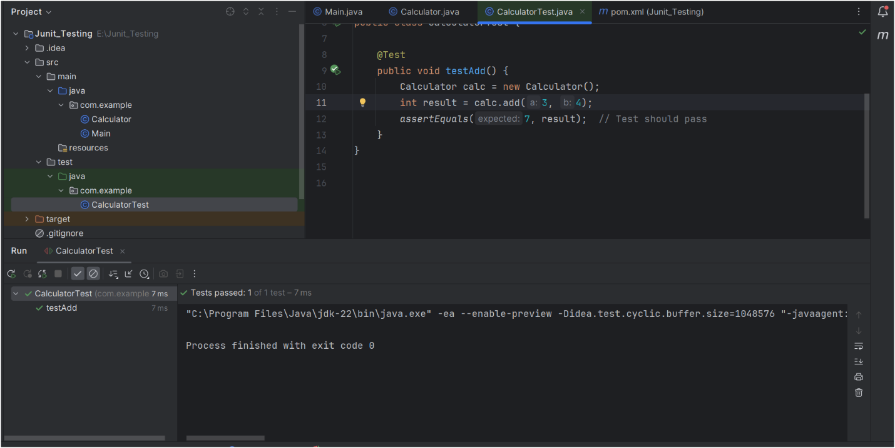

**Exercise 3: Assertion in JUnit**

Scenario: We needed to write a JUnit test that demonstrates the use of various assertion

assertEquals, assertTrue, assertFalse, assertNull, assertNotNull

* + - 1. Created a test class, called AssertionsTest.java, inside the test folder.
      2. Imported JUnit 5 Annotations and assertions.

*import org.junit.jupiter.api.Test;*

*import static org.junit.jupiter.api.Assertions.*;*

* + - 1. Created a method called testAssertions() and annotated it with @Test.

CODE:

*@Test*

*public void testAssertions() {*

*assertEquals(5, 2 + 3);*

*assertTrue(5 > 3);*

*assertFalse(5 < 3);*

*assertNull(null);*

*assertNotNull(new Object());*

*}*

**OUTPUT:**

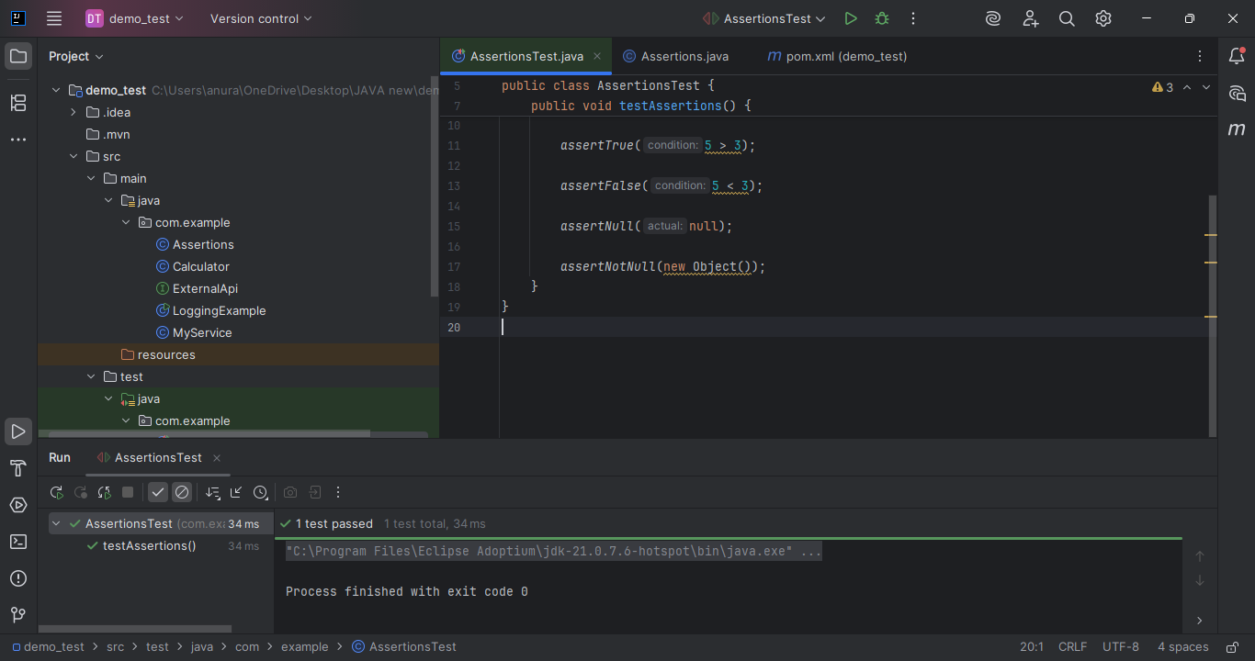

**Exercise 4:**

Scenario: We need to write test cases in the AAA structure (Arrange, Act, Assert)  
and manage setup/teardown logic using annotations.

* + - 1. Created a new test class, called CalculatorFixtureTest.java, into the test folder.

Implemented the AAA and TearDown pattern as under:  
  
CODE:  
*package com.example;*

*import org.junit.jupiter.api.BeforeEach;*

*import org.junit.jupiter.api.AfterEach;*

*import org.junit.jupiter.api.Test;*

*import static org.junit.jupiter.api.Assertions.*;*

*public class CalculatorFixtureTest {*

*private Calculator calc;*

*@BeforeEach*

*public void setUp() {*

*calc = new Calculator();*

*}*

*@AfterEach*

*public void tearDown() {*

*calc = null;*

*}*

*@Test*

*public void testAddition() {*

*int result = calc.add(10, 5);*

*assertEquals(15, result);*

*}*

*@Test*

*public void testSubtraction() {*

*int result = calc.subtract(10, 4);*

*assertEquals(6, result);*

*}*

*}*

**OUTPUT:**

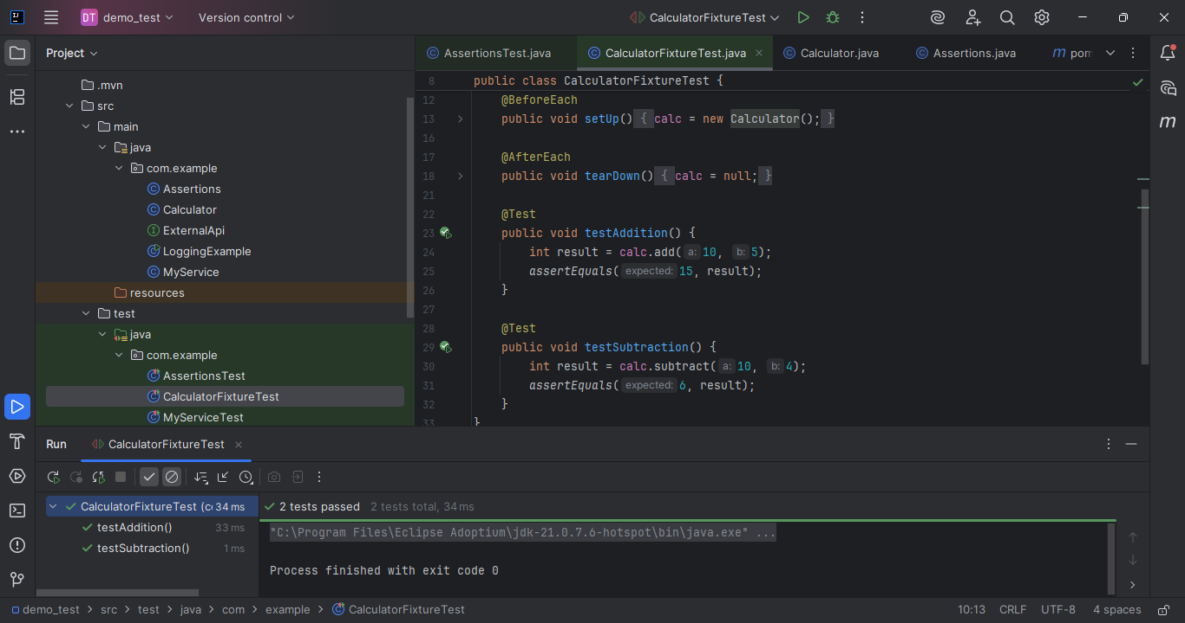

**Dependencies [added to pom.xml]:**

*<!-- JUnit 5 -->*

*<dependency>*

*<groupId>org.junit.jupiter</groupId>*

*<artifactId>junit-jupiter</artifactId>*

*<version>5.9.3</version>*

*<scope>test</scope>*

*</dependency>*