## Spring REST Assignment

As per document : **1. spring-rest-handson**

### Student Name: Divyansh Tiwari

### SuperSet ID: 6394658

### Week 4 – Spring REST

## Hands-on 1: Create Spring Web Project Using Maven

### Objective: Create a Spring Boot project using Spring Initializr, Import into IntelliJ IDEA and Verify project structure and run the application

### Steps Followed:

1. Visited https://start.spring.io
2. Set Group: com.cognizant, Artifact: spring-learn
3. Selected dependencies: Spring Boot DevTools, Spring Web
4. Extracted downloaded ZIP and opened it in IntelliJ
5. Ran the following Maven command:

* mvn clean package

1. Verified successful build and ran SpringLearnApplication.java

### Screenshot Placeholders:

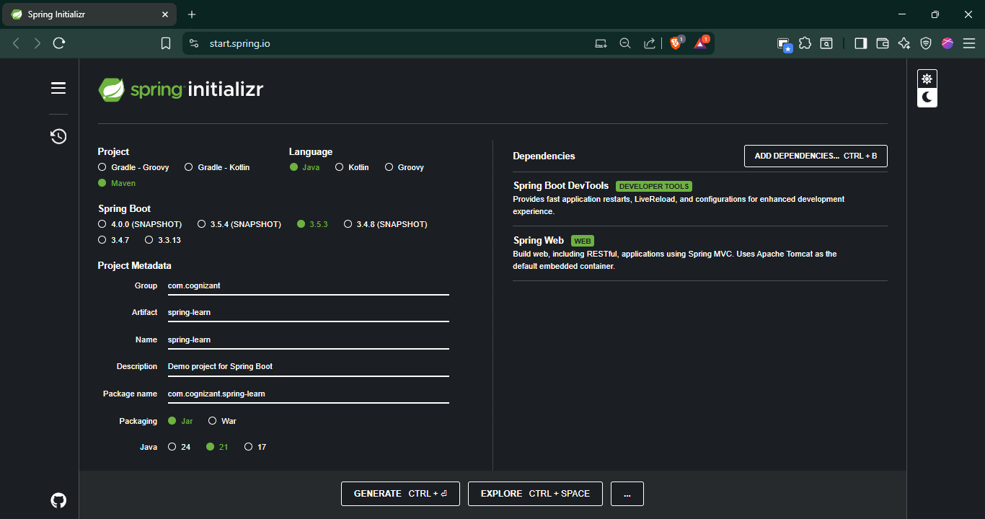

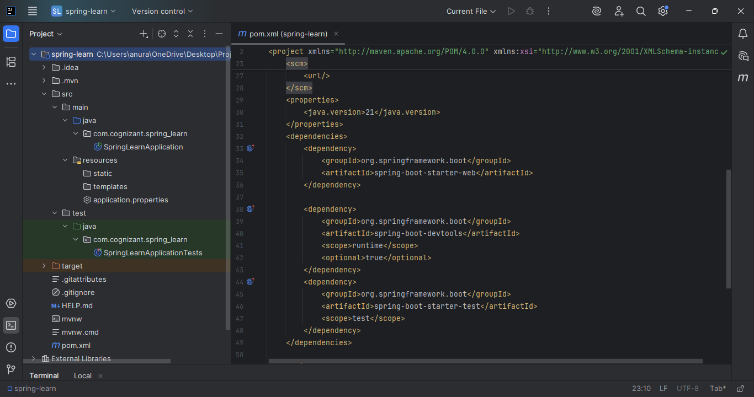

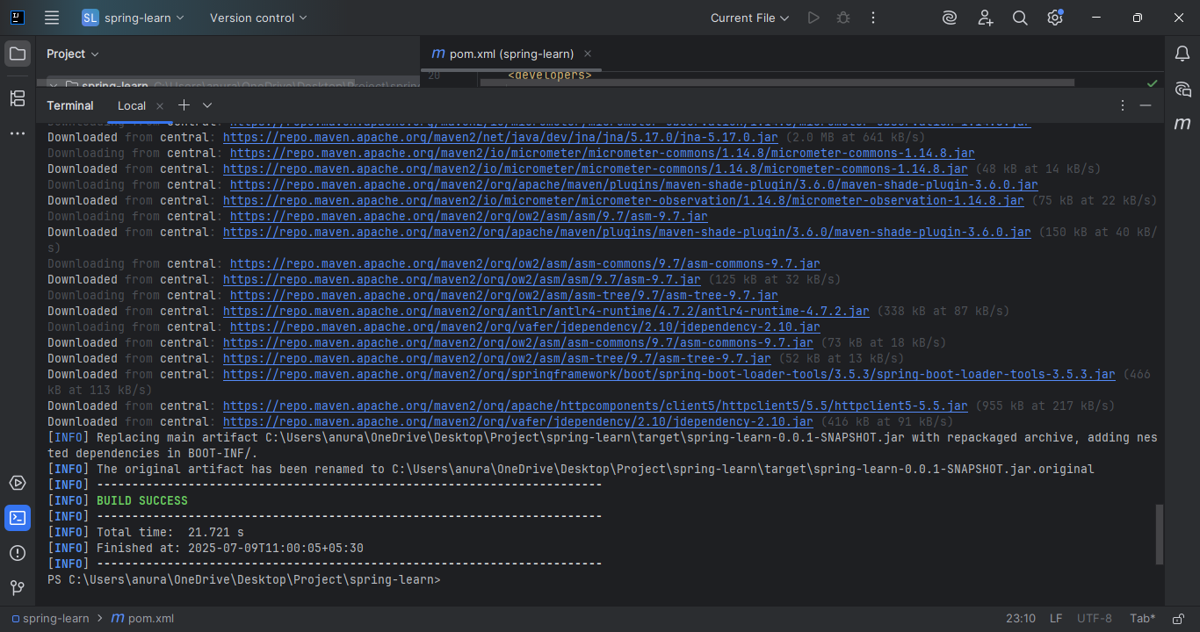

## Hands-on 2: Load SimpleDateFormat from Spring Configuration XML

### Objective: Define SimpleDateFormat bean in XML and use it

### Steps Followed:

1. Created date-format.xml under src/main/resources
2. Defined a SimpleDateFormat bean with pattern dd/MM/yyyy
3. Added displayDate() method in SpringLearnApplication.java
4. Used Spring’s ApplicationContext to load and use the bean

### Screenshot Placeholders:

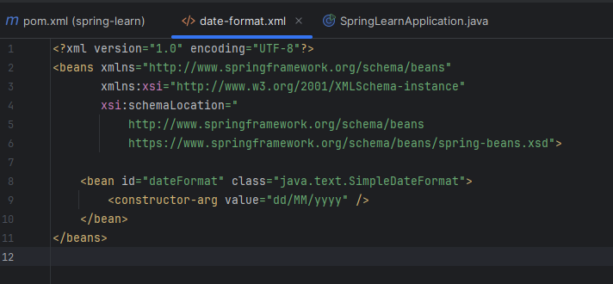

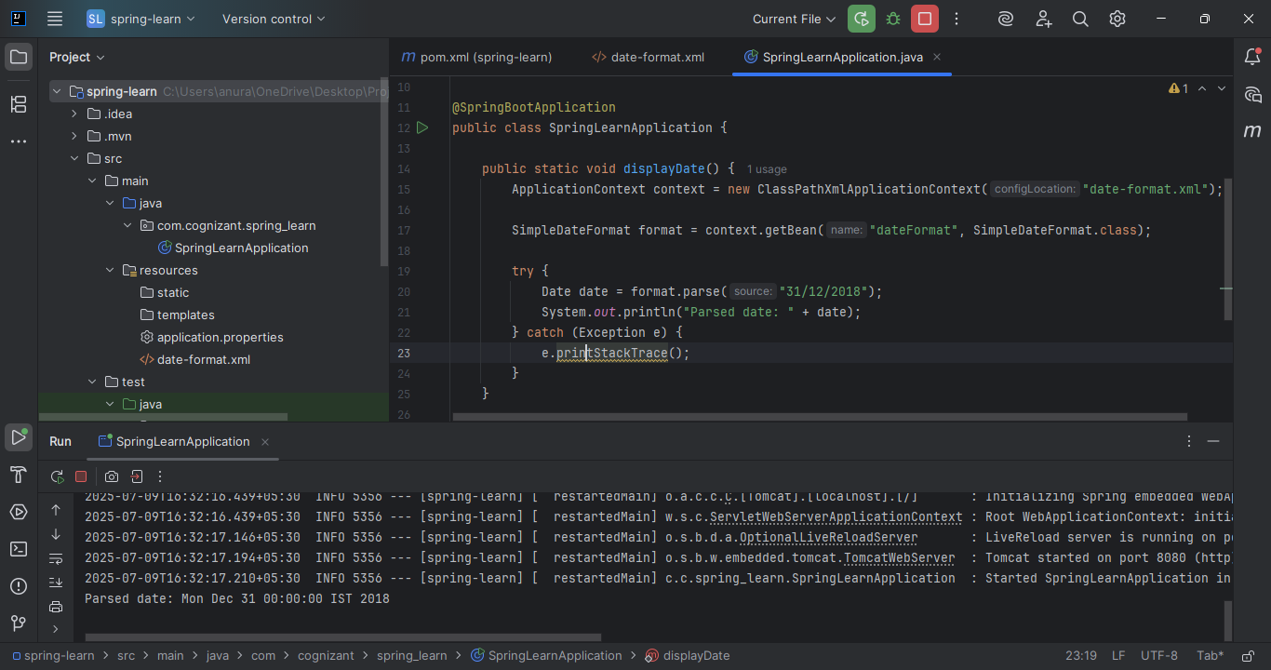

## Hands-on 3: Incorporate Logging in Spring Boot

### Objective: Replace System.out.println() with proper logging

### Steps Followed:

1. Created application.properties and configured logging levels
2. Added SLF4J logger in SpringLearnApplication.java
3. Replaced System.out.println() with LOGGER.debug/info()

### Screenshot Placeholders:

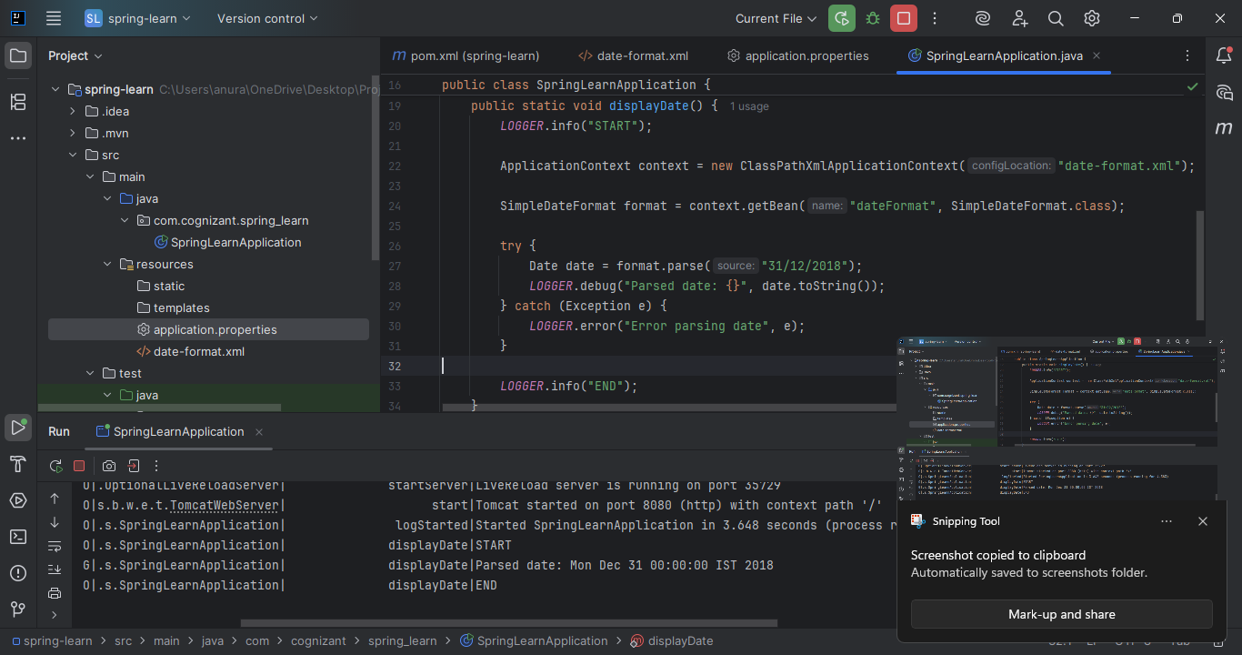

## Hands-on 4: Load Country Bean from Spring XML

### Objective: Define a Country class and load its instance from Spring XML

### Steps Followed:

1. Created Country.java class with logger, constructor, getters, setters
2. Created country.xml with one country bean (India)
3. Implemented displayCountry() to load and display the bean

### Screenshot Placeholders:

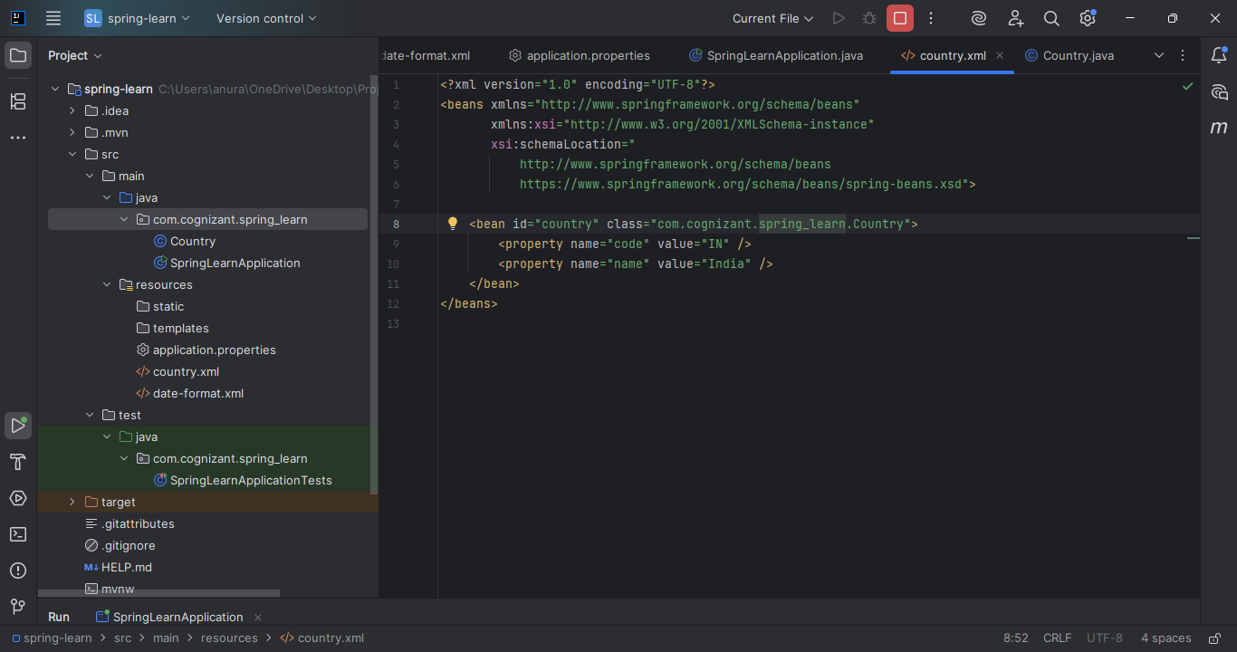

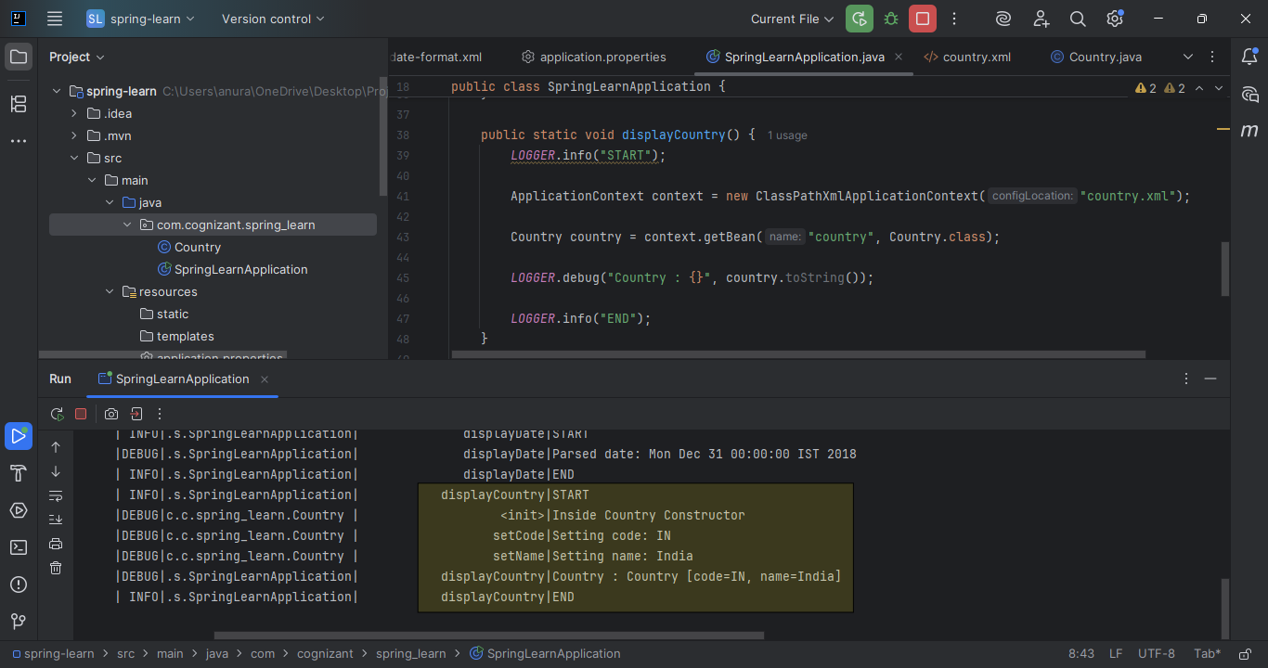

## Hands-on 5: Demonstrate Singleton and Prototype Scope

### Objective: Show difference between singleton and prototype bean scopes

### Steps Followed:

1. Loaded the same bean twice and compared object references
2. Verified singleton scope (same object)
3. Updated bean to scope="prototype" and repeated
4. Verified prototype scope (new object each time)

### Screenshot Placeholders:

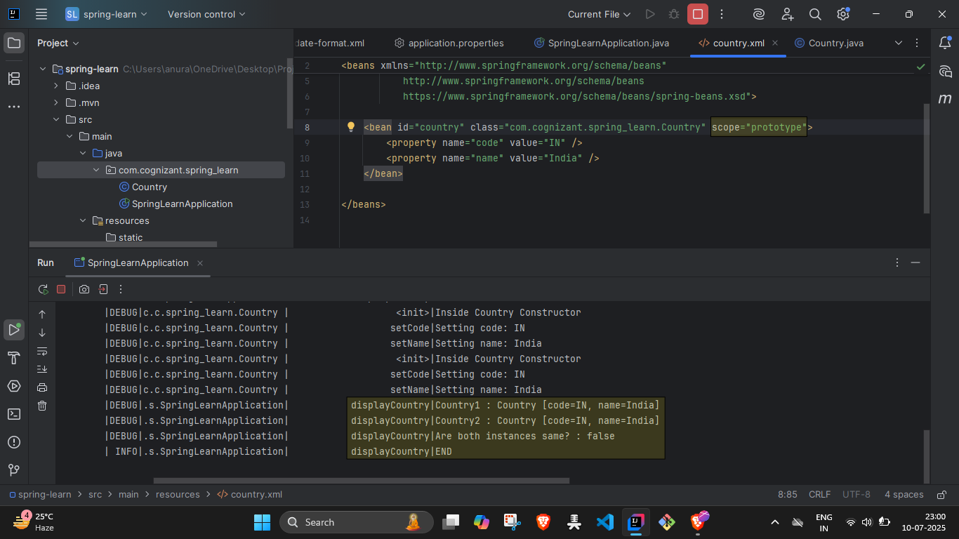

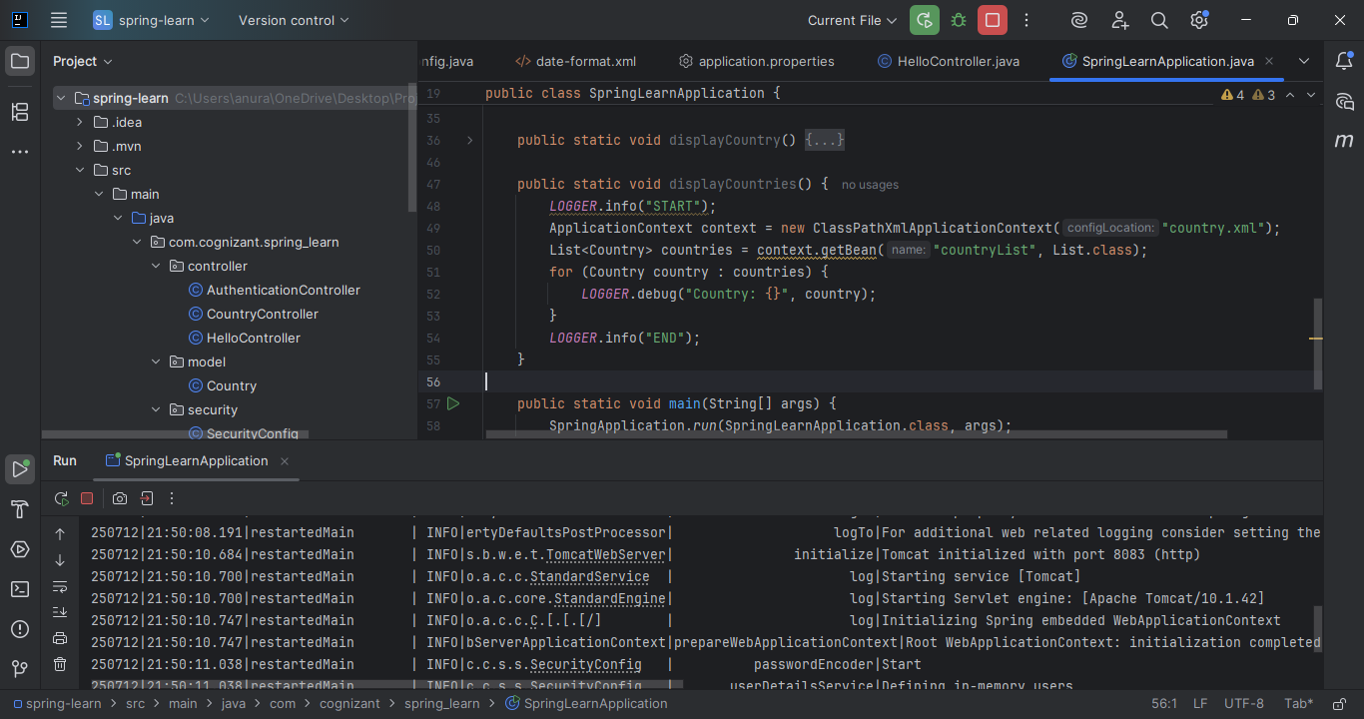

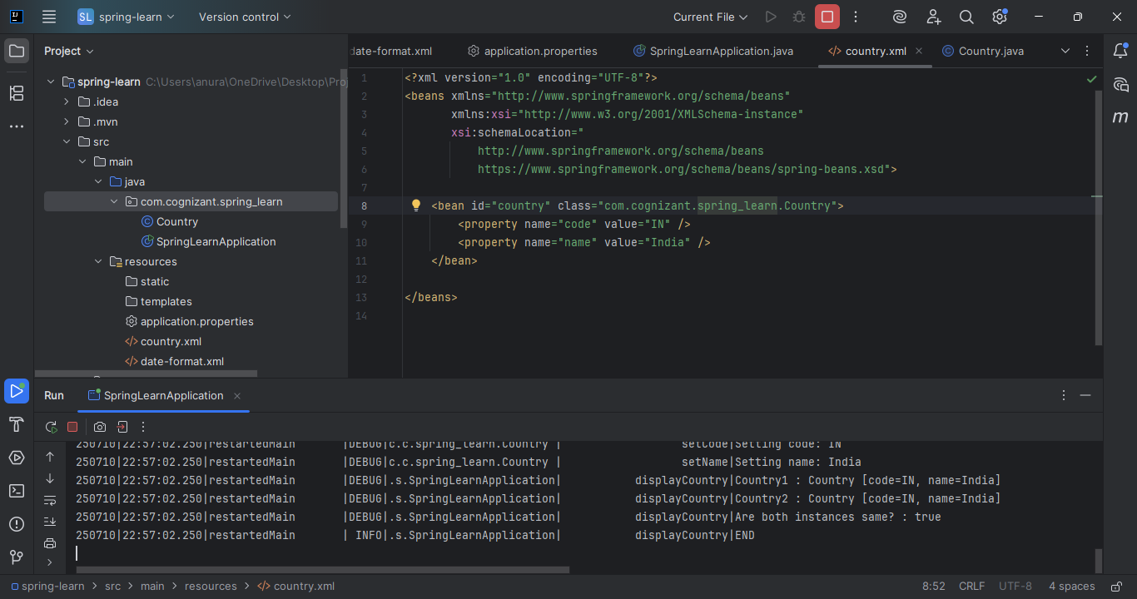

## Hands-on 6: Load List of Countries from XML

### Objective:

* Configure multiple country beans and inject them as a list

### Steps Followed:

1. Updated country.xml with beans: IN, US, DE, JP
2. Created countryList bean of type ArrayList with references
3. Implemented displayCountries() to retrieve and log each country

### Screenshot Placeholders:

