**React HOL 1 Submission**

**Student Details**

**Name**: *Divyansh Tiwari*

**SuperSet ID:** 6394658

**Assignment Title**: *ReactJS HOL 1 - Setting Up First React App*

**1. Objectives of the Lab**

In this hands-on lab, I learned to:

* Define Single Page Applications (SPA) and understand their benefits.
* Identify the differences between SPA and MPA.
* Understand what React is and how it works.
* Learn the concept of Virtual DOM.
* Set up the React development environment using create-react-app.
* Create and run a basic React app.

**2. Steps Performed**

**Step 1: Installed Node.js and NPM**

* **Source**: https://nodejs.org/en/download/
* Verified installation using:

*node -v*

*npm -v*

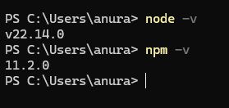

*Node.js and NPM version check in terminal*

**Step 2: Install create-react-app**

Using Command:

*npm install -g create-react-app*

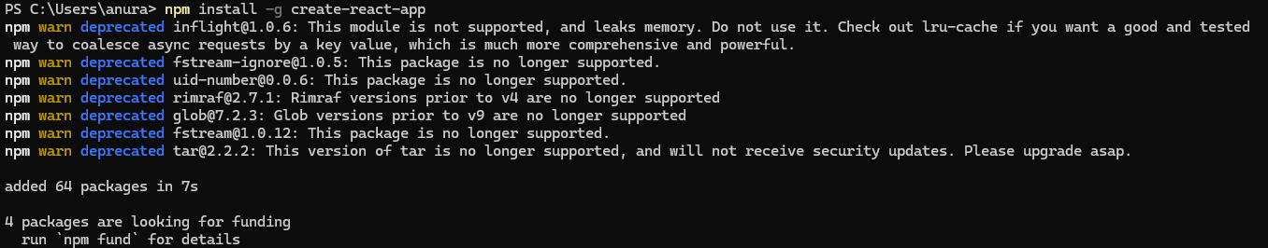

*Command prompt showing successful installation of create-react-app*

**Step 3: Create New React App**

*npx create-react-app myfirstreact*

**Step 4: Open Project in VS Code**

* Opened myfirstreact folder in Visual Studio Code.

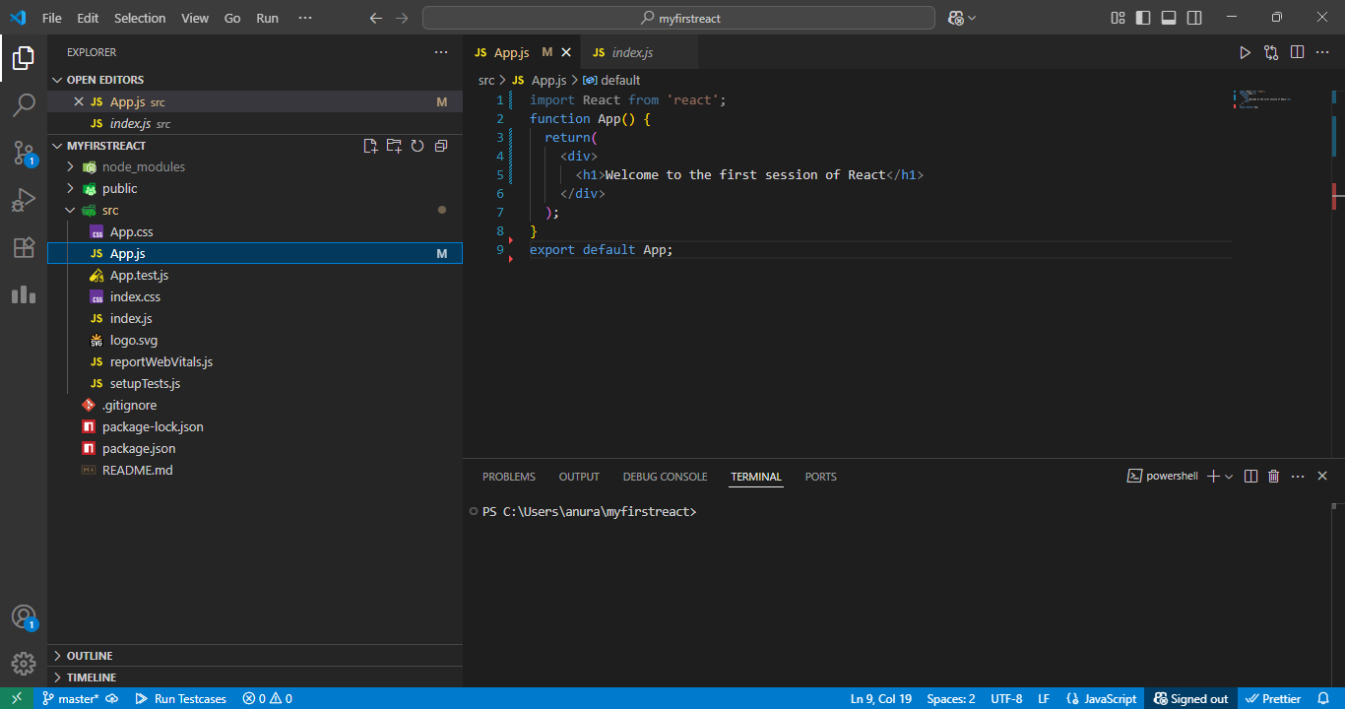

*Folder structure after app creation*

**Step 5: Modify App.js File**

* Replaced content of src/App.js with the following:

*function App() {*

*return (*

*<div>*

*<h1>Welcome to the first session of React</h1>*

*</div>*

*);*

*}*

*export default App;*

**

*Updated App.js content in VS Code*

**Step 6: Run the Application**

*npm start*

* Opened browser and visited http://localhost:3000

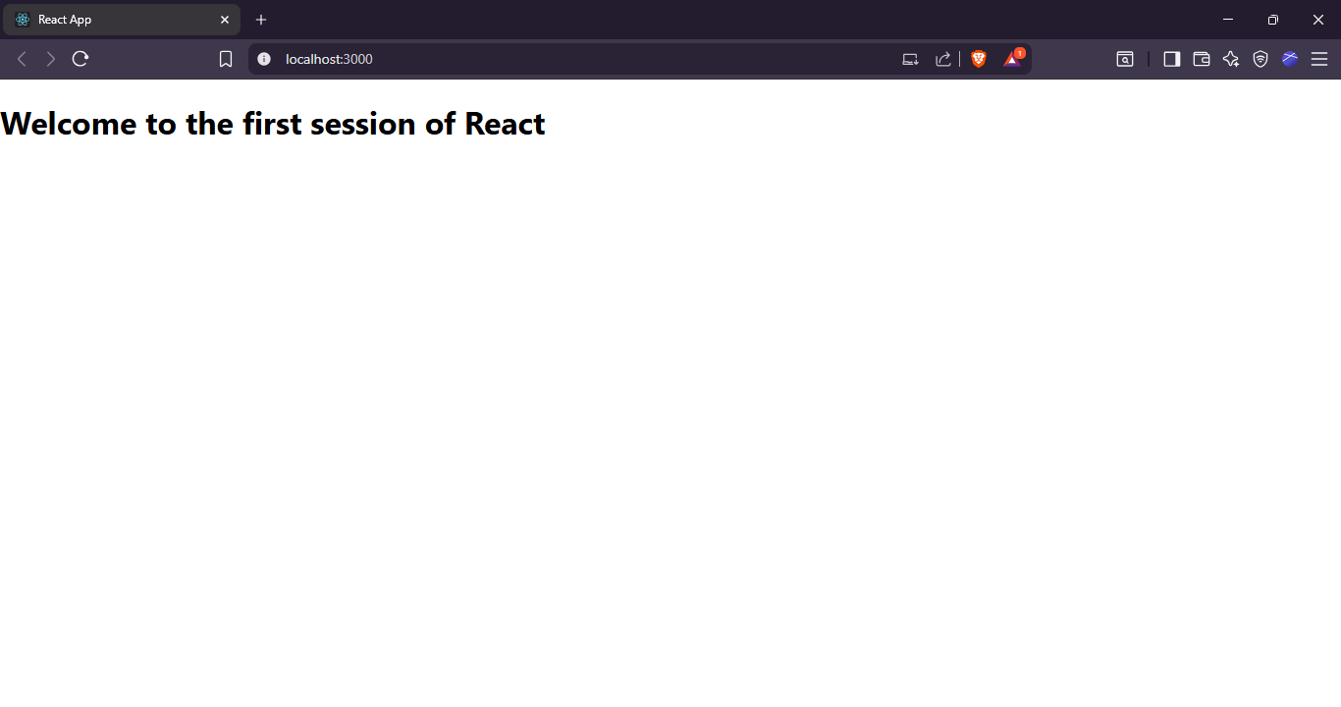

* *Browser output showing “Welcome to the first session of React”*