**React HOL 2 Submission**

**Student Details**

**Name**: *Divyansh Tiwari*

**SuperSet ID:** 6394658

**Assignment Title**: *ReactJS HOL 2 - Components in React*

**1. Objectives of the Lab**

In this hands-on lab, I learned to:

* Understand what components are in React.
* Identify the types of components (Function vs Class).
* Create multiple React components and render them.
* Define and use the constructor and render() method in class components.

**2. Steps Performed**

**Step 1: Created a New React Project**

*npx create-react-app StudentApp*

**Step 2: Opened Project in VS Code**

*cd StudentApp*

*code .*

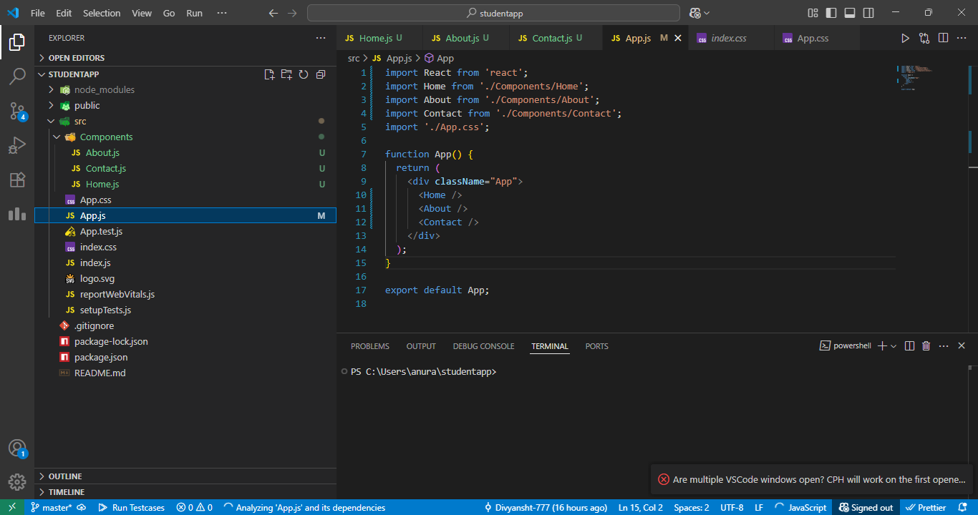

*VS Code showing folder structure of StudentApp*

**Step 3: Created “Components” Folder**

* Created a new folder named Components under src/

**Step 4: Created Home.js Component**

Path: src/Components/Home.js

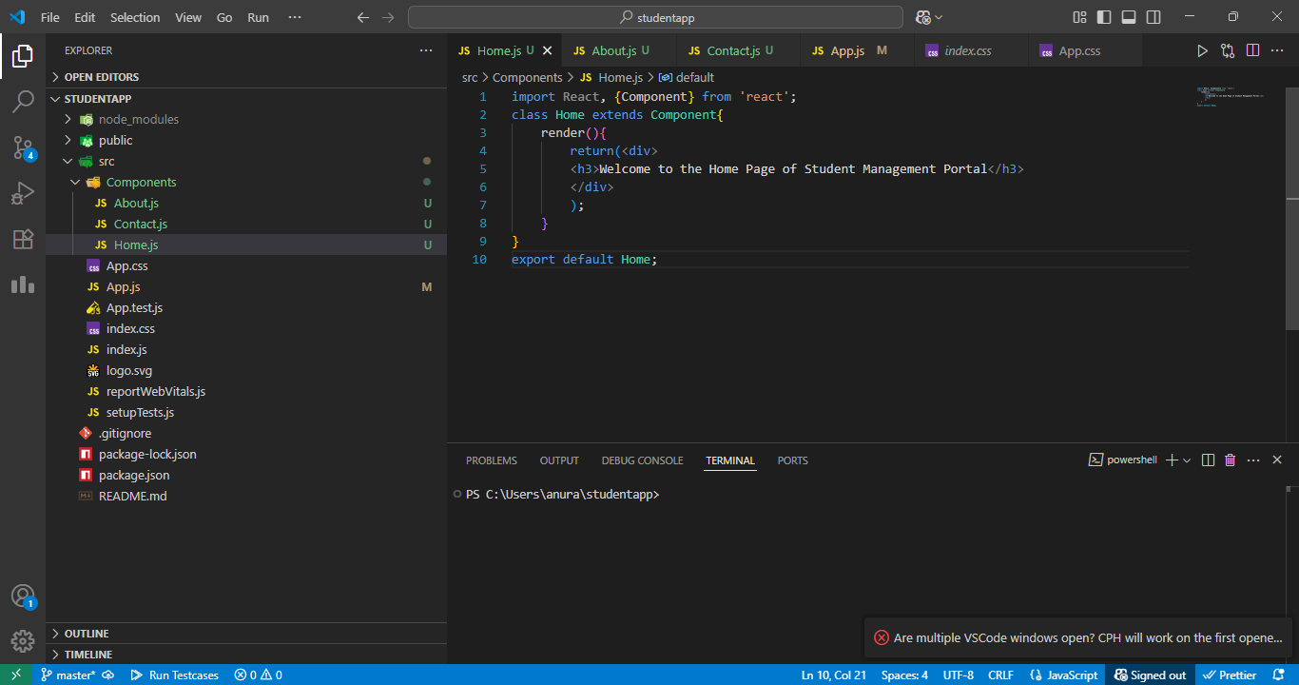

* *Code of Home.js displayed in VS Code*

**Step 5: Created About.js Component**

Path: src/Components/About.js

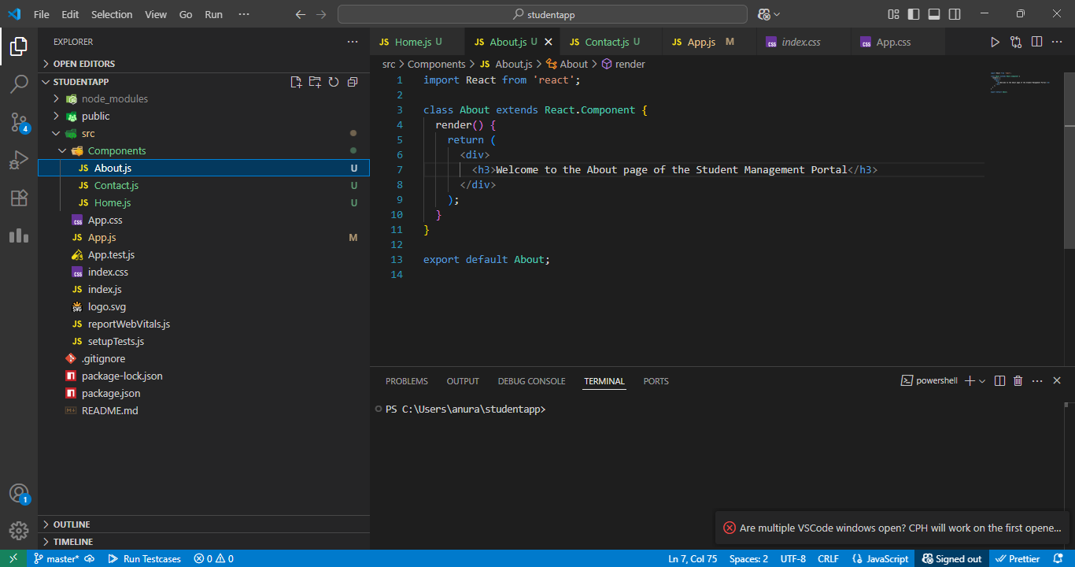

*Code of About.js displayed in VS Code*

**Step 6: Created Contact.js Component**

Path: src/Components/Contact.js

*Code of Contact.js displayed in VS Code*

**Step 7: Modified App.js to Render All Components**

Path: src/App.js

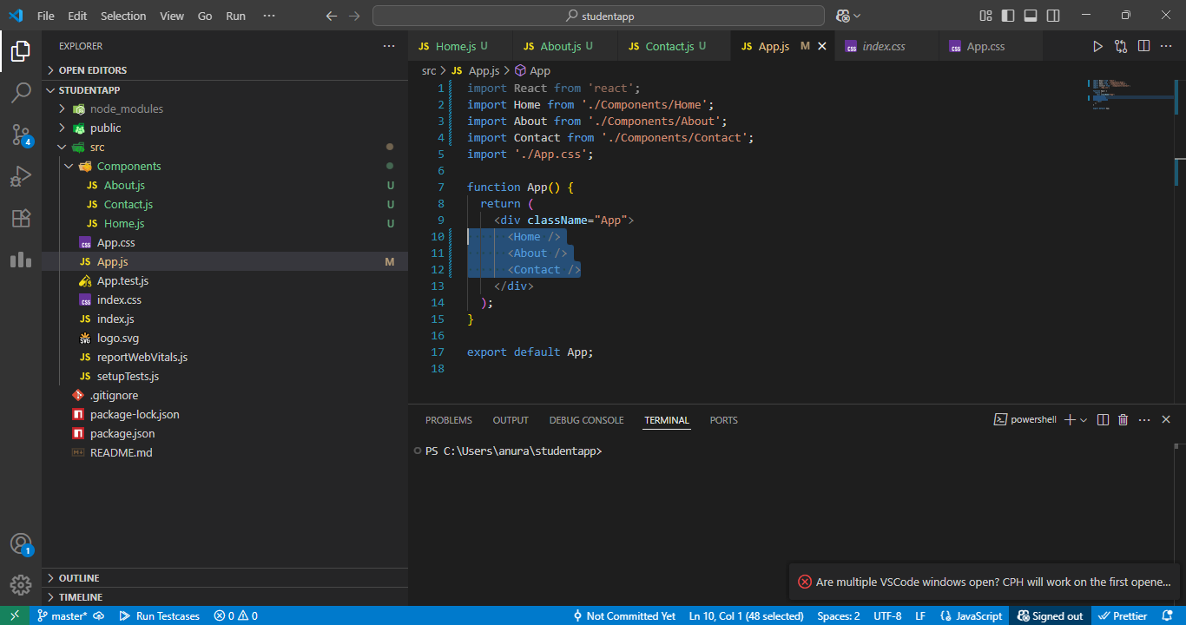

*Final App.js content showing all three components rendered*

**Step 8: Run the Application**

*npm start*

* Visited http://localhost:3000 to verify the output.

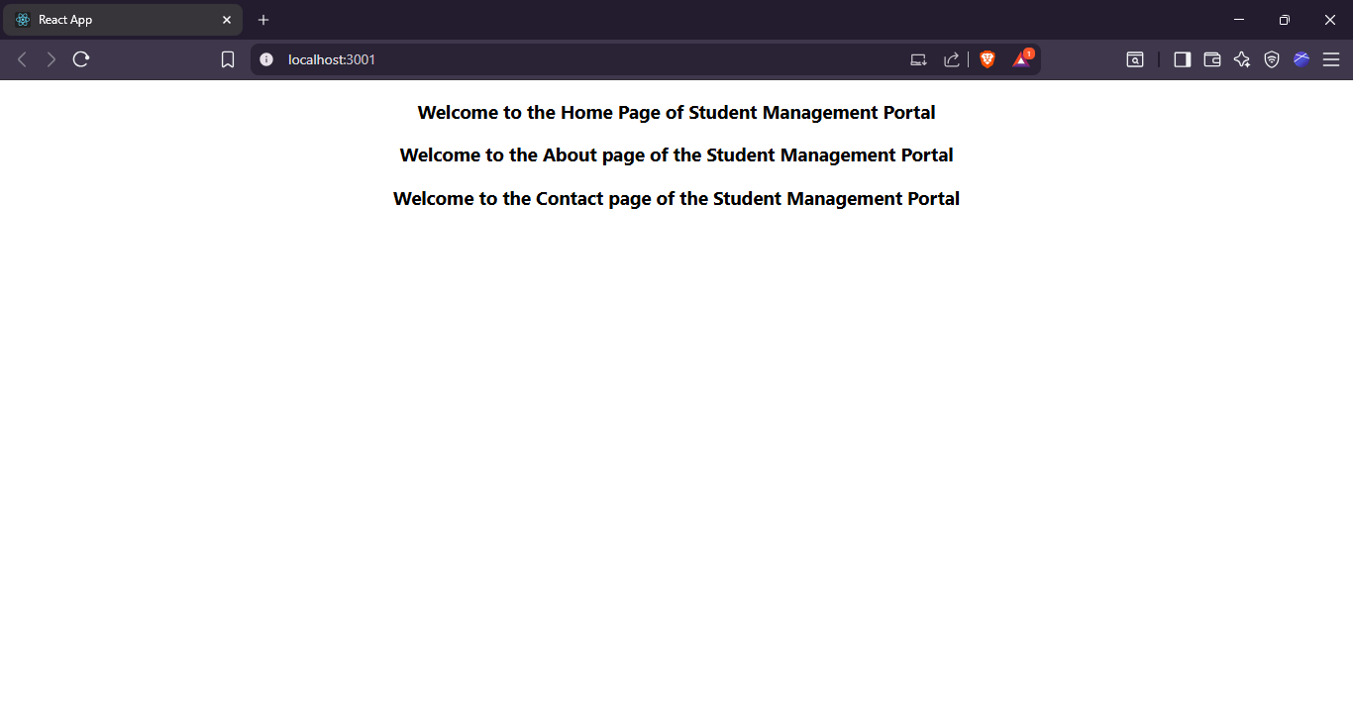

* *Browser output showing all three messages from Home, About, and Contact components*