**React HOL 3 Submission**

**Student Details**

**Name**: *Divyansh Tiwari*

**SuperSet ID:** 6394658

**Assignment Title**: *ReactJS HOL 3 - Functional Component and Styling*

**1. Objectives of the Lab**

In this hands-on lab, I learned to:

* Create and use a **functional component** in React.
* Pass **props** into the component.
* Apply **custom CSS styles** to components.
* Render the component within the React application.

**2. Steps Performed**

**Step 1: Create a New React Project**

*npx create-react-app scorecalculatorapp*

**Step 2: Open Project in VS Code**

*cd scorecalculatorapp*

*code .*

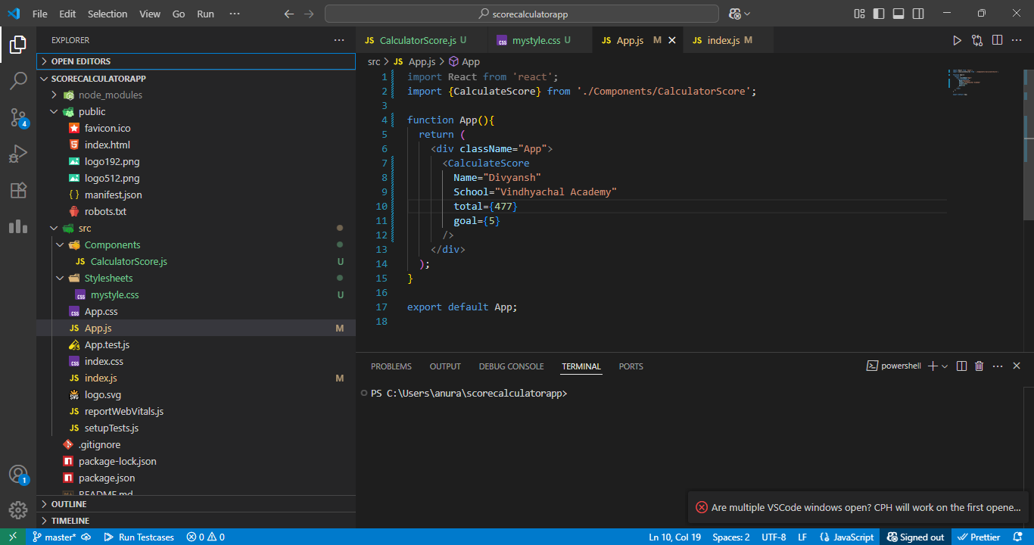

*VS Code showing the project folder open*

**Step 3: Create “Components” Folder and CalculateScore.js**

* Path: src/Components/CalculateScore.js

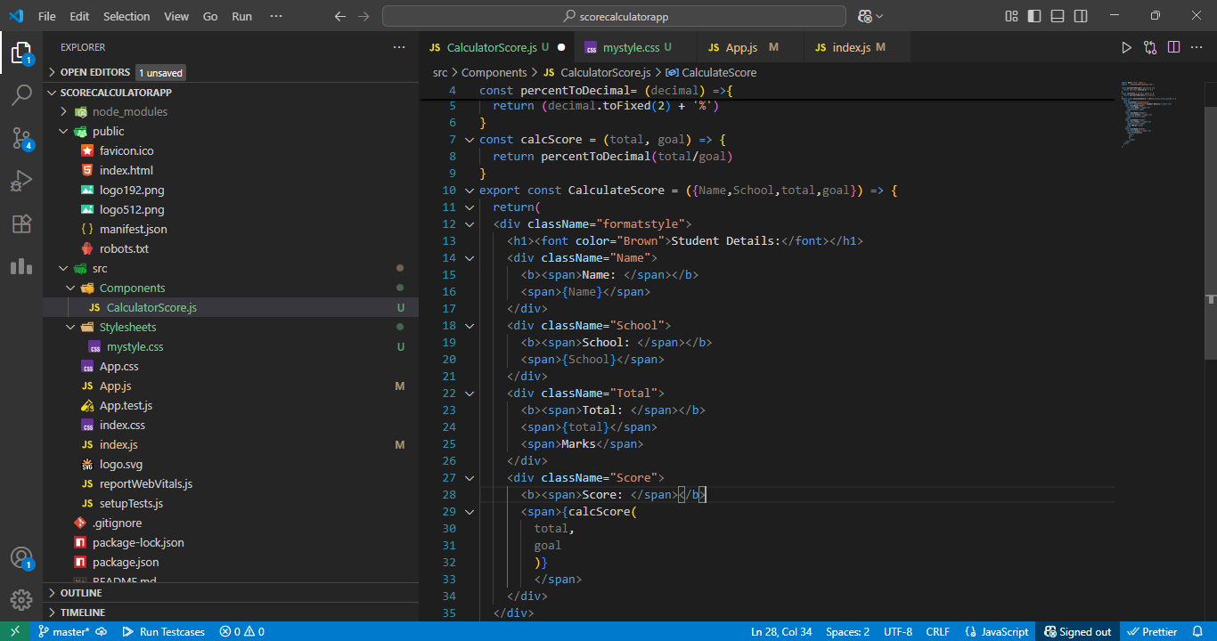

*CalculateScore.js code in VS Code*

**Step 4: Create “Stylesheets” Folder and mystyle.css**

* Path: src/Stylesheets/mystyle.css

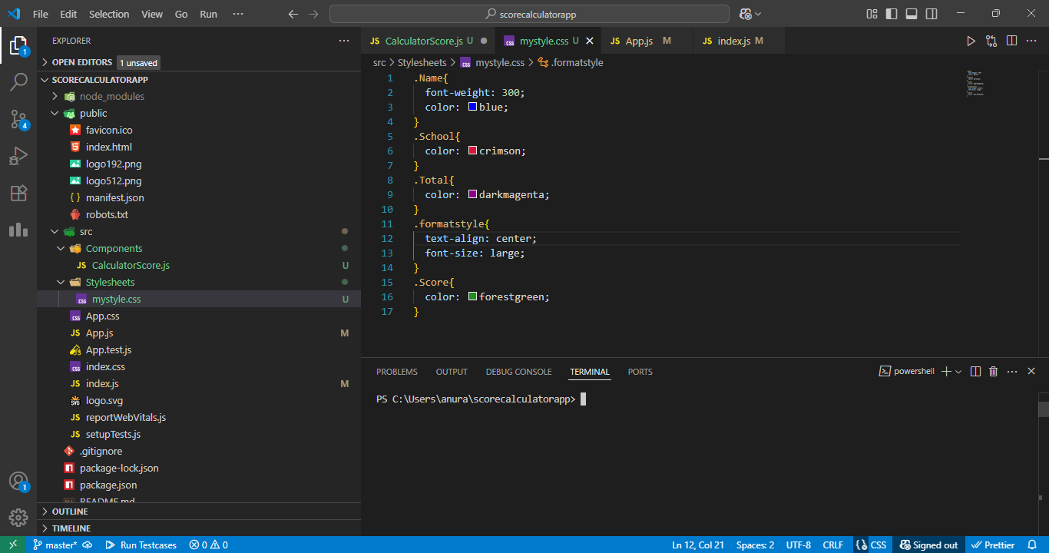

* *mystyle.css code in VS Code*

**Step 5: Modify App.js to Render CalculateScore Component**

* Path: src/App.js

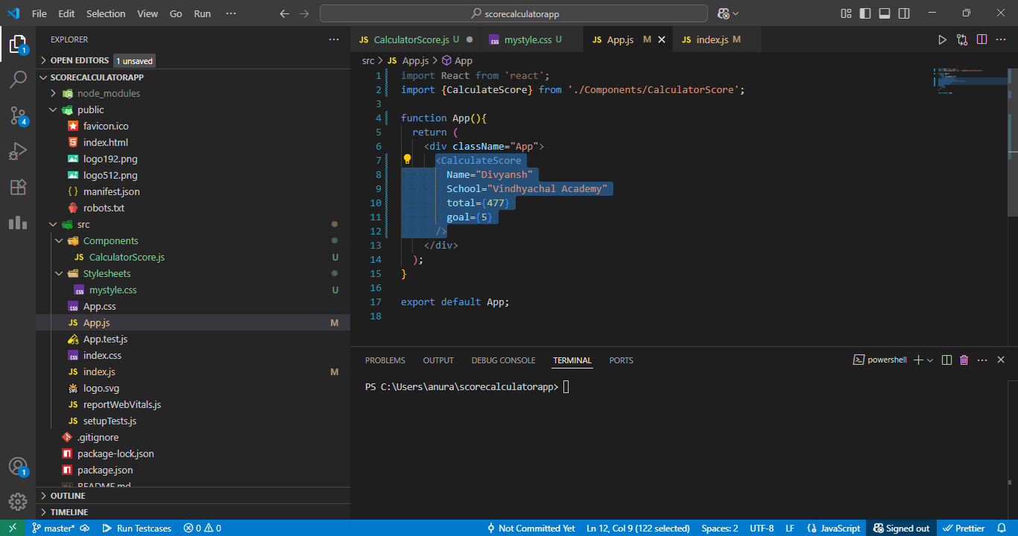

*App.js code showing CalculateScore usage*

**Step 6: Run the Application**

*npm start*

* Open browser at http://localhost:3000

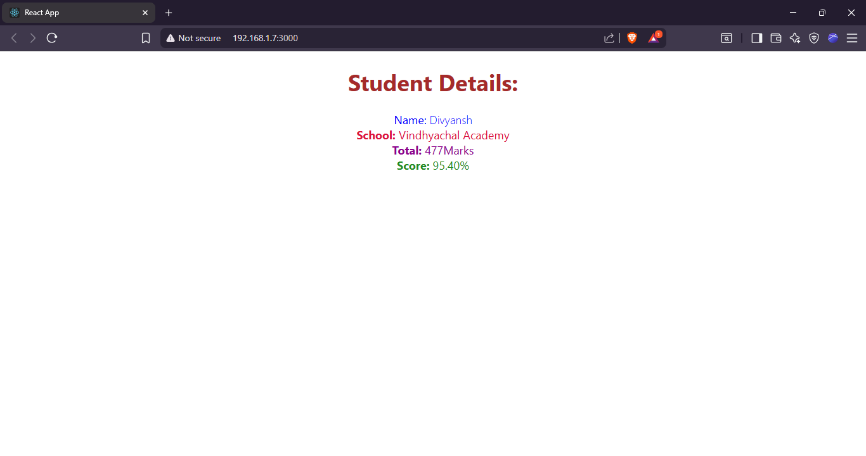

* *Browser showing the styled output with score and average*