**React HOL 5 Submission**

**Student Details**

**Name**: *Divyansh Tiwari*

**SuperSet ID:** 6394658

**Assignment Title**: *ReactJS HOL 5 - Styling Components with CSS Modules and Inline Styles*

**1. Objectives of the Lab**

In this hands-on lab, I learned:

* The need for styling components in React.
* How to use **CSS Modules** for scoped and reusable styles.
* How to apply both **className-based** and **inline** styling in functional components.
* How to conditionally style elements based on component data (like cohort status).

**2. Steps Performed**

**Step 1: Downloaded and Setup the Application**

* Unzipped the provided React application.
* Opened terminal and navigated into the project folder.

*npm install*

**Step 2: Open Project in Visual Studio Code**

*code .*

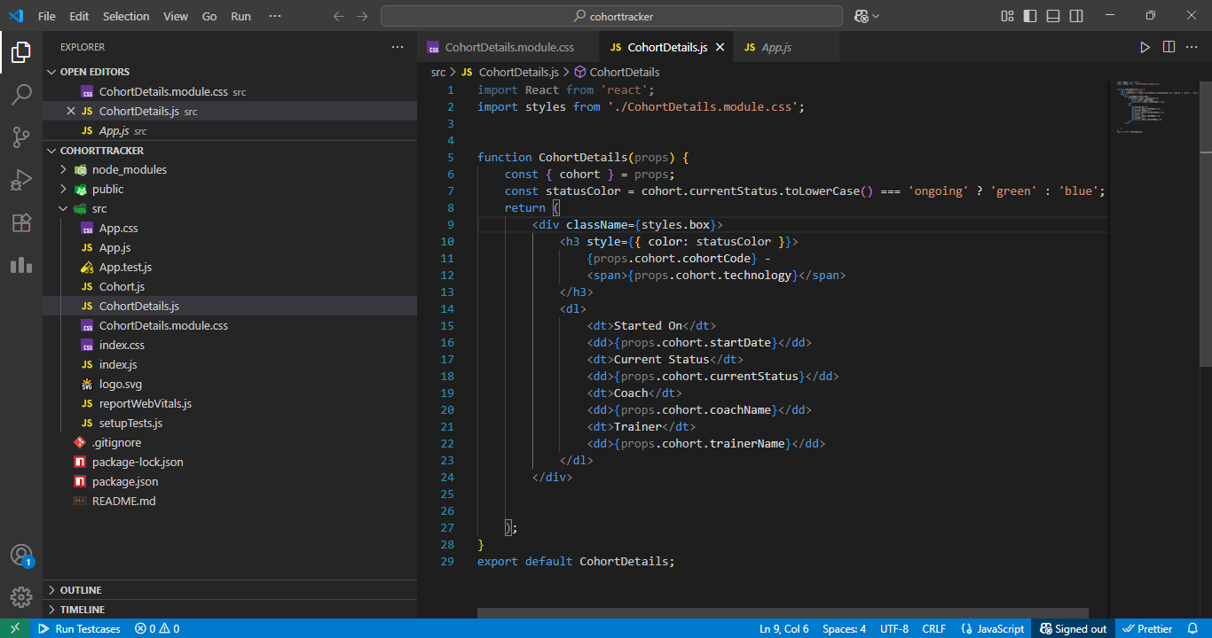

* *VS Code showing folder structure and CohortDetails.js file*

**Step 3: Create CSS Module CohortDetails.module.css**

Path: src/CohortDetails.module.css

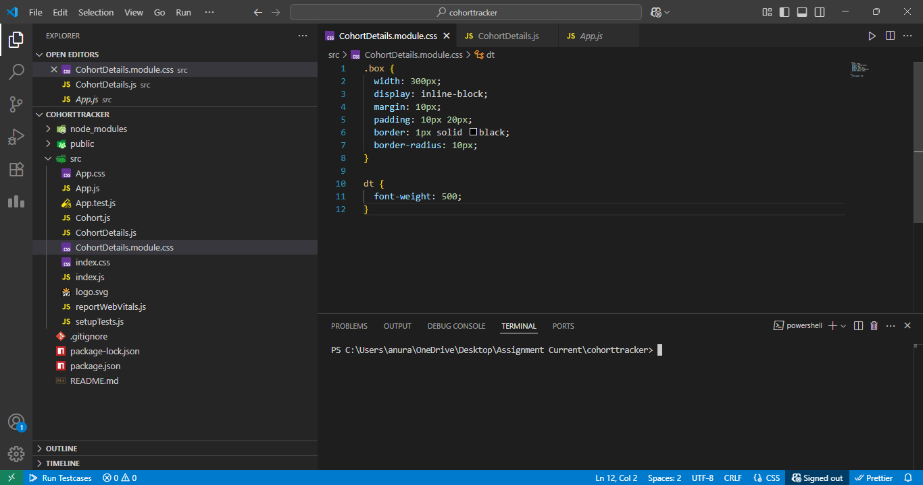

* *Code for CohortDetails.module.css in VS Code*

**Step 4: Apply Styles in CohortDetails.js**

Path: src/CohortDetails.js

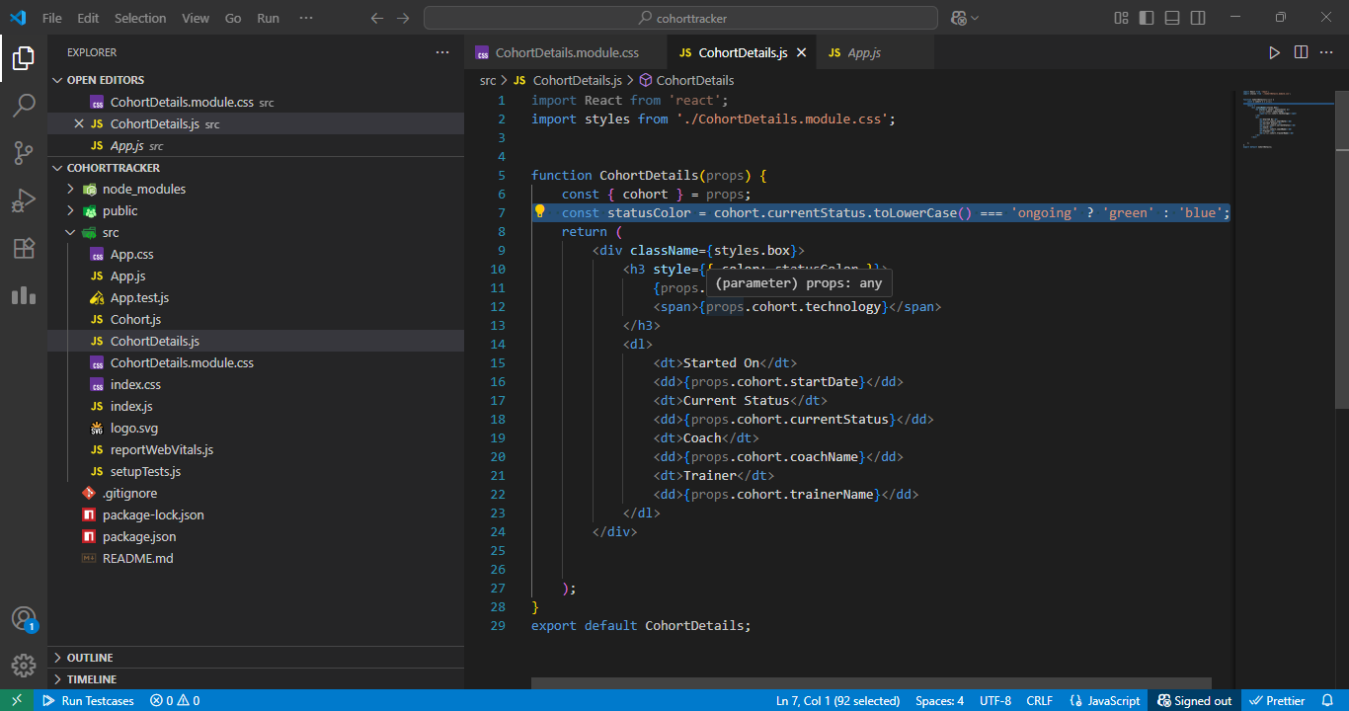

* *Final JSX implementation with CSS Module and inline styles*

**Step 5: Run the Application**

*npm start*

* Navigated to http://localhost:3000 to view the styled output.

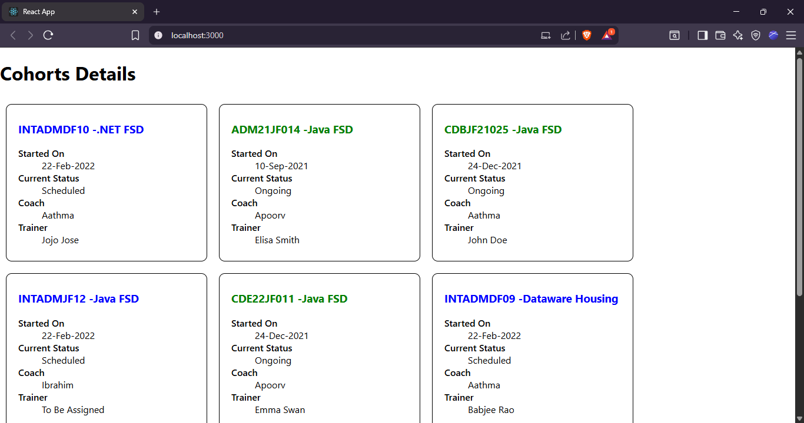

* *Browser showing styled cohort cards with green/blue heading based on status*