**ReactJS Hands-On Lab Submission**  
App Name: cricketapp  
Student Name: Divyansh Tiwari  
SuperSet ID: 6394658   
ReactJS HOL 9

**2. Objective**

* List the features of ES6
* Explain JavaScript let
* Identify the differences between var and let
* Explain JavaScript const
* Explain ES6 class fundamentals
* Explain ES6 class inheritance
* Define ES6 arrow functions
* Identify set(), map()

**3. Steps to Implement**

**1 Created React App**

*npx create-react-app cricketapp*

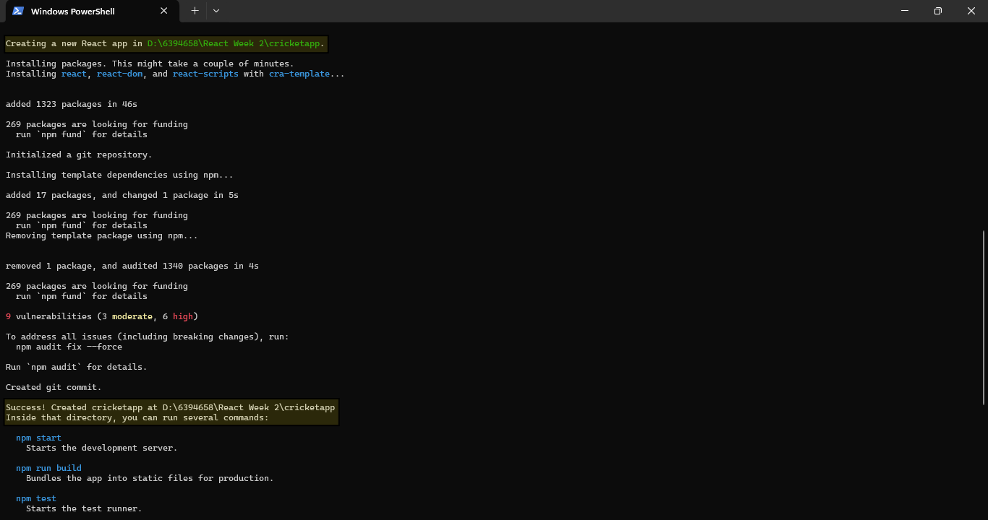

*Using CRA to create cricketapp*

Open cricketapp in VSCode

*cd cricketapp  
code .*

**2 Create Component: ListofPlayers.jsx**

• Displays 11 players using map()  
• Filters players with score < 70 using arrow functions  
  
ListofPlayers.jsx  
*const ListofPlayers = () => {*

*const players = [*

*{ name: 'Rohit', score: 80 },*

*{ name: 'Virat', score: 60 },*

*{ name: 'Gill', score: 72 },*

*{ name: 'SKY', score: 55 },*

*{ name: 'Rahul', score: 77 },*

*{ name: 'Jadeja', score: 69 },*

*{ name: 'Hardik', score: 82 },*

*{ name: 'Ashwin', score: 40 },*

*{ name: 'Bumrah', score: 30 },*

*{ name: 'Shami', score: 50 },*

*{ name: 'Kuldeep', score: 74 }*

*];*

*const below70 = players.filter(player => player.score < 70);*

*return (*

*<div>*

*<h2>All Players</h2>*

*<ul>*

*{players.map((player, idx) => (*

*<li key={idx}>{player.name} - {player.score}</li>*

*))}*

*</ul>*

*<h2>Players with Score Below 70</h2>*

*<ul>*

*{below70.map((player, idx) => (*

*<li key={idx}>{player.name} - {player.score}</li>*

*))}*

*</ul>*

*</div>*

*);*

*};*

*export default ListofPlayers;*

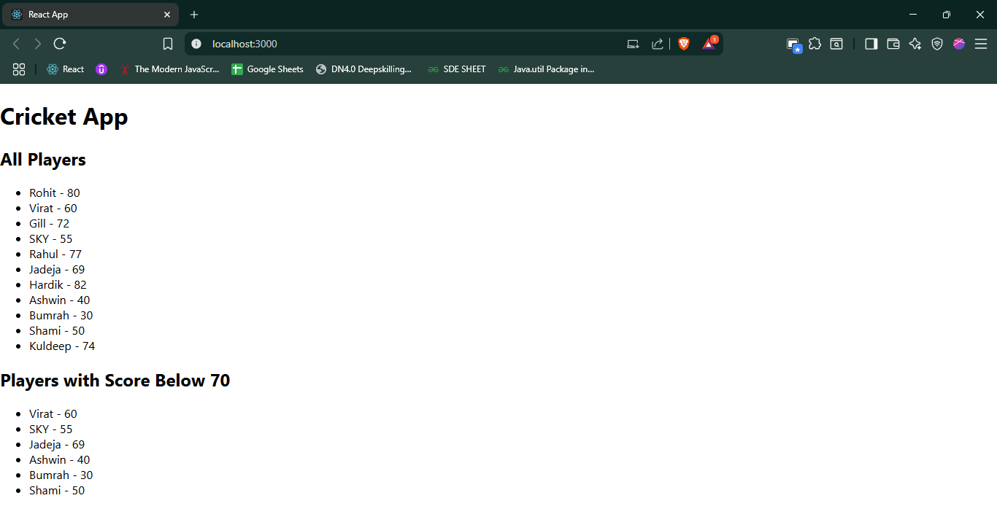  
*Screenshot showing ListofPlayers in browser*

**3 Create Component: IndianPlayers.jsx**

• Uses destructuring to separate Odd/Even team players  
• Merges T20players and RanjiTrophyplayers arrays using spread operator  
  
IndianPlayers.jsx  
*const IndianPlayers = () => {*

*const players = ['Rohit', 'Virat', 'Gill', 'SKY', 'Rahul', 'Jadeja'];*

*const [oddTeam, evenTeam] = [*

*players.filter((_, index) => index % 2 === 0),*

*players.filter((_, index) => index % 2 !== 0)*

*];*

*const T20players = ['Rohit', 'Gill', 'SKY'];*

*const RanjiTrophyplayers = ['Rahane', 'Pujara', 'Jadeja'];*

*const allPlayers = [...T20players, ...RanjiTrophyplayers];*

*return (*

*<div>*

*<h2>Odd Team Players</h2>*

*<ul>*

*{oddTeam.map((p, i) => <li key={i}>{p}</li>)}*

*</ul>*

*<h2>Even Team Players</h2>*

*<ul>*

*{evenTeam.map((p, i) => <li key={i}>{p}</li>)}*

*</ul>*

*<h2>All Merged Players</h2>*

*<ul>*

*{allPlayers.map((p, i) => <li key={i}>{p}</li>)}*

*</ul>*

*</div>*

*);*

*};*

*export default IndianPlayers;*

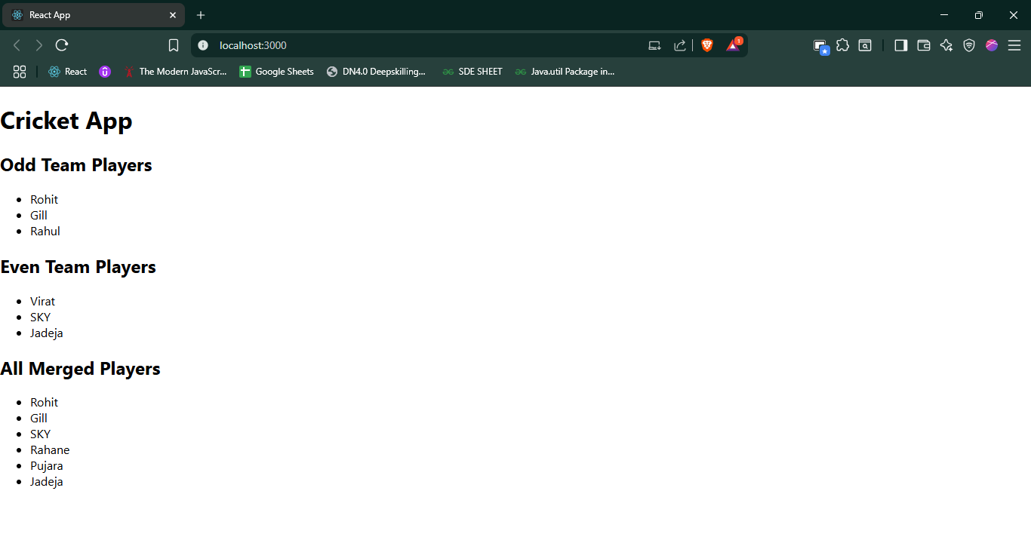  
*Screenshot showing IndianPlayers in browser*

**4 Conditional Rendering**

• A flag (flag = true/false) determines which component is shown  
  
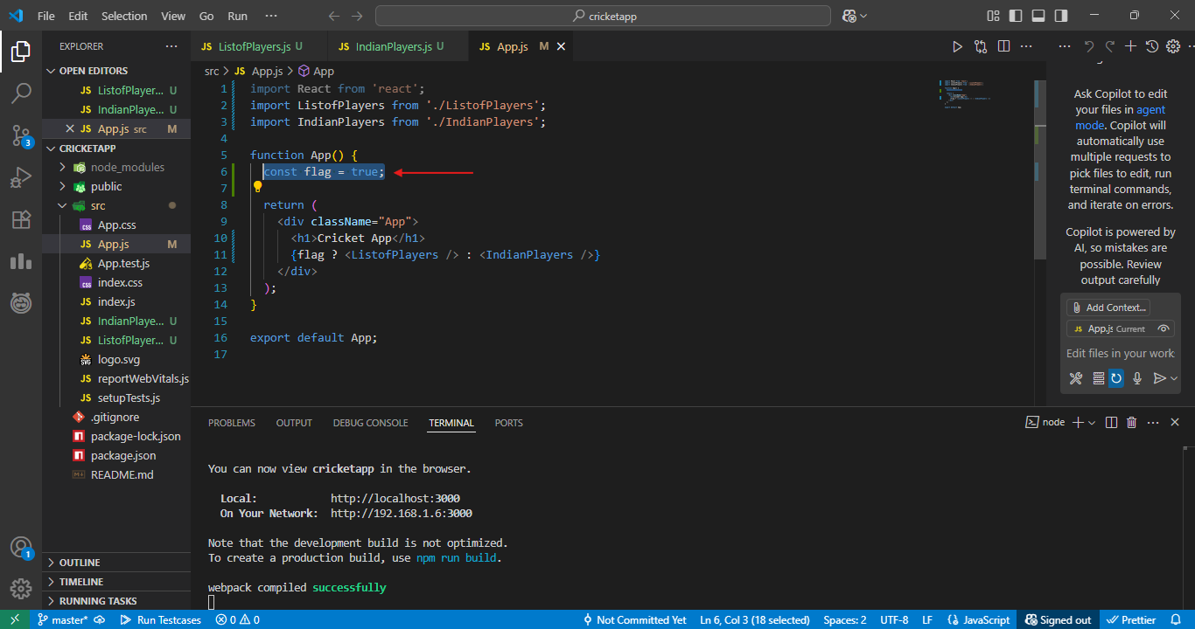

*VSCode showing Conditional Rendering*  
  
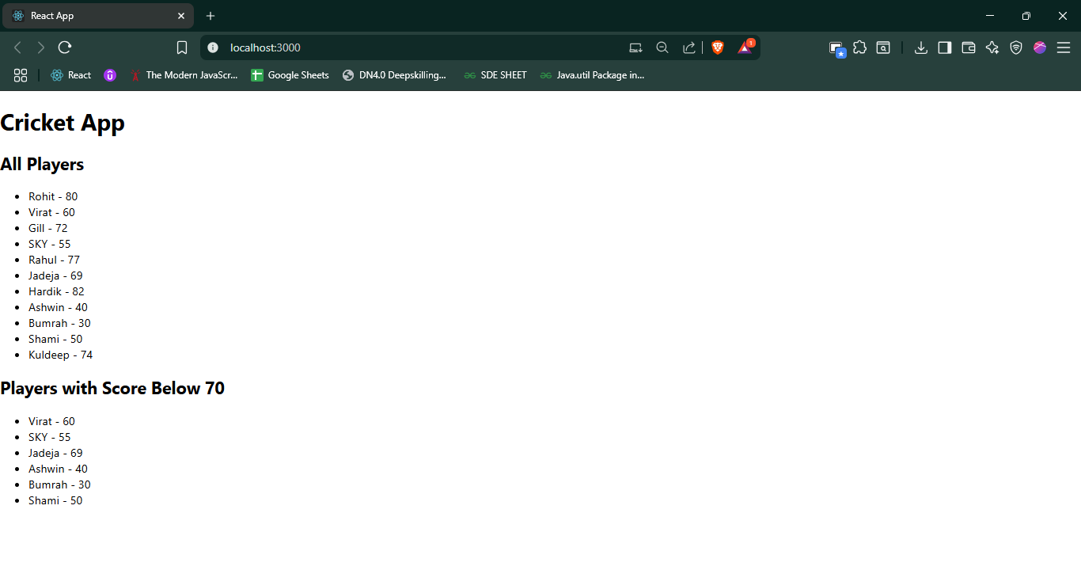*cricketapp with (flag = true):*  
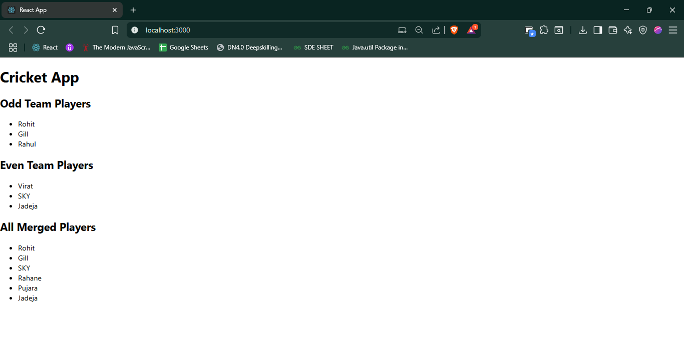  
*cricketapp with (flag = false)*