Git HOL 1 – Git Initialization, Configuration & First Commit
Name : Divyansh Tiwari
SuperSet ID: 6394658
Topic : Git

Objective:
Familiar with Git commands like git init, git status, git add, git commit, git push, and git pull.

Steps Followed:
Step 1: Git Configuration Setup
Check if Git is installed
git --version
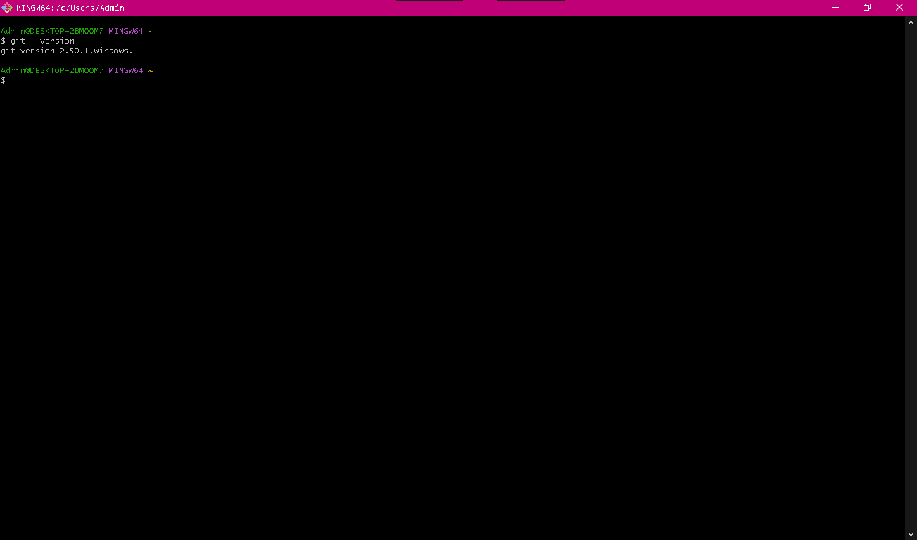
Output showing installed Git version
Configure Git user information:
git config --global user.name "Divyansh Tiwari"
git config --global user.email "divyanshtiwari04@gmail.com"
Verify configuration
git config --list

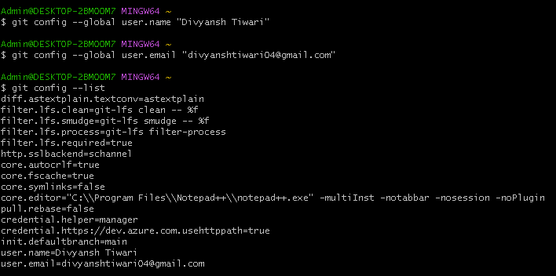
Output showing configured name and email

Step 2: Set Notepad++ as Default Git Editor
Check if notepad++ is recognized
notepad++

Add Notepad++ to system PATH (if needed)
Steps:
- Open sysdm.cpl → Advanced → Environment Variables
- Edit Path and add:
makefile
Copy code
C:\Program Files\Notepad++
Restart Git Bash.

Set Notepad++ as Git's editor
git config --global core.editor "notepad++"
Confirm editor configuration
git config --list

Output showing editor as notepad++

Step 3: Create Git Repo and Add File
Initialize Git repository
mkdir GitDemo
cd GitDemo
git init
Output of git init
Create a file with content
echo "Welcome to Git Demo!" > welcome.txt
Check file exists and view content
ls
cat welcome.txt

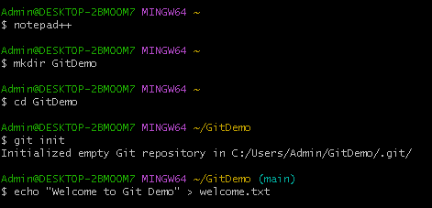
Screenshot 6: Output of ls and cat welcome.txt
Check Git status
git status
Output showing welcome.txt as untracked
Stage and commit the file
git add welcome.txt
git commit
Inside Notepad++
Initial commit
- Added welcome.txt
- Testing Git setup
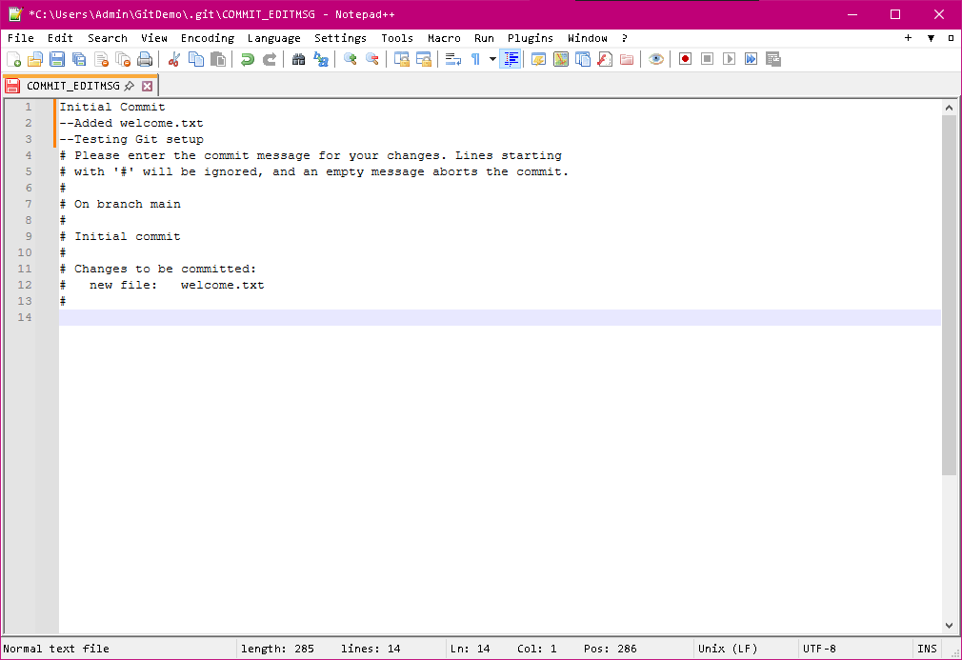
Commit message in Notepad++
Confirm status
git status

Step 4: Push to GitLab Remote Repository
Connect remote
git remote add origin https://gitlab.com/divyanshtiwari04-group/GitDemo.git
Push local branch to remote
git push -u origin main
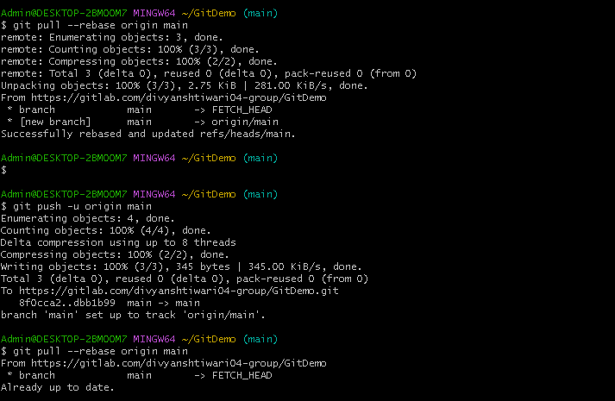
Successful push to GitLab

