Git HOL 2 – Using .gitignore to Exclude Unwanted Files
Name : Divyansh Tiwari
SuperSet ID: 6394658
Topic : Git

Objective:
- Understand the role of .gitignore in Git
- Ignore unwanted files (e.g., .log, folders like log/)
- Verify they are excluded from tracking and commits

Steps Followed:
1. Opened the working directory
cd GitDemo
2. Created a .log file and a log folder
touch error.log
mkdir log
touch log/system.log
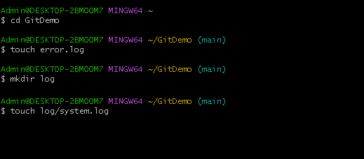
Output of ls and ls log/ showing error.log and log/system.log
3. Check Git status
git status
error.log and log/system.log should show as untracked files
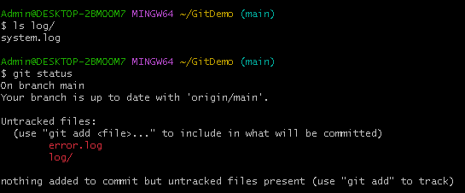
git status showing both as untracked
4. Create and edit .gitignore
touch .gitignore
notepad++ .gitignore

Inside .gitignore, add:
*.log
log/
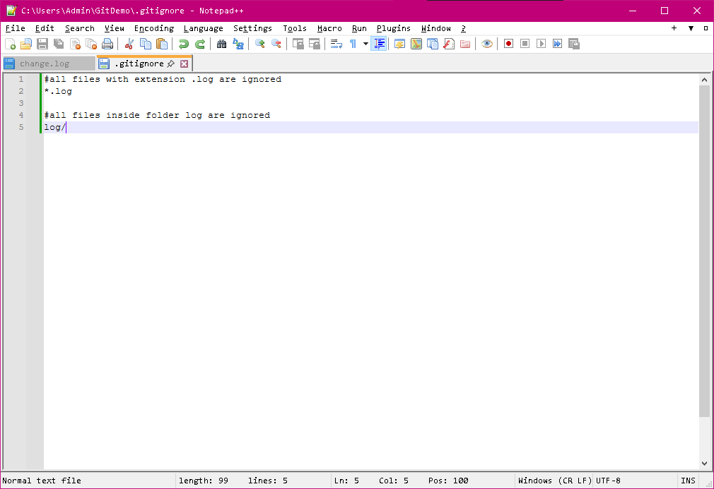
.gitignore opened in Notepad++ with above lines added
5. Check Git status again
git status
only .gitignore should be listed as untracked
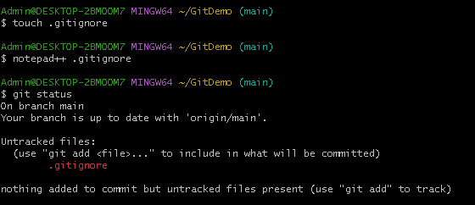
git status showing .gitignore as the only untracked file
6. Stage and commit .gitignore
git add .gitignore
git commit -m "Add .gitignore to exclude .log files and log directory"

7. Push the commit to GitLab
git push origin main
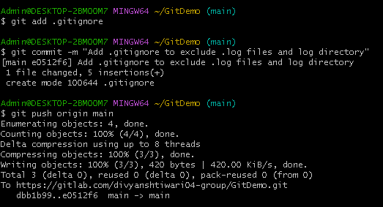 changes added to staging area and then committed to repository

