Git HOL 3 – Branching and Merging
Name : Divyansh Tiwari
SuperSet ID: 6394658
Topic : Git

Objective:
- Understand Git branching and merging
- Create and switch branches
- Commit changes in a feature branch
- Merge changes back into main
- Use git log and optionally P4Merge to visualize history

Steps Followed:

1. Navigate to your Git project
cd GitDemo
2. Create a new branch
git branch GitNewBranch
3. List all branches
git branch -a
The active branch marked with *
4. Switch to the new branch
git checkout GitNewBranch
5. Create and add content to a file
echo "This is a new feature branch." > new-feature.txt
git add new-feature.txt
git commit -m "Add new-feature.txt in GitNewBranch"

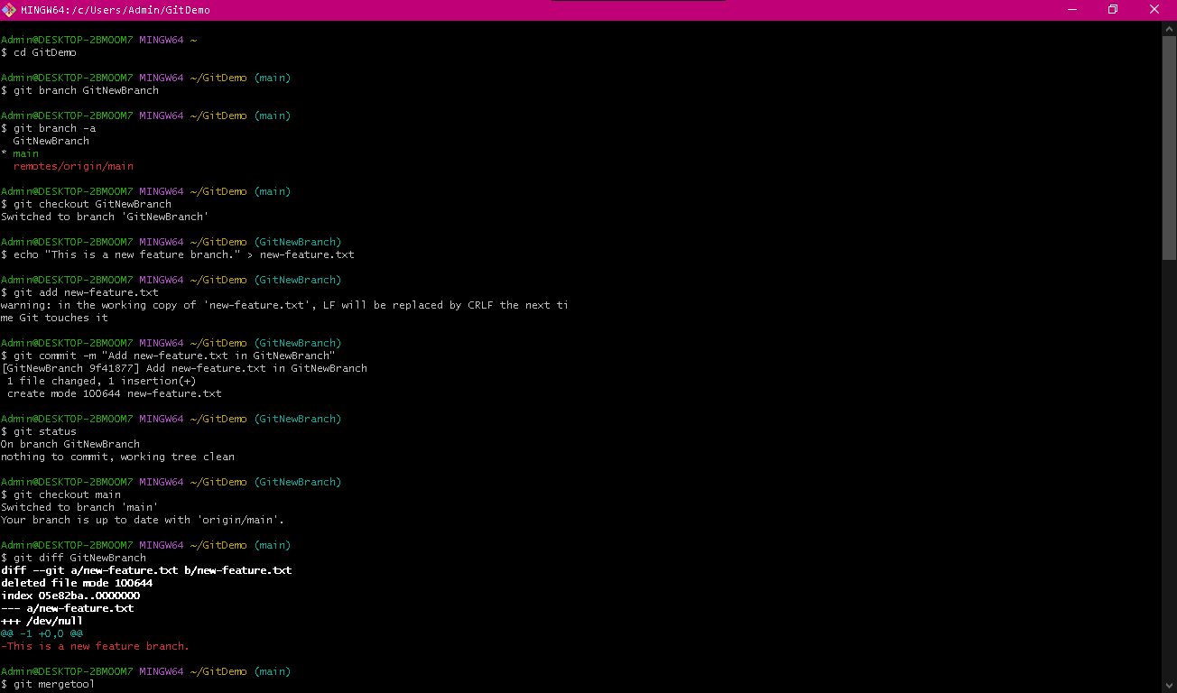 Git bash reflecting changes made

6. Check Git status
git status

Merging to Main
7. Switch to main
git checkout main
8. Compare differences (CLI)
git diff GitNewBranch

Output showing CLI diff between main and GitNewBranch
9. (Optional) View visual differences using P4Merge
git mergetool
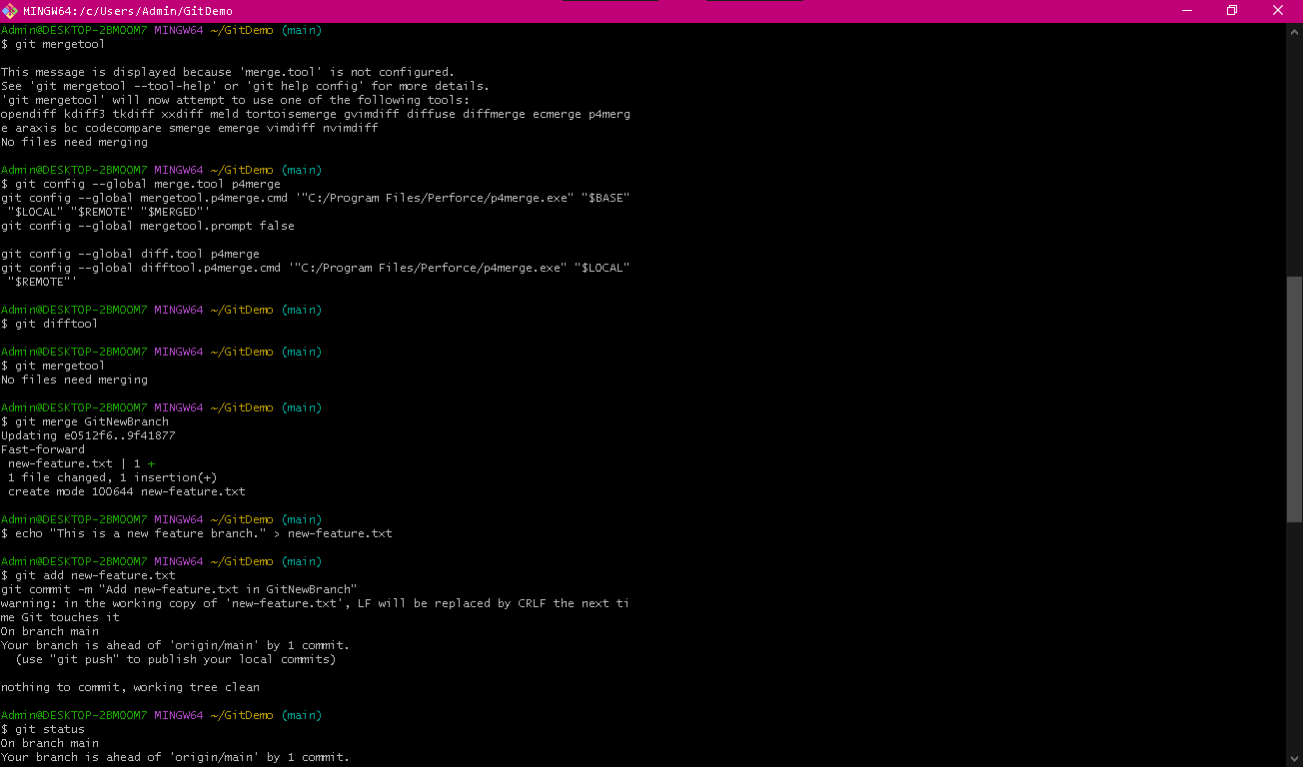
P4Merge configured and called
10. Merge the branch into main
git merge GitNewBranch
11. View log history
git log --oneline --graph --decorate
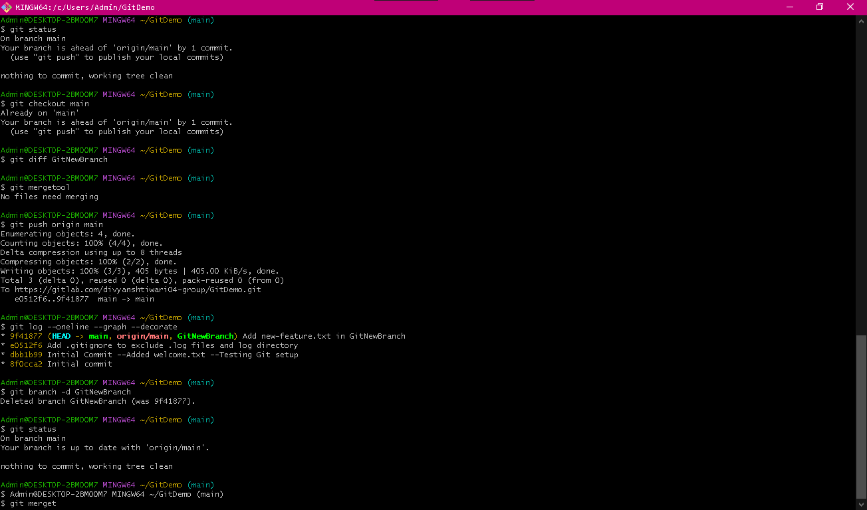
Graphical log view showing merge

12. Delete the merged branch
git branch -d GitNewBranch
13. Confirm final status
git status


