Git HOL 4 – Resolving Merge Conflicts
Name : Divyansh Tiwari
SuperSet ID: 6394658
Topic : Git

Objective:
- Understand merge conflicts in Git
- Resolve conflicts using 3-way merge
- Clean up and update .gitignore with backup files
- Track Git history during resolution

Steps Followed:
1. Ensure working branch is clean
cd GitDemo
git checkout main
git status
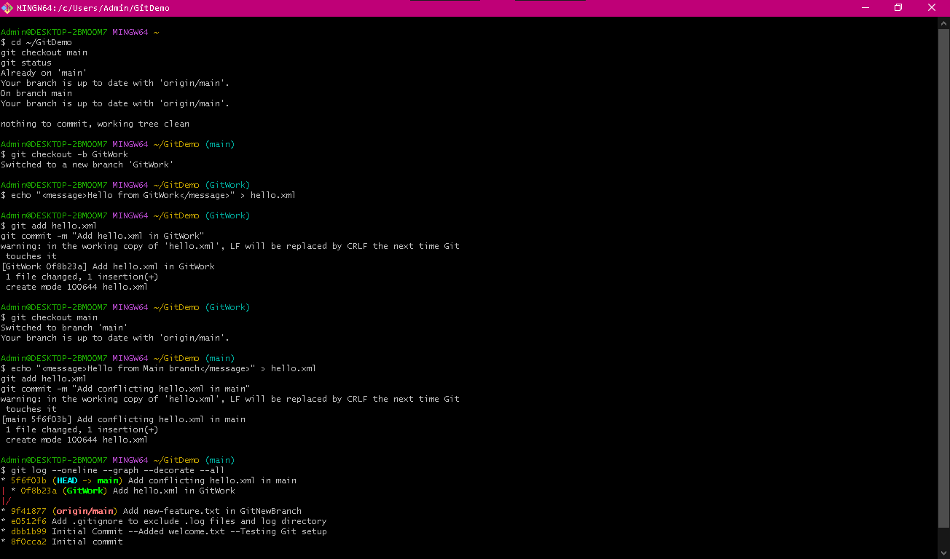
Output of git status showing clean working tree
2. Create new branch GitWork and add a file
git checkout -b GitWork
echo "<message>Hello from GitWork</message>" > hello.xml
git status

3. Commit the file in GitWork
git add hello.xml
git commit -m "Add hello.xml in GitWork"
4. Switch to main and create conflicting hello.xml
git checkout main
echo "<message>Hello from Main branch</message>" > hello.xml
git add hello.xml
git commit -m "Add conflicting hello.xml in main"
5. View commit graph
git log --oneline --graph --decorate --all

Graph showing diverged branches
6. Check differences before merge
git diff GitWork
7. Merge GitWork into main to trigger conflict
git merge GitWork

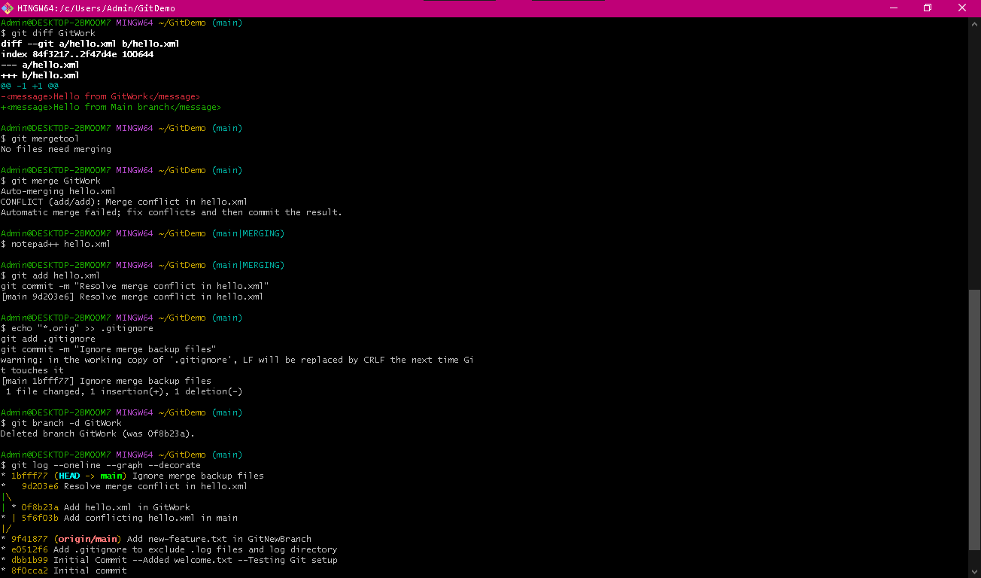
RESOLVE MERGE CONFLICT
9. Open and edit hello.xml to resolve conflict
notepad++ hello.xml
Replace merge markers:
<message>Hello from both branches</message>
10. Add and commit resolved file
git add hello.xml
git commit -m "Resolve merge conflict in hello.xml"

11. Add backup files to .gitignore
echo "*.orig" >> .gitignore
git add .gitignore
git commit -m "Add backup file rule to .gitignore"

Console output for add and commit command
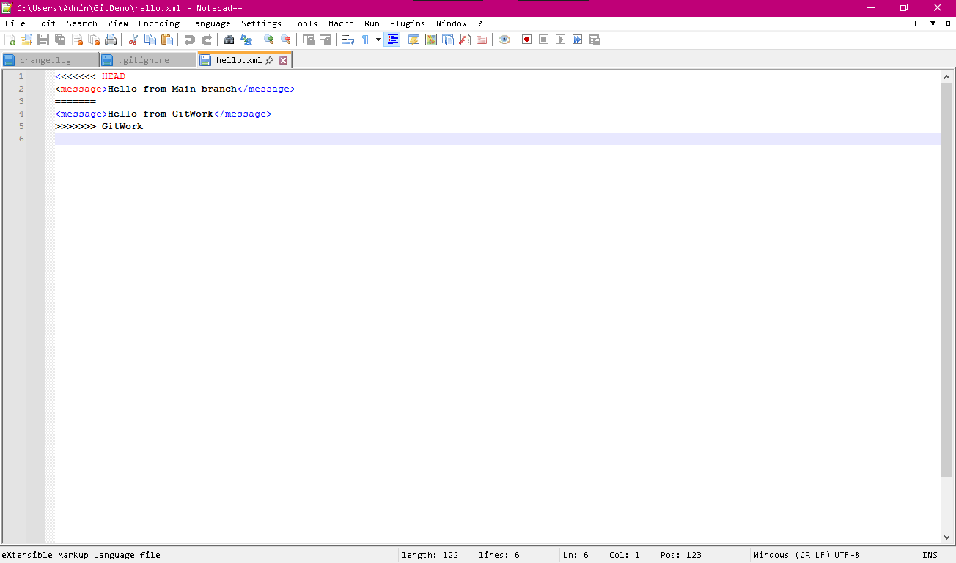hello.xml file
12. Delete merged branch
git branch -d GitWork

13. Final log to confirm
git log --oneline --graph --decorate
Final log after resolving and deleting branch


